Past, Present and Future of American Indian Nurses in North Dakota

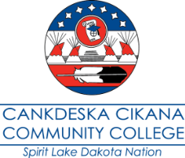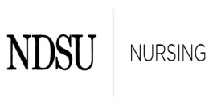
When: Tuesday, June 11 and Wednesday, June 12, 2013
Where: Spirit Lake Casino & Resort, Fort Totten, North Dakota &
Cankdeska Cikana Community College, Spirit Lake Dakota Nation

Registration Form
(Registration deadline May 29th, 2013)

First name: Click here to enter text.
Middle name: Click here to enter text.
Last name: Click here to enter text.
Address: Click here to enter text.
City: Click here to enter text.
State: Click here to enter text.
Zip code: Click here to enter text.
E-mail address: Click here to enter text.
Phone number: Click here to enter text.
Name of company: Click here to enter text.
Job title: Click here to enter text.
Will be attending full conference ☐
Will be attending one day ☐
Which day? Click here to enter text.
Will be attending dinner ☐
Registration form submission options:
Email to - Loretta.heuer@ndsu.edu,
Mail to - Loretta Heuer, PhD, RN, FAAN, North Dakota State University, Department of Nursing
Department 2670, PO Box 6050 / Fargo ND 58108-6050, or
Fax to - 701.231.6257

