Talking Points: February
February 27, 2015

AHSS News: Great interdisciplinary stuff
Three AHSS faculty have been named Gunlogson fellows for 2015: Meghan Kirkwood, assistant professor of visual arts; Ron Ramsey, associate professor of architecture; and Angela Smith, assistant professor of public history. During this year, the fellows will complete research projects that make use of the Institute for Regional Studies and/or make faculty research accessible to the state in alignment with NDSU’s land grant mission.

The College of AHSS worked with the division of Research and Creative Activity and Concordia College to offer an NEH regional grant-writing workshop at NDSU’s McGovern Alumni Center on February 13th. Over 120 people from three states and 30 different organizations participated in the day long workshop that featured NEH program director Russ Wyland. Ashley Baggett, assistant professor of history and history education, facilitated a networking workshop. In addition, Brad Benton, assistant professor of history; Kristen Fellows, UNITE assistant professor of anthropology; and Gary Totten, professor and chair of English served on a mock review panel. Dennis Cooley, professor of philosophy and associate director of the Northern Plains Ethics Institute, partnered with Brenna Gerhardt, Executive Director of the North Dakota Humanities Council, to provide travel funds for those coming from other places in North Dakota to attend the conference.

David Bertolini, head of architecture/landscape architecture, and Jessica Jung, assistant professor of theater arts, were appointed to Fargo's first arts and culture commission. They are joined on the 9-member commission by alumnae Dayna Del Val, (MA, English 2002), Executive Director of the Arts Partnership.

Women’s Week: Bending the Binary co-sponsored by the Women and Gender Studies program, offers many opportunities for AHSS faculty to collaborate on exceptional programming for the university. Twelve faculty and three graduate students from the college present next week: Alison Graham-Bertolini, Kelly Cameron, Emily Wicktor, Betsy Birmingham, Amber Fetch, Phil Bode, Heather Flute, Miriam Mara, Amy Rupiper Taggart, Natalie Smith Carlson, Gina Aalgaard Kelly, Kristen Fellows, Christina Weber, Sarah Boonstoopel, and Angela Smith.

Center for Social Research
- Karen Olson was promoted to the position of Associate Director at CSR.
- Xiangping Gao joined the CSR staff as a Research Specialist in February.
- ND KIDS COUNT received a $100,000 grant from the Annie E. Casey Foundation to support its efforts to enrich local and state discussions concerning ways to secure better futures for all children.
- ND KIDS COUNT is assisting the Annie E. Casey Foundation with the promotion and distribution of The Data Snapshot. This report highlights an alternative tool to measure poverty – and the impact of state and federal programs to address it. The impact of anti-poverty programs on North Dakota’s children is significant. Without government assistance, 18% of children in the state would live in poverty. However, when transfers from anti-poverty programs are incorporated using the Supplemental Poverty Measure (SPM), the percentage of North Dakota children living in poverty is reduced by 8 percentage points to 10%.
- To aid the planning processes of Sanford Health and Essentia Health, CSR is conducting Community Health Needs Assessment surveys in communities across North Dakota, Minnesota, and South Dakota. The Fargo-Moorhead area survey is underway. Selected sample survey participants will soon be receiving the survey in the mail.
- Presentations and Outreach: North Dakota Compass gave a presentation to Tribal leaders at the United Tribes Technical College discussing U.S. Census information for Tribal Governments in North Dakota in February. In addition, ND Compass participated in the Nonprofit Day at the Capitol and provided information about the project to legislators, possible collaborators, and nonprofits throughout the state. Kendra Erickson-Dockter, program director for North Dakota Compass was featured on Prairie Public’s Main Street, highlighting the two February articles featured on ND Compass regarding the importance of food systems in the state.

Challey School of Music
Composer-in-Residence Jocelyn Hagen has been invited to present a session at the National American Choral Directors Association Convention titled “Composers Have to Eat.” She will discuss issues and strategies in the composer’s world, such as the commissioning process, business models, and publication information. The convention is taking place February 25-March 1 in Salt Lake City, Utah. Jo Ann Miller, professor, Michael Weber, associate professor, and Charlette Moe, assistant professor, are also at the convention to promote their upcoming symposium titled “Contemporary Composition in America,” which will take place at NDSU in October.

Kyle Mack, associate professor of trombone, along with Matthew Patnode, associate professor of saxophone, will be guest clinicians and performing artists with the Mandan Middle School and High School Jazz Ensembles. They will work with students throughout the day running sectionals, teaching master classes and rehearsing for the evening concert. The concert was February 26 at Mandan High School.

Michael Weber, along with graduate assistants Erik Zinter and Frode Gundersen, are coordinating the Tri-College Men’s Choir Concert, which will take place on Thursday, March 12 at 7:30 PM at Trinity Lutheran Church in Moorhead. The performance will feature men’s choirs from NDSU, Concordia and MSUM. The concert is free and open to the public.

The NDSU men’s choir, the Statesmen, have been invited to perform at the North Dakota Music Educators Association conference on Thursday, March 26 at 7:30 PM at the Bismarck Civic Center. They were selected to perform through an audition process and are the only college choir selected. The Statesmen is conducted by Michael Weber along with graduate assistants Erik Zinter and Frode Gundersen.

Clara Osowski, (2008), student body vice-president, and graduate of the Challey School of Music, was the only American to advance to the final round of the Das Lied International Song Competition in Berlin. Thousands of aspiring students compete in this event, which is held every two years. Osowski advanced quickly in the initial rounds but did not place in the finals. Last year Osowski placed first in the Bel Canto Competition and will perform at the International Grieg Festival in Bergen, Norway in May.

Communication
Communication professor Ross Collins has launched a new plan to generate funds for the Dorothy Collins Memorial Endowment for student scholarships (rossfcollins.com/dorothyendowment). His Cachets for Charity program offers envelopes featuring photographic cachets (designs on the left side of an envelope) taken from his new Pictures & Pixels conceptual photography series (rossfcollins.com/pictures). For a scholarship contribution of $10 or more to the NDSU Foundation (ndsufoundation.com), Ross will mail an illustrated envelope, individually signed, to an address of the donor's choice. These signed envelopes are limited to a numbered edition of only 15 for each image. They may be collectible (or not), but one thing is for sure—you’ll never see anything else like it in a mailbox! (ross.collins@ndsu.edu) 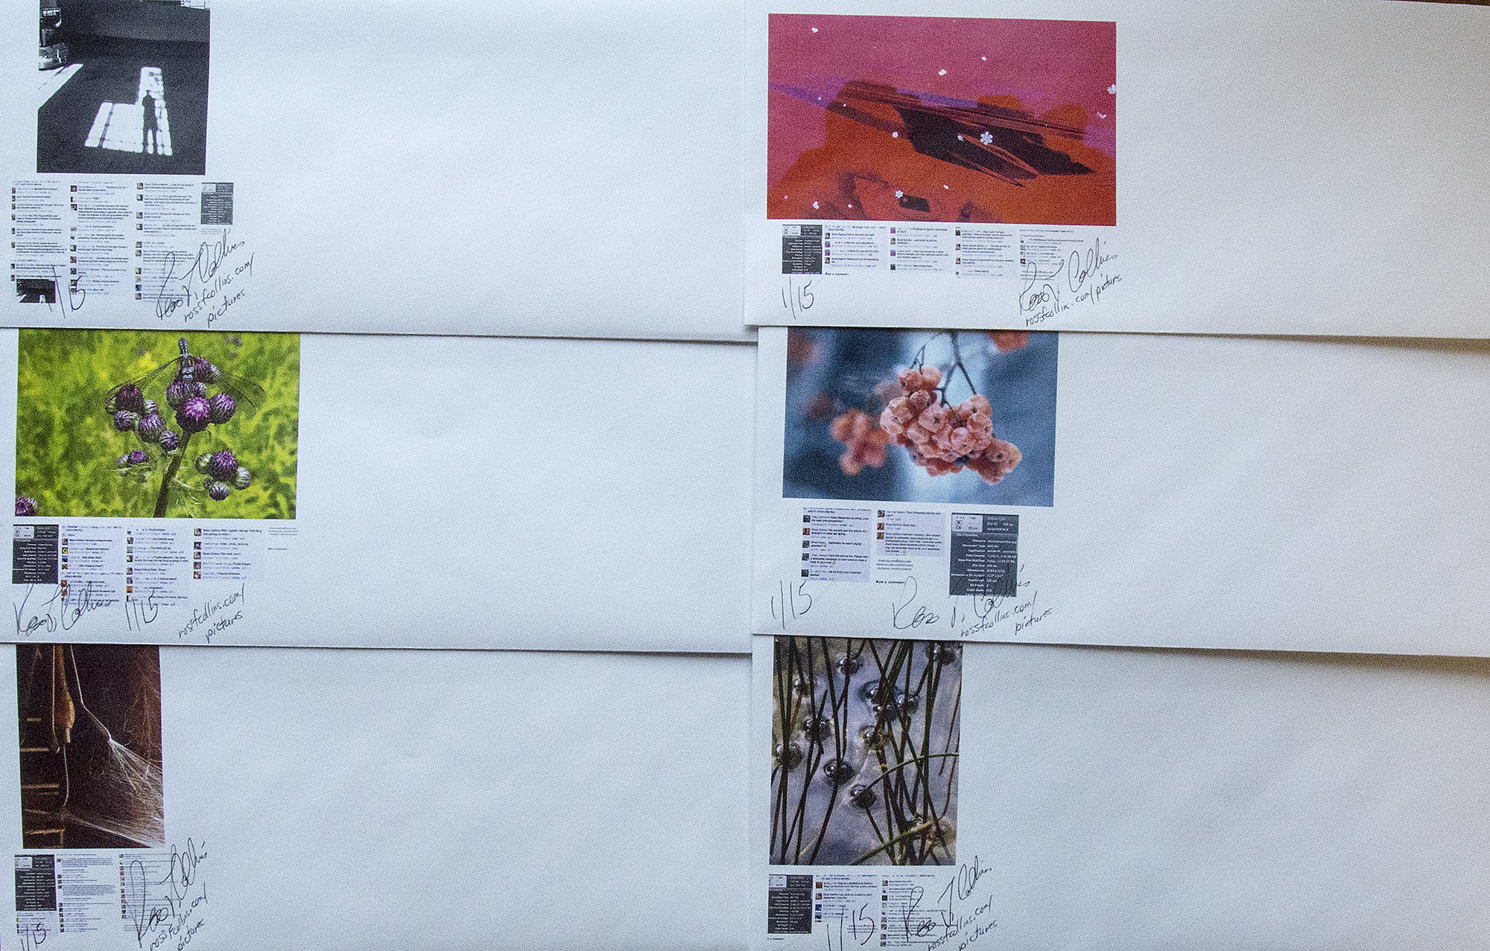

Criminal Justice and Political Science
Tom Ambrosio, professor of political science, is sole author of an article just published titled “Leadership Succession in Kazakhstan and Uzbekistan: Regime Survival after Nazarbayev and Karimov.” The article appears in the latest issue of the peer-reviewed Journal of Balkan and Near Eastern Studies. In addition, Ambrosio, received word that his manuscript titled “Mapping Kazakhstan’s Geopolitical Code: An Analysis of Nazarbayev’s Presidential Addresses, 1997-2014" has been accepted for publication in the peer-reviewed journal, Eurasian Geography and Economics. The article is co-authored with William Lange, an undergraduate history student. It will be published this year.

Carol A. Archbold, associate professor of criminal justice, will be a panelist for a discussion-based program called Idea Exchange: BAKKEN BOOM Lives, Land, & Labor, scheduled for Thursday, Feb. 19, 6:30-8 PM at the Plains Art Museum. Archbold will discuss her research on crime and policing in the Bakken.

Archbold was also interviewed Rodes Fishburne regarding her research in the Bakken. Fishburne is the co-executive producer of a television series ordered by ABC studios entitled, "Boom!" On Saturday, January 31, 2015, The Dickinson Press reported that “Boom!” tracks the pilgrimage of a young, ambitious couple, seeking a better life, to the oil fields of the Bakken, where they come across roughnecks, drifters, oil barons, criminals and fellow prospectors.

Assistant professor of political science Dan Pemstein's manuscript "Brussels Bound: Policy Experience and Candidate Selection in European Elections," co-authored with colleagues at Texas Tech University and the University of Illinois, has been accepted for publication in the peer reviewed journal Comparative Political Studies. Google also recently awarded Pembstein, and Steve Meserve at Texas Tech, a $50,025 Faculty Research Award for a project entitled "Defamation or Dirty Laundry? Clientelism and Internet Censorship." Finally, Pembstein was awarded an extension to his Riksbankens Jubileumsfond grant subcontract from the University of Gothenburg, which now provides a total of $66,819 to support his work developing latent variable models for the Varieties of Democracy project.

Emergency Management
Jessica Jensen, assistant professor, Department of Emergency Management, is a pro bono research consultant for the International Association of Emergency Managers and as such, she is conducting, for the 8th year in a row, a national survey of local emergency managers about the value of funding from the federal government. The data from the survey is used to advocate on Capitol Hill for local emergency managers.

Jensen also completed a survey of institutions offering one or more emergency management degrees to assess the degree to which consensus exists about accreditation standards for bachelor’s programs in emergency management. She has supported accreditation efforts by participating on a national working group, writing a variety of reports on accreditation progress, and conducting a number of surveys to get feedback and buy-in as the accreditation process has evolved.

In addition, Jensen has been asked to coordinate the second Emergency Management Theory and Research Workshop building on the success of the Workshop she coordinated last year. The Workshop is held immediately before the FEMA Higher Education Symposium and represents the first opportunity for scholars who identify with the emerging academic discipline of emergency management to present their work and exchange ideas.

A manuscript by Jensen and John Carr (MS 2014) has been published Online First by the indexed journal Natural Hazards. The manuscript, entitled “Explaining the pre-disaster integration of Community Emergency Response Teams (CERTs),” is the first of two reporting findings from a study Jensen and Carr did together. The second manuscript is forthcoming in the Journal of Emergency Management this spring.

English
Kevin Brooks (professor of English), Chris Lindgren (MA NDSU English and current PhD Student in Writing Studies at the University of Minnesota) and Matthew Warner (PhD English) published a white paper in the collection, Rhetoric and the Digital Humanities. Their chapter, "Tackling a Fundamental Problem: Using Digital Labs to Build Smarter Computing Cultures” considers what kinds of initiatives and collaborations it would take among higher education, k-12, and a community to build a smarter local computing cultures.

Brooks, Heather Flute (MA English), Katelyn Ostby (English 2014) and a number of librarians, literacy experts, and community organizers from Fargo have been selected to participate in an Otto Bremer Foundation funded program called L3: The Rural Libraries and Literacy Leadership Institute. The Institute will assign the Fargo team a mentor, the group will convene with other groups from the state three times in 12 months, and the teams will develop a plan for library and literacy program capacity building. Counsel

Brooks received funding from the City of Fargo to support his efforts to re-establish Giving + Learning, an in-home English Language Learning program that supports language acquisition, driver’s literacy, and citizenship test preparation for New Americans in the FM area.

Bruce Maylath, professor of English, has published the chapter "Translation Competence: Research Data in Multilateral and Interprofessional Collaborative Learning" in the Handbook of Research on Teaching Methods in Language Translation and Interpretation (IGI Global Press, 2015), with co-authors from Belgium, Denmark, Finland, and Italy. The chapter draws on data collected through the Trans-Atlantic & Pacific Project, a network of writing, translation, and usability testing instructors linking their classes across four continents and founded by Maylath and co-author Sonia Vandepitte, at Ghent University, Belgium, in the 1999-2000 academic year. Maylath serves as TAPP's coordinator.

Julie Sandland, senior lecturer, English, brought her English 326-Writing in the Design Professions class to The Great Plains Food Bank in Fargo on February 23 for a tour of the space with Heather Schmidt, Donor Relations Manager. The students, who are architecture and landscape architecture majors, will be completing a service learning project that involves working with local nonprofits on plans to re-design their spaces.

The Red River Valley Writing Project, under direction of associate professor Kelly Sassi, received an Assignments Matter grant from the National Writing Project to provide training for RRVWP Teacher Consultant Karen Taylor to lead the Assignments Matter Task Jam for local teachers on Saturday, January 24 at the Probstfield Center in Moorhead. Assignments Matter invites teachers to collaborate using tools from the Literacy Design Collaborative (LDC) as well as protocols and processes common in the NWP teacher community to create writing assignments for use in their own classrooms and to share with one another. The NWP grant was made possible by a grant from the Bill and Melinda Gates Foundation.

On February 19, Kelly Sassi was inducted into the Tapestry of Diverse Talents. Sassi’s three nominators cited her work with returning veterans, teacher training a support for those teaching at tribal high schools and colleges, and her commitment to social justice work as key components of her outstanding commitment to diversity at NDSU and in our state.

History, Philosophy, and Religious Studies:
John K. Cox, professor of history, published a chapter in the new book William T. Vollmann: A Critical Companion (University of Delaware Press), edited by Christopher K. Coffman and Daniel Lukes. Cox's contribution is "Writing Europe: Death, History, and the Intersecting Intellectual Worlds of William T. Vollmann and Danilo Kiš" (pp. 123-140). This essay is part of Cox's continuing engagement with the ideas, works, and biography of Kiš, a major Yugoslav intellectual who died in Paris in 1989. In a related project, Cox recently published translations of three poems by Kiš (1935-1989) in the online journal M-DASH, available at mdash-ahb.org. The works appeared in the Fall 2014 issue (#3) of the journal, under the collective title "Poems from Apollinaire Dreams of Love by Danilo Kiš." M-DASH is the journal of Autumn Hill Books, based at the University of Iowa and Indiana University.

Sociology and Anthropology
Gina Kelly, assistant professor of sociology, received a grant of $55,473 to work with Ransom County Public Health over the next 9 months. This project is a collaboration with the Center for Social Research, which will undertake the pre- and post- project evaluation. In addition, Kelly will be writing a bi-monthly column on social health issues including topics such as 1) Underage Drinking and 2) Adult Binge Drinking.

In addition, Kelly presented a research paper on December 9, 2014 at the Australian Consortium for Social Science Methodology; the paper, "Utilizing Photovoice Methodology to Examine Mental Health Medication Use," was peer reviewed and accepted for publication. In November, Kelly collaborated with two faculty in Pharmacy Practice to receive a $2500 grant to use Photovoice, a research technique, to study mental illness among NDSU students.

Theatre Arts
Assistant professor of set design, Tiffany Fier, is designing the set for Stages’ Theatre Company’s production of One Dog Canoe, which will take place later this spring in Hopkins, MN. One Dog Canoe is a world premiere based on the book by Mary Casanova with music and lyrics adapted from the Grammy Award winning music of the Okee Dokee Brothers.

Jess Jung, assistant professor of directing, will direct the full-length play titled (a love story) by Kelly Lusk at the Source Festival in Washington, D.C., June 2015. The Source Festival is an annual new play event the features three full-length plays, 18 ten-minute plays, and 3 devised pieces. Additional information can be found at www.sourcefestival.org.

Assistant professor and Theatre NDSU Artistic Director Hardy Koenig was invited to present a workshop at the Southeastern Theatre Conference, March 2-8 in Chattanooga, TN. Titled “Nail that Audition: How to Give a Fearless Audition” will be presented to theatre professionals and students as they work toward creating audition packages.

Koenig is also directing Into the Woods, presented by Music Theatre Fargo Moorhead and runs through March 1 at The Stage at Island Park. He is taking an unusual approach to this production in which only 12 actors will play all 23 roles.

Katherine Noone, assistant professor of musical theatre, was invited to present “Music Directing the Musical: The Complete and Healthy Way” at the North Dakota American Choral Directors Association state conference, February 7 in Bismarck, ND. The presentation addressed topics ranging from correct vocal techniques to acting issues that arise when music directing musicals set in different time periods.

Visual Arts
Professor Kim Bromley’s session proposal has been accepted for the Southeast College Art Conference in Pittsburg, PA this October. His proposal, “Metaphor and Understanding Visual Art,” explores questions surrounding metaphor: What part does metaphor play in determining the quality of a work of art? How does the metaphor assist us in understanding the work itself? As art instructors, how do we teach art students about metaphor and its significance? As session chair, Bromley will review paper submissions for inclusion in the conference session.

Kim Bromley’s series of FLOWER PAINTINGS opens at the Ecce Gallery in Fargo, March 12th and runs through April 5th, 2015. This series of paintings reflects “blossoming,” and the transformation of life. Exhibition opening reception will be held on March 12th at the Ecce Gallery from 6:00-8:00 pm.

Recently Professor Elizabeth Schultz interviewed Kim Bromley regarding his MOBY-DICK painting series. Professor Schultz, author of UNPAINTED TO THE LAST: MOBY-DICK AND THE TWENTIETH-CENTURY, is a Fulbright Lecturer, Chancellors’ Club Teaching Professor of English at the University of Kansas and a MOBY-DICK/Melville scholar. Professor Schultz plans on using information gleaned from the interview as well as images of Bromley’s MOBY-DICK series when presenting the keynote address at the Tenth Annual International Melville Society Conference in Tokyo this June.

Kim Bromley’s painting, “Self-Portrait,” as well as a number of student’s self-portraits, will be exhibited in the Wabi-Sabi exhibition at the Spirit Room. Students include: Justin Brown, Mataya Armstrong, Rosie Kelly, Andrea Qual, Candy Skauge, Zach Vraa, Joshua Barduson, Emma Beatrez and Beata Weber. Exhibition runs from March 3rd through April 23, 2015. Wabi-Sabi is a term based on the Japanese philosophy of imperfect beauty, where the beauty lies in the flaws. Exhibition reception takes place on March 7th from 6:30 to 9:30 pm at the Spirit Room.

Assistant professor of visual art, Meghan Kirkwood, presented her paper "What is the role of the Visual Arts Department at the Land Grant University?” paper at the 2015 College Art Association annual meeting in New York.

On February 5, together with their students, Kirkwood, and assistant professor of landscape architecture, Dominic Fischer, held a closing reception for "North Waters Rising" at the Memorial Union Gallery. The exhibition was on view from December 23-February 6 and combined work from advanced photography and environmental planning studio students that looked at the Red River Valley.

Women and Gender Studies Program
On March 26, WGS is bringing Dr. Tal Peretz, co-author of Some Men: Feminist Allies and the Movement to End Violence Against Women, co-authored with Michael Messner and Max Greenberg. The authors explore the trends and the tensions of men's work as feminist allies over the last 50 years. The brownbag presentation will be held on the 26th at noon in MU Hidatsa.

