USING TABLES, FIGURES, SCHEMES, AND NON-TEXT ITEMS IN CHAPTERS
Tables, figures, schemes, and non-text items can help your reader understand your data or discussion by converting it into a more visual format. If you use such non-text items, they should be integrated into the text of your disquisition – ideally, as close to the first in-text reference as possible, but not before it.
When you insert a table, figure, scheme, equation, algorithm, or other such non-text item into the text of your disquisition, try to do so at a natural break on the page. Natural breaks include at the top of the page, at the bottom of the page, between paragraphs, or between pages. Do not insert a non-text item in the middle of a long paragraph or sentence, if possible (unless there is a natural break). For a list and a demonstration of how to insert a table into the text, see Table 1.
Table 1. Preferred locations of non-text items
Location | Preferred | Not preferred
At the top of a page | X
At the bottom of a page | X
Between paragraph s | X
In the middle of a long paragraph |  | X
In the middle of a sentence |  | X

(Note that the table above is merely an example table. It does not follow any specific style manual, so consult the style manual of your discipline to see how your tables should be formatted.)
In addition, when you insert a non-text item into the disquisition, minimize the amount of blank space that appears before and after it. For example, if a table appears at the top of a page, make sure that there are no gaps in the text on the preceding page. The paragraphs should flow around the non-text items, with minimal blank space. However, if the paragraph text that appears after a table or figure is the start of a new section, then blank space is acceptable (because the item should appear in the same section where it is mentioned).
If you have a long non-text item that continues over a page break, that is a multi-page item. Refer to Table 2 for more information and an example.
Table 2. Requirements for multi-page items
Multi-Page Requirement | Description
First, consider using landscape orientation | - If a table, figure, scheme, or non-text item is too large to fit inside the required 1-inch margins of the page, consider converting it to landscape orientation. (Page numbers should remain in portrait orientation, so that all page numbers are aligned throughout the disquisition. See “Landscape Orientation” below.)
Minimize the number of page breaks that interrupt the item | - If a table, figure, scheme, or non-text item can feasibly fit onto a single page, in either landscape or portrait orientation, do not split up that content over multiple pages.  - If a non-text item must extend for multiple pages, minimize the number of pages that it occupies.
Repeat the item number and title on all pages of the multi-page item | - On the first page – Use the item number and title as per normal.  - On the subsequent pages – Use the same item number and title, but add the phrase “(continued) to the end of the title. If the title is more than one sentence long, you can abbreviate the title. For example, “Table 1. Title of table (continued)”.
For tables, repeat header rows on all pages | - If a table extends for multiple pages, the header row(s) should be repeated at the top of all pages in the table. This helps the reader to remember what the columns of data represent.
Indicate when an item is about to continue to the next page | - Preceding pages should include the phrase “(continues)” or “(continued) underneath the item. For example, if Table 1 is three pages long, then pages 1 and 2 should include the phrase “(continued)” under the item, like what is demonstrated with this table.
For tables, do not allow table cells to break across pages | - Table cells should remain intact. If a cell in a row contains a lot of information and continues over a page break, then either adjust the width of the cells in the table (so that the table is shorter in height), the line spacing of the text inside the table, or move the entire affected row of the table to the next page.
(continues)
Table 2. Requirements for multi-page items (continued)
Multi-Page Requirement | Description
For figures, consider dividing into separate components or reducing in size (if possible) | - If a figure consists of multiple components and continues for multiple pages, then consider dividing that figure into one or more figures. For example, if parts A and B of Figure 1 appear on one page, and parts C and D appear on the second page, consider dividing Figure 1 into two figures. (Depending on the content of your figure and your discussion, this might not be possible.)  - If your figure could be reduced in size and still remain readable, consider reducing the size of the figure.

Landscape Orientation
When a table, figure, scheme, or other non-text item is too large to fit in within the normal page margins (required 1-inch), you can convert the item to landscape orientation. However, the page numbers must remain in portrait orientation so that when your disquisition is printed, all of the page numbers throughout the disquisition are aligned correctly.
For an example, of a non-text item in landscape orientation, see Figure 1.
(Note the amount of empty space between this paragraph and the bottom of the page. Normally, when inserting a non-text item into the paragraph text, the paragraph text from the page after the landscape item would be inserted into this space, but because the next paragraph is the start of a new section, this amount of blank space is acceptable because the item should appear in the same section where it is mentioned).

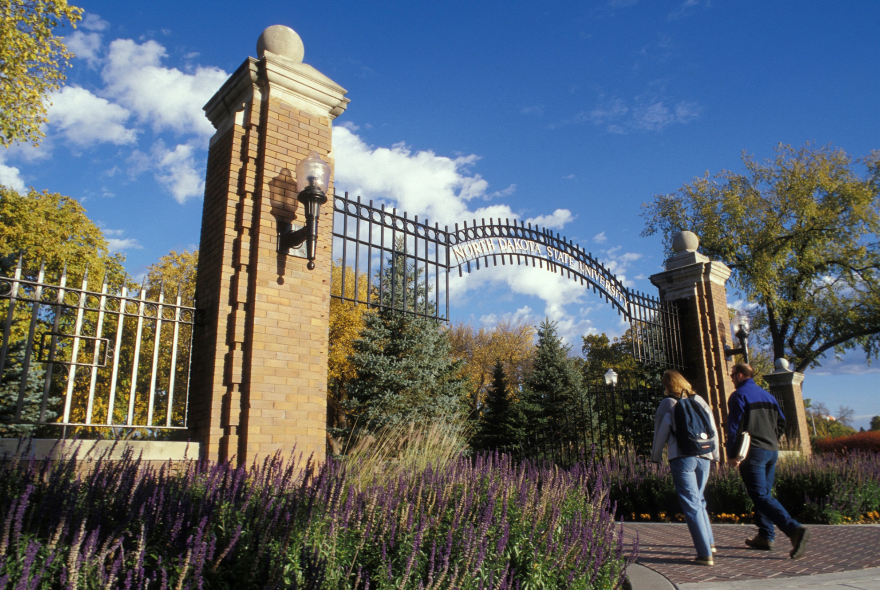
Figure 1. Example of a figure in landscape orientation. Note the location of the page numbers relative to the picture.

Numbering
Make sure that all non-text items in the disquisition are numbered consecutively for their type (such as “Table 1” and “Figure 1”). You can number consecutively from the beginning of the disquisition (e.g. “Table 1”, “Table 2”, “Table 3”) or consecutively from the beginning of each chapter (e.g. “Table 1.1”, “Table 1.2”, “Table 2.1”, and so on). For example, you cannot have two tables that are numbered as “Table 1”.
Either numbering method is acceptable, but it must be applied consistently to all non-text items in the disquisition, and not just the non-text items of a particular type. For example, if tables are numbered consecutively from the beginning of each chapter, then figures and schemes should also follow the same method.

Equations
When you use several equations in your disquisition, you might want to number the equations within the text. However, if you number one equation in the text, then you must number all of the equations that appear in the disquisition.
You can number the equations sequentially according to the chapter in which they appear (such as 1.1, 1.2, 1.3, 2.1, 2.2, 2.3, and so on), or you can number them in order of appearance, regardless of chapter or section (such as 1, 2, 3, 4, and so on). However, you cannot have two equations labeled as “Equation 1”, for example.
To number an equation, include the equation number in parentheses and place it to the right of the equation (unless the style manual of your discipline requires otherwise). For example:
a² + b² = c² (Eq. 1)
If you use a large number of equations in your disquisition, you might want to include a List of Equations in the prefatory material. For information about how to format lists, see “List of Tables, Figures, Schemes, Etc.” and “List of Abbreviations/Symbols” in the online Format Guidelines.

Appendix Tables, Figures, Schemes, Etc.
If you have tables, figures, schemes, and other non-text items in your appendices, then include the letter of the appendix (“A” if you have only one appendix) in the item number. For example, the first table of the first (or only) appendix would be labeled as “Table A1” (if you number from the beginning of the disquisition) or “Table A.1” (if you number from the beginning of each chapter). For more information about how to number appendix items, refer to the “List of Appendix Tables, Figures, Schemes, etc.” section of the online Format Guidelines.
In addition, you will need to include a “List of Appendix Tables” or “List of Appendix Figures” in the prefatory material, after the Table of Contents and Lists of Tables, Figures, Schemes, etc. Do not include appendix items in the normal Lists of Tables of Tables, Figures, Schemes, etc. Refer to the “Required Order of Elements” section of the online Format Guidelines.
Titles of appendix figures, schemes, etc. must follow the same formatting methods as the related items in the disquisition chapters. For example, appendix tables must be formatted similar to the tables in a disquisition chapter.
Note that, if you have an appendix that contains a single table, figure, scheme, etc, then some style manuals allow the title of the appendix to take the place of the item’s title. Then, the item would not require a separate title within the appendix, if that item is the only content in the appendix. For example, if Appendix B contains only a single table, then the table would not need an additional title within Appendix B, nor would it need an entry in the List of Appendix Tables. For more information about appendix tables, figures, schemes, etc., refer to the style manual of your discipline.

