Industrial & Manufacturing Engineering Department

North Dakota State University

2007-2008
Assessment Report

Submitted to:
Dr. Robert Harrold
University Assessment Committee

January 2009

Developed by:
Kambiz Farahmand
Professor and Chair

Table of Contents
Table of Contents 2
List of Tables 3
List of Figures 4
Glossary of Terms 5
Introduction 5
VISION 6
Mission 6
IME’s Assessment Plan 9
Assessment Methods 11
Graduating Seniors Exit Interview 12
Years to Degree 22
Fundamental of Engineering Exam (FE) 22
Internship/Co-op Evaluation 27
Formative Assessment 28
Faculty Course Assessment Report (FCAR) and Classroom Outcome Assessment 29
Capstone Assessment 30
IME Student Ratings of Instruction 36
Assessment Feedback and Implementation 45
Conclusion and Recommendations 46
Appendix AA1 - Industrial Engineering & Management Students Exit Interview Survey Results - Fall 2007 50
Appendix AA2 – Manufacturing Engineering Students Exit Interview Survey Results – Fall 2007 102
Appendix AA3 – Industrial Engineering & Management Students Exit Interview Survey Results – Spring 2008 155
Appendix AA4 – Manufacturing Engineering Students Exit Interview Survey Results – Spring 2008 213
Appendix BB1 – Industrial Engineering & Management Students Internship/Co-op Survey Results – Fall 2007 267
Appendix BB2 – Manufacturing Engineering Students Internship/Coop Survey Results – Fall 2007 305
Appendix BB3 – Industrial Engineering & Management Students Internship/Coop Survey Results – Spring 2008 341
Appendix CC1 – Industrial Engineering & Management Employers Internship/Coop Survey Results – Fall 2007 378
Appendix CC2 – Manufacturing Engineering Employers Internship/Coop Survey Results – Fall 2007 402
Appendix CC3 – Industrial Engineering & Management Employers Internship/Coop Survey Results – Spring 2008 426
Appendix DD1 – Faculty Courses Assessment Reports (FCAR) – Fall 2007 449
Appendix DD2 – Faculty Courses Assessment Reports (FCAR) – Spring 2008 455
Appendix EE1 – IME SRoI Results – Fall 2007 477
Appendix EE2 – IME SRoI Results – Spring 2008 481

List of Tables

Table 1 - IE&M Program Outcomes 8
Table 2 - Program Objectives vs. Outcomes 9
Table 3 - Assessment Calendar for IME Department 11
Table 4 – October 2007 FE (Industrial Exam) Results for IE&M Students 24
Table 5 - April 2008 FE (Industrial Exam) Results for IE&M Students 25
Table 6 - April 2008 (Industrial Exam) Results for MfgE Students 27
Table 7 - Summary of Formative Assessment Results 28

List of Figures

Figure 1 - Continuous Improvement Model 7
Figure 2 - Fall 2007 IE&M Exit Interview Results - Section 1 13
Figure 3 - Fall 2007 IE&M Exit Interview Results - Section 2 14
Figure 4 - Fall 2007 IE&M Exit Interview Results - Section 3 15
Figure 5 - Spring 2008 IE&M Exit Interview Results - Section 1 16
Figure 6 - Spring 2008 IE&M Exit Interview Results - Section 2 16
Figure 7 - Spring 2008 IE&M Exit Interview Results - Section 3 17
Figure 8 - Fall 2007 MfgE Exit Interview Results - Section 1 18
Figure 9 - Fall 2007 MfgE Exit Interview Results - Section 2 18
Figure 10 - Fall 2007 MfgE Exit Interview Results - Section 3 19
Figure 11 - Spring 2008 MfgE Exit Interview Results - Section 1 20
Figure 12 - Spring 2008 MfgE Exit Interview Results - Section 2 20
Figure 13 - Spring 2008 MfgE Exit Interview Results - Section 3 21
Figure 14 – IME student’s # of Years to Graduation at NDSU 22
Figure 15 - FE Results vs. National Results for IE&M Students 23
Figure 16 - FE Results vs. National Results for MfgE Students 26
Figure 17 - Formative Assessment Results Shown Against Benchmark 29
Figure 18 - Spring 2008 Capstone Projects Final Presentation Ratings 32
Figure 19 - Spring 2008 Capstone Client Project Ratings 33
Figure 20 - Spring 2008 Capstone Client's Evaluation 34
Figure 21 - Spring 2008 ABET Client's Evaluation 35
Figure 22 – 300 & 400 Level Courses SRoI rankings for Question #1 39
Figure 23 - 300 & 400 Level Courses SRoI rankings for Question #2 39
Figure 24 - 300 & 400 Level Courses SRoI rankings for Question #3 40
Figure 25 - 300 & 400 Level Courses SRoI rankings for Question #4 40
Figure 27 - 300 & 400 Level Courses SRoI rankings for Question #6 41
Figure 28 - 600 & 700 Level Courses SRoI rankings for Question #1 42
Figure 29 - 600 & 700 Level Courses SRoI rankings for Question #2 42
Figure 32 - 600 & 700 Level Courses SRoI rankings for Question #5 44
Figure 33 - 600 & 700 Level Courses SRoI rankings for Question #6 44

Glossary of Terms

Program Objectives: Broadly stated set of capabilities of our graduates 5 years after graduation

Program Outcomes: Knowledge, skills and behavior of our gradates at the time of graduation

Performance Criteria: Measurable attributes that define each of the program outcomes

Student Learning Outcome: Demonstrable knowledge and skills learned by students from the curriculum taught in each class

Achievement: Student’s accomplishments that allow us to measure program objectives

Assessment: Processes that identify, collect, use and prepare data that can be used to evaluate achievement

Evaluation: Process of reviewing the result of data collection and analysis and making a determination of the value of findings and action to be taken

Introduction
The following is the Industrial and Manufacturing Engineering (IME) Department’s assessment reports for the academic year 2007-2008. This report contains the assessment efforts (information and data) for both programs at IME department: (1) the assessment report for the BS in Industrial Engineering and Management, and (2) the assessment report for the BS in Manufacturing Engineering. These two reports are combined in this document and summarize the assessment efforts of the department’s faculty as a group. Some of the assessment tools are targeting the evaluation of the department as one entity and are common between the two programs.

Great care was taken to ensure that the IME department’s vision and mission was in line and consistent with the mission of the university and the College of Engineering and Architecture (CEA). The vision and mission statement were presented to our advisory board for review and approval during the last board meeting and are also available online at http://www.ndsu.nodak.edu/ndsu/ime/htmls/Vision.htm to the rest of our constituents and general public. Our advisory board consists of alumni, students, and industry leaders from across the country representing out constituency. Feedback is solicited as part of a continuous improvement effort at the department during spring and fall semester meetings with our advisory board. Recommendations are implemented after approval of the department faculty.

The vision and mission statement of the Industrial & Manufacturing Engineering department is as follows:

VISION
IME department will be a dynamic contributor to the local, regional, national, and international community through the development and dissemination of committed and advanced knowledge in the diverse field of Industrial and Manufacturing Engineering. We will create a nourishing environment that facilitates the growth of individuals through innovative teaching, imaginative research, and scholarship along with hands on applications and industry involvement.

Mission
The Industrial and Manufacturing Engineering Department has a three-fold educational mission. The teaching mission is to provide high quality undergraduate and graduate programs in industrial engineering and management, and manufacturing engineering. The research mission is to advance knowledge of manufacturing and industrial engineering, strengthen and support industry, and enhance teaching. The service mission is to participate in faculty governance, in the broader community of the engineering profession and its disciplines, and in the land-grant mission of the university through engagement in state, regional and national affairs.

For the purposes of assessment, the constituents of the IME department include; alumni, alumni employers, graduating and current students, and faculty. Assessment instruments are intended to solicit feedback from each constituent group.

A Continuous Improvement Model as shown in Figure 1, which was adopted in 2005, is utilized in order to assist the department in implementing a formal assessment and evaluation process. The model outlines the process of assessment and evaluation and how feedback from the various constituents is incorporated into the educational process and curriculum. We now know that the model will insure a self correcting mechanism for improvement allowing for development of a time-frame for assessment and review of data and feedback into the overall process for the purpose of continuous improvement.

Towards achieving the IE&M Program Educational Objectives, the Program Outcomes have been established. The eleven IE&M Program Outcomes are in line with ABET outcomes, and are recognized by faculty as being important to the achievement of the program objectives and satisfying mission of the department, college, and the institution.

NDSU Mission
CEA Mission
IME Mission

Program Objectives

Program Outcomes
Educational Strategies Technique
Measurable Performances Criteria
Evaluation of Evidence/ Analysis of Assessment data
Assessment: Collection of Evidence

Feedback from our Constituents

Educational
Objectives

Assess &
Evaluate

Feedback for
Continuous
Improvement

Department and College Curriculum Committee
Relationship between PO & SLO
Relationship between P Objectives & Outcomes
Figure 1 - Continuous Improvement Model
The Industrial Engineering and Management Program Outcomes are shown below in Table 1.

Table 1 - IE&M Program Outcomes
a | an ability to apply knowledge of mathematics, science, and engineering
b | an ability to design and conduct experiments, as well as to analyze and interpret data
c | an ability to design a system, component, or process to meet desired needs within realistic constraints such as economic, environmental, social, political, ethical, health and safety, manufacturability, and sustainability
d | an ability to function on multi-disciplinary teams
e | an ability to identify, formulate, and solve engineering problems
f | an understanding of professional and ethical responsibility
g | an ability to communicate effectively
h | the broad education necessary to understand the impact of engineering solutions in a global, economic, environmental, and social context
i | a recognition of the need for, and an ability to engage in life-long learning
j | a knowledge of contemporary issues
k | an ability to use the techniques, skills, and modern engineering tools necessary for engineering practice

The Program Outcomes are abbreviated to read:

a. Applications of mathematics, science, and engineering
b. Design, experimentation, analysis, and interpretation of data
c. Design of system, component, and process
d. Teamwork
e. Engineering Problem Solving
f. Professional and Ethical Responsibility
g. Communications.
h. Broad Education
i. Life Long Learning
j. Contemporary Issues
k. Techniques, skills, and modern engineering tools

The relationship between Program Objectives and Outcomes for the IE&M program is shown in Table 2.

Table 2 - Program Objectives vs. Outcomes
 |  | Industrial Engineering & Management Program Objectives
Outcomes |  | Apply statistical, operations research and simulation tools to solve problems relevant to modern production, commercial, social and/or governmental organizations, with principal emphasis on quality, productivity, continuous improvement and enterprise integration. | Design processes and systems to effectively and economically employ and integrate technology and people in organizational environments in industrial, healthcare, logistics, service and/or governmental settings, with appropriate consideration for environmental factors, health and safety, manufacturability and ethical, economic, social and political issues. | Engage in effective life-long learning in topics and areas relevant to professional advancement and to enhancing the quality of personal life in today’s global and social context. | Participate effectively in multi-disciplinary teams in both leadership and followership roles. | Effectively communicate complex technological concepts, issues and professional details to a variety of audiences.
Applications of mathematics, science, and engineering |  | XXX | XXX
Design, experimentation, analysis, and interpretation of data |  |  | XXX
Design of system, component, and process |  | XXX | XXX
Teamwork |  |  |  |  | XXX
Engineering Problem Solving |  | XXX | XXX
Professional and Ethical Responsibility |  |  | XXX
Communications. |  |  |  |  |  | XXX
Broad Education |  |  |  | XXX | XXX
Life Long Learning |  |  |  | XXX
Contemporary Issues |  |  |  | XXX |  | XXX
Techniques, skills, and modern engineering tools |  | XXX | XXX

IME’s Assessment Plan
IME’s assessment plan is summarized in Table 3. No assessment data was collected during summer 2008 semester. The Alumni surveys are sent out every three years to recent and old graduates of the two programs. This survey is scheduled to be conducted during summer 2009.

The results of the Exit Interview survey were collected and are presented for both spring and fall semester for the graduating seniors. The Coop surveys were conducted for students doing internships and coop and their employers or immediate supervisors. IME Capstone course is taught only during spring semesters. The assessment results from the spring 2008 capstone are provided and analyzed in this report.

Formative Assessment used to be performed only for IME 461, 472, and 431 during spring semesters and for IME 430 and 480 during fall semesters. As per University Assessment Committee’s recommendation we are implementing the formative assessment as an indirect self assessment of student learning in all of our classes. The latest FE results are presented and problem areas identified.

The following direct and indirect measures of student learning are implemented and are utilized in the IME department.

Direct measure of student learning was developed using:

Capstone Client (External) Survey correlated with Capstone students self-survey (Internal) and Faculty Surveys (Internal)
Capstone Portfolio Assessment
Fundamental of engineering national exam results
Internship and Coop surveys of students
Internship and Coop surveys of student’s employers
Formative Assessment

Indirect measure of student learning was developed using:

Exit Interviews
Alumni and Alumni Employers survey
Tracking Length of Time to degree and Retention rate (juniors or higher ranking)
Job Placement
Graduate follow-up studies
Faculty Course Assessment Report
Advisory Board Reviews and feedback

Since IME is a transition major and all general engineering students are designated pre-IME students, we are not able to track retention accurately for our freshmen and sophomores who are truly an Industrial Engineering and Management or Manufacturing Engineering students. Transfers are quite common for students in these two categories. However, transfer and retention data is tracked and recorded for our juniors and seniors in the two majors.

The assessment data presented in this report were shared with our advisory board members during the April advisory board meeting in spring and fall results were presented at our October meeting. Departmental review of findings was completed before the presentation of results to the advisory board.

Table 3 - Assessment Calendar for IME Department
IE&M | SPRING 2006 | SUMMER 2007 | Fall 2007
IE&M Alumni Survey |  | Every 3 years
IE&M Alumni Employer Survey |  | Every 3 years
IE&M Exit Interview | ● |  | ●
MfgE Exit Interview | ● |  | ●
Internship/Coop Evaluation
IE&M Student Evaluation | ● |  | ●
IE&M Employer Evaluation | ● |  | ●
Capstone Project Evaluation
Company's Eval. of Project | ●
Presentation/Report Eval. | ●
FE Exam Results
Industrial | ● |  | ●
Industrial/General | ● |  | ●
FCAR (Faculty Course Assessment Report) | ● |  | ●
Formative Assessment | All Courses |  | All Courses
Advisory Board Review | ● |  | ●
Department Review of Findings | ● |  | ●

Assessment Methods
IME faculty members understand that assessment is a critical element in the continuous improvement process of the department. The assessment methods used to assess program learning outcome vary somewhat from one outcome to another; however, a common set of methods were used in many cases. The methods include:

- Graduating Seniors Exit Survey/Interview
- FE Exam Results
- Internship/Coop Evaluation surveys
- Formative Assessment of Students
- Faculty Course Assessment Reports
- Capstone Project Evaluation Surveys
- SRoI Results
- Student’s Portfolios – length of time to graduation
- Advisory Board Reviews

Each set of data is examined for accuracy and verified for consistency. The raw data was summarized and combined in cases where two departments overlapped. Only the summary data or plot of the data is presented. Survey results are attached in one of the 14 appendices. The analysis of the data included identifying key elements that show need for improvement or potential areas of opportunity for continuous improvement of the educational process at the department or classroom level.

Graduating Seniors Exit Interview
The following Figures (2 -13) show the results of the exit interview surveys from fall 2007 and spring 2008 semesters for each of the IME programs. Section 1 of this survey covers the prospect of jobs and job interviews for our students. Section 2 of the surveys addresses specific program outcomes which includes the qualifications and skills that our students must poses at the time of graduation. Section 3 of this survey addresses the program specific outcome which includes course objectives and specific knowledge in various topics including student learning.

Figures 2, 5, 8, and 11 indicate that students on the average do 2 to 4 interviews. In these charts, the score of 1.0 across the board means 100% have job offers at the time of interview and any score above 0.5 indicates that more than 50% have job offers at the time of interview. In December of 2007, a couple of students were planning on travelling across Europe and one was going to the graduate school, so they were not actively interviewing or searching for jobs. All of the May 2008 graduates had job offers at the time of exit interviews. Our students on the average are receiving more than one job offer. Majority of our students are member of an academic student organization and are quite active on campus.

For the most part our students that are looking for jobs are successful and are offered great competitive salaries. This actually is a very strong feedback from the employers as to the caliper of our students and what they are looking for at the time of hiring.

The Program Outcomes are gauged in Figures 3 and 6 (IE&M students) and Figures 9 and 12 (MfgE students). The IE&M student’s lowest rating of 2.8 was for knowledge of contemporary issues” and the MfgE student’s lowest rating of 3.4 was for “an understanding of professional and ethical responsibility.” The results confirm the need for continual coverage of ethical issues and dilemma facing engineers in various classrooms and topics and a need for indentifying topics which are contemporary to students when these topics are presented.

Figures 4 and 7 gauges the program specific questions and student learning for the Industrial Engineering and Management program and figures 10 and 13 gauges the program specific questions and student learning for the Manufacturing Engineering program respectively. The lowest rating of 3.6 was given to the question “I feel confident in using simulation to model industrial & Manufacturing engineering scenarios for the purpose of optimization” by the IE&M students. Over all the score indicate an improvement in the program specific questions and student learning.

An understanding about packaged microelectronics was rated 1.8 in fall of 2007 program specific question in the manufacturing program. The lowest rating of 1.0 for program specific questions was given to the statement “I understand how discrete products are developed and produced in electronics, printed circuit board, and microelectronics” in the spring 2008 survey. These ratings are lowest rating in the past two years and could be an indication of not enough coverage in the classroom or labs about the specific topic(s).

The elements rated low in these surveys will be addressed in the courses impacting these outcomes the most. The changes and improvements made will be tracked in the Faculty Courses Assessment Report (FCAR). In manufacturing engineering we are aware about the shortcoming of the electronics manufacturing topic due to lack of adequate laboratory. The department is requesting additional space for teaching electronics manufacturing labs.

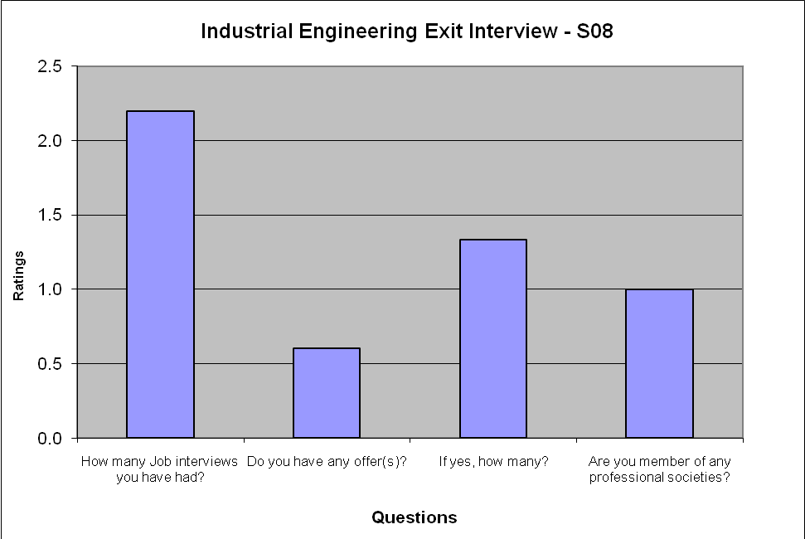
Figure 2 - Fall 2007 IE&M Exit Interview Results - Section 1

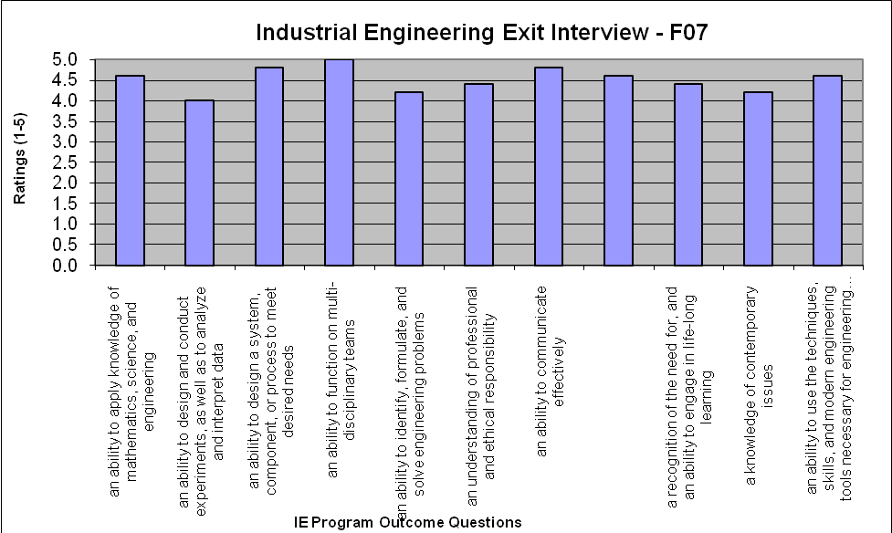
Figure 3 - Fall 2007 IE&M Exit Interview Results - Section 2

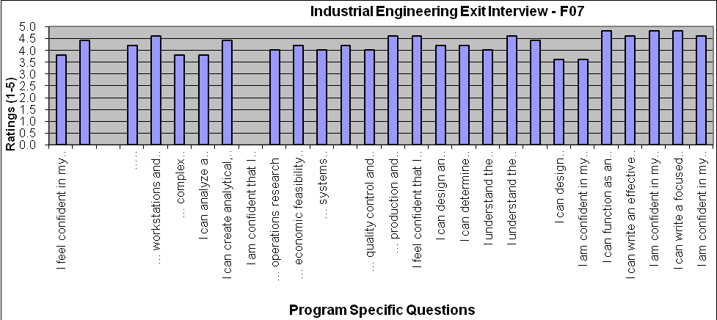
Figure 4 - Fall 2007 IE&M Exit Interview Results - Section 3

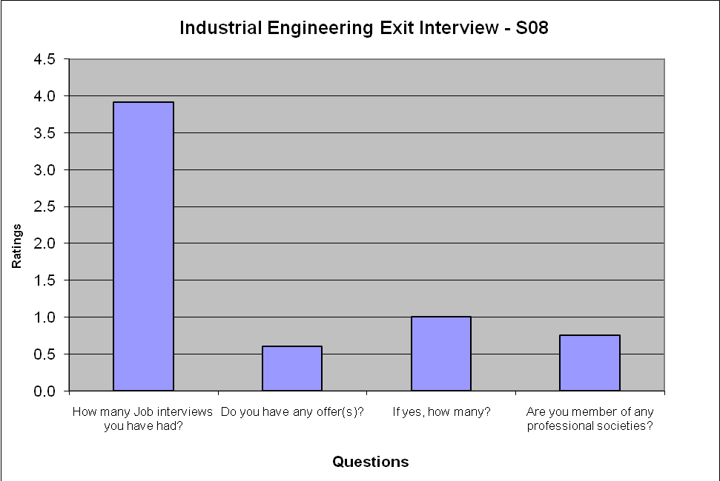
Figure 5 - Spring 2008 IE&M Exit Interview Results - Section 1

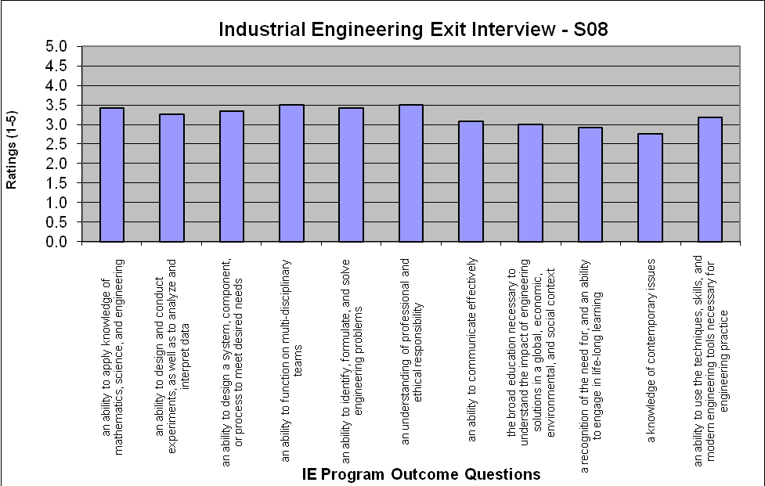
Figure 6 - Spring 2008 IE&M Exit Interview Results - Section 2

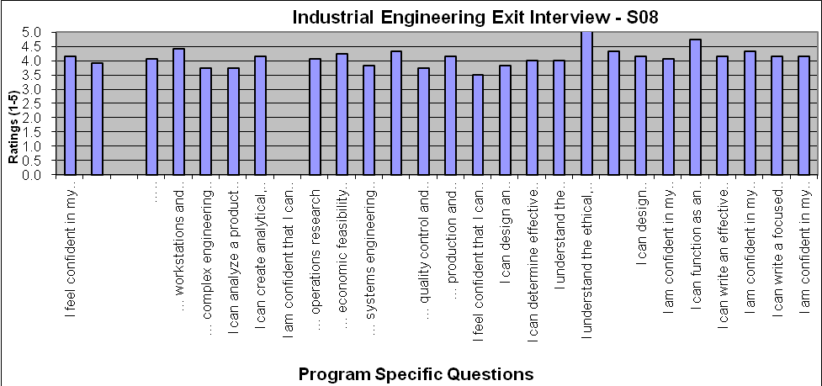
Figure 7 - Spring 2008 IE&M Exit Interview Results - Section 3

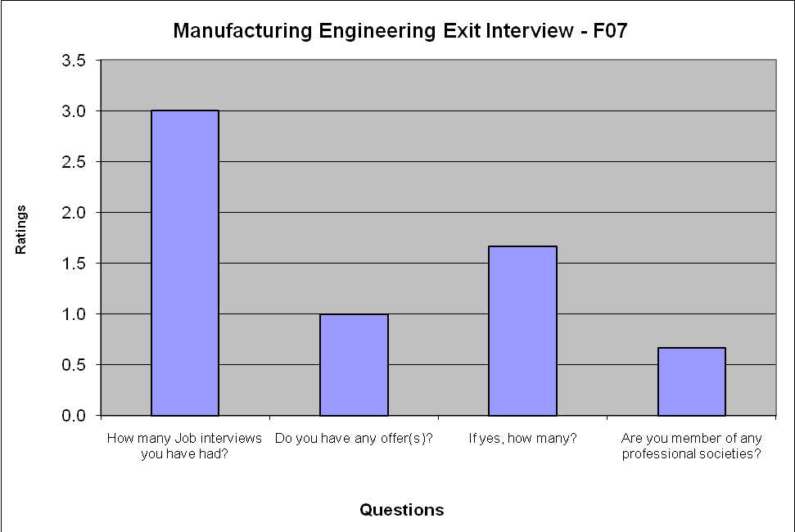
Figure 8 - Fall 2007 MfgE Exit Interview Results - Section 1

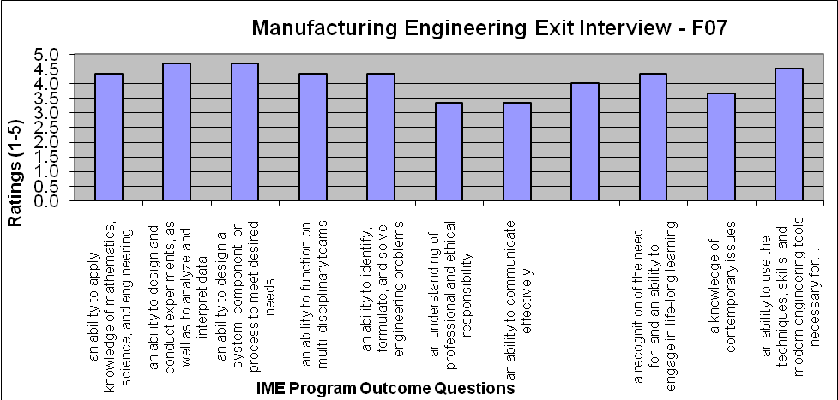
Figure 9 - Fall 2007 MfgE Exit Interview Results - Section 2

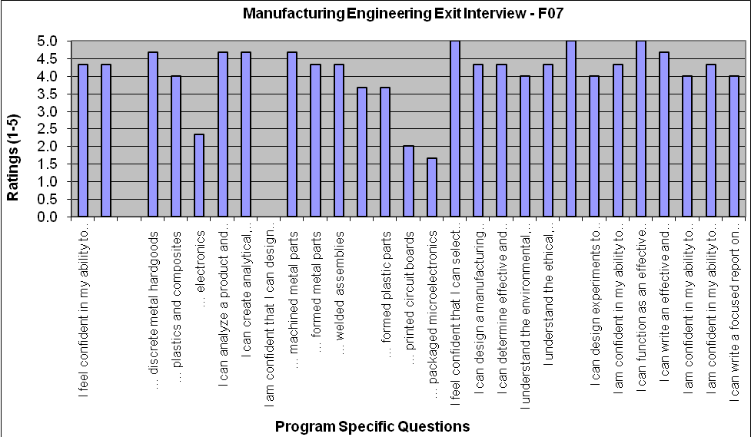
Figure 10 - Fall 2007 MfgE Exit Interview Results - Section 3
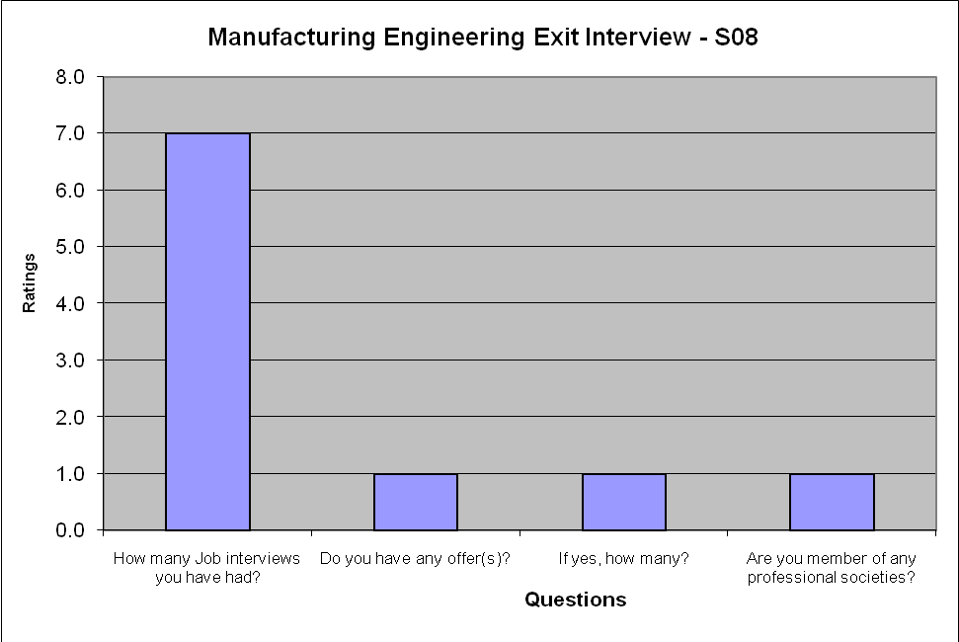
Figure 11 - Spring 2008 MfgE Exit Interview Results - Section 1

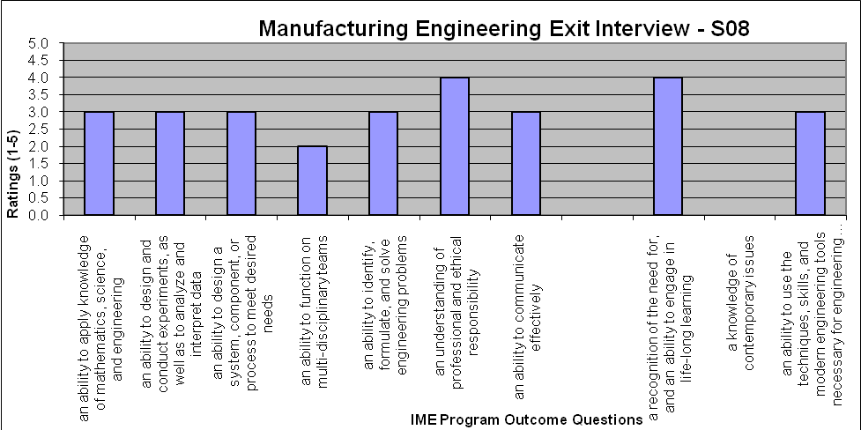
Figure 12 - Spring 2008 MfgE Exit Interview Results - Section 2

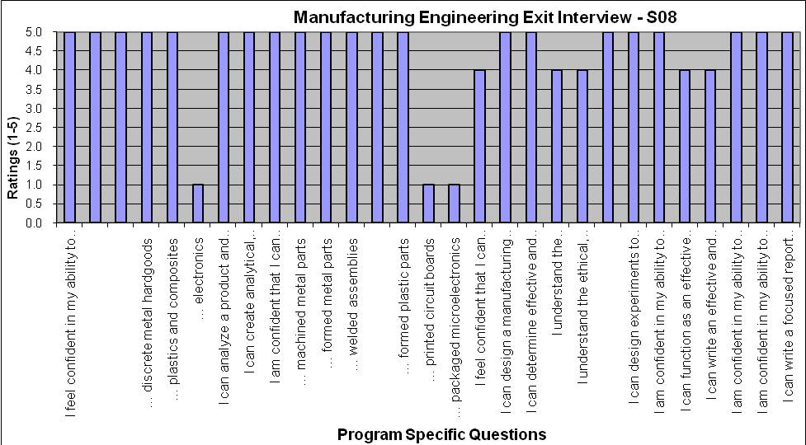
Figure 13 - Spring 2008 MfgE Exit Interview Results - Section 3

Years to Degree

Tracking our graduates since 2006, the average number of years IME students spend at NDSU is 4.7 years. This is on track with students completing their curriculum requirements and completing a semester and one summer of coop or internship. Eighty percent (80%) of IME students do at least one semester of internship. About 9% of our graduates spend more than 6 years at NDSU. Thirty six percent (36%) of our students actually transferred from other institutions where they spent an average of 2.3 years. Figure 14 shows our graduates and the length of time they spent at NDSU until graduation.

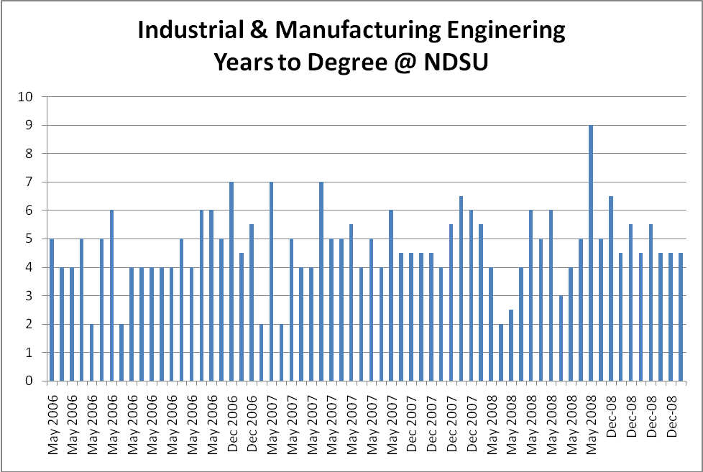
Figure 14 – IME student’s # of Years to Graduation at NDSU

Fundamental of Engineering Exam (FE)

The Industrial and Manufacturing Engineering (IME) department students are not required to take the FE exam; however, some students depending on the future employment goals are inclined to take the FE exam. IME department has decided to encourage students in both programs to take the FE exam as part of reinforcing Life-Long Learning and Professional and Ethical Responsibility. A professional License in any state has a required professional development educational element which usually reinforces both of these topics. After discouraging our students for the past two years not to take the general exam, none of our students took this option last year. The students in both programs took the IE specific exam which is the most appropriate for both majors.

The following is a summary of test results for IME students taking the FE exam. Figure 15 shows the FE results for IE&M students versus the national results. Since 2002, the IE&M students have performed much better than the national average. The IE&M students fell short of the national scores in June 2006.

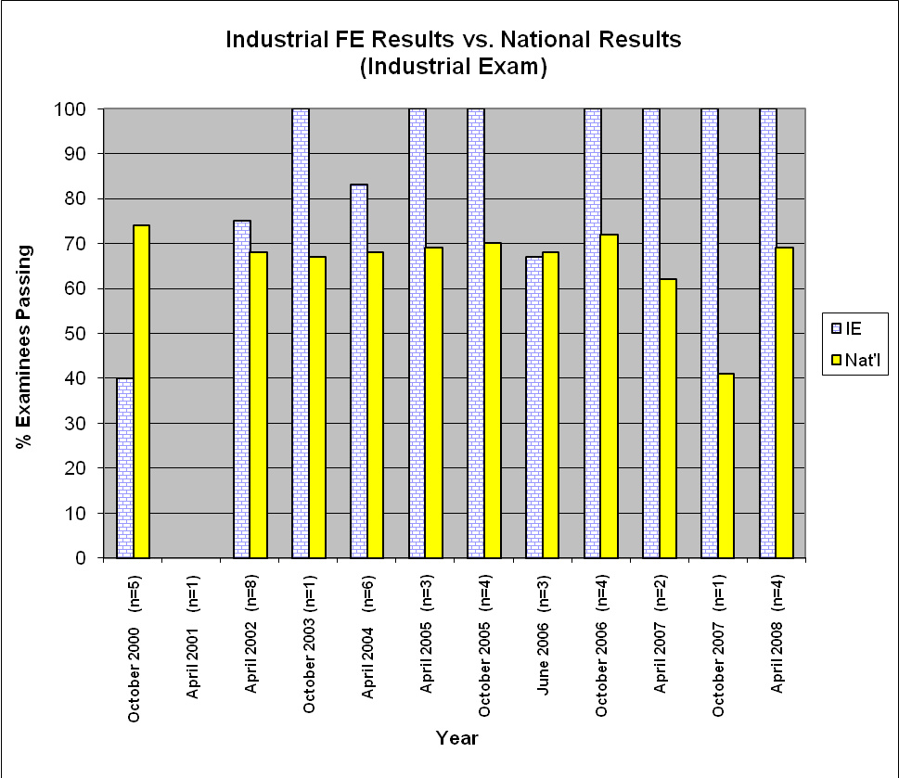
Figure 15 - FE Results vs. National Results for IE&M Students

Table 4 shows the actual results from the October 2007 testing cycle. Some of the areas where industrial engineering students scored less than the national average include: Facilities Engineering and Work Design. These courses are considered core courses in Industrial Engineering so further investigation is needed to determine root cause of the problem.

Table 4 – October 2007 FE (Industrial Exam) Results for IE&M Students
Industrial Engineering Supporting Data - Professional Engineering (PE) Exam
FE Industrial Exam | October 2007 (n=1)
 | # of Questions | IE/NDSU | Nat'l | Carnegie 1 | Carnegie 2 | Carnegie 3
% Examinees Passing |  | 100 | 41 | 76 | 80 | 27
Avg. % Correct
Facilities Engineering & Planning - Facility Requirements | 8 | 62 | 63 | 75 | 80 | 63
Facilities Engineering & Planning - Facility Design Alternatives | 8 | 62 | 58 | 73 | 65 | 54
Systems Analysis & Design - Analysis & Design Processes | 10 | 80 | 67 | 80 | 78 | 64
Systems Analysis & Design - Costing & Performance Measurement | 6 | 83 | 70 | 83 | 80 | 67
Logistics - Production Planning & Control | 12 | 67 | 55 | 65 | 63 | 52
Logistics - Distribution & Storage-Warehousing Methods | 4 | 100 | 60 | 75 | 75 | 55
Work Design - Methods to Measure Work | 5 | 40 | 56 | 61 | 60 | 56
Work Design - Methods Design & Analysis | 5 | 100 | 64 | 76 | 84 | 61
Ergonomics & Safety - Risk Factors & Exposure Limits | 6 | 83 | 75 | 80 | 77 | 74
Ergonomics & Safety - Design Issues | 4 | 100 | 53 | 72 | 75 | 48
Quality Engineering - Quality Control | 8 | 50 | 48 | 54 | 57 | 45
Quality Engineering - Reliability & Maintainability | 4 | 75 | 48 | 59 | 70 | 43

Table 5 shows the actual results from the April 2008 testing cycle. Some of the areas where industrial engineering students scored less than the national average include: Ethics & Business Practices, Electricity & Magnetism, Thermodynamics, Probability & Statistics, Modeling & Computation, Industrial Management, and Facilities, Logistics. Aside from engineering probability and Statistics and Facilities & Logistics, the rest of the courses are offered as electives and students may or may not take those courses. Our students are required to take a one credit Ethics course and topics related to engineering ethics are covered in all of our classes.

Figure 16 depicts the FE results versus national results for manufacturing engineering students. The data is available only for two students in 2002, three students in June 2006, three students in October 2006 and one in April 2008 who took the exam. Table 6 shows the FE exam results for April 2008 and areas where manufacturing engineering student’s performance was less than that of national average.

Some of the areas where this Manufacturing Engineering student scored less than the national average include: Ethics and Business Practice, Engineering Economics, Fluid mechanics, Electricity and Magnetism, Thermodynamics, Probability & Statistics, and Human Factors, Productivity, Ergonomics, & Work Study.

Table 5 - April 2008 FE (Industrial Exam) Results for IE&M Students
Industrial Engineering Supporting Data - Fundamental of Engineering (FE) Exam
FE Industrial Exam | April 2008 (n=4)
 | # of Questions | IE/NDSU | Nat'l | Carnegie 1 | Carnegie 2 | Carnegie 3
% Examinees Passing |  | 100 | 69 | 72 | 54 | 80
Avg. % Correct
AM SUBJECTS
Mathematics | 19 | 66 | 53 | 55 | 52 | 50
Engineering Probability & Statistics | 8 | 72 | 64 | 67 | 60 | 63
Chemistry | 11 | 71 | 58 | 61 | 54 | 53
Computers | 8 | 78 | 72 | 75 | 68 | 69
Ethics & Business Practices | 8 | 66 | 74 | 74 | 74 | 75
Engineering Economics | 10 | 75 | 62 | 65 | 56 | 64
Engr Mechanics ( Statics & Dynamics) | 13 | 75 | 51 | 54 | 46 | 50
Strength of Material | 8 | 50 | 40 | 40 | 39 | 40
Material Properties | 8 | 47 | 46 | 46 | 42 | 51
Fluid Mechanics | 8 | 63 | 47 | 50 | 41 | 46
Electricity & Magnetism | 11 | 38 | 40 | 40 | 41 | 43
Thermodynamics | 8 | 44 | 45 | 46 | 46 | 44
PM SUBJECTS
Engineering Economics | 9 | 64 | 52 | 54 | 48 | 54
Probability & Statistics | 9 | 47 | 48 | 52 | 41 | 47
Modeling & Computation | 7 | 46 | 55 | 58 | 48 | 55
Industrial Management | 6 | 58 | 59 | 61 | 57 | 54
Manufacturing & Production Systems | 8 | 84 | 66 | 68 | 64 | 63
Facilities & Logistics | 7 | 50 | 56 | 58 | 50 | 58
Human Factors, Productivity, Ergonomics, & Work Study | 7 | 46 | 43 | 43 | 43 | 43
Quality | 7 | 82 | 75 | 76 | 72 | 79

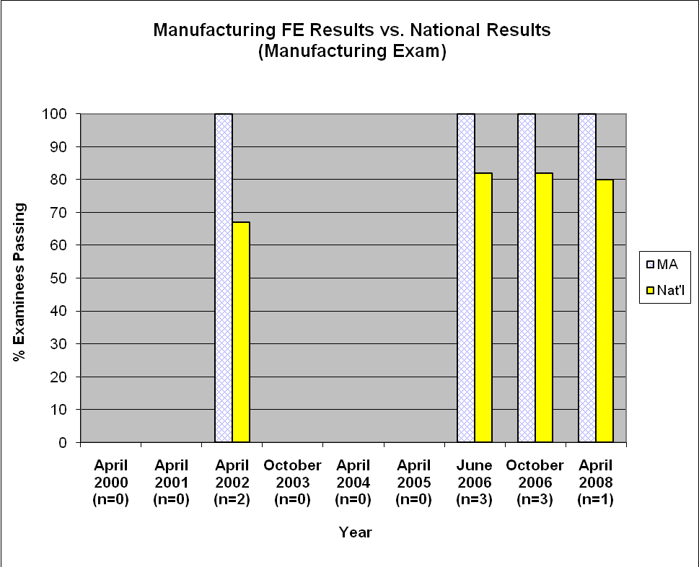
Figure 16 - FE Results vs. National Results for MfgE Students

The technical elective courses include: Fluid Mechanics, Electricity & Magnetism, Thermodynamics, Probability & Statistics, and Human Factors, Productivity, Ergonomics, & Work Study. Students seem to be doing poorly and perform below national average in technical elective topics for the most part.

Appendix AA shows the survey results for the graduating seniors exit interviews from December 2007 and May 2008.

Table 6 - April 2008 (Industrial Exam) Results for MfgE Students
Manufacturing Engineering Supporting Data - Fundamental of Engineering (FE) Exam
FE Industrial Exam | April 2008 (n=1)
 | # of Questions | IE/NDSU | Nat'l | Carnegie 1 | Carnegie 2 | Carnegie 3
% Examinees Passing |  | 100 | 80 | 100 | 100 | 75
AM SUBJECTS
Mathematics | 19 | 68 | 51 | 26 | 68 | 52
Engineering Probability & Statistics | 8 | 88 | 61 | 38 | 88 | 61
Chemistry | 11 | 91 | 71 | 73 | 91 | 68
Computers | 8 | 75 | 72 | 88 | 75 | 70
Ethics & Business Practices | 8 | 75 | 62 | 75 | 75 | 59
Engineering Economics | 10 | 50 | 66 | 80 | 50 | 66
Engr Mechanics ( Statics & Dynamics) | 13 | 77 | 60 | 69 | 77 | 57
Strength of Material | 8 | 100 | 62 | 62 | 100 | 58
Material Properties | 8 | 75 | 53 | 38 | 75 | 52
Fluid Mechanics | 8 | 38 | 54 | 62 | 38 | 55
Electricity & Magnetism | 11 | 27 | 49 | 27 | 27 | 54
Thermodynamics | 8 | 50 | 54 | 50 | 50 | 55
PM SUBJECTS
Engineering Economics | 9 | 67 | 51 | 67 | 67 | 47
Probability & Statistics | 9 | 33 | 40 | 11 | 33 | 44
Modeling & Computation | 7 | 71 | 36 | 43 | 71 | 30
Industrial Management | 6 | 83 | 68 | 83 | 83 | 65
Manufacturing & Production Systems | 8 | 88 | 80 | 88 | 88 | 78
Facilities & Logistics | 7 | 71 | 70 | 86 | 71 | 68
HF, Prod, Ergonomics, & Work Study | 7 | 29 | 42 | 29 | 29 | 45
Quality | 7 | 86 | 73 | 86 | 86 | 70

Internship/Co-op Evaluation

As a result of ongoing and strong interaction between the IME department and local and regional industries, the internship and coop programs have flourished. Many of our students do short term and long term internship with companies in North Dakota, Minnesota, and other states as far as California. Student’s performance with respect to program outcomes and objectives are evaluated as part of these surveys. IME student’s response was most positive and the Employer’s evaluation of our students was excellent. Appendix BB shows the summary of the student’s survey results and appendix CC shows the summary of the employer’s survey results.

Formative Assessment

Formative Assessment results for IME 430, 480, 472, 431, and 461 are shown in Table 7. The responses for IME 472, 431, and 461 were combined since all ratings were above the benchmark of 2.70. The averages for each outcome is summarized and presented. The areas (outcomes) that were ranked below the benchmark of 2.70 are shown in red. Each shortcoming will be addressed as part of an overall continuous improvement plan of the department and in each specific course as needed. Figure 17 shows the program outcomes ranked against the benchmark.

Table 7 - Summary of Formative Assessment Results
Program Outcomes | IME 430 (7) | IME 480 (21) | IME472 (25) IME431 (1) IME461 (18)
a. Applications of mathematics, science, and engineering | 2.9 | 3.1 | 3.2
b. Design, experimentation, analysis, and interpretation of data | 2.6 | 2.7 | 2.7
c. Design of system, component, and process | 2.9 | 2.8 | 3.0
d. Teamwork | 2.6 | 2.9 | 3.1
e. Engineering Problem Solving | 2.7 | 2.8 | 3.0
f. Professional and Ethical Responsibility | 2.0 | 2.4 | 2.8
g. Communications | 2.5 | 2.7 | 2.9
h. Broad Education | 2.6 | 2.6 | 2.8
i. Life Long Learning | 2.3 | 2.4 | 2.9
j. Contemporary Issues | 2.5 | 2.6 | 2.9
k. Techniques, skills, and modern engineering tools | 2.9 | 3.2 | 3.2
Key:
Excellent = 5
Good = 4
Average = 3
Poor = 2
No opinion = 1
Benchmark=2.7

As part of the continuous improvement process at the IME department and as per University Assessment Committee’s recommendation we are implementing the formative assessment as an indirect self assessment of student learning in all of our classes this fall. Students will be gauged as to the extent of their learning at all levels. The results will be reported starting next academic year.

Figure 17 - Formative Assessment Results Shown Against Benchmark

Faculty Course Assessment Report (FCAR) and Classroom Outcome Assessment

The Faculty Courses Assessment Report (FCAR) is used to provide faculty a mechanism for keeping track of classroom performance and to allow for reflection and self-assessment based on student’s feedback and to provide recommendation for future teaching of each class. FCARs have been generated for each class taught in our department since fall 2005.

Each faculty could choose to assess their individual classes based on the parameter they see important to their performance in class and teaching outcomes. These classroom assessments are for faculty purposes and recommendations are summarized and reported as part of FCAR. This instrument is an indirect measure of student learning and also serves as a teaching performance improvement mechanism. Faculty members will be able to look back at the course SRoIs and student comments and reflect on what they could do in the future to improve student learning. Copies of Course FCARs are presented in appendix DD.

Capstone Assessment
The Capstone experience is used as a major assessment instrument in evaluating the program outcomes. The students take the Capstone class during the spring semester. The Industrial Engineering and Management Capstone requires concurrent enrollment in IME 485, Industrial and Manufacturing Facility Design and IME 456, Program and Project Management. Industrial Engineering and Management Capstone student learning outcomes are tied to The ABET a-k outcomes as is the case for all other courses. The assessment process for Capstone is not solely a self-assessment process.

The majority of Capstone learning outcomes are met through participation of students in in-class projects as well as real-life (Capstone) projects conducted on behalf of industry clients. The in-class projects are selected in a way so they can be helpful to students in conducting their Capstone projects.

The development of the Capstone project document is an ongoing process. The document is the final product that each student team produces. In addition to regularly scheduled class meetings, the instructor meets with each project team six times during the semester for 90 minutes. During each meeting, the instructor evaluates the project report and progress and provides feedback to the students. The final Capstone document grade will reflect not only the quality of the final document, but also meeting deadlines to complete various project-related tasks. At the end of the semester, the project teams evaluate and report the performance and contribution of their team members in developing the Capstone document.

Capstone clients provide feedback on the quality and usefulness of the Capstone documents. A 70% benchmark is set for the client’s rating of the Capstone project. The lowest rating of 3.75 or 75% was given for Technical Work criteria as shown in Figure 19. This was also resonated in the client’s evaluation of the final presentation with the same ranking presented in Figure 18. Client’s evaluation of capstone received ratings ranging from 3.92 to 4.38 (78.4% - 87.6%) as shown in Figure 20. This is certainly an indirect measure of student learning by outside or industry constituents addressing learning, application, quality, and delivery. Figure 21 shows the capstone clients or industry evaluation of ABET outcomes also ranging from 3.92 to 4.38.

During the semester, each project team makes three in-class presentations as well as a final presentation. The final presentation audience includes Capstone course members, IME faculty and students, project clients, IME Advisory Board members, other students, and invited members of business/industry community. Average ratings from the Capstone final presentations are shown in Figure 18. The first two presentations are evaluated and graded by the course instructor and all course participants that are not part of the team. The third presentation is evaluated by the course participants and only for the purpose of providing feedback to teams so they can improve their final presentations. Figures 19, 20, and 21 depict the project ratings by the industry clients. The final presentation is evaluated by the same clients, Advisory Board members, faculty, and other guests who provide feedback about the projects and quality of presentations. A 75% benchmark is considered acceptable for the final presentation.

The students’ learning outcomes are also measured using quizzes and/or tests. The quizzes or tests cover material from the class lecture and handouts, textbook, supplementary readings, and in-class activities. The quizzes and tests are evaluated by the course instructor. A 75% benchmark for all quizzes, tests, and assignments is considered acceptable for achieving Educational Objectives for MfgE program.

 | Project Clients
 |  |  |  |  |  |  |  |  | All Project Presentations Average
  Layout Improvements
  New Facility Layout
  Layout Improvements
  Warehouse Operations
  Container Logistics
  Inventory Management
  Packaging / Warehousing
  Improving Warehousing
Criteria | Average Ratings Received from Audience During the Final Presentations ( lowest=1 5=highest ) |  |  |  |  |  |  |  | All Project Presentations Average
Introduction – Explained who they are/what they are doing/the problems/and the need for the project. | 4.36 | 4.40 | 3.73 | 4.18 | 3.97 | 4.46 | 3.77 | 4.02 | 4.11
Technical work – Sufficient quantity/quality of engineering work including why that work was done | 3.94 | 3.53 | 3.64 | 3.47 | 3.75 | 4.42 | 3.37 | 3.89 | 3.75
Conclusion and recommendations – Usability of project work | 3.81 | 3.27 | 4.00 | 3.49 | 4.19 | 4.50 | 3.60 | 4.26 | 3.89
Presentation organization – Overall flow | 4.06 | 4.00 | 3.91 | 3.65 | 4.11 | 4.31 | 4.00 | 4.00 | 4.00
Presentation skills – Overall quality of the presentation | 3.83 | 3.73 | 3.36 | 3.50 | 3.94 | 4.15 | 3.67 | 4.27 | 3.81
Q and A – Ability to answer questions | 4.00 | 3.33 | 3.36 | 3.50 | 3.97 | 4.27 | 3.55 | 4.06 | 3.76
Rate the presentation for readability of the slides, figures, graphs. | 4.17 | 4.13 | 3.80 | 3.71 | 4.39 | 4.27 | 3.82 | 4.44 | 4.09
Overall rating of the presentation | 3.93 | 3.64 | 3.41 | 3.59 | 3.85 | 4.29 | 3.73 | 4.07 | 3.81
Figure 18 - Spring 2008 Capstone Projects Final Presentation Ratings

Industrial and Manufacturing Engineering Program and Project Management/Capstone Spring 2008 | Relationship of Project Presentation Evaluation Criteria Used by Constituents to ABET a-k and Corresponding Ratings |  |  |  |  |  |  |  |  |  |  | Criterion Average for all Teams
 | ABET Criterion 3 |  |  |  |  |  |  |  |  |  |  | Criterion Average for all Teams
Criteria used by project clients to evaluate project team performance | a | b | c | d | e | f | g | h | i | j | k | Criterion Average for all Teams
Criteria | Shaded areas show the evaluation criterion link to ABET a-k Average client ratings (5=highest ) are shown in the shaded areas |  |  |  |  |  |  |  |  |  |  | Criterion Average for all Teams
Introduction – Explained who they are/what they are doing/the problems/and the need for the project. |  | 4.11 |  |  | 4.11 |  | 4.11 |  |  |  |  | 4.11
Technical work – Sufficient quantity/quality of engineering work including why that work was done | 3.75 | 3.75 | 3.75 | 3.75 | 3.75 |  | 3.75 |  |  | 3.75 | 3.75 | 3.75
Conclusion and recommendations – Usability of project work | 3.89 | 3.89 | 3.89 |  | 3.89 |  | 3.89 |  |  |  | 3.89 | 3.89
Presentation organization – Overall flow |  |  |  | 4.00 |  |  | 4.00 |  |  |  | 4.00 | 4.00
Presentation skills – Overall quality of the presentation | 3.81 | 3.81 | 3.81 | 3.81 | 3.81 |  | 3.81 |  |  | 3.81 | 3.81 | 3.81
Q and A – Ability to answer questions |  | 3.76 | 3.76 |  | 3.76 |  | 3.76 | 3.76 |  |  | 3.76 | 3.76
Rate the presentation for readability of the slides, figures, graphs. |  |  |  |  |  |  | 4.09 |  |  |  | 4.09 | 4.09
Overall rating of the presentation | 3.81 | 3.81 | 3.81 |  | 3.81 |  | 3.81 |  |  | 3.81 | 3.81 | 3.81
Percent Ratings of Presentation Evaluation Criteria with Respect to ABET a-k Program Outcomes | 76.3 | 77.1 | 76.1 | 77.1 | 77.1 |  | 78.1 | 75.1 |  | 75.8 | 77.5
Figure 19 - Spring 2008 Capstone Client Project Ratings
Client Evaluation of Capstone | Industrial and Manufacturing Engineering
Client Evaluation of Capstone | Program and Project Management/Capstone Spring 2008
 | Project Clients
Criteria used by project clients to evaluate project team performance | Aldevron Layout Improvements | Aldevron New Layout | BTD Layout Improvements | BTD Warehouse Operations | CNH Container Logistics | Sioux Inventory Management | SK Foods Packaging and Warehousing | Vinylite Warehousing/Manufacturing | Criterion Average for All Teams
Criteria | Average Client Ratings ( lowest=1 5=highest ) |  |  |  |  |  |  |  | Criterion Average for All Teams
The project team understood your problems and needs | 4.50 | 4.00 | 3.00 | 4.00 | 5.00 | 5.00 | 4.00 | 3.50 | 4.13
The team maintained acceptable level of communication and provided timely feedback as well as soliciting your input | 5.00 | 5.00 | 4.00 | 3.00 | 5.00 | 4.00 | 4.00 | 4.00 | 4.25
The team dealt with you in a professional manner (e.g., on time for meetings, prepared for meetings, courteous, neat, high ethical standards, high technical standards, positive attitude, etc.) | 5.00 | 4.00 | 4.00 | 3.00 | 5.00 | 4.00 | 3.00 | 4.00 | 4.00
The approaches used for developing proposals and solutions are clear | 5.00 | 5.00 | 3.00 | 3.00 | 5.00 | 4.00 | 4.00 | 3.00 | 4.00
The project team fulfilled all the deliverables as was outlined in the “statement of work” | 5.00 | 5.00 | 3.00 | 4.00 | 5.00 | 5.00 | 4.00 | 3.00 | 4.25
The results of the project have value for my organization | 4.00 | 4.00 | 4.00 | 4.00 | 4.00 | 5.00 | 4.00 | 3.50 | 4.06
Attention to design and or/documentation details | 4.50 | 4.50 | 3.00 | 3.00 | 5.00 | 5.00 | 3.00 | 3.50 | 3.94
The results of the project are of high quality | 4.50 | 4.00 | 4.00 | 4.00 | 5.00 | 5.00 | 4.00 | 3.50 | 4.25
This project was representative of activities by practicing engineers |  |  | 4.00 | 3.00 | 5.00 | 4.00 | 4.00 | 3.50 | 3.92
This project was a challenging engineering project | 4.00 | 5.00 | 3.00 | 4.00 | 4.00 | 4.00 |  | 4.00 | 4.00
This project was a valuable learning experience for the project team members | 5.00 | 5.00 | 4.00 | 4.00 | 5.00 | 4.00 | 4.00 | 4.00 | 4.38
Would you consider using Capstone teams for future projects | 4.50 | 4.50 | 3.00 | 4.00 | 5.00 | 5.00 | 4.00 | 3.50 | 4.19
Overall satisfaction with the experience and the project results | 4.50 | 4.50 |  | 4.00 | 5.00 | 5.00 | 4.00 | 3.50 | 4.36
Figure 20 - Spring 2008 Capstone Client's Evaluation

Industrial and Manufacturing Engineering Program and Project Management/Capstone Spring 2008 | Relationship of Project Team Performance Evaluation Criteria Used by Project Clients to ABET a-k and Corresponding Ratings |  |  |  |  |  |  |  |  |  |  | Criterion Average for all Teams
 | ABET Criterion 3 |  |  |  |  |  |  |  |  |  |  | Criterion Average for all Teams
Criteria used by project clients to evaluate project team performance | a | b | c | d | e | f | g | h | i | j | k | Criterion Average for all Teams
Criteria | Shaded areas show the evaluation criterion link to ABET a-k Average client ratings (5=highest ) are shown in the shaded areas |  |  |  |  |  |  |  |  |  |  | Criterion Average for all Teams
The project team understood your problems and needs |  |  |  | 4.13 | 4.13 |  | 4.13 |  | 4.13 | 4.13 |  | 4.13
The team maintained acceptable level of communication and provided timely feedback as well as soliciting your input |  |  |  | 4.25 |  | 4.25 | 4.25 |  |  |  |  | 4.25
The team dealt with you in a professional manner (e.g., on time for meetings, prepared for meetings, courteous, neat, high ethical standards, high technical standards, positive attitude, etc.) |  |  |  | 4.00 |  | 4.00 | 4.00 |  |  |  |  | 4.00
The approaches used for developing proposals and solutions are clear | 4.00 | 4.00 | 4.00 | 4.00 | 4.00 |  | 4.00 | 4.00 |  | 4.00 | 4.00 | 4.00
The project team fulfilled all the deliverables as was outlined in the “statement of work” | 4.25 | 4.25 | 4.25 | 4.25 | 4.25 | 4.25 | 4.25 |  |  |  | 4.25 | 4.25
The results of the project have value for my organization | 4.06 | 4.06 | 4.06 | 4.06 | 4.06 |  | 4.06 |  |  |  | 4.06 | 4.06
Attention to design and or/documentation details |  | 3.94 | 3.94 | 3.94 | 3.94 |  | 3.94 |  |  |  |  | 3.94
The results of the project are of high quality | 4.25 | 4.25 | 4.25 | 4.25 | 4.25 |  | 4.25 |  |  | 4.25 | 4.25 | 4.25
This project was representative of activities by practicing engineers | 3.92 | 3.92 | 3.92 | 3.92 | 3.92 |  | 3.92 | 3.92 | 3.92 | 3.92 | 3.92 | 3.92
This project was a challenging engineering project |  | 4.00 | 4.00 | 4.00 | 4.00 |  |  | 4.00 | 4.00 | 4.00 | 4.00 | 4.00
This project was a valuable learning experience for the project team members |  |  |  | 4.38 |  | 4.38 | 4.38 |  | 4.38 |  |  | 4.38
Would you consider using Capstone teams for future projects |  |  |  |  |  |  |  |  |  |  |  | 4.19
Overall satisfaction with the experience and the project results |  |  |  |  |  |  |  |  |  |  |  | 4.36
Percent Ratings of Project Team Evaluation Criteria with Respect to ABET a-k Program Outcomes | 81.9 | 81.2 | 81.2 | 82.1 | 81.4 | 84.4 | 82.3 | 79.4 | 82.1 | 81.2 | 81.6
Figure 21 - Spring 2008 ABET Client's Evaluation

IME Student Ratings of Instruction

IME SRoI summary results are provided in appendix EE1 for fall 2007 and EE2 for spring 2008 semesters. For 100 and 200 level courses, the average ratings vary with respect to department, college, and university mean values. The IME department does not offer any 100 or 200 level courses during fall semesters. Figures 22 through 27 show the ratings for the 100 and 200 level courses since spring of 2006. Most students’ rating was good for these classes considering a benchmark of 3.5 for the department. The ranking for the spring 2008 is lower than the average for the department. The only ranking below 3.5 was given for questions #1 in Figure 22.

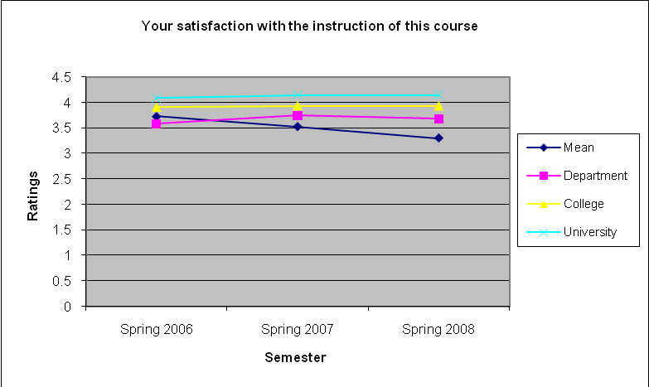
Figure 22 – 100 & 200 Level Courses SRoI rankings for Question #1

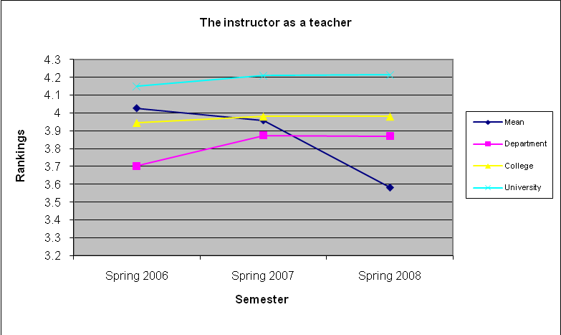
Figure 23 - 100 & 200 Level Courses SRoI rankings for Question #2

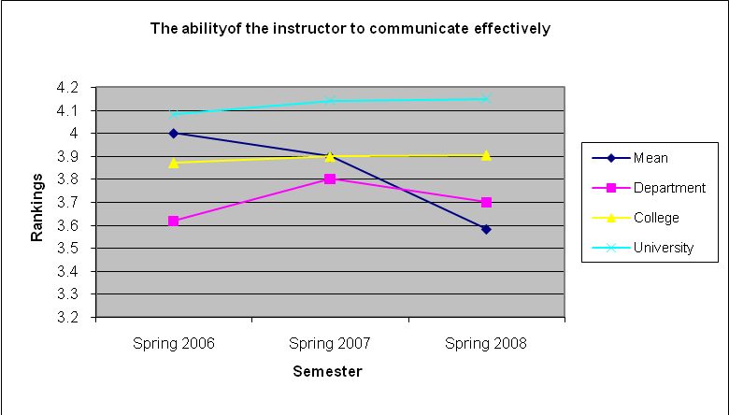
Figure 24 - 100 & 200 Level Courses SRoI rankings for Question #3

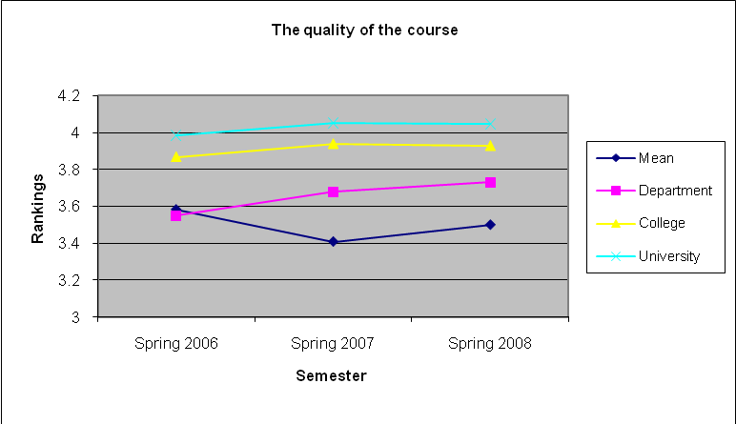
Figure 25 - 100 & 200 Level Courses SRoI rankings for Question #4

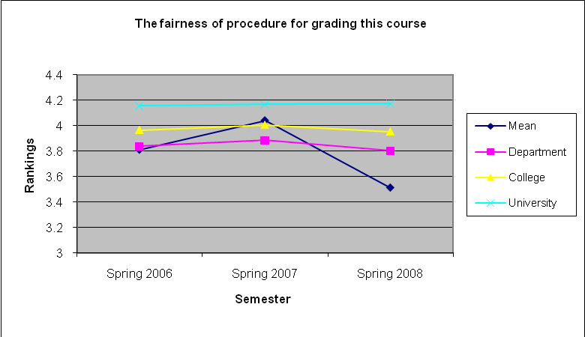
Figure 26 - 100 & 200 Level Courses SRoI rankings for Question #5

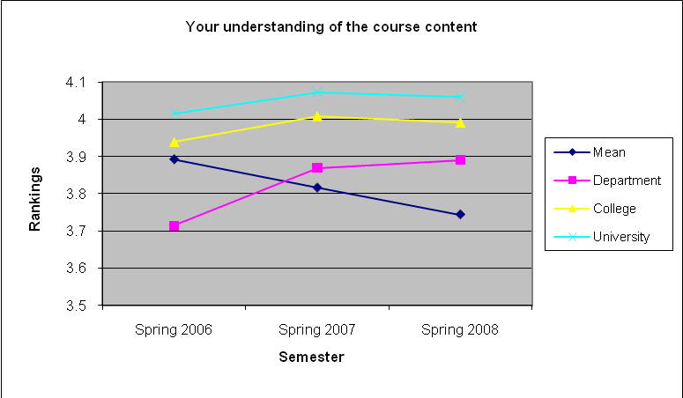
Figure 26 - 100 & 200 Level Courses SRoI rankings for Question #6

Figures 28 – 33 depict the SRoI ratings for the 300 and 400 level classes since spring 2006 semester against department, college, and the university average rankings. For the 300 and 400 level courses, the ratings track very closely with the Department averages. This is due to the fact that most of the courses taught are 300 and 400 level courses. In general, there is an increasing trend since spring 2006 semester in the various ratings. All ratings are above 3.5. An improvement plan has been devised and implemented with the faculty teaching these courses. The outcome was good against a benchmark of 3.500 for the department.

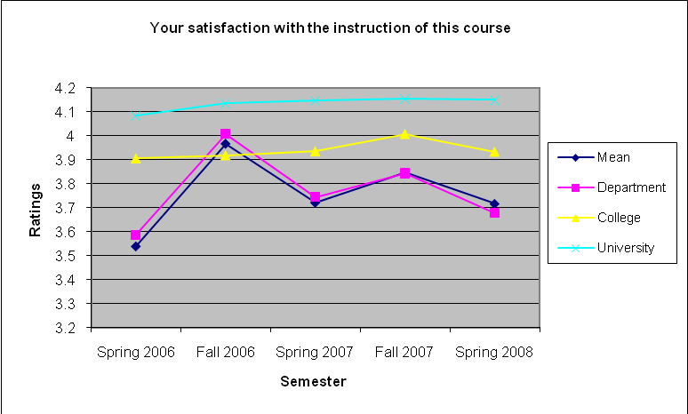
Figure 27 – 300 & 400 Level Courses SRoI rankings for Question #1

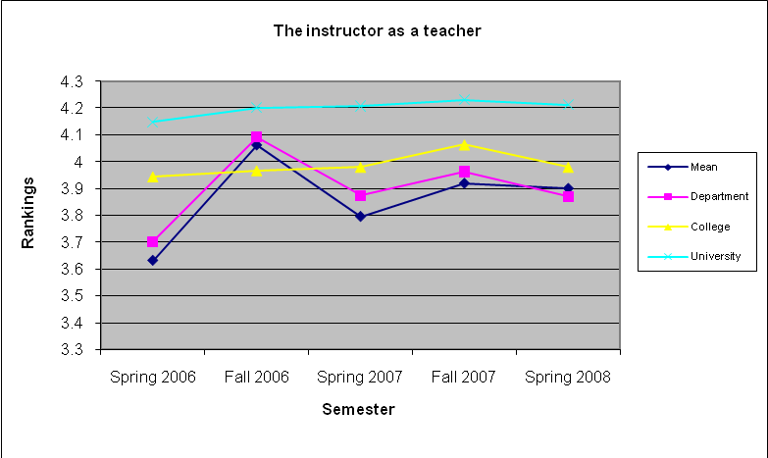
Figure 28 - 300 & 400 Level Courses SRoI rankings for Question #2

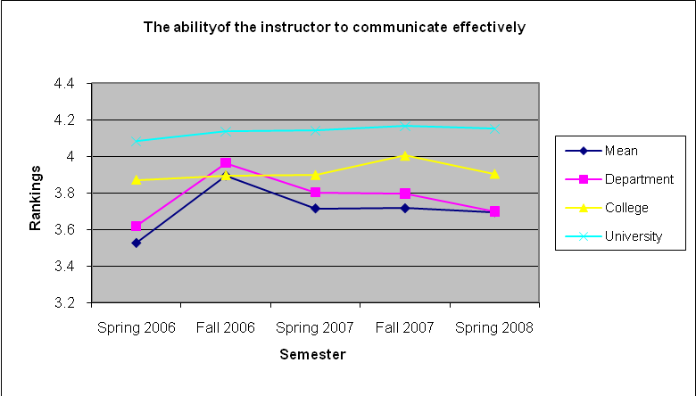
Figure 30 - 300 & 400 Level Courses SRoI rankings for Question #3

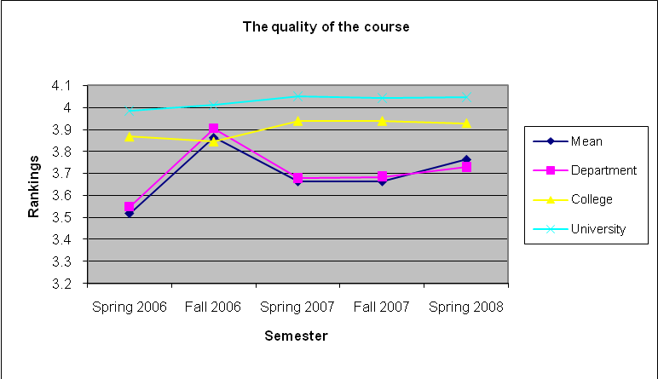
Figure 31 - 300 & 400 Level Courses SRoI rankings for Question #4

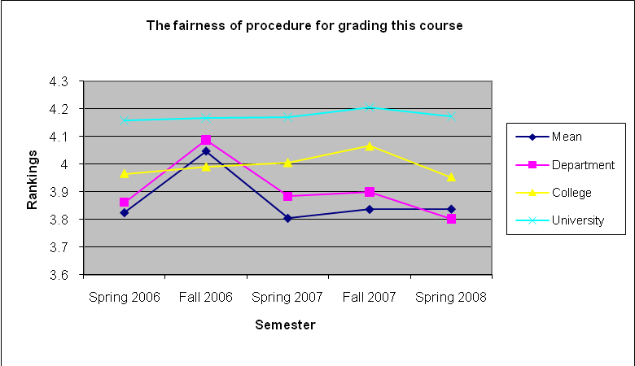
Figure 32 - 300 & 400 Level Courses SRoI rankings for Question #5

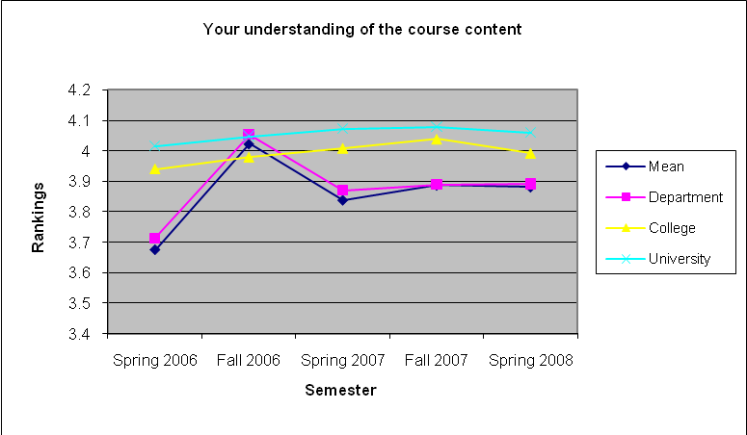
Figure 33 - 300 & 400 Level Courses SRoI rankings for Question #6

Figures 34 – 39 depict the SRoI ratings for the 600 and 700 level classes since spring 2006 semester against department, college, and the university average rankings. For the 600 and 700 level classes, the average ratings are usually higher than the department and college mean values. Most students’ rating was good for these classes. Overall, the SRoI scores improved for higher level courses. The outcome was good against a benchmark of 3.500 for the department.

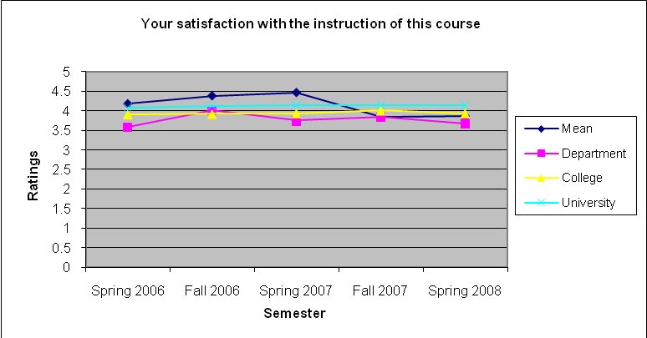
Figure 34 - 600 & 700 Level Courses SRoI rankings for Question #1

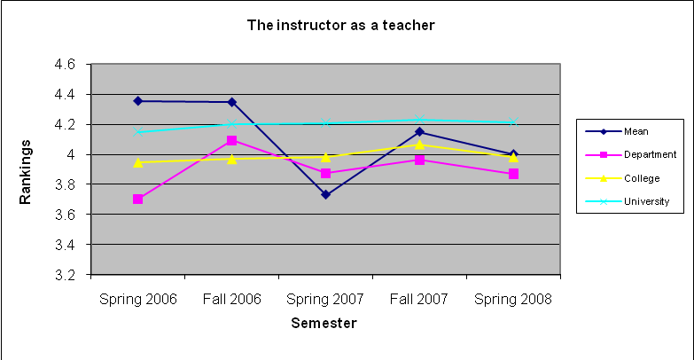
Figure 35- 600 & 700 Level Courses SRoI rankings for Question #2

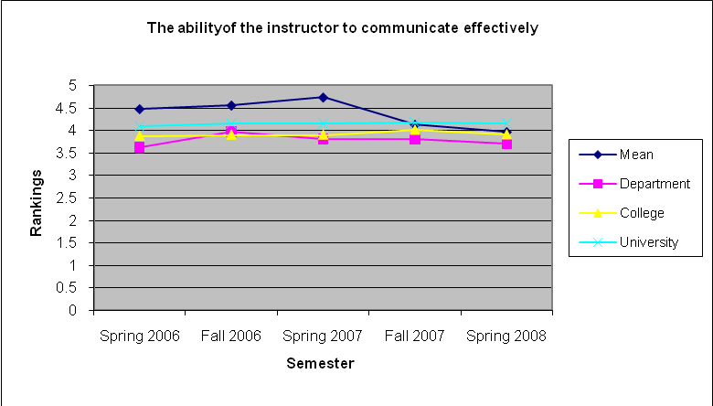
Figure 36 - 600 & 700 Level Courses SRoI rankings for Question #3

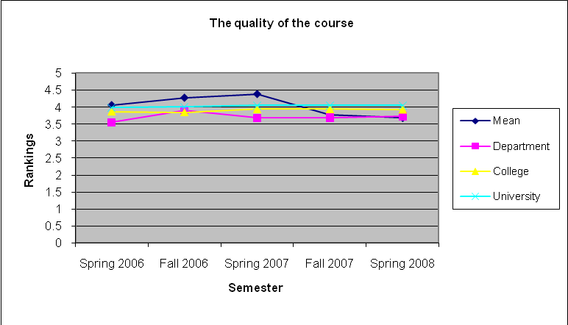
Figure 37 - 600 & 700 Level Courses SRoI rankings for Question #4

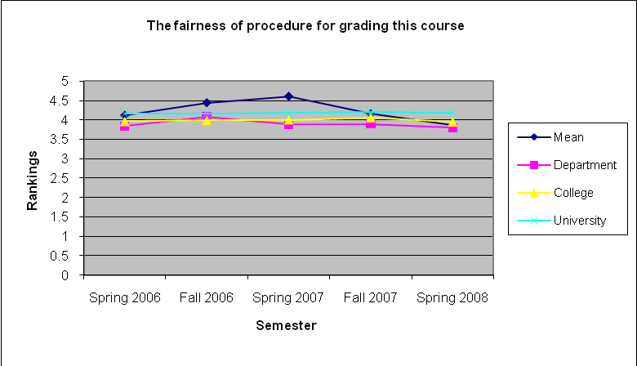
Figure 29 - 600 & 700 Level Courses SRoI rankings for Question #5

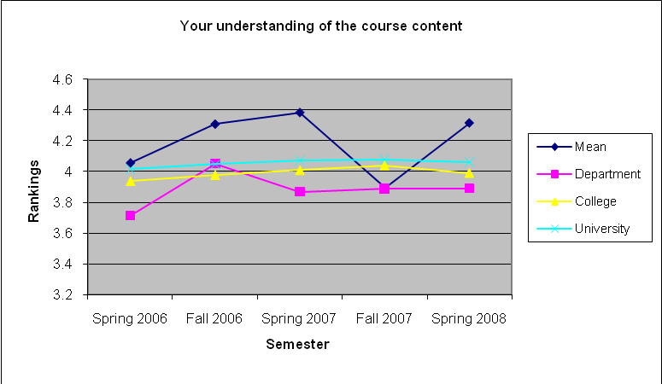
Figure 39 - 600 & 700 Level Courses SRoI rankings for Question #6

Assessment Feedback and Implementation
As part of the feedback review process, the IME faculty reviewed the feedback from our constituents during the department fall retreat. The following are the recommendations continued from previous years and new recommendations that emerged from the meeting which are to be implemented during this academic year.

- Communicate Vision, Mission, Objective, and Outcomes for each program to our students as part of the syllabus, an assignment or in-class discussion. This is continuation of the same effort to communicate these statements with our students. These statements are also published on our website for review at http://www.ndsu.nodak.edu/ndsu/ime/htmls/Vision.htm.
We are doing a good job with communicating the Student Learning Outcomes as part of the course syllabus but the departmental goals and objectives are not communicated as they should be.

- Allocate space in syllabus for contemporary issues and identify the topic as such is essential. Topics related to contemporary issues must be identified to students for recognition and association purposes. Therefore identify these topics in the course syllabus or before any discussions in class so students can relate these topics towards advancing Program Objectives and Outcomes. Include links to CNN (science & Tech), Wall Street Journal, etc. in the course syllabus.

- As per result of the various surveys, the department will continue its effort to cover Ethics and Ethical Issues facing engineers in all course curriculums and where appropriate. It is obvious from the Formative Assessment results that we are making progress but more work is needed to make our students aware of the importance of professional and ethical responsibilities.

- The global perspective and Broad Education required as part of ABET outcome (h) is already implemented and discussed frequently in various classes. The department is aware of the importance of this topic and as part of this effort multidisciplinary and global projects are encouraged. We are communicating with universities in India and Mexico about projects where students work on problems having global impact and solution that are work on by teams across the globe.

- Encourage students to take the Industrial FE exam (Not the General Exam) and continue toward receiving their professional engineering license. This message has been communicated to all of students and the results are now visible. We will continue telling our students to considering the FE exam in Industrial Engineering specially the Manufacturing engineering students.

Conclusion and Recommendations
This report considers assessment of two distinct and yet overlapping programs. Although many issues are similar, some are unique to each program. We have assessed the student learning in each ABET outcome using the following measures:

Direct measure of student learning
Capstone Client (External) Survey correlated with Capstone students self-survey (Internal) and Faculty Surveys (Internal)
Capstone Portfolio Assessment
Fundamental of engineering national exam results
Internship and Coop surveys of students
Internship and Coop surveys of student’s employers
Formative Assessment

Indirect measure of student learning
Exit Interviews
Alumni and Alumni Employers survey
Tracking Length of Time to degree and Retention rate (juniors or higher ranking)
Job Placement
Graduate follow-up studies
Faculty Course Assessment Report
Advisory Board Reviews and feedback

Each set of data is examined for accuracy and verified for consistency. The raw data was summarized and combined in specific cases where two departments overlapped. Only the summary data and plots were presented as part of this report. The GDC raw survey results along with other data are provided in the appendices. The analysis of the data included identifying key elements that show need for improvement or potential areas of opportunity for continuous improvement of the educational process at the department or classroom level.

The focus of this assessment report is mainly on student learning, curriculum, program outcomes, and objectives of the two programs. We have learned the following:

- The excellent ratings received from employers of our students using the co-op survey instrument are a very positive feedback on the department’s performance and the ability to prepare our students for the workplace. Many of our students do short term and long term internship with companies in North Dakota, Minnesota, and other states as far as California. IME student’s response was most positive and the Employer’s evaluation of our students was excellent.
- In class communication about ABET and Program Outcomes is useful to the students and the faculty. Students become familiar with the department’s vision, mission, objective, and outcomes for each program as part of the syllabus, an assignment or in-class discussion.
- Allocate space in syllabus for contemporary issues and identify the topic as such when presented to the students will help student understand the importance of discussion contemporary issues in the classroom which helps them keep abreast of latest technology development in related areas.
- FCAR has proven to be a useful tool in assessing individual courses and their contents for our faculty. Faculty have expressed that FCAR has been a wonderful tool for reflecting on their performance in the classroom.
- Capstone experience is a fantastic experience from the point of view of the students and employers. Our students are far more advanced that other engineering students when it comes to maturity, being able to manage a project, and to take on responsibility in the workforce as per employer feedbacks.
- Encouraging students not to take the FE general exam has paid off. None of our students in either program have taken the general exam since 1997. We encourage our students to take the FE exam. Majority of students do take the FE exam or plan to take it after graduation.

From the survey of Graduating students during the exit interviews, we realized the following:

- For the most part our students that are looking for jobs are successful and are offered great competitive salaries. This actually is a very strong feedback from the employers as to the caliper of our students and what they are looking for at the time of hiring.
- The results confirm the need for continual coverage of ethical issues and dilemma facing engineers in various classrooms and topics and a need for indentifying topics which are contemporary to students when these topics are presented.
- These ratings are lowest rating in the past two years and could be an indication of not enough coverage in the classroom or labs about the microelectronics and related topic(s) or a lack of laboratory for this course.
- Over all the score indicate an improvement in the program specific questions and student learning.

From Length to Graduation data we found that:

- The average number of years IME students spend at NDSU is 4.7 years. This is on track with students completing their curriculum requirements and completing a semester and one summer of coop or internship.
- About 9% of our graduates spend more than 6 years at NDSU.
- Thirty six percent (36%) of our students actually transferred from other institutions where they spent an average of 2.3 years.

From the results of the FE exam we found out that:

- Since 2002, the IE&M students have performed much better than the national average. The IE&M students fell short of the national scores in June 2006.
- Some of the core areas where industrial engineering students scored less than the national average include: Facilities Engineering and Work Design.
- Some of the other areas where industrial engineering students scored less than the national average include: Ethics & Business Practices, Electricity & Magnetism, Thermodynamics, Probability & Statistics, Modeling & Computation, Industrial Management, and Facilities, Logistics.
- Some of the areas where this Manufacturing Engineering student scored less than the national average include: Ethics and Business Practice, Engineering Economics, Fluid mechanics, Electricity and Magnetism, Thermodynamics, Probability & Statistics, and Human Factors, Productivity, Ergonomics, & Work Study.
- The technical elective courses include: Fluid Mechanics, Electricity & Magnetism, Thermodynamics, Probability & Statistics, and Human Factors, Productivity, Ergonomics, & Work Study. Students seem to be doing poorly and perform below national average in technical elective topics for the most part.

From the results of the Internship/Coop surveys we found out that:

- IME student’s response was most positive and the Employer’s evaluation of our students was excellent.

From the results of the Formative Assessments we found out that:

- New space for teaching an Electronics Manufacturing lab is needed to address the short comings identified by the students in the formative assessments.
- Topics related to understanding impact of engineering solutions in a global, economic, environmental, and social context must be identified to students as such. These topics must be identified in the course syllabus or before any discussions in class so students can relate these topics towards advancing Program Objectives and Outcomes.

From the Capstone assessment results we found out that:

- The lowest rating of 3.75 or 75% (70% is the benchmark) was given for Technical Work criteria. This was also resonated in the client’s evaluation of the final presentation with the same ranking.
- Client’s evaluation of capstone received ratings ranging from 3.92 to 4.38 (78.4%-87.6%). This is certainly an indirect measure of student learning by outside or industry constituents addressing learning, application, quality, and delivery.
- Capstone clients or industry evaluation of ABET outcomes also ranging from 3.92 to 4.38.
- Overall students are performing marvelously in their capstone projects and constituents are very satisfied with the results.
- Students rank the capstone experience very high as far learning is concerned.

From the SRoI results we found that:

- Most students’ rating was good for these classes considering a benchmark of 3.5 for the department. For the 100 and 200 level courses, the ranking for the spring 2008 is lower than the average for the department.
- For the 300 and 400 level courses, the ratings track very closely with the Department averages. This is due to the fact that most of the courses taught are 300 and 400 level courses.
- For the 600 and 700 level classes, the average ratings are usually higher than the department and college mean values.
- Most students’ rating was good for these classes. Overall, the SRoI scores improved for higher level courses. The outcome was good against a benchmark of 3.500 for the department.

The Industrial and Manufacturing Engineering department will be assessing various outcomes and performance criteria following a review calendar presented in Table 1. We will continue to assess student’s performance with respect to department’s objectives and outcomes. The students will be assessed on their learning outcomes along with their communication skills (written, oral, and presentation). FE exam results, even though inconclusive, will be used to evaluate student’s performance. Formative assessment will be done in selected classes and Faculty Course Assessment Report filed for each course taught in the department. The FCAR will be used to provide faculty a mechanism for keeping track of classroom performance and to allow for reflection and recommendation for future teaching of that class. For next year we will focus on the following:

- We will ask the college and the University for Space for teaching Electronics Manufacturing laboratory.
- At least one discussion topic in upper-level courses must be dedicated to ethical issues and dilemmas for practicing engineers. Even though our students take a formal class in Engineering Ethics (ENGR 402 – Engineering Ethics & Social Responsibility), we as a department need to include discussions about ethics in all classes.
- Continue encourage students to take the Industrial FE exam (Not the General Exam) and continue toward receiving their professional engineering license.
- The curriculum committee will reevaluate all courses in both programs to identify overlaps and gaps to include Technical electives needed to pass the FE exam.
- Faculty will reexamine the course syllabus and contents to address topics that require improvement as identified in this report. This includes identifying contemporary topics in the class room and including projects requiring a global perspective.
- Faculty to include vision and mission of the department in the syllabus.
- The department will continue placing special emphasis on the following program outcomes for the junior and seniors in the program:
  - Professional & Ethical Responsibilities
  - Life-Long learning
  - Contemporary issues

Appendix AA1 - Industrial Engineering & Management Students Exit Interview Survey Results - Fall 2007
Industrial Engineering and Management Graduation Seniors Exit Interview Survey (Survey) – F07
Survey Results
1 filter(s) defined - Total Number of Respondents (N): 5 of 8
1. Name:
A) Ballot
Method: Open-Ended
Options: Maximum Number of Characters: [12288]
Descriptions: Click in the box to enter text.
B) Text Responses
Total Number of Respondents (N): 5
Number of responses to this question (n): 5
1. Chase H. Kelner
2. Jason Materi
3. Ivan Anheluk
4. Eric Vasko
5. Mark Henning

Filter- Industrial Engineering & Management
2. Major:
A) Ballot
Method: Multiple Selections
Options: Maximum Selections: [1]
Descriptions: Please choose one
Number of Choices: 2
B) Results Spread
Statistics
Total 1.00
N 5
Table Sorted By Total
Choices | Total
Industrial Engineering & Management | 5
Manufacturing Engineering | 0
Results Chart (2. Major: )
3. Semester and Year Graduating:
A) Ballot
Method: Open-Ended
Options: Maximum Number of Characters: [12288]
Descriptions: Click in the box to enter text.
B) Text Responses
Total Number of Respondents (N): 5
Number of responses to this question (n): 5
1. Fall '07
2. December, 2007
3. Fall 2007
4. December 2007
5. Fall 2007

4. To how many firms did you apply?
A) Ballot
Method: Open-Ended
Options: Allow Bypass
Maximum Number of Characters: [12288]
Descriptions: Click in the box to enter text.
B) Text Responses
Total Number of Respondents (N): 5
Number of responses to this question (n): 5
1. 10
2. 1
3. 5
4. 1
5. 10

5. How many Job interviews you have had?
A) Ballot
Method: Open-Ended
Options: Allow Bypass
Maximum Number of Characters: [12288]
Descriptions: Click in the box to enter text.
B) Text Responses
Total Number of Respondents (N): 5
Number of responses to this question (n): 5
1. 3
2. 1
3. 4
4. 1
5. 2

6. Do you have any offer(s)?
A) Ballot
Method: Yes/No
Options: Allow Bypass
Descriptions: Select either Yes or No.
B) Results Spread
Choices | Count
Y | 3
N | 2
Statistics
Yes% 60.00
No% 40.00
N 5
n 5
Results Chart (6. Do you have any offer(s)?)

7. If yes, how many?
A) Ballot
Method: Open-Ended
Options: Allow Bypass
Maximum Number of Characters: [12288]
Descriptions: Click in the box to enter text.
B) Text Responses
Total Number of Respondents (N): 5
Number of responses to this question (n): 3
1. 1
2. 2
3. 1

8. Have you accepted an offer?
A) Ballot
Method: Yes/No
Options: Allow Bypass
Descriptions: Select either Yes or No.
B) Results Spread
Choices | Count
Y | 3
N | 2
Statistics
Yes% 60.00
No% 40.00
N 5
n 5
Results Chart (8. Have you accepted an offer?)

9. If yes, please provide Company name, location and Job Title:
A) Ballot
Method: Open-Ended
Options: Allow Bypass
Maximum Number of Characters: [12288]
Descriptions: Click in the box to enter text.
B) Text Responses
Total Number of Respondents (N): 5
Number of responses to this question (n): 3
1. Boston Scientific, Maple Grove, MN, Industrial Engineer I
2. Red Prairie, Eden Prairie Minnesota
3. Tecton Products LLC, Fargo ND, Process Engineer - Quality Team

10. Have you taken the FE?
A) Ballot
Method: Yes/No
Options: Allow Bypass
Descriptions: Select either Yes or No.
B) Results Spread
Choices | Count
Y | 4
N | 1
Statistics
Yes% 80.00
No% 20.00
N 5
n 5
Results Chart (10. Have you taken the FE?)
11. If not, do you plan to take it within the year?
A) Ballot
Method: Yes/No
Options: Allow Bypass
Descriptions: Select either Yes or No.
B) Results Spread
Choices | Count
Y | 1
N | 0
Statistics
Yes% 100.00
No% 0.00
N 5
n 1
Results Chart (11. If not, do you plan to take it within the year?)
12. Are you member of any professional societies?
A) Ballot
Method: Yes/No
Options: Allow Bypass
Descriptions: Select either Yes or No.
B) Results Spread
Choices | Count
Y | 5
N | 0
Statistics
Yes% 100.00
No% 0.00
N 5
n 5
Results Chart (12. Are you member of any professional societies?)
13. If yes, please name:
A) Ballot
Method: Open-Ended
Options: Allow Bypass
Maximum Number of Characters: [12288]
Descriptions: Click in the box to enter text.
B) Text Responses
Total Number of Respondents (N): 5
Number of responses to this question (n): 5
1. IIE
2. Institute of Industrial Engineers
3. Institute of Industrial Engineers
4. IIE
5. IIE HIMSS

14. a. Applications of mathematics, science, and engineering - The ability to apply the knowledge of mathematics, science, and engineering to the analysis of various problems and issues related to the fields of Industrial and Manufacturing Engineering.
• The overall NDSU experience contributed to applications of math, science, and engineering.
• The IME programs provide ample opportunities to apply knowledge of math, science, and engineering.
• I can employ general principles, theories, concepts, and/or formulas from mathematics, science, and engineering in the solution of a wide range of problems related to my engineering program.
A) Ballot
Method: Custom Method
Options: Allow Bypass
Descriptions: VW- Very Well W-Well M-Marginally NA- Not At All NO-No Opinion
B) Results Spread
Choices | Count
VW(4) | 3
W(3) | 2
M(2) | 0
NA(1) | 0
NO(0) | 0
Statistics
Total 18
Mean VW(3.60)
Mode VW
High VW
Low W
STD 0.55
N 5
n 5
Results Chart (14. a. Applications of mathematics, science, and...)

15. b. Design, experimentation, analysis, and interpretation of data – An ability to design and conduct scientific and engineering experiments, and interpret the results for analyzing alternative designs or problem solutions.
• The NDSU educational experiences promoted my ability to design and conduct experiments.
• My program provided opportunities to increase my ability to design and conduct experiments.
• I am adequately prepared to independently design and conduct experiments
• The laboratory experiences were helpful in increasing my ability to design and conduct experiments.
• I can measure, record and present raw and summary data and analyze those data for the purposes of understanding and explaining the data.
• I can define variable types (pertinent dependent and independent), and determine how many and where to take measurements based on a thorough understanding of accuracy and precision.
A) Ballot
Method: Custom Method
Options: Allow Bypass
Descriptions: VW- Very Well W-Well M-Marginally NA- Not At All NO-No Opinion
B) Results Spread
Choices | Count
VW(4) | 1
W(3) | 3
M(2) | 1
NA(1) | 0
NO(0) | 0
Statistics
Total 15
Mean W(3.00)
Mode W
High VW
Low M
STD 0.71
N 5
n 5
Results Chart (15. b. Design, experimentation, analysis, and...)
16. c. Design of system, component, and process – The ability to apply various tools, techniques, and philosophies to design productive systems, components, and processes that meet desired needs.
• I can engage productively and creatively in the design process.
• In conducting projects, I am able to: identify the project goal; define the project scope; and search for alternatives for achieving the outcome.
• In conducting projects, I am able to use various tools to choose among possible solutions.
• I am able to conduct and document economics analysis of proposals for alternative solutions.
• The design experiences offered through program courses were valuable.
A) Ballot
Method: Custom Method
Options: Allow Bypass
Descriptions: VW- Very Well W-Well M-Marginally NA- Not At All NO-No Opinion
B) Results Spread
Choices | Count
VW(4) | 4
W(3) | 1
M(2) | 0
NA(1) | 0
NO(0) | 0
Statistics
Total 19
Mean VW(3.80)
Mode VW
High VW
Low W
STD 0.45
N 5
n 5
Results Chart (16. c. Design of system, component, and process –...)
17. d. Teamwork - An ability to function on multi-disciplinary teams and be an effective contributing member, and an ability to manage projects.
• The program offered many opportunities to work in teams.
• In general, teamwork experiences in all of my undergraduate courses were positive.
• I had the opportunity to interact with other disciplines.
• I have a conceptual understanding of group dynamics and team project experiences have given me the skills and strategies that will make any future teamwork successful.
• I can participate effectively as member of multi-disciplinary team, working with people who bring different skills, expertise, and perspectives to a project.
• The instruction and guidance in teamwork I have received from professors in IME was adequate.

A) Ballot
Method: Custom Method
Options: Allow Bypass
Descriptions: VW- Very Well W-Well M-Marginally NA- Not At All NO-No Opinion
B) Results Spread
Choices | Count
VW(4) | 5
W(3) | 0
M(2) | 0
NA(1) | 0
NO(0) | 0
Statistics
Total 20
Mean VW(4.00)
Mode VW
High VW
Low VW
STD 0.00
N 5
n 5
Results Chart (17. d. Teamwork - An ability to function on...)
18. e. Engineering Problem Solving – An ability to identify, formulate, and solve engineering problems, using a system approach that includes people, materials, equipment, facilities, energy and information.
• Program courses and laboratories have given me opportunities to solve engineering problems.
• I can define a program-related problem by specifically describing the problem conditions—what is known or given, and what the unknowns are.
• I can apply the appropriate program-related principles to find the unknowns and arrive at correct and effective solutions to the problem.
A) Ballot
Method: Custom Method
Options: Allow Bypass
Descriptions: VW- Very Well W-Well M-Marginally NA- Not At All NO-No Opinion
B) Results Spread
Choices | Count
VW(4) | 2
W(3) | 2
M(2) | 1
NA(1) | 0
NO(0) | 0
Statistics
Total 16
Mean W(3.20)
Mode ??
High VW
Low M
STD 0.84
N 5
n 5
Results Chart (18. e. Engineering Problem Solving – An ability to...)
19. f. Professional and Ethical Responsibility – An understanding of professional and ethical responsibilities.
• I belong to a professional society in my field.
• I was encouraged by the faculty to join a professional society.
• Ethical considerations covered/addressed in some of the engineering courses.
• The coverage of ethics was adequate.
• I am familiar with the applicable professional codes of conduct for my engineering program.
A) Ballot
Method: Custom Method
Options: Allow Bypass
Descriptions: VW- Very Well W-Well M-Marginally NA- Not At All NO-No Opinion
B) Results Spread
Choices | Count
VW(4) | 3
W(3) | 1
M(2) | 1
NA(1) | 0
NO(0) | 0
Statistics
Total 17
Mean W(3.40)
Mode VW
High VW
Low M
STD 0.89
N 5
n 5
Results Chart (19. f. Professional and Ethical Responsibility – An...)
20. g. Communications – An ability to communicate effectively in oral and written forms and an ability to use technology for enhanced communications to express ideas and findings.
• The program helped me to improve my communication skills.
• The program emphasizes the importance of lab/project reports in helping to improve communication skills.
• The program offered many opportunities to help with communication skills.
• Outside the IME courses, there were other experiences that helped me with communication skills.
• I understand the kinds of writing and speaking I will be asked to do as professional engineer.
• I can develop professional documents appropriate such as laboratory reports, progress reports, technical reports, technical presentations, etc.
• I can summarize technical material (mathematical solutions, charts, graphs, figures, tables, design drawings, etc) in ways appropriate to a particular audience.
• I received high quality guidance and instruction in writing and speaking.
A) Ballot
Method: Custom Method
Options: Allow Bypass
Descriptions: VW- Very Well W-Well M-Marginally NA- Not At All NO-No Opinion
B) Results Spread
Choices | Count
VW(4) | 4
W(3) | 1
M(2) | 0
NA(1) | 0
NO(0) | 0
Statistics
Total 19
Mean VW(3.80)
Mode VW
High VW
Low W
STD 0.45
N 5
n 5
Results Chart (20. g. Communications – An ability to communicate...)
21. h. Broad Education – The broad education necessary to understand the impact of engineering solutions on societies, including environmental, economical, humanitarian, and legal implications.
• I perceive my profession and my individual contribution to the profession as having an impact on society.
• I recognize and understand the nature of and significance of the vital interactions among science, technology, and social values.
• I understand the influence of science and technology on civilization and of the way science and technology have been applied to the betterment of humankind.
• My education at NDSU has contributed to my understanding of the global issues relating to engineering and the societal context of engineering as a profession.
• The Department and/or program helped me shape my understanding of my responsibilities.
• The humanities and social sciences courses that I took influence my thinking about the role of engineering in society.

A) Ballot
Method: Custom Method
Options: Allow Bypass
Descriptions: VW- Very Well W-Well M-Marginally NA- Not At All NO-No Opinion
B) Results Spread
Choices | Count
VW(4) | 3
W(3) | 2
M(2) | 0
NA(1) | 0
NO(0) | 0
Statistics
Total 18
Mean VW(3.60)
Mode VW
High VW
Low W
STD 0.55
N 5
n 5
Results Chart (21. h. Broad Education – The broad education...)
22. i. Life Long Learning - The recognition of the need for, and an ability to engage in continuous professional self-improvement and lifelong learning.
• I attended lecture(s) in the field of engineering that was not part of the curriculum.
• I browsed the internet or in the library for engineering information that was not related to my classes.
• In my engineering assignments, I went beyond the assignment just because it interested me.
• I have read technical article(s) just for fun.
• I understand the need for further education and self-improvement.
• I was a student member and participated actively in an engineering society.
• I understand the value of membership in an appropriate professional organization.
• I plan to become a full member in an engineering society after graduation.
A) Ballot
Method: Custom Method
Options: Allow Bypass
Descriptions: VW- Very Well W-Well M-Marginally NA- Not At All NO-No Opinion
B) Results Spread
Choices | Count
VW(4) | 2
W(3) | 3
M(2) | 0
NA(1) | 0
NO(0) | 0
Statistics
Total 17
Mean W(3.40)
Mode W
High VW
Low W
STD 0.55
N 5
n 5
Results Chart (22. i. Life Long Learning - The recognition of the...)
23. j. Contemporary Issues - Knowledge of contemporary issues including world events, emerging technologies, productivity tools and techniques, and human and environmental safety and welfare.
• The use of periodicals, both technical and non-technical to learn about contemporary issues was emphasized.
• Reading topics outside of the IME field and related to contemporary issues was encouraged.
• I took advantage of available facilities and media to learn about the contemporary issues.
• I recognize and understand the various modes of inquiry into human nature and experience, organization and change in human societies, and the nature of the world relevant to my field of engineering.
A) Ballot
Method: Custom Method
Options: Allow Bypass
Descriptions: VW- Very Well W-Well M-Marginally NA- Not At All NO-No Opinion
B) Results Spread
Choices | Count
VW(4) | 2
W(3) | 2
M(2) | 1
NA(1) | 0
NO(0) | 0
Statistics
Total 16
Mean W(3.20)
Mode ??
High VW
Low M
STD 0.84
N 5
n 5
Results Chart (23. j. Contemporary Issues - Knowledge of...)
24. k. Techniques, skills, and modern engineering tools – An ability to use the techniques, skills, and modern engineering tools necessary for industrial and manufacturing engineering practices.
• As a result of my education I am comfortable with computers as a tool of engineering.
• The use of application software for engineering purposes was emphasized enough.
• Programming for engineering applications was adequately emphasized
• The use of internet was emphasized as a tool of engineering
• I made extensive use of the internet as a tool of engineering
A) Ballot
Method: Custom Method
Options: Allow Bypass
Descriptions: VW- Very Well W-Well M-Marginally NA- Not At All NO-No Opinion
B) Results Spread
Choices | Count
VW(4) | 3
W(3) | 2
M(2) | 0
NA(1) | 0
NO(0) | 0
Statistics
Total 18
Mean VW(3.60)
Mode VW
High VW
Low W
STD 0.55
N 5
n 5
Results Chart (24. k. Techniques, skills, and modern engineering...)
25. Please identify strengths of the NDSU Industrial and Manufacturing Engineering programs:
A) Ballot
Method: Open-Ended
Options: Allow Bypass
Maximum Number of Characters: [12288]
Descriptions: Click in the box to enter text.
B) Text Responses
Total Number of Respondents (N): 5
Number of responses to this question (n): 5
1. sciences, teamwork concepts, presentations
2. Very good at developing teamwork, communication, & presentation skills. Almost every IME course involves some sort of team project. Great student-teacher interaction. All of the professors are very accessable & approachable. Also, the program is very good at providing co-op & internship oportunities. I feel that the NDSU IME program has strong ties to local industry and facilitates co-ops/internships very well.
3. Very hands on. The applications of coursework to industry projects provides for better learning situations.
4. small program, close to the instructors
5. For the most part a great faculty, small class sizes, many professors more interested in Students then research.

26. Please identify areas for improvement of the NDSU Industrial and Manufacturing Engineering programs:
A) Ballot
Method: Open-Ended
Options: Allow Bypass
Maximum Number of Characters: [12288]
Descriptions: Click in the box to enter text.
B) Text Responses
Total Number of Respondents (N): 5
Number of responses to this question (n): 4
1. make IE lab technology better and more reliable, AC in there would also be a plus
2. Although general industrial engineering principles are the backbone of lean manufacturing, I think a greater emphasis should be placed on this area. Considering the importance of lean mfg. & TPS in modern industry, I believe a course on lean principles & systems should be developed. Also, although material handling systems are briefly discussed in the Facilities Design course, I think think this topic could be covered in a little more detail?
3. I would like to see more or all of the professors take more active roles in participating in the different engineering societies. I feel that the professors that have taken the time to get to know the students outside of the classroom have had more of an impact on the students and their abilities.
4. More professors(ones who can communicate better with students), electives offered more often, the computer lab is over crowded and the computers seldom work correctly.

There isn't a good work space for group work, which is a large part of the curriculum, Stricter acceptance guidelines into the department. More equipment for lab work.

Also update and upgrade the Simulation class, I learned very little in the class but still received a B.

27. I feel confident in my ability to define, analyze and solve problems in process engineering relevant to modern industries.
A) Ballot
Method: Custom Method
Options: Allow Bypass
Descriptions: 5-Statement describes me perfectly -- Complete mastery 4-Statement describes me pretty well, but I have some holes -- good, but not complete, mastery 3-Statement only partly describes me -- parital mastery 2-Statement doesn't describe me very well -- on
B) Results Spread
Choices | Count
5(5) | 0
4(4) | 4
3(3) | 1
2(2) | 0
1(1) | 0
Statistics
Total 19
Mean 4(3.80)
Mode 4
High 4
Low 3
STD 0.45
N 5
n 5
Results Chart (27. I feel confident in my ability to define, analyze...)
28. I feel confident in my ability to define, analyze and solve problems in production engineering relevant to modern industries
A) Ballot
Method: Custom Method
Options: Allow Bypass
Descriptions: 5-Statement describes me perfectly -- Complete mastery 4-Statement describes me pretty well, but I have some holes -- good, but not complete, mastery 3-Statement only partly describes me -- parital mastery 2-Statement doesn't describe me very well -- on
B) Results Spread
Choices | Count
5(5) | 2
4(4) | 3
3(3) | 0
2(2) | 0
1(1) | 0
Statistics
Total 22
Mean 4(4.40)
Mode 4
High 5
Low 4
STD 0.55
N 5
n 5
Results Chart (28. I feel confident in my ability to define, analyze...)
29. ...industrial/manufacturing facilities
A) Ballot
Method: Custom Method
Options: Allow Bypass
Descriptions: 5-Statement describes me perfectly -- Complete mastery 4-Statement describes me pretty well, but I have some holes -- good, but not complete, mastery 3-Statement only partly describes me -- parital mastery 2-Statement doesn't describe me very well -- on
B) Results Spread
Choices | Count
5(5) | 2
4(4) | 2
3(3) | 1
2(2) | 0
1(1) | 0
Statistics
Total 21
Mean 4(4.20)
Mode ??
High 5
Low 3
STD 0.84
N 5
n 5
Results Chart (29. ...industrial/manufacturing facilities)
30. ...workstations and production cells
A) Ballot
Method: Custom Method
Options: Allow Bypass
Descriptions: 5-Statement describes me perfectly -- Complete mastery 4-Statement describes me pretty well, but I have some holes -- good, but not complete, mastery 3-Statement only partly describes me -- parital mastery 2-Statement doesn't describe me very well -- on
B) Results Spread
Choices | Count
5(5) | 3
4(4) | 2
3(3) | 0
2(2) | 0
1(1) | 0
Statistics
Total 23
Mean 5(4.60)
Mode 5
High 5
Low 4
STD 0.55
N 5
n 5
Results Chart (30. ...workstations and production cells)
31. ...complex engineering and management systems
A) Ballot
Method: Custom Method
Options: Allow Bypass
Descriptions: 5-Statement describes me perfectly -- Complete mastery 4-Statement describes me pretty well, but I have some holes -- good, but not complete, mastery 3-Statement only partly describes me -- parital mastery 2-Statement doesn't describe me very well -- on
B) Results Spread
Choices | Count
5(5) | 0
4(4) | 4
3(3) | 1
2(2) | 0
1(1) | 0
Statistics
Total 19
Mean 4(3.80)
Mode 4
High 4
Low 3
STD 0.45
N 5
n 5
Results Chart (31. ...complex engineering and management systems)
32. I can analyze a product and determine which parts/system should be out-sourced and which produced in a factory.
A) Ballot
Method: Custom Method
Options: Allow Bypass
Descriptions: 5-Statement describes me perfectly -- Complete mastery 4-Statement describes me pretty well, but I have some holes -- good, but not complete, mastery 3-Statement only partly describes me -- parital mastery 2-Statement doesn't describe me very well -- on
B) Results Spread
Choices | Count
5(5) | 1
4(4) | 2
3(3) | 2
2(2) | 0
1(1) | 0
Statistics
Total 19
Mean 4(3.80)
Mode ??
High 5
Low 3
STD 0.84
N 5
n 5
Results Chart (32. I can analyze a product and determine which...)
33. I can create analytical, schematic, process flow and computer models of industrial/manufacturing processes and production systems that can be manipulated to provide information to support design decisions.
A) Ballot
Method: Custom Method
Options: Allow Bypass
Descriptions: 5-Statement describes me perfectly -- Complete mastery 4-Statement describes me pretty well, but I have some holes -- good, but not complete, mastery 3-Statement only partly describes me -- parital mastery 2-Statement doesn't describe me very well -- on
B) Results Spread
Choices | Count
5(5) | 2
4(4) | 3
3(3) | 0
2(2) | 0
1(1) | 0
Statistics
Total 22
Mean 4(4.40)
Mode 4
High 5
Low 4
STD 0.55
N 5
n 5
Results Chart (33. I can create analytical, schematic, process flow...)
34. … operations research
A) Ballot
Method: Custom Method
Options: Allow Bypass
Descriptions: 5-Statement describes me perfectly -- Complete mastery 4-Statement describes me pretty well, but I have some holes -- good, but not complete, mastery 3-Statement only partly describes me -- parital mastery 2-Statement doesn't describe me very well -- on
B) Results Spread
Choices | Count
5(5) | 0
4(4) | 5
3(3) | 0
2(2) | 0
1(1) | 0
Statistics
Total 20
Mean 4(4.00)
Mode 4
High 4
Low 4
STD 0.00
N 5
n 5
Results Chart (34. … operations research)
35. … economic feasibility of engineering projects
A) Ballot
Method: Custom Method
Options: Allow Bypass
Descriptions: 5-Statement describes me perfectly -- Complete mastery 4-Statement describes me pretty well, but I have some holes -- good, but not complete, mastery 3-Statement only partly describes me -- parital mastery 2-Statement doesn't describe me very well -- on
B) Results Spread
Choices | Count
5(5) | 2
4(4) | 2
3(3) | 1
2(2) | 0
1(1) | 0
Statistics
Total 21
Mean 4(4.20)
Mode ??
High 5
Low 3
STD 0.84
N 5
n 5
Results Chart (35. … economic feasibility of engineering projects)
36. … systems engineering and management
A) Ballot
Method: Custom Method
Options: Allow Bypass
Descriptions: 5-Statement describes me perfectly -- Complete mastery 4-Statement describes me pretty well, but I have some holes -- good, but not complete, mastery 3-Statement only partly describes me -- parital mastery 2-Statement doesn't describe me very well -- on
B) Results Spread
Choices | Count
5(5) | 0
4(4) | 4
3(3) | 0
2(2) | 0
1(1) | 0
Statistics
Total 16
Mean 4(4.00)
Mode 4
High 4
Low 4
STD 0.00
N 5
n 4
Results Chart (36. … systems engineering and management)
37. … data analysis and evaluations
A) Ballot
Method: Custom Method
Options: Allow Bypass
Descriptions: 5-Statement describes me perfectly -- Complete mastery 4-Statement describes me pretty well, but I have some holes -- good, but not complete, mastery 3-Statement only partly describes me -- parital mastery 2-Statement doesn't describe me very well -- on
B) Results Spread
Choices | Count
5(5) | 1
4(4) | 4
3(3) | 0
2(2) | 0
1(1) | 0
Statistics
Total 21
Mean 4(4.20)
Mode 4
High 5
Low 4
STD 0.45
N 5
n 5
Results Chart (37. … data analysis and evaluations)
38. … quality control and total quality assurance
A) Ballot
Method: Custom Method
Options: Allow Bypass
Descriptions: 5-Statement describes me perfectly -- Complete mastery 4-Statement describes me pretty well, but I have some holes -- good, but not complete, mastery 3-Statement only partly describes me -- parital mastery 2-Statement doesn't describe me very well -- on
B) Results Spread
Choices | Count
5(5) | 1
4(4) | 3
3(3) | 1
2(2) | 0
1(1) | 0
Statistics
Total 20
Mean 4(4.00)
Mode 4
High 5
Low 3
STD 0.71
N 5
n 5
Results Chart (38. … quality control and total quality assurance)
39. … production and inventory control
A) Ballot
Method: Custom Method
Options: Allow Bypass
Descriptions: 5-Statement describes me perfectly -- Complete mastery 4-Statement describes me pretty well, but I have some holes -- good, but not complete, mastery 3-Statement only partly describes me -- parital mastery 2-Statement doesn't describe me very well -- on
B) Results Spread
Choices | Count
5(5) | 3
4(4) | 2
3(3) | 0
2(2) | 0
1(1) | 0
Statistics
Total 23
Mean 5(4.60)
Mode 5
High 5
Low 4
STD 0.55
N 5
n 5
Results Chart (39. … production and inventory control)
40. I feel confident that I can use simulation to model industrial/manufacturing scenarios for the purpose of optimization.
A) Ballot
Method: Custom Method
Options: Allow Bypass
Descriptions: 5-Statement describes me perfectly -- Complete mastery 4-Statement describes me pretty well, but I have some holes -- good, but not complete, mastery 3-Statement only partly describes me -- parital mastery 2-Statement doesn't describe me very well -- on
B) Results Spread
Choices | Count
5(5) | 0
4(4) | 3
3(3) | 2
2(2) | 0
1(1) | 0
Statistics
Total 18
Mean 4(3.60)
Mode 4
High 4
Low 3
STD 0.55
N 5
n 5
Results Chart (40. I feel confident that I can use simulation to...)
41. I can design an industrial/manufacturing processing or production system solution that is cost-effective for my company.
A) Ballot
Method: Custom Method
Options: Allow Bypass
Descriptions: 5-Statement describes me perfectly -- Complete mastery 4-Statement describes me pretty well, but I have some holes -- good, but not complete, mastery 3-Statement only partly describes me -- parital mastery 2-Statement doesn't describe me very well -- on
B) Results Spread
Choices | Count
5(5) | 1
4(4) | 4
3(3) | 0
2(2) | 0
1(1) | 0
Statistics
Total 21
Mean 4(4.20)
Mode 4
High 5
Low 4
STD 0.45
N 5
n 5
Results Chart (41. I can design an industrial/manufacturing...)
42. I can determine effective and efficient staffing for an industrial/manufacturing processing station or workcell or for a complete production system.
A) Ballot
Method: Custom Method
Options: Allow Bypass
Descriptions: 5-Statement describes me perfectly -- Complete mastery 4-Statement describes me pretty well, but I have some holes -- good, but not complete, mastery 3-Statement only partly describes me -- parital mastery 2-Statement doesn't describe me very well -- on
B) Results Spread
Choices | Count
5(5) | 2
4(4) | 2
3(3) | 1
2(2) | 0
1(1) | 0
Statistics
Total 21
Mean 4(4.20)
Mode ??
High 5
Low 3
STD 0.84
N 5
n 5
Results Chart (42. I can determine effective and efficient staffing...)
43. I understand the environmental, health and safety and sustainablility factors in an industrial/manufacturing processing or production system design.
A) Ballot
Method: Custom Method
Options: Allow Bypass
Descriptions: 5-Statement describes me perfectly -- Complete mastery 4-Statement describes me pretty well, but I have some holes -- good, but not complete, mastery 3-Statement only partly describes me -- parital mastery 2-Statement doesn't describe me very well -- on
B) Results Spread
Choices | Count
5(5) | 1
4(4) | 3
3(3) | 1
2(2) | 0
1(1) | 0
Statistics
Total 20
Mean 4(4.00)
Mode 4
High 5
Low 3
STD 0.71
N 5
n 5
Results Chart (43. I understand the environmental, health and safety...)
44. I understand the ethical, economic, social and political implications of industrial/manufacturing process and production system designs.
A) Ballot
Method: Custom Method
Options: Allow Bypass
Descriptions: 5-Statement describes me perfectly -- Complete mastery 4-Statement describes me pretty well, but I have some holes -- good, but not complete, mastery 3-Statement only partly describes me -- parital mastery 2-Statement doesn't describe me very well -- on
B) Results Spread
Choices | Count
5(5) | 3
4(4) | 2
3(3) | 0
2(2) | 0
1(1) | 0
Statistics
Total 23
Mean 5(4.60)
Mode 5
High 5
Low 4
STD 0.55
N 5
n 5
Results Chart (44. I understand the ethical, economic, social and...)
45. I believe that I am equipped with the understanding, capabilities and insights necessary to independently attain new knowledge for my continuing professional and personal development.
A) Ballot
Method: Custom Method
Options: Allow Bypass
Descriptions: 5-Statement describes me perfectly -- Complete mastery 4-Statement describes me pretty well, but I have some holes -- good, but not complete, mastery 3-Statement only partly describes me -- parital mastery 2-Statement doesn't describe me very well -- on
B) Results Spread
Choices | Count
5(5) | 2
4(4) | 3
3(3) | 0
2(2) | 0
1(1) | 0
Statistics
Total 22
Mean 4(4.40)
Mode 4
High 5
Low 4
STD 0.55
N 5
n 5
Results Chart (45. I believe that I am equipped with the...)
46. I can design experiments to investigate industrial/manufacturing situations and obtain the data needed to reach effective engineering judgments.
A) Ballot
Method: Custom Method
Options: Allow Bypass
Descriptions: 5-Statement describes me perfectly -- Complete mastery 4-Statement describes me pretty well, but I have some holes -- good, but not complete, mastery 3-Statement only partly describes me -- parital mastery 2-Statement doesn't describe me very well -- on
B) Results Spread
Choices | Count
5(5) | 0
4(4) | 4
3(3) | 0
2(2) | 1
1(1) | 0
Statistics
Total 18
Mean 4(3.60)
Mode 4
High 4
Low 2
STD 0.89
N 5
n 5
Results Chart (46. I can design experiments to investigate...)
47. I am confident in my ability to identify, select and search out the necessary data for designing industrial/manufacturing processing and production systems solutions.
A) Ballot
Method: Custom Method
Options: Allow Bypass
Descriptions: 5-Statement describes me perfectly -- Complete mastery 4-Statement describes me pretty well, but I have some holes -- good, but not complete, mastery 3-Statement only partly describes me -- parital mastery 2-Statement doesn't describe me very well -- on
B) Results Spread
Choices | Count
5(5) | 0
4(4) | 3
3(3) | 2
2(2) | 0
1(1) | 0
Statistics
Total 18
Mean 4(3.60)
Mode 4
High 4
Low 3
STD 0.55
N 5
n 5
Results Chart (47. I am confident in my ability to identify, select...)
48. I can function as an effective team member in either leadership or fellowship roles.
A) Ballot
Method: Custom Method
Options: Allow Bypass
Descriptions: 5-Statement describes me perfectly -- Complete mastery 4-Statement describes me pretty well, but I have some holes -- good, but not complete, mastery 3-Statement only partly describes me -- parital mastery 2-Statement doesn't describe me very well -- on
B) Results Spread
Choices | Count
5(5) | 4
4(4) | 1
3(3) | 0
2(2) | 0
1(1) | 0
Statistics
Total 24
Mean 5(4.80)
Mode 5
High 5
Low 4
STD 0.45
N 5
n 5
Results Chart (48. I can function as an effective team member in...)
49. I can write an effective and focused engineering report.
A) Ballot
Method: Custom Method
Options: Allow Bypass
Descriptions: 5-Statement describes me perfectly -- Complete mastery 4-Statement describes me pretty well, but I have some holes -- good, but not complete, mastery 3-Statement only partly describes me -- parital mastery 2-Statement doesn't describe me very well -- on
B) Results Spread
Choices | Count
5(5) | 3
4(4) | 2
3(3) | 0
2(2) | 0
1(1) | 0
Statistics
Total 23
Mean 5(4.60)
Mode 5
High 5
Low 4
STD 0.55
N 5
n 5
Results Chart (49. I can write an effective and focused engineering...)
50. I am confident in my ability to prepare and deliver a professional presentation on an engineering subject.
A) Ballot
Method: Custom Method
Options: Allow Bypass
Descriptions: 5-Statement describes me perfectly -- Complete mastery 4-Statement describes me pretty well, but I have some holes -- good, but not complete, mastery 3-Statement only partly describes me -- parital mastery 2-Statement doesn't describe me very well -- on
B) Results Spread
Choices | Count
5(5) | 4
4(4) | 1
3(3) | 0
2(2) | 0
1(1) | 0
Statistics
Total 24
Mean 5(4.80)
Mode 5
High 5
Low 4
STD 0.45
N 5
n 5
Results Chart (50. I am confident in my ability to prepare and...)
51. I can write a focused report on engineering subjects that will effectively inform a non-technical audience.
A) Ballot
Method: Custom Method
Options: Allow Bypass
Descriptions: 5-Statement describes me perfectly -- Complete mastery 4-Statement describes me pretty well, but I have some holes -- good, but not complete, mastery 3-Statement only partly describes me -- parital mastery 2-Statement doesn't describe me very well -- on
B) Results Spread
Choices | Count
5(5) | 4
4(4) | 1
3(3) | 0
2(2) | 0
1(1) | 0
Statistics
Total 24
Mean 5(4.80)
Mode 5
High 5
Low 4
STD 0.45
N 5
n 5
Results Chart (51. I can write a focused report on engineering...)
52. I am confident in my ability to prepare and deliver a presentation on engineering subjects that will effectively inform a non-technical audience.
A) Ballot
Method: Custom Method
Options: Allow Bypass
Descriptions: 5-Statement describes me perfectly -- Complete mastery 4-Statement describes me pretty well, but I have some holes -- good, but not complete, mastery 3-Statement only partly describes me -- parital mastery 2-Statement doesn't describe me very well -- on
B) Results Spread
Choices | Count
5(5) | 3
4(4) | 2
3(3) | 0
2(2) | 0
1(1) | 0
Statistics
Total 23
Mean 5(4.60)
Mode 5
High 5
Low 4
STD 0.55
N 5
n 5
Results Chart (52. I am confident in my ability to prepare and...)

Appendix AA2 – Manufacturing Engineering Students Exit Interview Survey Results – Fall 2007
Industrial Engineering and Management Graduation Seniors Exit Interview Survey (Survey) – F07
Survey Results
1 filter(s) defined - Total Number of Respondents (N): 3 of 8
1. Name:
A) Ballot
Method: Open-Ended
Options: Maximum Number of Characters: [12288]
Descriptions: Click in the box to enter text.
B) Text Responses
Total Number of Respondents (N): 3
Number of responses to this question (n): 3
1. Jason Melcher
2. Damon Anderson
3. Sean Bittle

Filter- Manufacturing Engineering
2. Major:
A) Ballot
Method: Multiple Selection
Options: Maximum Selections: [1]
Descriptions: Please choose one
Number of Choices: 2
B) Results Spread
Statistics
Total 1.00
N 3
Table Sorted By Total
Choices | Total
Manufacturing Engineering | 3
Industrial Engineering & Management | 0
Results Chart (2. Major: )
3. Semester and Year Graduating:
A) Ballot
Method: Open-Ended
Options: Maximum Number of Characters: [12288]
Descriptions: Click in the box to enter text.
B) Text Responses
Total Number of Respondents (N): 3
Number of responses to this question (n): 3
1. December 07
2. Fall 2007
3. Fall 2007

4. To how many firms did you apply?
A) Ballot
Method: Open-Ended
Options: Allow Bypass
Maximum Number of Characters: [12288]
Descriptions: Click in the box to enter text.
B) Text Responses
Total Number of Respondents (N): 3
Number of responses to this question (n): 3
1. 5
2. One
3. 4

5. How many Job interviews you have had?
A) Ballot
Method: Open-Ended
Options: Allow Bypass
Maximum Number of Characters: [12288]
Descriptions: Click in the box to enter text.
B) Text Responses
Total Number of Respondents (N): 3
Number of responses to this question (n): 3
1. 4
2. One
3. 4

6. Do you have any offer(s)?
A) Ballot
Method: Yes/No
Options: Allow Bypass
Descriptions: Select either Yes or No.
B) Results Spread
Choices | Count
Y | 3
N | 0
Statistics
Yes% 100.00
No% 0.00
N 3
n 3
Results Chart (6. Do you have any offer(s)?)

7. If yes, how many?
A) Ballot
Method: Open-Ended
Options: Allow Bypass
Maximum Number of Characters: [12288]
Descriptions: Click in the box to enter text.
B) Text Responses
Total Number of Respondents (N): 3
Number of responses to this question (n): 3
1. 1
2. One
3. 3

8. Have you accepted an offer?
A) Ballot
Method: Yes/No
Options: Allow Bypass
Descriptions: Select either Yes or No.
B) Results Spread
Choices | Count
Y | 1
N | 2
Statistics
Yes% 33.33
No% 66.67
N 3
n 3
Results Chart (8. Have you accepted an offer?)

9. If yes, please provide Company name, location and Job Title:
A) Ballot
Method: Open-Ended
Options: Allow Bypass
Maximum Number of Characters: [12288]
Descriptions: Click in the box to enter text.
B) Text Responses
Total Number of Respondents (N): 3
Number of responses to this question (n): 1
1. Bobcat Company Gwinner ND

10. Have you taken the FE?
A) Ballot
Method: Yes/No
Options: Allow Bypass
Descriptions: Select either Yes or No.
B) Results Spread
Choices | Count
Y | 0
N | 3
Statistics
Yes% 0.00
No% 100.00
N 3
n 3
Results Chart (10. Have you taken the FE?)
11. If not, do you plan to take it within the year?
A) Ballot
Method: Yes/No
Options: Allow Bypass
Descriptions: Select either Yes or No.
B) Results Spread
Choices | Count
Y | 0
N | 3
Statistics
Yes% 0.00
No% 100.00
N 3
n 3
Results Chart (11. If not, do you plan to take it within the year?)

12. Are you member of any professional societies?
A) Ballot
Method: Yes/No
Options: Allow Bypass
Descriptions: Select either Yes or No.
B) Results Spread
Choices | Count
Y | 2
N | 1
Statistics
Yes% 66.67
No% 33.33
N 3
n 3
Results Chart (12. Are you member of any professional societies?)
13. If yes, please name:
A) Ballot
Method: Open-Ended
Options: Allow Bypass
Maximum Number of Characters: [12288]
Descriptions: Click in the box to enter text.
B) Text Responses
Total Number of Respondents (N): 3
Number of responses to this question (n): 2
1. IIE, SME
2. IIE

14. a. Applications of mathematics, science, and engineering - The ability to apply the knowledge of mathematics, science, and engineering to the analysis of various problems and issues related to the fields of Industrial and Manufacturing Engineering.
• The overall NDSU experience contributed to applications of math, science, and engineering.
• The IME programs provide ample opportunities to apply knowledge of math, science, and engineering.
• I can employ general principles, theories, concepts, and/or formulas from mathematics, science, and engineering in the solution of a wide range of problems related to my engineering program.
A) Ballot
Method: Custom Method
Options: Allow Bypass
Descriptions: VW- Very Well W-Well M-Marginally NA- Not At All NO-No Opinion
B) Results Spread
Choices | Count
VW(4) | 1
W(3) | 2
M(2) | 0
NA(1) | 0
NO(0) | 0
Statistics
Total 10
Mean W(3.33)
Mode W
High VW
Low W
STD 0.58
N 3
n 3
Results Chart (14. a. Applications of mathematics, science, and...)
15. b. Design, experimentation, analysis, and interpretation of data – An ability to design and conduct scientific and engineering experiments, and interpret the results for analyzing alternative designs or problem solutions.
• The NDSU educational experiences promoted my ability to design and conduct experiments.
• My program provided opportunities to increase my ability to design and conduct experiments.
• I am adequately prepared to independently design and conduct experiments
• The laboratory experiences were helpful in increasing my ability to design and conduct experiments.
• I can measure, record and present raw and summary data and analyze those data for the purposes of understanding and explaining the data.
• I can define variable types (pertinent dependent and independent), and determine how many and where to take measurements based on a thorough understanding of accuracy and precision.
A) Ballot
Method: Custom Method
Options: Allow Bypass
Descriptions: VW- Very Well W-Well M-Marginally NA- Not At All NO-No Opinion
B) Results Spread
Choices | Count
VW(4) | 2
W(3) | 1
M(2) | 0
NA(1) | 0
NO(0) | 0
Statistics
Total 11
Mean VW(3.67)
Mode VW
High VW
Low W
STD 0.58
N 3
n 3
Results Chart (15. b. Design, experimentation, analysis, and...)

16. c. Design of system, component, and process – The ability to apply various tools, techniques, and philosophies to design productive systems, components, and processes that meet desired needs.
• I can engage productively and creatively in the design process.
• In conducting projects, I am able to: identify the project goal; define the project scope; and search for alternatives for achieving the outcome.
• In conducting projects, I am able to use various tools to choose among possible solutions.
• I am able to conduct and document economics analysis of proposals for alternative solutions.
• The design experiences offered through program courses were valuable.
A) Ballot
Method: Custom Method
Options: Allow Bypass
Descriptions: VW- Very Well W-Well M-Marginally NA- Not At All NO-No Opinion
B) Results Spread
Choices | Count
VW(4) | 2
W(3) | 1
M(2) | 0
NA(1) | 0
NO(0) | 0
Statistics
Total 11
Mean VW(3.67)
Mode VW
High VW
Low W
STD 0.58
N 3
n 3
Results Chart (16. c. Design of system, component, and process –...)
17. d. Teamwork - An ability to function on multi-disciplinary teams and be an effective contributing member, and an ability to manage projects.
• The program offered many opportunities to work in teams.
• In general, teamwork experiences in all of my undergraduate courses were positive.
• I had the opportunity to interact with other disciplines.
• I have a conceptual understanding of group dynamics and team project experiences have given me the skills and strategies that will make any future teamwork successful.
• I can participate effectively as member of multi-disciplinary team, working with people who bring different skills, expertise, and perspectives to a project.
• The instruction and guidance in teamwork I have received from professors in IME was adequate.

A) Ballot
Method: Custom Method
Options: Allow Bypass
Descriptions: VW- Very Well W-Well M-Marginally NA- Not At All NO-No Opinion
B) Results Spread
Choices | Count
VW(4) | 1
W(3) | 2
M(2) | 0
NA(1) | 0
NO(0) | 0
Statistics
Total 10
Mean W(3.33)
Mode W
High VW
Low W
STD 0.58
N 3
n 3
Results Chart (17. d. Teamwork - An ability to function on...)
18. e. Engineering Problem Solving – An ability to identify, formulate, and solve engineering problems, using a system approach that includes people, materials, equipment, facilities, energy and information.
• Program courses and laboratories have given me opportunities to solve engineering problems.
• I can define a program-related problem by specifically describing the problem conditions—what is known or given, and what the unknowns are.
• I can apply the appropriate program-related principles to find the unknowns and arrive at correct and effective solutions to the problem.
A) Ballot
Method: Custom Method
Options: Allow Bypass
Descriptions: VW- Very Well W-Well M-Marginally NA- Not At All NO-No Opinion
B) Results Spread
Choices | Count
VW(4) | 1
W(3) | 2
M(2) | 0
NA(1) | 0
NO(0) | 0
Statistics
Total 10
Mean W(3.33)
Mode W
High VW
Low W
STD 0.58
N 3
n 3
Results Chart (18. e. Engineering Problem Solving – An ability to...)
19. f. Professional and Ethical Responsibility – An understanding of professional and ethical responsibilities.
• I belong to a professional society in my field.
• I was encouraged by the faculty to join a professional society.
• Ethical considerations covered/addressed in some of the engineering courses.
• The coverage of ethics was adequate.
• I am familiar with the applicable professional codes of conduct for my engineering program.
A) Ballot
Method: Custom Method
Options: Allow Bypass
Descriptions: VW- Very Well W-Well M-Marginally NA- Not At All NO-No Opinion
B) Results Spread
Choices | Count
VW(4) | 0
W(3) | 1
M(2) | 2
NA(1) | 0
NO(0) | 0
Statistics
Total 7
Mean M(2.33)
Mode M
High W
Low M
STD 0.58
N 3
n 3
Results Chart (19. f. Professional and Ethical Responsibility – An...)
20. g. Communications – An ability to communicate effectively in oral and written forms and an ability to use technology for enhanced communications to express ideas and findings.
• The program helped me to improve my communication skills.
• The program emphasizes the importance of lab/project reports in helping to improve communication skills.
• The program offered many opportunities to help with communication skills.
• Outside the IME courses, there were other experiences that helped me with communication skills.
• I understand the kinds of writing and speaking I will be asked to do as professional engineer.
• I can develop professional documents appropriate such as laboratory reports, progress reports, technical reports, technical presentations, etc.
• I can summarize technical material (mathematical solutions, charts, graphs, figures, tables, design drawings, etc) in ways appropriate to a particular audience.
• I received high quality guidance and instruction in writing and speaking.
A) Ballot
Method: Custom Method
Options: Allow Bypass
Descriptions: VW- Very Well W-Well M-Marginally NA- Not At All NO-No Opinion
B) Results Spread
Choices | Count
VW(4) | 0
W(3) | 1
M(2) | 2
NA(1) | 0
NO(0) | 0
Statistics
Total 7
Mean M(2.33)
Mode M
High W
Low M
STD 0.58
N 3
n 3
Results Chart (20. g. Communications – An ability to communicate...)
21. h. Broad Education – The broad education necessary to understand the impact of engineering solutions on societies, including environmental, economical, humanitarian, and legal implications.
• I perceive my profession and my individual contribution to the profession as having an impact on society.
• I recognize and understand the nature of and significance of the vital interactions among science, technology, and social values.
• I understand the influence of science and technology on civilization and of the way science and technology have been applied to the betterment of humankind.
• My education at NDSU has contributed to my understanding of the global issues relating to engineering and the societal context of engineering as a profession.
• The Department and/or program helped me shape my understanding of my responsibilities.
• The humanities and social sciences courses that I took influence my thinking about the role of engineering in society.

A) Ballot
Method: Custom Method
Options: Allow Bypass
Descriptions: VW- Very Well W-Well M-Marginally NA- Not At All NO-No Opinion
B) Results Spread
Choices | Count
VW(4) | 0
W(3) | 3
M(2) | 0
NA(1) | 0
NO(0) | 0
Statistics
Total 9
Mean W(3.00)
Mode W
High W
Low W
STD 0.00
N 3
n 3
Results Chart (21. h. Broad Education – The broad education...)
22. i. Life Long Learning - The recognition of the need for, and an ability to engage in continuous professional self-improvement and lifelong learning.
• I attended lecture(s) in the field of engineering that was not part of the curriculum.
• I browsed the internet or in the library for engineering information that was not related to my classes.
• In my engineering assignments, I went beyond the assignment just because it interested me.
• I have read technical article(s) just for fun.
• I understand the need for further education and self-improvement.
• I was a student member and participated actively in an engineering society.
• I understand the value of membership in an appropriate professional organization.
• I plan to become a full member in an engineering society after graduation.
A) Ballot
Method: Custom Method
Options: Allow Bypass
Descriptions: VW- Very Well W-Well M-Marginally NA- Not At All NO-No Opinion
B) Results Spread
Choices | Count
VW(4) | 1
W(3) | 2
M(2) | 0
NA(1) | 0
NO(0) | 0
Statistics
Total 10
Mean W(3.33)
Mode W
High VW
Low W
STD 0.58
N 3
n 3
Results Chart (22. i. Life Long Learning - The recognition of the...)
23. j. Contemporary Issues - Knowledge of contemporary issues including world events, emerging technologies, productivity tools and techniques, and human and environmental safety and welfare.
• The use of periodicals, both technical and non-technical to learn about contemporary issues was emphasized.
• Reading topics outside of the IME field and related to contemporary issues was encouraged.
• I took advantage of available facilities and media to learn about the contemporary issues.
• I recognize and understand the various modes of inquiry into human nature and experience, organization and change in human societies, and the nature of the world relevant to my field of engineering.
A) Ballot
Method: Custom Method
Options: Allow Bypass
Descriptions: VW- Very Well W-Well M-Marginally NA- Not At All NO-No Opinion
B) Results Spread
Choices | Count
VW(4) | 0
W(3) | 2
M(2) | 1
NA(1) | 0
NO(0) | 0
Statistics
Total 8
Mean W(2.67)
Mode W
High W
Low M
STD 0.58
N 3
n 3
Results Chart (23. j. Contemporary Issues - Knowledge of...)
24. k. Techniques, skills, and modern engineering tools – An ability to use the techniques, skills, and modern engineering tools necessary for industrial and manufacturing engineering practices.
• As a result of my education I am comfortable with computers as a tool of engineering.
• The use of application software for engineering purposes was emphasized enough.
• Programming for engineering applications was adequately emphasized
• The use of internet was emphasized as a tool of engineering
• I made extensive use of the internet as a tool of engineering
A) Ballot
Method: Custom Method
Options: Allow Bypass
Descriptions: VW- Very Well W-Well M-Marginally NA- Not At All NO-No Opinion
B) Results Spread
Choices | Count
VW(4) | 1
W(3) | 1
M(2) | 0
NA(1) | 0
NO(0) | 0
Statistics
Total 7
Mean VW(3.50)
Mode ??
High VW
Low W
STD 0.71
N 3
n 2
Results Chart (24. k. Techniques, skills, and modern engineering...)
25. Please identify strengths of the NDSU Industrial and Manufacturing Engineering programs:
A) Ballot
Method: Open-Ended
Options: Allow Bypass
Maximum Number of Characters: [12288]
Descriptions: Click in the box to enter text.
B) Text Responses
Total Number of Respondents (N): 3
Number of responses to this question (n): 3
1. A lot of outside experience which is very helpful
2. There Teachers are very helpful and willing to work with there students.
3. Lean Manufacturing Concepts

Process Engineering Concepts

26. Please identify areas for improvement of the NDSU Industrial and Manufacturing Engineering programs:
A) Ballot
Method: Open-Ended
Options: Allow Bypass
Maximum Number of Characters: [12288]
Descriptions: Click in the box to enter text.
B) Text Responses
Total Number of Respondents (N): 3
Number of responses to this question (n): 2
1. There is too much group work. I don't mind group work, but some students get by every class because other people in their groups do all the work. This is especially true with the Graduate Students. Many of them do nothing, and pass their classes.
2. Computer Lab sucks, and faculty seems to only want to work with the graduate students.

27. I feel confident in my ability to define, analyze and solve problems in process engineering relevant to modern industries.
A) Ballot
Method: Custom Method
Options: Allow Bypass
Descriptions: 5-Statement describes me perfectly -- Complete mastery 4-Statement describes me pretty well, but I have some holes -- good, but not complete, mastery 3-Statement only partly describes me -- parital mastery 2-Statement doesn't describe me very well -- on
B) Results Spread
Choices | Count
5(5) | 1
4(4) | 2
3(3) | 0
2(2) | 0
1(1) | 0
Statistics
Total 13
Mean 4(4.33)
Mode 4
High 5
Low 4
STD 0.58
N 3
n 3
Results Chart (27. I feel confident in my ability to define, analyze...)
28. I feel confident in my ability to define, analyze and solve problems in production engineering relevant to modern industries
A) Ballot
Method: Custom Method
Options: Allow Bypass
Descriptions: 5-Statement describes me perfectly -- Complete mastery 4-Statement describes me pretty well, but I have some holes -- good, but not complete, mastery 3-Statement only partly describes me -- parital mastery 2-Statement doesn't describe me very well -- on
B) Results Spread
Choices | Count
5(5) | 1
4(4) | 2
3(3) | 0
2(2) | 0
1(1) | 0
Statistics
Total 13
Mean 4(4.33)
Mode 4
High 5
Low 4
STD 0.58
N 3
n 3
Results Chart (28. I feel confident in my ability to define, analyze...)
29. ...industrial/manufacturing facilities
A) Ballot
Method: Custom Method
Options: Allow Bypass
Descriptions: 5-Statement describes me perfectly -- Complete mastery 4-Statement describes me pretty well, but I have some holes -- good, but not complete, mastery 3-Statement only partly describes me -- parital mastery 2-Statement doesn't describe me very well -- on
B) Results Spread
Choices | Count
5(5) | 1
4(4) | 2
3(3) | 0
2(2) | 0
1(1) | 0
Statistics
Total 13
Mean 4(4.33)
Mode 4
High 5
Low 4
STD 0.58
N 3
n 3
Results Chart (29. ...industrial/manufacturing facilities)
30. ...workstations and production cells
A) Ballot
Method: Custom Method
Options: Allow Bypass
Descriptions: 5-Statement describes me perfectly -- Complete mastery 4-Statement describes me pretty well, but I have some holes -- good, but not complete, mastery 3-Statement only partly describes me -- parital mastery 2-Statement doesn't describe me very well -- on
B) Results Spread
Choices | Count
5(5) | 1
4(4) | 2
3(3) | 0
2(2) | 0
1(1) | 0
Statistics
Total 13
Mean 4(4.33)
Mode 4
High 5
Low 4
STD 0.58
N 3
n 3
Results Chart (30. ...workstations and production cells)
31. ...complex engineering and management systems
A) Ballot
Method: Custom Method
Options: Allow Bypass
Descriptions: 5-Statement describes me perfectly -- Complete mastery 4-Statement describes me pretty well, but I have some holes -- good, but not complete, mastery 3-Statement only partly describes me -- parital mastery 2-Statement doesn't describe me very well -- on
B) Results Spread
Choices | Count
5(5) | 0
4(4) | 2
3(3) | 1
2(2) | 0
1(1) | 0
Statistics
Total 11
Mean 4(3.67)
Mode 4
High 4
Low 3
STD 0.58
N 3
n 3
Results Chart (31. ...complex engineering and management systems)
32. I can analyze a product and determine which parts/system should be out-sourced and which produced in a factory.
A) Ballot
Method: Custom Method
Options: Allow Bypass
Descriptions: 5-Statement describes me perfectly -- Complete mastery 4-Statement describes me pretty well, but I have some holes -- good, but not complete, mastery 3-Statement only partly describes me -- parital mastery 2-Statement doesn't describe me very well -- on
B) Results Spread
Choices | Count
5(5) | 1
4(4) | 1
3(3) | 0
2(2) | 1
1(1) | 0
Statistics
Total 11
Mean 4(3.67)
Mode ??
High 5
Low 2
STD 1.53
N 3
n 3
Results Chart (32. I can analyze a product and determine which...)
33. I can create analytical, schematic, process flow and computer models of industrial/manufacturing processes and production systems that can be manipulated to provide information to support design decisions.
A) Ballot
Method: Custom Method
Options: Allow Bypass
Descriptions: 5-Statement describes me perfectly -- Complete mastery 4-Statement describes me pretty well, but I have some holes -- good, but not complete, mastery 3-Statement only partly describes me -- parital mastery 2-Statement doesn't describe me very well -- on
B) Results Spread
Choices | Count
5(5) | 1
4(4) | 2
3(3) | 0
2(2) | 0
1(1) | 0
Statistics
Total 13
Mean 4(4.33)
Mode 4
High 5
Low 4
STD 0.58
N 3
n 3
Results Chart (33. I can create analytical, schematic, process flow...)
34. … operations research
A) Ballot
Method: Custom Method
Options: Allow Bypass
Descriptions: 5-Statement describes me perfectly -- Complete mastery 4-Statement describes me pretty well, but I have some holes -- good, but not complete, mastery 3-Statement only partly describes me -- parital mastery 2-Statement doesn't describe me very well -- on
B) Results Spread
Choices | Count
5(5) | 1
4(4) | 1
3(3) | 0
2(2) | 1
1(1) | 0
Statistics
Total 11
Mean 4(3.67)
Mode ??
High 5
Low 2
STD 1.53
N 3
n 3
Results Chart (34. … operations research)
35. … economic feasibility of engineering projects
A) Ballot
Method: Custom Method
Options: Allow Bypass
Descriptions: 5-Statement describes me perfectly -- Complete mastery 4-Statement describes me pretty well, but I have some holes -- good, but not complete, mastery 3-Statement only partly describes me -- parital mastery 2-Statement doesn't describe me very well -- on
B) Results Spread
Choices | Count
5(5) | 0
4(4) | 1
3(3) | 1
2(2) | 1
1(1) | 0
Statistics
Total 9
Mean 3(3.00)
Mode ??
High 4
Low 2
STD 1.00
N 3
n 3
Results Chart (35. … economic feasibility of engineering projects)
36. … systems engineering and management
A) Ballot
Method: Custom Method
Options: Allow Bypass
Descriptions: 5-Statement describes me perfectly -- Complete mastery 4-Statement describes me pretty well, but I have some holes -- good, but not complete, mastery 3-Statement only partly describes me -- parital mastery 2-Statement doesn't describe me very well -- on
B) Results Spread
Choices | Count
5(5) | 0
4(4) | 1
3(3) | 1
2(2) | 1
1(1) | 0
Statistics
Total 9
Mean 3(3.00)
Mode ??
High 4
Low 2
STD 1.00
N 3
n 3
Results Chart (36. … systems engineering and management)
37. … data analysis and evaluations
A) Ballot
Method: Custom Method
Options: Allow Bypass
Descriptions: 5-Statement describes me perfectly -- Complete mastery 4-Statement describes me pretty well, but I have some holes -- good, but not complete, mastery 3-Statement only partly describes me -- parital mastery 2-Statement doesn't describe me very well -- on
B) Results Spread
Choices | Count
5(5) | 0
4(4) | 3
3(3) | 0
2(2) | 0
1(1) | 0
Statistics
Total 12
Mean 4(4.00)
Mode 4
High 4
Low 4
STD 0.00
N 3
n 3
Results Chart (37. … data analysis and evaluations)
38. … quality control and total quality assurance
A) Ballot
Method: Custom Method
Options: Allow Bypass
Descriptions: 5-Statement describes me perfectly -- Complete mastery 4-Statement describes me pretty well, but I have some holes -- good, but not complete, mastery 3-Statement only partly describes me -- parital mastery 2-Statement doesn't describe me very well -- on
B) Results Spread
Choices | Count
5(5) | 1
4(4) | 2
3(3) | 0
2(2) | 0
1(1) | 0
Statistics
Total 13
Mean 4(4.33)
Mode 4
High 5
Low 4
STD 0.58
N 3
n 3
Results Chart (38. … quality control and total quality assurance)
39. … production and inventory control
A) Ballot
Method: Custom Method
Options: Allow Bypass
Descriptions: 5-Statement describes me perfectly -- Complete mastery 4-Statement describes me pretty well, but I have some holes -- good, but not complete, mastery 3-Statement only partly describes me -- parital mastery 2-Statement doesn't describe me very well -- on
B) Results Spread
Choices | Count
5(5) | 1
4(4) | 2
3(3) | 0
2(2) | 0
1(1) | 0
Statistics
Total 13
Mean 4(4.33)
Mode 4
High 5
Low 4
STD 0.58
N 3
n 3
Results Chart (39. … production and inventory control)
40. I feel confident that I can use simulation to model industrial/manufacturing scenarios for the purpose of optimization.
A) Ballot
Method: Custom Method
Options: Allow Bypass
Descriptions: 5-Statement describes me perfectly -- Complete mastery 4-Statement describes me pretty well, but I have some holes -- good, but not complete, mastery 3-Statement only partly describes me -- parital mastery 2-Statement doesn't describe me very well -- on
B) Results Spread
Choices | Count
5(5) | 0
4(4) | 1
3(3) | 0
2(2) | 1
1(1) | 1
Statistics
Total 7
Mean 2(2.33)
Mode ??
High 4
Low 1
STD 1.53
N 3
n 3
Results Chart (40. I feel confident that I can use simulation to...)
41. I can design an industrial/manufacturing processing or production system solution that is cost-effective for my company.
A) Ballot
Method: Custom Method
Options: Allow Bypass
Descriptions: 5-Statement describes me perfectly -- Complete mastery 4-Statement describes me pretty well, but I have some holes -- good, but not complete, mastery 3-Statement only partly describes me -- parital mastery 2-Statement doesn't describe me very well -- on
B) Results Spread
Choices | Count
5(5) | 2
4(4) | 1
3(3) | 0
2(2) | 0
1(1) | 0
Statistics
Total 14
Mean 5(4.67)
Mode 5
High 5
Low 4
STD 0.58
N 3
n 3
Results Chart (41. I can design an industrial/manufacturing...)
42. I can determine effective and efficient staffing for an industrial/manufacturing processing station or workcell or for a complete production system.
A) Ballot
Method: Custom Method
Options: Allow Bypass
Descriptions: 5-Statement describes me perfectly -- Complete mastery 4-Statement describes me pretty well, but I have some holes -- good, but not complete, mastery 3-Statement only partly describes me -- parital mastery 2-Statement doesn't describe me very well -- on
B) Results Spread
Choices | Count
5(5) | 1
4(4) | 2
3(3) | 0
2(2) | 0
1(1) | 0
Statistics
Total 13
Mean 4(4.33)
Mode 4
High 5
Low 4
STD 0.58
N 3
n 3
Results Chart (42. I can determine effective and efficient staffing...)
43. I understand the environmental, health and safety and sustainablility factors in an industrial/manufacturing processing or production system design.
A) Ballot
Method: Custom Method
Options: Allow Bypass
Descriptions: 5-Statement describes me perfectly -- Complete mastery 4-Statement describes me pretty well, but I have some holes -- good, but not complete, mastery 3-Statement only partly describes me -- parital mastery 2-Statement doesn't describe me very well -- on
B) Results Spread
Choices | Count
5(5) | 0
4(4) | 3
3(3) | 0
2(2) | 0
1(1) | 0
Statistics
Total 12
Mean 4(4.00)
Mode 4
High 4
Low 4
STD 0.00
N 3
n 3
Results Chart (43. I understand the environmental, health and safety...)
44. I understand the ethical, economic, social and political implications of industrial/manufacturing process and production system designs.
A) Ballot
Method: Custom Method
Options: Allow Bypass
Descriptions: 5-Statement describes me perfectly -- Complete mastery 4-Statement describes me pretty well, but I have some holes -- good, but not complete, mastery 3-Statement only partly describes me -- parital mastery 2-Statement doesn't describe me very well -- on
B) Results Spread
Choices | Count
5(5) | 0
4(4) | 2
3(3) | 1
2(2) | 0
1(1) | 0
Statistics
Total 11
Mean 4(3.67)
Mode 4
High 4
Low 3
STD 0.58
N 3
n 3
Results Chart (44. I understand the ethical, economic, social and...)
45. I believe that I am equipped with the understanding, capabilities and insights necessary to independently attain new knowledge for my continuing professional and personal development.
A) Ballot
Method: Custom Method
Options: Allow Bypass
Descriptions: 5-Statement describes me perfectly -- Complete mastery 4-Statement describes me pretty well, but I have some holes -- good, but not complete, mastery 3-Statement only partly describes me -- parital mastery 2-Statement doesn't describe me very well -- on
B) Results Spread
Choices | Count
5(5) | 1
4(4) | 2
3(3) | 0
2(2) | 0
1(1) | 0
Statistics
Total 13
Mean 4(4.33)
Mode 4
High 5
Low 4
STD 0.58
N 3
n 3
Results Chart (45. I believe that I am equipped with the...)
46. I can design experiments to investigate industrial/manufacturing situations and obtain the data needed to reach effective engineering judgments.
A) Ballot
Method: Custom Method
Options: Allow Bypass
Descriptions: 5-Statement describes me perfectly -- Complete mastery 4-Statement describes me pretty well, but I have some holes -- good, but not complete, mastery 3-Statement only partly describes me -- parital mastery 2-Statement doesn't describe me very well -- on
B) Results Spread
Choices | Count
5(5) | 1
4(4) | 2
3(3) | 0
2(2) | 0
1(1) | 0
Statistics
Total 13
Mean 4(4.33)
Mode 4
High 5
Low 4
STD 0.58
N 3
n 3
Results Chart (46. I can design experiments to investigate...)
47. I am confident in my ability to identify, select and search out the necessary data for designing industrial/manufacturing processing and production systems solutions.
A) Ballot
Method: Custom Method
Options: Allow Bypass
Descriptions: 5-Statement describes me perfectly -- Complete mastery 4-Statement describes me pretty well, but I have some holes -- good, but not complete, mastery 3-Statement only partly describes me -- parital mastery 2-Statement doesn't describe me very well -- on
B) Results Spread
Choices | Count
5(5) | 1
4(4) | 1
3(3) | 0
2(2) | 0
1(1) | 0
Statistics
Total 9
Mean 5(4.50)
Mode ??
High 5
Low 4
STD 0.71
N 3
n 2
Results Chart (47. I am confident in my ability to identify, select...)
48. I can function as an effective team member in either leadership or fellowship roles.
A) Ballot
Method: Custom Method
Options: Allow Bypass
Descriptions: 5-Statement describes me perfectly -- Complete mastery 4-Statement describes me pretty well, but I have some holes -- good, but not complete, mastery 3-Statement only partly describes me -- parital mastery 2-Statement doesn't describe me very well -- on
B) Results Spread
Choices | Count
5(5) | 2
4(4) | 1
3(3) | 0
2(2) | 0
1(1) | 0
Statistics
Total 14
Mean 5(4.67)
Mode 5
High 5
Low 4
STD 0.58
N 3
n 3
Results Chart (48. I can function as an effective team member in...)
49. I can write an effective and focused engineering report.
A) Ballot
Method: Custom Method
Options: Allow Bypass
Descriptions: 5-Statement describes me perfectly -- Complete mastery 4-Statement describes me pretty well, but I have some holes -- good, but not complete, mastery 3-Statement only partly describes me -- parital mastery 2-Statement doesn't describe me very well -- on
B) Results Spread
Choices | Count
5(5) | 1
4(4) | 1
3(3) | 1
2(2) | 0
1(1) | 0
Statistics
Total 12
Mean 4(4.00)
Mode ??
High 5
Low 3
STD 1.00
N 3
n 3
Results Chart (49. I can write an effective and focused engineering...)
50. I am confident in my ability to prepare and deliver a professional presentation on an engineering subject.
A) Ballot
Method: Custom Method
Options: Allow Bypass
Descriptions: 5-Statement describes me perfectly -- Complete mastery 4-Statement describes me pretty well, but I have some holes -- good, but not complete, mastery 3-Statement only partly describes me -- parital mastery 2-Statement doesn't describe me very well -- on
B) Results Spread
Choices | Count
5(5) | 0
4(4) | 1
3(3) | 2
2(2) | 0
1(1) | 0
Statistics
Total 10
Mean 3(3.33)
Mode 3
High 4
Low 3
STD 0.58
N 3
n 3
Results Chart (50. I am confident in my ability to prepare and...)
51. I can write a focused report on engineering subjects that will effectively inform a non-technical audience.
A) Ballot
Method: Custom Method
Options: Allow Bypass
Descriptions: 5-Statement describes me perfectly -- Complete mastery 4-Statement describes me pretty well, but I have some holes -- good, but not complete, mastery 3-Statement only partly describes me -- parital mastery 2-Statement doesn't describe me very well -- on
B) Results Spread
Choices | Count
5(5) | 0
4(4) | 2
3(3) | 1
2(2) | 0
1(1) | 0
Statistics
Total 11
Mean 4(3.67)
Mode 4
High 4
Low 3
STD 0.58
N 3
n 3
Results Chart (51. I can write a focused report on engineering...)
52. I am confident in my ability to prepare and deliver a presentation on engineering subjects that will effectively inform a non-technical audience.
A) Ballot
Method: Custom Method
Options: Allow Bypass
Descriptions: 5-Statement describes me perfectly -- Complete mastery 4-Statement describes me pretty well, but I have some holes -- good, but not complete, mastery 3-Statement only partly describes me -- parital mastery 2-Statement doesn't describe me very well -- on
B) Results Spread
Choices | Count
5(5) | 0
4(4) | 2
3(3) | 1
2(2) | 0
1(1) | 0
Statistics
Total 11
Mean 4(3.67)
Mode 4
High 4
Low 3
STD 0.58
N 3
n 3
Results Chart (52. I am confident in my ability to prepare and...)

Appendix AA3 – Industrial Engineering & Management Students Exit Interview Survey Results – Spring 2008
Industrial Engineering and Management Graduation Seniors Exit Interview Survey (Survey) – S08
Survey Results
1. Name:
A) Ballot
Method: Open-Ended
Options: Maximum Number of Characters: [12288]
Descriptions: Click in the box to enter text.
B) Text Responses
Total Number of Respondents (N): 12
Number of responses to this question (n): 12
1. Kelsey A Foldesi
2. Joshua Brantner
3. Scott Engberg
4. Bradley Buck
5. Chris Rivard
6. Jesse Johnson
7. Jeff Comegys
8. Jared Baldwin
9. Andrea Hopf
10. Doug Peterson
11. Jonathan Reimche
12. Jordan DeBilzan

2. Major:
A) Ballot
Method: Multiple Selection
Options: Maximum Selections: [1]
Descriptions: Please choose one
Number of Choices: 2
B) Results Spread
Statistics
Total 1.00
N 12
Table Sorted By Total
Choices | Total
Industrial Engineering & Management | 12
Manufacturing Engineering | 0
Results Chart (2. Major: )
3. Semester and Year Graduating:
A) Ballot
Method: Open-Ended
Options: Maximum Number of Characters: [12288]
Descriptions: Click in the box to enter text.
B) Text Responses
Total Number of Respondents (N): 12
Number of responses to this question (n): 12
1. Summer 2008
2. Spring 2008
3. Spring 2008
4. Spring 2008
5. Spring 2008
6. Spring 2008
7. Spring 2008
8. Spring 2008
9. Spring 2008
10. Spring Semester of 2008
11. Spring 2008
12. Spring 2008

4. To how many firms did you apply?
A) Ballot
Method: Open-Ended
Options: Allow Bypass
Maximum Number of Characters: [12288]
Descriptions: Click in the box to enter text.
B) Text Responses
Total Number of Respondents (N): 12
Number of responses to this question (n): 12
1. Have not started to apply yet
2. 32
3. 8
4. 12
5. 5
6. 1
7. 4
8. None. Starting the search in the next week or two.
9. 1
10. About a dozen.
11. 6
12. 15

5. How many Job interviews you have had?
A) Ballot
Method: Open-Ended
Options: Allow Bypass
Maximum Number of Characters: [12288]
Descriptions: Click in the box to enter text.
B) Text Responses
Total Number of Respondents (N): 12
Number of responses to this question (n): 12
1. I have had 3 interviews for co-ops, I have yet to apply for any jobs
2. 9
3. 5
4. 5
5. 3
6. 1
7. 2
8. N/A
9. 1
10. 1 On site interview

1 On Campus Interview

4 Phone Interviews
11. about 9 but could have had more
12. 3

6. Do you have any offer(s)?
A) Ballot
Method: Yes/No
Options: Allow Bypass
Descriptions: Select either Yes or No.
B) Results Spread
Choices | Count
Y | 6
N | 4
Statistics
Yes% 60.00
No% 40.00
N 12
n 10
Results Chart (6. Do you have any offer(s)?)

7. If yes, how many?
A) Ballot
Method: Open-Ended
Options: Allow Bypass
Maximum Number of Characters: [12288]
Descriptions: Click in the box to enter text.
B) Text Responses
Total Number of Respondents (N): 12
Number of responses to this question (n): 6
1. 1
2. 1
3. 1
4. One with D.H. Blatner in Avon MN.

One with the current company I am working with at CNH Fargo.
5. 5
6. 1

8. Have you accepted an offer?
A) Ballot
Method: Yes/No
Options: Allow Bypass
Descriptions: Select either Yes or No.
B) Results Spread
Choices | Count
Y | 4
N | 6
Statistics
Yes% 40.00
No% 60.00
N 12
n 10
Results Chart (8. Have you accepted an offer?)

9. If yes, please provide Company name, location and Job Title:
A) Ballot
Method: Open-Ended
Options: Allow Bypass
Maximum Number of Characters: [12288]
Descriptions: Click in the box to enter text.
B) Text Responses
Total Number of Respondents (N): 12
Number of responses to this question (n): 4
1. 3M-Hutchinson, MN-Resident Engineer
2. Name: General Electric Aviation
Location: Cincinnati, OH
Title: Operations Management Leadership Program
3. John Deere Harvester, East Moline IL, Engineering Development Plan
4. Meier Tool and Engineering Inc. Anoka, MN Manufacturing Engineer

10. Have you taken the FE?
A) Ballot
Method: Yes/No
Options: Allow Bypass
Descriptions: Select either Yes or No.
B) Results Spread
Choices | Count
Y | 4
N | 8
Statistics
Yes% 33.33
No% 66.67
N 12
n 12
Results Chart (10. Have you taken the FE?)
11. If not, do you plan to take it within the year?
A) Ballot
Method: Yes/No
Options: Allow Bypass
Descriptions: Select either Yes or No.
B) Results Spread
Choices | Count
Y | 2
N | 5
Statistics
Yes% 28.57
No% 71.43
N 12
n 7
Results Chart (11. If not, do you plan to take it within the year?)
12. Are you member of any professional societies?
A) Ballot
Method: Yes/No
Options: Allow Bypass
Descriptions: Select either Yes or No.
B) Results Spread
Choices | Count
Y | 9
N | 3
Statistics
Yes% 75.00
No% 25.00
N 12
n 12
Results Chart (12. Are you member of any professional societies?)

13. If yes, please name:
A) Ballot
Method: Open-Ended
Options: Allow Bypass
Maximum Number of Characters: [12288]
Descriptions: Click in the box to enter text.
B) Text Responses
Total Number of Respondents (N): 12
Number of responses to this question (n): 9
1. institute of industrial engineers
society of health systems
INFORMS
HIMSS
2. IIE
3. IIE
4. IIE
5. Tau Beta Pi
6. Society of Women Engineers
7. IEEE - Institute of Electrical Engineering
IIE - Institute of Industrial Engineers
SME - Surface Mount Engineers
8. Alpha Pi Mu
9. Institute of Industrial Engineers, HIMMS

14. a. Applications of mathematics, science, and engineering - The ability to apply the knowledge of mathematics, science, and engineering to the analysis of various problems and issues related to the fields of Industrial and Manufacturing Engineering.
• The overall NDSU experience contributed to applications of math, science, and engineering.
• The IME programs provide ample opportunities to apply knowledge of math, science, and engineering.
• I can employ general principles, theories, concepts, and/or formulas from mathematics, science, and engineering in the solution of a wide range of problems related to my engineering program.
A) Ballot
Method: Custom Method
Options: Allow Bypass
Descriptions: VW- Very Well W-Well M-Marginally NA- Not At All NO-No Opinion
B) Results Spread
Choices | Count
VW(4) | 5
W(3) | 7
M(2) | 0
NA(1) | 0
NO(0) | 0
Statistics
Total 41
Mean W(3.42)
Mode W
High VW
Low W
STD 0.51
N 12
n 12
Results Chart (14. a. Applications of mathematics, science, and...)

15. b. Design, experimentation, analysis, and interpretation of data – An ability to design and conduct scientific and engineering experiments, and interpret the results for analyzing alternative designs or problem solutions.
• The NDSU educational experiences promoted my ability to design and conduct experiments.
• My program provided opportunities to increase my ability to design and conduct experiments.
• I am adequately prepared to independently design and conduct experiments
• The laboratory experiences were helpful in increasing my ability to design and conduct experiments.
• I can measure, record and present raw and summary data and analyze those data for the purposes of understanding and explaining the data.
• I can define variable types (pertinent dependent and independent), and determine how many and where to take measurements based on a thorough understanding of accuracy and precision.
A) Ballot
Method: Custom Method
Options: Allow Bypass
Descriptions: VW- Very Well W-Well M-Marginally NA- Not At All NO-No Opinion
B) Results Spread
Choices | Count
VW(4) | 3
W(3) | 9
M(2) | 0
NA(1) | 0
NO(0) | 0
Statistics
Total 39
Mean W(3.25)
Mode W
High VW
Low W
STD 0.45
N 12
n 12
Results Chart (15. b. Design, experimentation, analysis, and...)
16. c. Design of system, component, and process – The ability to apply various tools, techniques, and philosophies to design productive systems, components, and processes that meet desired needs.
• I can engage productively and creatively in the design process.
• In conducting projects, I am able to: identify the project goal; define the project scope; and search for alternatives for achieving the outcome.
• In conducting projects, I am able to use various tools to choose among possible solutions.
• I am able to conduct and document economics analysis of proposals for alternative solutions.
• The design experiences offered through program courses were valuable.
A) Ballot
Method: Custom Method
Options: Allow Bypass
Descriptions: VW- Very Well W-Well M-Marginally NA- Not At All NO-No Opinion
B) Results Spread
Choices | Count
VW(4) | 4
W(3) | 8
M(2) | 0
NA(1) | 0
NO(0) | 0
Statistics
Total 40
Mean W(3.33)
Mode W
High VW
Low W
STD 0.49
N 12
n 12
Results Chart (16. c. Design of system, component, and process –...)
17. d. Teamwork - An ability to function on multi-disciplinary teams and be an effective contributing member, and an ability to manage projects.
• The program offered many opportunities to work in teams.
• In general, teamwork experiences in all of my undergraduate courses were positive.
• I had the opportunity to interact with other disciplines.
• I have a conceptual understanding of group dynamics and team project experiences have given me the skills and strategies that will make any future teamwork successful.
• I can participate effectively as member of multi-disciplinary team, working with people who bring different skills, expertise, and perspectives to a project.
• The instruction and guidance in teamwork I have received from professors in IME was adequate.

A) Ballot
Method: Custom Method
Options: Allow Bypass
Descriptions: VW- Very Well W-Well M-Marginally NA- Not At All NO-No Opinion
B) Results Spread
Choices | Count
VW(4) | 7
W(3) | 4
M(2) | 1
NA(1) | 0
NO(0) | 0
Statistics
Total 42
Mean VW(3.50)
Mode VW
High VW
Low M
STD 0.67
N 12
n 12
Results Chart (17. d. Teamwork - An ability to function on...)
18. e. Engineering Problem Solving – An ability to identify, formulate, and solve engineering problems, using a system approach that includes people, materials, equipment, facilities, energy and information.
• Program courses and laboratories have given me opportunities to solve engineering problems.
• I can define a program-related problem by specifically describing the problem conditions—what is known or given, and what the unknowns are.
• I can apply the appropriate program-related principles to find the unknowns and arrive at correct and effective solutions to the problem.
A) Ballot
Method: Custom Method
Options: Allow Bypass
Descriptions: VW- Very Well W-Well M-Marginally NA- Not At All NO-No Opinion
B) Results Spread
Choices | Count
VW(4) | 5
W(3) | 7
M(2) | 0
NA(1) | 0
NO(0) | 0
Statistics
Total 41
Mean W(3.42)
Mode W
High VW
Low W
STD 0.51
N 12
n 12
Results Chart (18. e. Engineering Problem Solving – An ability to...)
19. f. Professional and Ethical Responsibility – An understanding of professional and ethical responsibilities.
• I belong to a professional society in my field.
• I was encouraged by the faculty to join a professional society.
• Ethical considerations covered/addressed in some of the engineering courses.
• The coverage of ethics was adequate.
• I am familiar with the applicable professional codes of conduct for my engineering program.
A) Ballot
Method: Custom Method
Options: Allow Bypass
Descriptions: VW- Very Well W-Well M-Marginally NA- Not At All NO-No Opinion
B) Results Spread
Choices | Count
VW(4) | 7
W(3) | 4
M(2) | 1
NA(1) | 0
NO(0) | 0
Statistics
Total 42
Mean VW(3.50)
Mode VW
High VW
Low M
STD 0.67
N 12
n 12
Results Chart (19. f. Professional and Ethical Responsibility – An...)
20. g. Communications – An ability to communicate effectively in oral and written forms and an ability to use technology for enhanced communications to express ideas and findings.
• The program helped me to improve my communication skills.
• The program emphasizes the importance of lab/project reports in helping to improve communication skills.
• The program offered many opportunities to help with communication skills.
• Outside the IME courses, there were other experiences that helped me with communication skills.
• I understand the kinds of writing and speaking I will be asked to do as professional engineer.
• I can develop professional documents appropriate such as laboratory reports, progress reports, technical reports, technical presentations, etc.
• I can summarize technical material (mathematical solutions, charts, graphs, figures, tables, design drawings, etc) in ways appropriate to a particular audience.
• I received high quality guidance and instruction in writing and speaking.
A) Ballot
Method: Custom Method
Options: Allow Bypass
Descriptions: VW- Very Well W-Well M-Marginally NA- Not At All NO-No Opinion
B) Results Spread
Choices | Count
VW(4) | 3
W(3) | 7
M(2) | 2
NA(1) | 0
NO(0) | 0
Statistics
Total 37
Mean W(3.08)
Mode W
High VW
Low M
STD 0.67
N 12
n 12
Results Chart (20. g. Communications – An ability to communicate...)
21. h. Broad Education – The broad education necessary to understand the impact of engineering solutions on societies, including environmental, economical, humanitarian, and legal implications.
• I perceive my profession and my individual contribution to the profession as having an impact on society.
• I recognize and understand the nature of and significance of the vital interactions among science, technology, and social values.
• I understand the influence of science and technology on civilization and of the way science and technology have been applied to the betterment of humankind.
• My education at NDSU has contributed to my understanding of the global issues relating to engineering and the societal context of engineering as a profession.
• The Department and/or program helped me shape my understanding of my responsibilities.
• The humanities and social sciences courses that I took influence my thinking about the role of engineering in society.
A) Ballot
Method: Custom Method
Options: Allow Bypass
Descriptions: VW- Very Well W-Well M-Marginally NA- Not At All NO-No Opinion
B) Results Spread
Choices | Count
VW(4) | 1
W(3) | 10
M(2) | 1
NA(1) | 0
NO(0) | 0
Statistics
Total 36
Mean W(3.00)
Mode W
High VW
Low M
STD 0.43
N 12
n 12
Results Chart (21. h. Broad Education – The broad education...)
22. i. Life Long Learning - The recognition of the need for, and an ability to engage in continuous professional self-improvement and lifelong learning.
• I attended lecture(s) in the field of engineering that was not part of the curriculum.
• I browsed the internet or in the library for engineering information that was not related to my classes.
• In my engineering assignments, I went beyond the assignment just because it interested me.
• I have read technical article(s) just for fun.
• I understand the need for further education and self-improvement.
• I was a student member and participated actively in an engineering society.
• I understand the value of membership in an appropriate professional organization.
• I plan to become a full member in an engineering society after graduation.
A) Ballot
Method: Custom Method
Options: Allow Bypass
Descriptions: VW- Very Well W-Well M-Marginally NA- Not At All NO-No Opinion
B) Results Spread
Choices | Count
VW(4) | 3
W(3) | 6
M(2) | 2
NA(1) | 1
NO(0) | 0
Statistics
Total 35
Mean W(2.92)
Mode W
High VW
Low NA
STD 0.90
N 12
n 12
Results Chart (22. i. Life Long Learning - The recognition of the...)
23. j. Contemporary Issues - Knowledge of contemporary issues including world events, emerging technologies, productivity tools and techniques, and human and environmental safety and welfare.
• The use of periodicals, both technical and non-technical to learn about contemporary issues was emphasized.
• Reading topics outside of the IME field and related to contemporary issues was encouraged.
• I took advantage of available facilities and media to learn about the contemporary issues.
• I recognize and understand the various modes of inquiry into human nature and experience, organization and change in human societies, and the nature of the world relevant to my field of engineering.
A) Ballot
Method: Custom Method
Options: Allow Bypass
Descriptions: VW- Very Well W-Well M-Marginally NA- Not At All NO-No Opinion
B) Results Spread
Choices | Count
VW(4) | 2
W(3) | 6
M(2) | 3
NA(1) | 1
NO(0) | 0
Statistics
Total 33
Mean W(2.75)
Mode W
High VW
Low NA
STD 0.87
N 12
n 12
Results Chart (23. j. Contemporary Issues - Knowledge of...)
24. k. Techniques, skills, and modern engineering tools – An ability to use the techniques, skills, and modern engineering tools necessary for industrial and manufacturing engineering practices.
• As a result of my education I am comfortable with computers as a tool of engineering.
• The use of application software for engineering purposes was emphasized enough.
• Programming for engineering applications was adequately emphasized
• The use of internet was emphasized as a tool of engineering
• I made extensive use of the internet as a tool of engineering
A) Ballot
Method: Custom Method
Options: Allow Bypass
Descriptions: VW- Very Well W-Well M-Marginally NA- Not At All NO-No Opinion
B) Results Spread
Choices | Count
VW(4) | 3
W(3) | 8
M(2) | 1
NA(1) | 0
NO(0) | 0
Statistics
Total 38
Mean W(3.17)
Mode W
High VW
Low M
STD 0.58
N 12
n 12
Results Chart (24. k. Techniques, skills, and modern engineering...)
25. Please identify strengths of the NDSU Industrial and Manufacturing Engineering programs:
A) Ballot
Method: Open-Ended
Options: Allow Bypass
Maximum Number of Characters: [12288]
Descriptions: Click in the box to enter text.
B) Text Responses
Total Number of Respondents (N): 12
Number of responses to this question (n): 12
1. Smaller classes allows one to know their profs. and students in their classes well.
2. Many good opportunities for group activities in academics
student and professional organizations are available
curriculum allows practical applications, and not just theory
3. The NDSU IME programs do a very good job of incorporating teamwork into the work schedule. In addition to utilizing teamwork, the IME programs do a good job of extending outside the university and visiting various companies in the area. This enabled students to see the ideas and concepts we learn in the classroom implemented in a company's practice.
4. Good people.
5. We received a broad scope of topics, and we used many types of technology.
6. Stress of team work and communication
7. Team Work
8. The program develops well rounded individuals. As well as many project opportunities are given, many of which are with outside companies.
9. Faculty is available and very helpful outside of classroom hours. A lot of the courses contain projects where teams must be formed - this was helpful since we may be asked many times in the field to work in teams on projects.
10. Very Student Focused
Most Faculity Members could remember students names by their face.
11. Working with local companies to analyze and improve problems that they are currently dealing with. This type of group work has helped me understand how the principles that I learned in school can be utilized in the real world. It has also given me experience that has helped me find a job.
12. Excellent faculty and advisory board, Well developed program, NDSU is a teaching university instead of a research university allowing for more learning.

26. Please identify areas for improvement of the NDSU Industrial and Manufacturing Engineering programs:
A) Ballot
Method: Open-Ended
Options: Allow Bypass
Maximum Number of Characters: [12288]
Descriptions: Click in the box to enter text.
B) Text Responses
Total Number of Respondents (N): 12
Number of responses to this question (n): 12
1. To acknowledge the importance of engineers working crossfunctional with other departments at a company, also to place a higher importance on communication and ethics in the workplace.
2. there are few "extracurricular" research activities available
would be beneficial to have study-abroad and exchange student programs more easily accessible
3. Possibly offer a wider variety of technical electives. The IME program could also offer expand on courses pertaining to management engineering in healthcare.
4. Course instruction, guidance, better computer lab, relate material to actual situations that may occur. Encourage societies more and what they offer.
5. The computer lab was not kept up to date for the longest time.
6. Selection of instructors (communication skills)
7. Laboratory Expiramentation
8. I've enjoyed the entire program.
9. Provide a computer lab where all of the computers work - they all turn on, they all print to all of the printers in the room, etc... this is currently not the case. We utilize this room quite often especially during senior design and it would be beneficial to not have to wonder if a document is going to print or if the computer will shut down in the middle of typing.
10. The computer cluster. Large ammounts of studying and socializing with project members goes in the computer clusters. It helps to have more study table space to plan. Lab equipment with robotics, and fabrication equipment seems a bit outdated.
11. Require Engl 321 so that everyone understands how to communicate to different groups of people. We will be working with people everyday at our jobs, so we should know how to do it effectively.
12. More faculty to allow for smaller class sizes and more engineering electives to be offered. Invest in better technology.

27. I feel confident in my ability to define, analyze and solve problems in process engineering relevant to modern industries.
A) Ballot
Method: Custom Method
Options: Allow Bypass
Descriptions: 5-Statement describes me perfectly -- Complete mastery 4-Statement describes me pretty well, but I have some holes -- good, but not complete, mastery 3-Statement only partly describes me -- parital mastery 2-Statement doesn't describe me very well -- on
B) Results Spread
Choices | Count
5(5) | 4
4(4) | 6
3(3) | 2
2(2) | 0
1(1) | 0
Statistics
Total 50
Mean 4(4.17)
Mode 4
High 5
Low 3
STD 0.72
N 12
n 12
Results Chart (27. I feel confident in my ability to define, analyze...)
28. I feel confident in my ability to define, analyze and solve problems in production engineering relevant to modern industries
A) Ballot
Method: Custom Method
Options: Allow Bypass
Descriptions: 5-Statement describes me perfectly -- Complete mastery 4-Statement describes me pretty well, but I have some holes -- good, but not complete, mastery 3-Statement only partly describes me -- parital mastery 2-Statement doesn't describe me very well -- on
B) Results Spread
Choices | Count
5(5) | 2
4(4) | 7
3(3) | 3
2(2) | 0
1(1) | 0
Statistics
Total 47
Mean 4(3.92)
Mode 4
High 5
Low 3
STD 0.67
N 12
n 12
Results Chart (28. I feel confident in my ability to define, analyze...)
29. ...industrial/manufacturing facilities
A) Ballot
Method: Custom Method
Options: Allow Bypass
Descriptions: 5-Statement describes me perfectly -- Complete mastery 4-Statement describes me pretty well, but I have some holes -- good, but not complete, mastery 3-Statement only partly describes me -- parital mastery 2-Statement doesn't describe me very well -- on
B) Results Spread
Choices | Count
5(5) | 3
4(4) | 7
3(3) | 2
2(2) | 0
1(1) | 0
Statistics
Total 49
Mean 4(4.08)
Mode 4
High 5
Low 3
STD 0.67
N 12
n 12
Results Chart (29. ...industrial/manufacturing facilities)
30. ...workstations and production cells
A) Ballot
Method: Custom Method
Options: Allow Bypass
Descriptions: 5-Statement describes me perfectly -- Complete mastery 4-Statement describes me pretty well, but I have some holes -- good, but not complete, mastery 3-Statement only partly describes me -- parital mastery 2-Statement doesn't describe me very well -- on
B) Results Spread
Choices | Count
5(5) | 6
4(4) | 5
3(3) | 1
2(2) | 0
1(1) | 0
Statistics
Total 53
Mean 4(4.42)
Mode 5
High 5
Low 3
STD 0.67
N 12
n 12
Results Chart (30. ...workstations and production cells)
31. ...complex engineering and management systems
A) Ballot
Method: Custom Method
Options: Allow Bypass
Descriptions: 5-Statement describes me perfectly -- Complete mastery 4-Statement describes me pretty well, but I have some holes -- good, but not complete, mastery 3-Statement only partly describes me -- parital mastery 2-Statement doesn't describe me very well -- on
B) Results Spread
Choices | Count
5(5) | 1
4(4) | 7
3(3) | 4
2(2) | 0
1(1) | 0
Statistics
Total 45
Mean 4(3.75)
Mode 4
High 5
Low 3
STD 0.62
N 12
n 12
Results Chart (31. ...complex engineering and management systems)
32. I can analyze a product and determine which parts/system should be out-sourced and which produced in a factory.
A) Ballot
Method: Custom Method
Options: Allow Bypass
Descriptions: 5-Statement describes me perfectly -- Complete mastery 4-Statement describes me pretty well, but I have some holes -- good, but not complete, mastery 3-Statement only partly describes me -- parital mastery 2-Statement doesn't describe me very well -- on
B) Results Spread
Choices | Count
5(5) | 1
4(4) | 7
3(3) | 4
2(2) | 0
1(1) | 0
Statistics
Total 45
Mean 4(3.75)
Mode 4
High 5
Low 3
STD 0.62
N 12
n 12
Results Chart (32. I can analyze a product and determine which...)
33. I can create analytical, schematic, process flow and computer models of industrial/manufacturing processes and production systems that can be manipulated to provide information to support design decisions.
A) Ballot
Method: Custom Method
Options: Allow Bypass
Descriptions: 5-Statement describes me perfectly -- Complete mastery 4-Statement describes me pretty well, but I have some holes -- good, but not complete, mastery 3-Statement only partly describes me -- parital mastery 2-Statement doesn't describe me very well -- on
B) Results Spread
Choices | Count
5(5) | 4
4(4) | 6
3(3) | 2
2(2) | 0
1(1) | 0
Statistics
Total 50
Mean 4(4.17)
Mode 4
High 5
Low 3
STD 0.72
N 12
n 12
Results Chart (33. I can create analytical, schematic, process flow...)
34. … operations research
A) Ballot
Method: Custom Method
Options: Allow Bypass
Descriptions: 5-Statement describes me perfectly -- Complete mastery 4-Statement describes me pretty well, but I have some holes -- good, but not complete, mastery 3-Statement only partly describes me -- parital mastery 2-Statement doesn't describe me very well -- on
B) Results Spread
Choices | Count
5(5) | 2
4(4) | 9
3(3) | 1
2(2) | 0
1(1) | 0
Statistics
Total 49
Mean 4(4.08)
Mode 4
High 5
Low 3
STD 0.51
N 12
n 12
Results Chart (34. … operations research)
35. … economic feasibility of engineering projects
A) Ballot
Method: Custom Method
Options: Allow Bypass
Descriptions: 5-Statement describes me perfectly -- Complete mastery 4-Statement describes me pretty well, but I have some holes -- good, but not complete, mastery 3-Statement only partly describes me -- parital mastery 2-Statement doesn't describe me very well -- on
B) Results Spread
Choices | Count
5(5) | 5
4(4) | 6
3(3) | 0
2(2) | 1
1(1) | 0
Statistics
Total 51
Mean 4(4.25)
Mode 4
High 5
Low 2
STD 0.87
N 12
n 12
Results Chart (35. … economic feasibility of engineering projects)
36. … systems engineering and management
A) Ballot
Method: Custom Method
Options: Allow Bypass
Descriptions: 5-Statement describes me perfectly -- Complete mastery 4-Statement describes me pretty well, but I have some holes -- good, but not complete, mastery 3-Statement only partly describes me -- parital mastery 2-Statement doesn't describe me very well -- on
B) Results Spread
Choices | Count
5(5) | 2
4(4) | 6
3(3) | 4
2(2) | 0
1(1) | 0
Statistics
Total 46
Mean 4(3.83)
Mode 4
High 5
Low 3
STD 0.72
N 12
n 12
Results Chart (36. … systems engineering and management)
37. … data analysis and evaluations
A) Ballot
Method: Custom Method
Options: Allow Bypass
Descriptions: 5-Statement describes me perfectly -- Complete mastery 4-Statement describes me pretty well, but I have some holes -- good, but not complete, mastery 3-Statement only partly describes me -- parital mastery 2-Statement doesn't describe me very well -- on
B) Results Spread
Choices | Count
5(5) | 5
4(4) | 6
3(3) | 1
2(2) | 0
1(1) | 0
Statistics
Total 52
Mean 4(4.33)
Mode 4
High 5
Low 3
STD 0.65
N 12
n 12
Results Chart (37. … data analysis and evaluations)
38. … quality control and total quality assurance
A) Ballot
Method: Custom Method
Options: Allow Bypass
Descriptions: 5-Statement describes me perfectly -- Complete mastery 4-Statement describes me pretty well, but I have some holes -- good, but not complete, mastery 3-Statement only partly describes me -- parital mastery 2-Statement doesn't describe me very well -- on
B) Results Spread
Choices | Count
5(5) | 2
4(4) | 6
3(3) | 3
2(2) | 1
1(1) | 0
Statistics
Total 45
Mean 4(3.75)
Mode 4
High 5
Low 2
STD 0.87
N 12
n 12
Results Chart (38. … quality control and total quality assurance)
39. … production and inventory control
A) Ballot
Method: Custom Method
Options: Allow Bypass
Descriptions: 5-Statement describes me perfectly -- Complete mastery 4-Statement describes me pretty well, but I have some holes -- good, but not complete, mastery 3-Statement only partly describes me -- parital mastery 2-Statement doesn't describe me very well -- on
B) Results Spread
Choices | Count
5(5) | 4
4(4) | 6
3(3) | 2
2(2) | 0
1(1) | 0
Statistics
Total 50
Mean 4(4.17)
Mode 4
High 5
Low 3
STD 0.72
N 12
n 12
Results Chart (39. … production and inventory control)
40. I feel confident that I can use simulation to model industrial/manufacturing scenarios for the purpose of optimization.
A) Ballot
Method: Custom Method
Options: Allow Bypass
Descriptions: 5-Statement describes me perfectly -- Complete mastery 4-Statement describes me pretty well, but I have some holes -- good, but not complete, mastery 3-Statement only partly describes me -- parital mastery 2-Statement doesn't describe me very well -- on
B) Results Spread
Choices | Count
5(5) | 1
4(4) | 6
3(3) | 3
2(2) | 2
1(1) | 0
Statistics
Total 42
Mean 4(3.50)
Mode 4
High 5
Low 2
STD 0.90
N 12
n 12
Results Chart (40. I feel confident that I can use simulation to...)
41. I can design an industrial/manufacturing processing or production system solution that is cost-effective for my company.
A) Ballot
Method: Custom Method
Options: Allow Bypass
Descriptions: 5-Statement describes me perfectly -- Complete mastery 4-Statement describes me pretty well, but I have some holes -- good, but not complete, mastery 3-Statement only partly describes me -- parital mastery 2-Statement doesn't describe me very well -- on
B) Results Spread
Choices | Count
5(5) | 2
4(4) | 7
3(3) | 2
2(2) | 1
1(1) | 0
Statistics
Total 46
Mean 4(3.83)
Mode 4
High 5
Low 2
STD 0.83
N 12
n 12
Results Chart (41. I can design an industrial/manufacturing...)
42. I can determine effective and efficient staffing for an industrial/manufacturing processing station or workcell or for a complete production system.
A) Ballot
Method: Custom Method
Options: Allow Bypass
Descriptions: 5-Statement describes me perfectly -- Complete mastery 4-Statement describes me pretty well, but I have some holes -- good, but not complete, mastery 3-Statement only partly describes me -- parital mastery 2-Statement doesn't describe me very well -- on
B) Results Spread
Choices | Count
5(5) | 3
4(4) | 7
3(3) | 1
2(2) | 1
1(1) | 0
Statistics
Total 48
Mean 4(4.00)
Mode 4
High 5
Low 2
STD 0.85
N 12
n 12
Results Chart (42. I can determine effective and efficient staffing...)
43. I understand the environmental, health and safety and sustainablility factors in an industrial/manufacturing processing or production system design.
A) Ballot
Method: Custom Method
Options: Allow Bypass
Descriptions: 5-Statement describes me perfectly -- Complete mastery 4-Statement describes me pretty well, but I have some holes -- good, but not complete, mastery 3-Statement only partly describes me -- parital mastery 2-Statement doesn't describe me very well -- on
B) Results Spread
Choices | Count
5(5) | 3
4(4) | 6
3(3) | 3
2(2) | 0
1(1) | 0
Statistics
Total 48
Mean 4(4.00)
Mode 4
High 5
Low 3
STD 0.74
N 12
n 12
Results Chart (43. I understand the environmental, health and safety...)
44. I understand the ethical, economic, social and political implications of industrial/manufacturing process and production system designs.
A) Ballot
Method: Custom Method
Options: Allow Bypass
Descriptions: 5-Statement describes me perfectly -- Complete mastery 4-Statement describes me pretty well, but I have some holes -- good, but not complete, mastery 3-Statement only partly describes me -- parital mastery 2-Statement doesn't describe me very well -- on
B) Results Spread
Choices | Count
5(5) | 6
4(4) | 4
3(3) | 1
2(2) | 1
1(1) | 0
Statistics
Total 51
Mean 4(4.25)
Mode 5
High 5
Low 2
STD 0.97
N 12
n 12
Results Chart (44. I understand the ethical, economic, social and...)
45. I believe that I am equipped with the understanding, capabilities and insights necessary to independently attain new knowledge for my continuing professional and personal development.
A) Ballot
Method: Custom Method
Options: Allow Bypass
Descriptions: 5-Statement describes me perfectly -- Complete mastery 4-Statement describes me pretty well, but I have some holes -- good, but not complete, mastery 3-Statement only partly describes me -- parital mastery 2-Statement doesn't describe me very well -- on
B) Results Spread
Choices | Count
5(5) | 5
4(4) | 6
3(3) | 1
2(2) | 0
1(1) | 0
Statistics
Total 52
Mean 4(4.33)
Mode 4
High 5
Low 3
STD 0.65
N 12
n 12
Results Chart (45. I believe that I am equipped with the...)
46. I can design experiments to investigate industrial/manufacturing situations and obtain the data needed to reach effective engineering judgments.
A) Ballot
Method: Custom Method
Options: Allow Bypass
Descriptions: 5-Statement describes me perfectly -- Complete mastery 4-Statement describes me pretty well, but I have some holes -- good, but not complete, mastery 3-Statement only partly describes me -- parital mastery 2-Statement doesn't describe me very well -- on
B) Results Spread
Choices | Count
5(5) | 3
4(4) | 8
3(3) | 1
2(2) | 0
1(1) | 0
Statistics
Total 50
Mean 4(4.17)
Mode 4
High 5
Low 3
STD 0.58
N 12
n 12
Results Chart (46. I can design experiments to investigate...)
47. I am confident in my ability to identify, select and search out the necessary data for designing industrial/manufacturing processing and production systems solutions.
A) Ballot
Method: Custom Method
Options: Allow Bypass
Descriptions: 5-Statement describes me perfectly -- Complete mastery 4-Statement describes me pretty well, but I have some holes -- good, but not complete, mastery 3-Statement only partly describes me -- parital mastery 2-Statement doesn't describe me very well -- on
B) Results Spread
Choices | Count
5(5) | 4
4(4) | 6
3(3) | 1
2(2) | 1
1(1) | 0
Statistics
Total 49
Mean 4(4.08)
Mode 4
High 5
Low 2
STD 0.90
N 12
n 12
Results Chart (47. I am confident in my ability to identify, select...)
48. I can function as an effective team member in either leadership or fellowship roles.
A) Ballot
Method: Custom Method
Options: Allow Bypass
Descriptions: 5-Statement describes me perfectly -- Complete mastery 4-Statement describes me pretty well, but I have some holes -- good, but not complete, mastery 3-Statement only partly describes me -- parital mastery 2-Statement doesn't describe me very well -- on
B) Results Spread
Choices | Count
5(5) | 9
4(4) | 3
3(3) | 0
2(2) | 0
1(1) | 0
Statistics
Total 57
Mean 5(4.75)
Mode 5
High 5
Low 4
STD 0.45
N 12
n 12
Results Chart (48. I can function as an effective team member in...)
49. I can write an effective and focused engineering report.
A) Ballot
Method: Custom Method
Options: Allow Bypass
Descriptions: 5-Statement describes me perfectly -- Complete mastery 4-Statement describes me pretty well, but I have some holes -- good, but not complete, mastery 3-Statement only partly describes me -- parital mastery 2-Statement doesn't describe me very well -- on
B) Results Spread
Choices | Count
5(5) | 6
4(4) | 3
3(3) | 2
2(2) | 1
1(1) | 0
Statistics
Total 50
Mean 4(4.17)
Mode 5
High 5
Low 2
STD 1.03
N 12
n 12
Results Chart (49. I can write an effective and focused engineering...)
50. I am confident in my ability to prepare and deliver a professional presentation on an engineering subject.
A) Ballot
Method: Custom Method
Options: Allow Bypass
Descriptions: 5-Statement describes me perfectly -- Complete mastery 4-Statement describes me pretty well, but I have some holes -- good, but not complete, mastery 3-Statement only partly describes me -- parital mastery 2-Statement doesn't describe me very well -- on
B) Results Spread
Choices | Count
5(5) | 5
4(4) | 6
3(3) | 1
2(2) | 0
1(1) | 0
Statistics
Total 52
Mean 4(4.33)
Mode 4
High 5
Low 3
STD 0.65
N 12
n 12
Results Chart (50. I am confident in my ability to prepare and...)
51. I can write a focused report on engineering subjects that will effectively inform a non-technical audience.
A) Ballot
Method: Custom Method
Options: Allow Bypass
Descriptions: 5-Statement describes me perfectly -- Complete mastery 4-Statement describes me pretty well, but I have some holes -- good, but not complete, mastery 3-Statement only partly describes me -- parital mastery 2-Statement doesn't describe me very well -- on
B) Results Spread
Choices | Count
5(5) | 5
4(4) | 4
3(3) | 3
2(2) | 0
1(1) | 0
Statistics
Total 50
Mean 4(4.17)
Mode 5
High 5
Low 3
STD 0.83
N 12
n 12
Results Chart (51. I can write a focused report on engineering...)
52. I am confident in my ability to prepare and deliver a presentation on engineering subjects that will effectively inform a non-technical audience.
A) Ballot
Method: Custom Method
Options: Allow Bypass
Descriptions: 5-Statement describes me perfectly -- Complete mastery 4-Statement describes me pretty well, but I have some holes -- good, but not complete, mastery 3-Statement only partly describes me -- parital mastery 2-Statement doesn't describe me very well -- on
B) Results Spread
Choices | Count
5(5) | 4
4(4) | 6
3(3) | 2
2(2) | 0
1(1) | 0
Statistics
Total 50
Mean 4(4.17)
Mode 4
High 5
Low 3
STD 0.72
N 12
n 12
Results Chart (52. I am confident in my ability to prepare and...)

Appendix AA4 – Manufacturing Engineering Students Exit Interview Survey Results – Spring 2008
Manufacturing Engineering Graduation Seniors Exit Interview Survey (Survey) – S08
Survey Results
1. Name:
A) Ballot
Method: Open-Ended
Options: Maximum Number of Characters: [12288]
Descriptions: Click in the box to enter text.
B) Text Responses
Total Number of Respondents (N): 1
Number of responses to this question (n): 1
1. Jennifer Vad

2. Semester and Year Graduating:
A) Ballot
Method: Open-Ended
Options: Maximum Number of Characters: [12288]
Descriptions: Click in the box to enter text.
B) Text Responses
Total Number of Respondents (N): 1
Number of responses to this question (n): 1
1. May 2008

3. To how many firms did you apply?
A) Ballot
Method: Open-Ended
Options: Allow Bypass
Maximum Number of Characters: [12288]
Descriptions: Click in the box to enter text.
B) Text Responses
Total Number of Respondents (N): 1
Number of responses to this question (n): 1
1. Infinitely many

4. How many Job interviews you have had?
A) Ballot
Method: Open-Ended
Options: Allow Bypass
Maximum Number of Characters: [12288]
Descriptions: Click in the box to enter text.
B) Text Responses
Total Number of Respondents (N): 1
Number of responses to this question (n): 1
1. Quite a few

5. Do you have any offer(s)?
A) Ballot
Method: Yes/No
Options: Allow Bypass
Descriptions: Select either Yes or No.
B) Results Spread
Choices | Count
Y | 1
N | 0
Statistics
Yes% 100.00
No% 00.00
N 1
n 1
Results Chart (5. Do you have any offer(s)?)
6. If yes, how many?
A) Ballot
Method: Open-Ended
Options: Allow Bypass
Maximum Number of Characters: [12288]
Descriptions: Click in the box to enter text.
B) Text Responses
Total Number of Respondents (N): 1
Number of responses to this question (n): 0

7. Have you accepted an offer?
A) Ballot
Method: Yes/No
Options: Allow Bypass
Descriptions: Select either Yes or No.
B) Results Spread
Choices | Count
Y | 1
N | 0
Statistics
Yes% 0.00
No% 100.00
N 1
n 1
Results Chart (7. Have you accepted an offer?)
8. If yes, please provide Company name, location and Job Title:
A) Ballot
Method: Open-Ended
Options: Allow Bypass
Maximum Number of Characters: [12288]
Descriptions: Global Electric Motorcars in Fargo.
B) Text Responses
Total Number of Respondents (N): 1
Number of responses to this question (n): 0

9. Have you taken the FE?
A) Ballot
Method: Yes/No
Options: Allow Bypass
Descriptions: Select either Yes or No.
B) Results Spread
Choices | Count
Y | 1
N | 0
Statistics
Yes% 100.00
No% 0.00
N 1
n 1
Results Chart (9. Have you taken the FE?)
10. If not, do you plan to take it within the year?
A) Ballot
Method: Yes/No
Options: Allow Bypass
Descriptions: Select either Yes or No.
B) Results Spread
Total Number of Respondents (N): 1
Number of responses to this question (n): 0

11. Are you member of any professional societies?
A) Ballot
Method: Yes/No
Options: Allow Bypass
Descriptions: Select either Yes or No.
B) Results Spread
Choices | Count
Y | 1
N | 0
Statistics
Yes% 100.00
No% 0.00
N 1
n 1
Results Chart (11. Are you member of any professional societies?)
12. If yes, please name:
A) Ballot
Method: Open-Ended
Options: Allow Bypass
Maximum Number of Characters: [12288]
Descriptions: Click in the box to enter text.
B) Text Responses
Total Number of Respondents (N): 1
Number of responses to this question (n): 1
1. SME, IIE, ITE, ASCE, AWWA

13. a. Applications of mathematics, science, and engineering - The ability to apply the knowledge of mathematics, science, and engineering to the analysis of various problems and issues related to the fields of Industrial and Manufacturing Engineering.
o The overall NDSU experience contributed to applications of math, science, and engineering.
o The IME programs provide ample opportunities to apply knowledge of math, science, and engineering.
o I can employ general principles, theories, concepts, and/or formulas from mathematics, science, and engineering in the solution of a wide range of problems related to my engineering program.
A) Ballot
Method: Custom Method
Options: Allow Bypass
Descriptions: VW- Very Well W-Well M-Marginally NA- Not At All NO-No Opinion
B) Results Spread
Choices | Count
VW(4) | 0
W(3) | 1
M(2) | 0
NA(1) | 0
NO(0) | 0
Statistics
Total 3
Mean W(3.00)
Mode W
High W
Low W
STD 0.00
N 1
n 1
Results Chart (13. a. Applications of mathematics, science, and...)
14. b. Design, experimentation, analysis, and interpretation of data - An ability to design and conduct scientific and engineering experiments, and interpret the results for analyzing alternative designs or problem solutions.
o The NDSU educational experiences promoted my ability to design and conduct experiments.
o My program provided opportunities to increase my ability to design and conduct experiments.
o I am adequately prepared to independently design and conduct experiments
o The laboratory experiences were helpful in increasing my ability to design and conduct experiments.
o I can measure, record and present raw and summary data and analyze those data for the purposes of understanding and explaining the data.
o I can define variable types (pertinent dependent and independent), and determine how many and where to take measurements based on a thorough understanding of accuracy and precision.
A) Ballot
Method: Custom Method
Options: Allow Bypass
Descriptions: VW- Very Well W-Well M-Marginally NA- Not At All NO-No Opinion
B) Results Spread
Choices | Count
VW(4) | 0
W(3) | 1
M(2) | 0
NA(1) | 0
NO(0) | 0
Statistics
Total 3
Mean W(3.00)
Mode W
High W
Low W
STD 0.00
N 1
n 1
Results Chart (14. b. Design, experimentation, analysis, and...)
15. c. Design of system, component, and process - The ability to apply various tools, techniques, and philosophies to design productive systems, components, and processes that meet desired needs.
o I can engage productively and creatively in the design process.
o In conducting projects, I am able to: identify the project goal; define the project scope; and search for alternatives for achieving the outcome.
o In conducting projects, I am able to use various tools to choose among possible solutions.
o I am able to conduct and document economics analysis of proposals for alternative solutions.
o The design experiences offered through program courses were valuable.
A) Ballot
Method: Custom Method
Options: Allow Bypass
Descriptions: VW- Very Well W-Well M-Marginally NA- Not At All NO-No Opinion
B) Results Spread
Choices | Count
VW(4) | 0
W(3) | 1
M(2) | 0
NA(1) | 0
NO(0) | 0
Statistics
Total 3
Mean W(3.00)
Mode W
High W
Low W
STD 0.00
N 1
n 1
Results Chart (15. c. Design of system, component, and process -...)
16. d. Teamwork - An ability to function on multi-disciplinary teams and be an effective contributing member, and an ability to manage projects.
o The program offered many opportunities to work in teams.
o In general, teamwork experiences in all of my undergraduate courses were positive.
o I had the opportunity to interact with other disciplines.
o I have a conceptual understanding of group dynamics and team project experiences have given me the skills and strategies that will make any future teamwork successful.
o I can participate effectively as member of multi-disciplinary team, working with people who bring different skills, expertise, and perspectives to a project.
o The instruction and guidance in teamwork I have received from professors in IME was adequate.

A) Ballot
Method: Custom Method
Options: Allow Bypass
Descriptions: VW- Very Well W-Well M-Marginally NA- Not At All NO-No Opinion
B) Results Spread
Choices | Count
VW(4) | 0
W(3) | 0
M(2) | 1
NA(1) | 0
NO(0) | 0
Statistics
Total 2
Mean M(2.00)
Mode M
High M
Low M
STD 0.00
N 1
n 1
Results Chart (16. d. Teamwork - An ability to function on...)
17. e. Engineering Problem Solving - An ability to identify, formulate, and solve engineering problems, using a system approach that includes people, materials, equipment, facilities, energy and information.
o Program courses and laboratories have given me opportunities to solve engineering problems.
o I can define a program-related problem by specifically describing the problem conditions-what is known or given, and what the unknowns are.
o I can apply the appropriate program-related principles to find the unknowns and arrive at correct and effective solutions to the problem.
A) Ballot
Method: Custom Method
Options: Allow Bypass
Descriptions: VW- Very Well W-Well M-Marginally NA- Not At All NO-No Opinion
B) Results Spread
Choices | Count
VW(4) | 0
W(3) | 1
M(2) | 0
NA(1) | 0
NO(0) | 0
Statistics
Total 3
Mean W(3.00)
Mode W
High W
Low W
STD 0.00
N 1
n 1
Results Chart (17. e. Engineering Problem Solving - An ability to...)
18. f. Professional and Ethical Responsibility - An understanding of professional and ethical responsibilities.
o I belong to a professional society in my field.
o I was encouraged by the faculty to join a professional society.
o Ethical considerations covered/addressed in some of the engineering courses.
o The coverage of ethics was adequate.
o I am familiar with the applicable professional codes of conduct for my engineering program.

A) Ballot
Method: Custom Method
Options: Allow Bypass
Descriptions: VW- Very Well W-Well M-Marginally NA- Not At All NO-No Opinion
B) Results Spread
Choices | Count
VW(4) | 1
W(3) | 0
M(2) | 0
NA(1) | 0
NO(0) | 0
Statistics
Total 4
Mean VW(4.00)
Mode VW
High VW
Low VW
STD 0.00
N 1
n 1
Results Chart (18. f. Professional and Ethical Responsibility - An...)
19. g. Communications - An ability to communicate effectively in oral and written forms and an ability to use technology for enhanced communications to express ideas and findings.
o The program helped me to improve my communication skills.
o The program emphasizes the importance of lab/project reports in helping to improve communication skills.
o The program offered many opportunities to help with communication skills.
o Outside the IME courses, there were other experiences that helped me with communication skills.
o I understand the kinds of writing and speaking I will be asked to do as professional engineer.
o I can develop professional documents appropriate such as laboratory reports, progress reports, technical reports, technical presentations, etc.
o I can summarize technical material (mathematical solutions, charts, graphs, figures, tables, design drawings, etc) in ways appropriate to a particular audience.
o I received high quality guidance and instruction in writing and speaking.
A) Ballot
Method: Custom Method
Options: Allow Bypass
Descriptions: VW- Very Well W-Well M-Marginally NA- Not At All NO-No Opinion
B) Results Spread
Choices | Count
VW(4) | 0
W(3) | 1
M(2) | 0
NA(1) | 0
NO(0) | 0
Statistics
Total 3
Mean W(3.00)
Mode W
High W
Low W
STD 0.00
N 1
n 1
Results Chart (19. g. Communications - An ability to communicate...)
20. h. Broad Education - The broad education necessary to understand the impact of engineering solutions on societies, including environmental, economical, humanitarian, and legal implications.
o I perceive my profession and my individual contribution to the profession as having an impact on society.
o I recognize and understand the nature of and significance of the vital interactions among science, technology, and social values.
o I understand the influence of science and technology on civilization and of the way science and technology have been applied to the betterment of humankind.
o My education at NDSU has contributed to my understanding of the global issues relating to engineering and the societal context of engineering as a profession.
o The Department and/or program helped me shape my understanding of my responsibilities.
o The humanities and social sciences courses that I took influence my thinking about the role of engineering in society.
A) Ballot
Method: Custom Method
Options: Allow Bypass
Descriptions: VW- Very Well W-Well M-Marginally NA- Not At All NO-No Opinion
B) Results Spread
Choices | Count
VW(4) | 0
W(3) | 0
M(2) | 0
NA(1) | 0
NO(0) | 1
Statistics
Total 0
Mean NO(0.00)
Mode NO
High NO
Low NO
STD 0.00
N 1
n 1
Results Chart (20. h. Broad Education - The broad education...)
21. i. Life Long Learning - The recognition of the need for, and an ability to engage in continuous professional self-improvement and lifelong learning.
o I attended lecture(s) in the field of engineering that was not part of the curriculum.
o I browsed the internet or in the library for engineering information that was not related to my classes.
o In my engineering assignments, I went beyond the assignment just because it interested me.
o I have read technical article(s) just for fun.
o I understand the need for further education and self-improvement.
o I was a student member and participated actively in an engineering society.
o I understand the value of membership in an appropriate professional organization.
o I plan to become a full member in an engineering society after graduation.
A) Ballot
Method: Custom Method
Options: Allow Bypass
Descriptions: VW- Very Well W-Well M-Marginally NA- Not At All NO-No Opinion
B) Results Spread
Choices | Count
VW(4) | 1
W(3) | 0
M(2) | 0
NA(1) | 0
NO(0) | 0
Statistics
Total 4
Mean VW(4.00)
Mode VW
High VW
Low VW
STD 0.00
N 1
n 1
Results Chart (21. i. Life Long Learning - The recognition of the...)
22. j. Contemporary Issues - Knowledge of contemporary issues including world events, emerging technologies, productivity tools and techniques, and human and environmental safety and welfare.
o The use of periodicals, both technical and non-technical to learn about contemporary issues was emphasized.
o Reading topics outside of the IME field and related to contemporary issues was encouraged.
o I took advantage of available facilities and media to learn about the contemporary issues.
o I recognize and understand the various modes of inquiry into human nature and experience, organization and change in human societies, and the nature of the world relevant to my field of engineering.
A) Ballot
Method: Custom Method
Options: Allow Bypass
Descriptions: VW- Very Well W-Well M-Marginally NA- Not At All NO-No Opinion
B) Results Spread
Choices | Count
VW(4) | 0
W(3) | 0
M(2) | 0
NA(1) | 0
NO(0) | 1
Statistics
Total 0
Mean NO(0.00)
Mode NO
High NO
Low NO
STD 0.00
N 1
n 1
Results Chart (22. j. Contemporary Issues - Knowledge of...)
23. k. Techniques, skills, and modern engineering tools - An ability to use the techniques, skills, and modern engineering tools necessary for industrial and manufacturing engineering practices.
o As a result of my education I am comfortable with computers as a tool of engineering.
o The use of application software for engineering purposes was emphasized enough.
o Programming for engineering applications was adequately emphasized
o The use of internet was emphasized as a tool of engineering
o I made extensive use of the internet as a tool of engineering

A) Ballot
Method: Custom Method
Options: Allow Bypass
Descriptions: VW- Very Well W-Well M-Marginally NA- Not At All NO-No Opinion
B) Results Spread
Choices | Count
VW(4) | 0
W(3) | 1
M(2) | 0
NA(1) | 0
NO(0) | 0
Statistics
Total 3
Mean W(3.00)
Mode W
High W
Low W
STD 0.00
N 1
n 1
Results Chart (23. k. Techniques, skills, and modern engineering...)
24. Please identify strengths of the NDSU Industrial and Manufacturing Engineering programs:
A) Ballot
Method: Open-Ended
Options: Allow Bypass
Maximum Number of Characters: [12288]
Descriptions: Click in the box to enter text.
B) Text Responses
Total Number of Respondents (N): 1
Number of responses to this question (n): 1
1. Some of the teachers are very knowledgeable and helpful in the program.

25. Please identify areas for improvement of the NDSU Industrial and Manufacturing Engineering programs:
A) Ballot
Method: Open-Ended
Options: Allow Bypass
Maximum Number of Characters: [12288]
Descriptions: Click in the box to enter text.
B) Text Responses
Total Number of Respondents (N): 1
Number of responses to this question (n): 1
1. The department needs to have more classes offered and expand the program. Currently, there is not much opportunity for students to pursue an education in this degree. The faculty also needs to understand the policies on campus and not tell a person the wrong rules when advising.

26. I feel confident in my ability to define, analyze and solve problems in process engineering relevant to modern industries.
A) Ballot
Method: Custom Method
Options: Allow Bypass
Descriptions: 5-Statement describes me perfectly -- Complete mastery 4-Statement describes me pretty well, but I have some holes -- good, but not complete, mastery 3-Statement only partly describes me -- parital mastery 2-Statement doesn't describe me very well -- on
B) Results Spread
Choices | Count
5(5) | 1
4(4) | 0
3(3) | 0
2(2) | 0
1(1) | 0
Statistics
Total 5
Mean 5(5.00)
Mode 5
High 5
Low 5
STD 0.00
N 1
n 1
Results Chart (26. I feel confident in my ability to define, analyze...)
27. I feel confident in my ability to define, analyze and solve problems in production engineering relevant to modern industries
A) Ballot
Method: Custom Method
Options: Allow Bypass
Descriptions: 5-Statement describes me perfectly -- Complete mastery 4-Statement describes me pretty well, but I have some holes -- good, but not complete, mastery 3-Statement only partly describes me -- parital mastery 2-Statement doesn't describe me very well -- on
B) Results Spread
Choices | Count
5(5) | 1
4(4) | 0
3(3) | 0
2(2) | 0
1(1) | 0
Statistics
Total 5
Mean 5(5.00)
Mode 5
High 5
Low 5
STD 0.00
N 1
n 1
Results Chart (27. I feel confident in my ability to define, analyze...)
28. … discrete metal hardgoods
A) Ballot
Method: Custom Method
Options: Allow Bypass
Descriptions: 5-Statement describes me perfectly -- Complete mastery 4-Statement describes me pretty well, but I have some holes -- good, but not complete, mastery 3-Statement only partly describes me -- parital mastery 2-Statement doesn't describe me very well -- on
B) Results Spread
Choices | Count
5(5) | 1
4(4) | 0
3(3) | 0
2(2) | 0
1(1) | 0
Statistics
Total 5
Mean 5(5.00)
Mode 5
High 5
Low 5
STD 0.00
N 1
n 1
Results Chart (28. … discrete metal hardgoods)
29. … plastics and composites
A) Ballot
Method: Custom Method
Options: Allow Bypass
Descriptions: 5-Statement describes me perfectly -- Complete mastery 4-Statement describes me pretty well, but I have some holes -- good, but not complete, mastery 3-Statement only partly describes me -- parital mastery 2-Statement doesn't describe me very well -- on
B) Results Spread
Choices | Count
5(5) | 1
4(4) | 0
3(3) | 0
2(2) | 0
1(1) | 0
Statistics
Total 5
Mean 5(5.00)
Mode 5
High 5
Low 5
STD 0.00
N 1
n 1
Results Chart (29. … plastics and composites)
30. … electronics
A) Ballot
Method: Custom Method
Options: Allow Bypass
Descriptions: 5-Statement describes me perfectly -- Complete mastery 4-Statement describes me pretty well, but I have some holes -- good, but not complete, mastery 3-Statement only partly describes me -- parital mastery 2-Statement doesn't describe me very well -- on
B) Results Spread
Choices | Count
5(5) | 0
4(4) | 0
3(3) | 0
2(2) | 0
1(1) | 1
Statistics
Total 1
Mean 1(1.00)
Mode 1
High 1
Low 1
STD 0.00
N 1
n 1
Results Chart (30. … electronics)
31. I can analyze a product and determine which parts should be out-sourced and which produced in a factory.
A) Ballot
Method: Custom Method
Options: Allow Bypass
Descriptions: 5-Statement describes me perfectly -- Complete mastery 4-Statement describes me pretty well, but I have some holes -- good, but not complete, mastery 3-Statement only partly describes me -- parital mastery 2-Statement doesn't describe me very well -- on
B) Results Spread
Choices | Count
5(5) | 1
4(4) | 0
3(3) | 0
2(2) | 0
1(1) | 0
Statistics
Total 5
Mean 5(5.00)
Mode 5
High 5
Low 5
STD 0.00
N 1
n 1
Results Chart (31. I can analyze a product and determine which parts...)
32. I can create analytical, schematic, process flow and computer models of manufacturing processes and production systems that can be manipulated to provide information to support design decisions.
A) Ballot
Method: Custom Method
Options: Allow Bypass
Descriptions: 5-Statement describes me perfectly -- Complete mastery 4-Statement describes me pretty well, but I have some holes -- good, but not complete, mastery 3-Statement only partly describes me -- parital mastery 2-Statement doesn't describe me very well -- on
B) Results Spread
Choices | Count
5(5) | 1
4(4) | 0
3(3) | 0
2(2) | 0
1(1) | 0
Statistics
Total 5
Mean 5(5.00)
Mode 5
High 5
Low 5
STD 0.00
N 1
n 1
Results Chart (32. I can create analytical, schematic, process flow...)
33. … machined metal parts
A) Ballot
Method: Custom Method
Options: Allow Bypass
Descriptions: 5-Statement describes me perfectly -- Complete mastery 4-Statement describes me pretty well, but I have some holes -- good, but not complete, mastery 3-Statement only partly describes me -- parital mastery 2-Statement doesn't describe me very well -- on
B) Results Spread
Choices | Count
5(5) | 1
4(4) | 0
3(3) | 0
2(2) | 0
1(1) | 0
Statistics
Total 5
Mean 5(5.00)
Mode 5
High 5
Low 5
STD 0.00
N 1
n 1
Results Chart (33. … machined metal parts)
34. … formed metal parts
A) Ballot
Method: Custom Method
Options: Allow Bypass
Descriptions: 5-Statement describes me perfectly -- Complete mastery 4-Statement describes me pretty well, but I have some holes -- good, but not complete, mastery 3-Statement only partly describes me -- parital mastery 2-Statement doesn't describe me very well -- on
B) Results Spread
Choices | Count
5(5) | 1
4(4) | 0
3(3) | 0
2(2) | 0
1(1) | 0
Statistics
Total 5
Mean 5(5.00)
Mode 5
High 5
Low 5
STD 0.00
N 1
n 1
Results Chart (34. … formed metal parts)
35. … welded assemblies
A) Ballot
Method: Custom Method
Options: Allow Bypass
Descriptions: 5-Statement describes me perfectly -- Complete mastery 4-Statement describes me pretty well, but I have some holes -- good, but not complete, mastery 3-Statement only partly describes me -- parital mastery 2-Statement doesn't describe me very well -- on
B) Results Spread
Choices | Count
5(5) | 1
4(4) | 0
3(3) | 0
2(2) | 0
1(1) | 0
Statistics
Total 5
Mean 5(5.00)
Mode 5
High 5
Low 5
STD 0.00
N 1
n 1
Results Chart (35. … welded assemblies)
36. … parts formed from composite materials
A) Ballot
Method: Custom Method
Options: Allow Bypass
Descriptions: 5-Statement describes me perfectly -- Complete mastery 4-Statement describes me pretty well, but I have some holes -- good, but not complete, mastery 3-Statement only partly describes me -- parital mastery 2-Statement doesn't describe me very well -- on
B) Results Spread
Choices | Count
5(5) | 1
4(4) | 0
3(3) | 0
2(2) | 0
1(1) | 0
Statistics
Total 5
Mean 5(5.00)
Mode 5
High 5
Low 5
STD 0.00
N 1
n 1
Results Chart (36. … parts formed from composite materials )
37. … formed plastic parts
A) Ballot
Method: Custom Method
Options: Allow Bypass
Descriptions: 5-Statement describes me perfectly -- Complete mastery 4-Statement describes me pretty well, but I have some holes -- good, but not complete, mastery 3-Statement only partly describes me -- parital mastery 2-Statement doesn't describe me very well -- on
B) Results Spread
Choices | Count
5(5) | 1
4(4) | 0
3(3) | 0
2(2) | 0
1(1) | 0
Statistics
Total 5
Mean 5(5.00)
Mode 5
High 5
Low 5
STD 0.00
N 1
n 1
Results Chart (37. … formed plastic parts)
38. … printed circuit boards
A) Ballot
Method: Custom Method
Options: Allow Bypass
Descriptions: 5-Statement describes me perfectly -- Complete mastery 4-Statement describes me pretty well, but I have some holes -- good, but not complete, mastery 3-Statement only partly describes me -- parital mastery 2-Statement doesn't describe me very well -- on
B) Results Spread
Choices | Count
5(5) | 0
4(4) | 0
3(3) | 0
2(2) | 0
1(1) | 1
Statistics
Total 1
Mean 1(1.00)
Mode 1
High 1
Low 1
STD 0.00
N 1
n 1
Results Chart (38. … printed circuit boards)
39. … packaged microelectronics
A) Ballot
Method: Custom Method
Options: Allow Bypass
Descriptions: 5-Statement describes me perfectly -- Complete mastery 4-Statement describes me pretty well, but I have some holes -- good, but not complete, mastery 3-Statement only partly describes me -- parital mastery 2-Statement doesn't describe me very well -- on
B) Results Spread
Choices | Count
5(5) | 0
4(4) | 0
3(3) | 0
2(2) | 0
1(1) | 1
Statistics
Total 1
Mean 1(1.00)
Mode 1
High 1
Low 1
STD 0.00
N 1
n 1
Results Chart (39. … packaged microelectronics)
40. I feel confident that I can select specific machine tools and tooling for effective and efficient processing of a defined part.
A) Ballot
Method: Custom Method
Options: Allow Bypass
Descriptions: 5-Statement describes me perfectly -- Complete mastery 4-Statement describes me pretty well, but I have some holes -- good, but not complete, mastery 3-Statement only partly describes me -- parital mastery 2-Statement doesn't describe me very well -- on
B) Results Spread
Choices | Count
5(5) | 0
4(4) | 1
3(3) | 0
2(2) | 0
1(1) | 0
Statistics
Total 4
Mean 4(4.00)
Mode 4
High 4
Low 4
STD 0.00
N 1
n 1
Results Chart (40. I feel confident that I can select specific...)
41. I can design a manufacturing processing or production system solution that is cost-effective for my company.
A) Ballot
Method: Custom Method
Options: Allow Bypass
Descriptions: 5-Statement describes me perfectly -- Complete mastery 4-Statement describes me pretty well, but I have some holes -- good, but not complete, mastery 3-Statement only partly describes me -- parital mastery 2-Statement doesn't describe me very well -- on
B) Results Spread
Choices | Count
5(5) | 1
4(4) | 0
3(3) | 0
2(2) | 0
1(1) | 0
Statistics
Total 5
Mean 5(5.00)
Mode 5
High 5
Low 5
STD 0.00
N 1
n 1
Results Chart (41. I can design a manufacturing processing or...)
42. I can determine effective and efficient staffing for a manufacturing processing station or workcell or for a complete production system.
A) Ballot
Method: Custom Method
Options: Allow Bypass
Descriptions: 5-Statement describes me perfectly -- Complete mastery 4-Statement describes me pretty well, but I have some holes -- good, but not complete, mastery 3-Statement only partly describes me -- parital mastery 2-Statement doesn't describe me very well -- on
B) Results Spread
Choices | Count
5(5) | 1
4(4) | 0
3(3) | 0
2(2) | 0
1(1) | 0
Statistics
Total 5
Mean 5(5.00)
Mode 5
High 5
Low 5
STD 0.00
N 1
n 1
Results Chart (42. I can determine effective and efficient staffing...)
43. I understand the environmental, health and safety and sustainablility factors in a manufacturing processing or production system design.
A) Ballot
Method: Custom Method
Options: Allow Bypass
Descriptions: 5-Statement describes me perfectly -- Complete mastery 4-Statement describes me pretty well, but I have some holes -- good, but not complete, mastery 3-Statement only partly describes me -- parital mastery 2-Statement doesn't describe me very well -- on
B) Results Spread
Choices | Count
5(5) | 0
4(4) | 1
3(3) | 0
2(2) | 0
1(1) | 0
Statistics
Total 4
Mean 4(4.00)
Mode 4
High 4
Low 4
STD 0.00
N 1
n 1
Results Chart (43. I understand the environmental, health and safety...)
44. I understand the ethical, economic, social and political implications of manufacturing process and production system designs.
A) Ballot
Method: Custom Method
Options: Allow Bypass
Descriptions: 5-Statement describes me perfectly -- Complete mastery 4-Statement describes me pretty well, but I have some holes -- good, but not complete, mastery 3-Statement only partly describes me -- parital mastery 2-Statement doesn't describe me very well -- on
B) Results Spread
Choices | Count
5(5) | 0
4(4) | 1
3(3) | 0
2(2) | 0
1(1) | 0
Statistics
Total 4
Mean 4(4.00)
Mode 4
High 4
Low 4
STD 0.00
N 1
n 1
Results Chart (44. I understand the ethical, economic, social and...)
45. I believe that I am equipped with the understanding, capabilities and insights necessary to independently attain new knowledge for my continuing professional and personal development.
A) Ballot
Method: Custom Method
Options: Allow Bypass
Descriptions: 5-Statement describes me perfectly -- Complete mastery 4-Statement describes me pretty well, but I have some holes -- good, but not complete, mastery 3-Statement only partly describes me -- parital mastery 2-Statement doesn't describe me very well -- on
B) Results Spread
Choices | Count
5(5) | 1
4(4) | 0
3(3) | 0
2(2) | 0
1(1) | 0
Statistics
Total 5
Mean 5(5.00)
Mode 5
High 5
Low 5
STD 0.00
N 1
n 1
Results Chart (45. I believe that I am equipped with the...)
46. I can design experiments to investigate manufacturing situations and obtain the data needed to reach effective engineering judgments.
A) Ballot
Method: Custom Method
Options: Allow Bypass
Descriptions: 5-Statement describes me perfectly -- Complete mastery 4-Statement describes me pretty well, but I have some holes -- good, but not complete, mastery 3-Statement only partly describes me -- parital mastery 2-Statement doesn't describe me very well -- on
B) Results Spread
Choices | Count
5(5) | 1
4(4) | 0
3(3) | 0
2(2) | 0
1(1) | 0
Statistics
Total 5
Mean 5(5.00)
Mode 5
High 5
Low 5
STD 0.00
N 1
n 1
Results Chart (46. I can design experiments to investigate...)
47. I am confident in my ability to identify, select and search out the necessary data for designing manufacturing processing and production systems solutions.
A) Ballot
Method: Custom Method
Options: Allow Bypass
Descriptions: 5-Statement describes me perfectly -- Complete mastery 4-Statement describes me pretty well, but I have some holes -- good, but not complete, mastery 3-Statement only partly describes me -- parital mastery 2-Statement doesn't describe me very well -- on
B) Results Spread
Choices | Count
5(5) | 1
4(4) | 0
3(3) | 0
2(2) | 0
1(1) | 0
Statistics
Total 5
Mean 5(5.00)
Mode 5
High 5
Low 5
STD 0.00
N 1
n 1
Results Chart (47. I am confident in my ability to identify, select...)
48. I can function as an effective team member in either leadership or fellowship roles.
A) Ballot
Method: Custom Method
Options: Allow Bypass
Descriptions: 5-Statement describes me perfectly -- Complete mastery 4-Statement describes me pretty well, but I have some holes -- good, but not complete, mastery 3-Statement only partly describes me -- parital mastery 2-Statement doesn't describe me very well -- on
B) Results Spread
Choices | Count
5(5) | 0
4(4) | 1
3(3) | 0
2(2) | 0
1(1) | 0
Statistics
Total 4
Mean 4(4.00)
Mode 4
High 4
Low 4
STD 0.00
N 1
n 1
Results Chart (48. I can function as an effective team member in...)
49. I can write an effective and focused engineering report.
A) Ballot
Method: Custom Method
Options: Allow Bypass
Descriptions: 5-Statement describes me perfectly -- Complete mastery 4-Statement describes me pretty well, but I have some holes -- good, but not complete, mastery 3-Statement only partly describes me -- parital mastery 2-Statement doesn't describe me very well -- on
B) Results Spread
Choices | Count
5(5) | 0
4(4) | 1
3(3) | 0
2(2) | 0
1(1) | 0
Statistics
Total 4
Mean 4(4.00)
Mode 4
High 4
Low 4
STD 0.00
N 1
n 1
Results Chart (49. I can write an effective and focused engineering...)
50. I am confident in my ability to prepare and deliver a professional presentation on an engineering subject.
A) Ballot
Method: Custom Method
Options: Allow Bypass
Descriptions: 5-Statement describes me perfectly -- Complete mastery 4-Statement describes me pretty well, but I have some holes -- good, but not complete, mastery 3-Statement only partly describes me -- parital mastery 2-Statement doesn't describe me very well -- on
B) Results Spread
Choices | Count
5(5) | 1
4(4) | 0
3(3) | 0
2(2) | 0
1(1) | 0
Statistics
Total 5
Mean 5(5.00)
Mode 5
High 5
Low 5
STD 0.00
N 1
n 1
Results Chart (50. I am confident in my ability to prepare and...)
51. I can write a focused report on engineering subjects that will effectively inform a non-technical audience.
A) Ballot
Method: Custom Method
Options: Allow Bypass
Descriptions: 5-Statement describes me perfectly -- Complete mastery 4-Statement describes me pretty well, but I have some holes -- good, but not complete, mastery 3-Statement only partly describes me -- parital mastery 2-Statement doesn't describe me very well -- on
B) Results Spread
Choices | Count
5(5) | 1
4(4) | 0
3(3) | 0
2(2) | 0
1(1) | 0
Statistics
Total 5
Mean 5(5.00)
Mode 5
High 5
Low 5
STD 0.00
N 1
n 1
Results Chart (51. I can write a focused report on engineering...)
52. I am confident in my ability to prepare and deliver a presentation on engineering subject that will effectively inform a non-technical audience.
A) Ballot
Method: Custom Method
Options: Allow Bypass
Descriptions: 5-Statement describes me perfectly -- Complete mastery 4-Statement describes me pretty well, but I have some holes -- good, but not complete, mastery 3-Statement only partly describes me -- parital mastery 2-Statement doesn't describe me very well -- on
B) Results Spread
Choices | Count
5(5) | 1
4(4) | 0
3(3) | 0
2(2) | 0
1(1) | 0
Statistics
Total 5
Mean 5(5.00)
Mode 5
High 5
Low 5
STD 0.00
N 1
n 1
Results Chart (52. I am confident in my ability to prepare and...)

Appendix BB1 – Industrial Engineering & Management Students Internship/Co-op Survey Results – Fall 2007
Department of Industrial & Manufacturing Engineering North Dakota State University Internship/Co-op (Survey) – F07
Survey Results
1 filter(s) defined - Total Number of Respondents (N): 6 of 7
1. Student’s Name:
A) Ballot
Method: Open-Ended
Options: Maximum Number of Characters: [12288]
Descriptions: Click in the box to enter text.
B) Text Responses
Total Number of Respondents (N): 6
Number of responses to this question (n): 6
1. Mclain L. Woessner
2. Jenna Ludwig
3. Eric Vasko
4. Kelsey Foldesi
5. Scott McCamy
6. Doug Peterson

2. Today’s Date:
A) Ballot
Method: Open-Ended
Options: Allow Bypass
Maximum Number of Characters: [12288]
Descriptions: Click in the box to enter text.
B) Text Responses
Total Number of Respondents (N): 6
Number of responses to this question (n): 6
1. 11/2/07
2. 11-20-07
3. 11/30/07
4. 12/4/2007
5. 12/11/07
6. 12/27/07

3. GPA:
A) Ballot
Method: Open-Ended
Options: Allow Bypass
Maximum Number of Characters: [12288]
Descriptions: Click in the box to enter text.
B) Text Responses
Total Number of Respondents (N): 6
Number of responses to this question (n): 5
1. 2.88
2. 3.5
3. 3.0
4. 3.22
5. 2.41 ish?

4. Sex:
A) Ballot
Method: Multiple Selection
Options: Allow Bypass
Maximum Selections: [1]
Descriptions: Please choose one
Number of Choices: 2
B) Results Spread
Statistics
Total 2.00
N 6
Table Sorted By Total
Choices | Total
Male | 4
Female | 2
Results Chart (4. Sex: )
5. Class Standing:
A) Ballot
Method: Multiple Selection
Options: Allow Bypass
Enter Text for Last Choice
Maximum Selections: [1]
Descriptions: Please choose one
Number of Choices: 6
B) Results Spread
Statistics
Total 2.00
N 6
Table Sorted By Total
C) Text Responses
Choices | Total
Senior | 4
Junior | 2
Freshman | 0
Sophomore | 0
Graduate | 0
Other (please specify) | 0
Results Chart (5. Class Standing: )
Filter- Industrial Engineering & Management
6. Major:
A) Ballot
Method: Multiple Selection
Options: Maximum Selections: [1]
Descriptions: Please choose one
Number of Choices: 2
B) Results Spread
Statistics
Total 1.00
N 6
Table Sorted By Total
Choices | Total
Industrial Engineering & Management | 6
Manufacturing Engineering | 0
Results Chart (6. Major: )
7. Faculty Supervisor:
A) Ballot
Method: Open-Ended
Options: Allow Bypass
Maximum Number of Characters: [12288]
Descriptions: Click in the box to enter text.
B) Text Responses
Total Number of Respondents (N): 6
Number of responses to this question (n): 6
1. John Cook
2. John Cook
3. Dr. John Cook
4. Dr. John Cook
5. Jeffery Hennen
6. Dr. John Cook

8. Employer:
A) Ballot
Method: Open-Ended
Options: Allow Bypass
Maximum Number of Characters: [12288]
Descriptions: Click in the box to enter text.
B) Text Responses
Total Number of Respondents (N): 6
Number of responses to this question (n): 6
1. ShoreMaster Inc.
2. Cargill Inc.
3. Tecton Products, LLC

4401 15th Ave NW

P.O. Box 2712

Fargo, ND 58108-2712
4. Integrity Windows and Doors
5. Integrity Windows and Doors Fargo
6. Case New Holland of Fargo ND

9. Supervisor Name:
A) Ballot
Method: Open-Ended
Options: Allow Bypass
Maximum Number of Characters: [12288]
Descriptions: Click in the box to enter text.
B) Text Responses
Total Number of Respondents (N): 6
Number of responses to this question (n): 6
1. James Konynenbelt, Lindsay Horgan
2. Matt Pearson
3. Heather Goulet, Ph.D
4. Jeremy Trostad
5. Jeremy Trostad
6. Mike Froemke

10. Supervisor's Title:
A) Ballot
Method: Open-Ended
Options: Allow Bypass
Maximum Number of Characters: [12288]
Descriptions: Click in the box to enter text.
B) Text Responses
Total Number of Respondents (N): 6
Number of responses to this question (n): 6
1. Manufacturing Manager, Design/Draftsman (respectively)
2. Facility Superintendent
3. Quality Manager
4. Senior Process Engineer
5. Senior Process Engineer
6. I.E. supervisor

11. How well your overall academic experience prepared you for your internship/coop?
A) Ballot
Method: Custom Method
Options: Allow Bypass
Descriptions: VW-Very Well W-Well M-Marginally P-Poorly NO-No Opinion
B) Results Spread
Choices | Count
VW(4) | 1
W(3) | 4
M(2) | 1
P(1) | 0
NO(0) | 0
Statistics
Total 18
Mean W(3.00)
Mode W
High VW
Low M
STD 0.63
N 6
n 6
Results Chart (11. How well your overall academic experience...)
12. How well your courses/labs/project prepared you for your internship/coop?
A) Ballot
Method: Custom Method
Options: Allow Bypass
Descriptions: VW-Very Well W-Well M-Marginally P-Poorly NO-No Opinion
B) Results Spread
Choices | Count
VW(4) | 1
W(3) | 5
M(2) | 0
P(1) | 0
NO(0) | 0
Statistics
Total 19
Mean W(3.17)
Mode W
High VW
Low W
STD 0.41
N 6
n 6
Results Chart (12. How well your courses/labs/project prepared you...)
13. How well were you prepared to meet your new challenges?
A) Ballot
Method: Custom Method
Options: Allow Bypass
Descriptions: VW-Very Well W-Well M-Marginally P-Poorly NO-No Opinion
B) Results Spread
Choices | Count
VW(4) | 3
W(3) | 2
M(2) | 1
P(1) | 0
NO(0) | 0
Statistics
Total 20
Mean W(3.33)
Mode VW
High VW
Low M
STD 0.82
N 6
n 6
Results Chart (13. How well were you prepared to meet your new...)
14. How well were you prepared to meet your communication challenges?
A) Ballot
Method: Custom Method
Options: Allow Bypass
Descriptions: VW-Very Well W-Well M-Marginally P-Poorly NO-No Opinion
B) Results Spread
Choices | Count
VW(4) | 0
W(3) | 3
M(2) | 2
P(1) | 1
NO(0) | 0
Statistics
Total 14
Mean M(2.33)
Mode W
High W
Low P
STD 0.82
N 6
n 6
Results Chart (14. How well were you prepared to meet your...)
15. How well were you prepared to meet your problem solving challenges?
A) Ballot
Method: Custom Method
Options: Allow Bypass
Descriptions: VW-Very Well W-Well M-Marginally P-Poorly NO-No Opinion
B) Results Spread
Choices | Count
VW(4) | 1
W(3) | 5
M(2) | 0
P(1) | 0
NO(0) | 0
Statistics
Total 19
Mean W(3.17)
Mode W
High VW
Low W
STD 0.41
N 6
n 6
Results Chart (15. How well were you prepared to meet your problem...)
16. How well were you prepared to meet your ethical challenges?
A) Ballot
Method: Custom Method
Options: Allow Bypass
Descriptions: VW-Very Well W-Well M-Marginally P-Poorly NO-No Opinion
B) Results Spread
Choices | Count
VW(4) | 2
W(3) | 2
M(2) | 2
P(1) | 0
NO(0) | 0
Statistics
Total 18
Mean W(3.00)
Mode ??
High VW
Low M
STD 0.89
N 6
n 6
Results Chart (16. How well were you prepared to meet your ethical...)
17. How well were you prepared to meet your teamwork challenges?
A) Ballot
Method: Custom Method
Options: Allow Bypass
Descriptions: VW-Very Well W-Well M-Marginally P-Poorly NO-No Opinion
B) Results Spread
Choices | Count
VW(4) | 2
W(3) | 4
M(2) | 0
P(1) | 0
NO(0) | 0
Statistics
Total 20
Mean W(3.33)
Mode W
High VW
Low W
STD 0.52
N 6
n 6
Results Chart (17. How well were you prepared to meet your teamwork...)
18. Level of practical work experience related to my major
A) Ballot
Method: Custom Method
Options: Allow Bypass
Descriptions: VW-Very Well W-Well M-Marginally P-Poorly NO-No Opinion
B) Results Spread
Choices | Count
VW(4) | 1
W(3) | 4
M(2) | 1
P(1) | 0
NO(0) | 0
Statistics
Total 18
Mean W(3.00)
Mode W
High VW
Low M
STD 0.63
N 6
n 6
Results Chart (18. Level of practical work experience related to my...)
19. Level of practical work experience related to my career goals
A) Ballot
Method: Custom Method
Options: Allow Bypass
Descriptions: VW-Very Well W-Well M-Marginally P-Poorly NO-No Opinion
B) Results Spread
Choices | Count
VW(4) | 1
W(3) | 3
M(2) | 1
P(1) | 1
NO(0) | 0
Statistics
Total 16
Mean W(2.67)
Mode W
High VW
Low P
STD 1.03
N 6
n 6
Results Chart (19. Level of practical work experience related to my...)
20. Understanding of how organizations function
A) Ballot
Method: Custom Method
Options: Allow Bypass
Descriptions: VW-Very Well W-Well M-Marginally P-Poorly NO-No Opinion
B) Results Spread
Choices | Count
VW(4) | 2
W(3) | 4
M(2) | 0
P(1) | 0
NO(0) | 0
Statistics
Total 20
Mean W(3.33)
Mode W
High VW
Low W
STD 0.52
N 6
n 6
Results Chart (20. Understanding of how organizations function)
21. Clarity of career goals
A) Ballot
Method: Custom Method
Options: Allow Bypass
Descriptions: VW-Very Well W-Well M-Marginally P-Poorly NO-No Opinion
B) Results Spread
Choices | Count
VW(4) | 0
W(3) | 4
M(2) | 1
P(1) | 1
NO(0) | 0
Statistics
Total 15
Mean W(2.50)
Mode W
High W
Low P
STD 0.84
N 6
n 6
Results Chart (21. Clarity of career goals)
22. Career expectations
A) Ballot
Method: Custom Method
Options: Allow Bypass
Descriptions: VW-Very Well W-Well M-Marginally P-Poorly NO-No Opinion
B) Results Spread
Choices | Count
VW(4) | 0
W(3) | 3
M(2) | 2
P(1) | 1
NO(0) | 0
Statistics
Total 14
Mean M(2.33)
Mode W
High W
Low P
STD 0.82
N 6
n 6
Results Chart (22. Career expectations)
23. Professional network of contacts in field
A) Ballot
Method: Custom Method
Options: Allow Bypass
Descriptions: VW-Very Well W-Well M-Marginally P-Poorly NO-No Opinion
B) Results Spread
Choices | Count
VW(4) | 0
W(3) | 3
M(2) | 2
P(1) | 1
NO(0) | 0
Statistics
Total 14
Mean M(2.33)
Mode W
High W
Low P
STD 0.82
N 6
n 6
Results Chart (23. Professional network of contacts in field)
24. Ability to apply knowledge related to my field of study
A) Ballot
Method: Custom Method
Options: Allow Bypass
Descriptions: VW-Very Well W-Well M-Marginally P-Poorly NO-No Opinion
B) Results Spread
Choices | Count
VW(4) | 0
W(3) | 5
M(2) | 1
P(1) | 0
NO(0) | 0
Statistics
Total 17
Mean W(2.83)
Mode W
High W
Low M
STD 0.41
N 6
n 6
Results Chart (24. Ability to apply knowledge related to my field of...)
25. Motivation to learn in the classroom
A) Ballot
Method: Custom Method
Options: Allow Bypass
Descriptions: VW-Very Well W-Well M-Marginally P-Poorly NO-No Opinion
B) Results Spread
Choices | Count
VW(4) | 1
W(3) | 4
M(2) | 1
P(1) | 0
NO(0) | 0
Statistics
Total 18
Mean W(3.00)
Mode W
High VW
Low M
STD 0.63
N 6
n 6
Results Chart (25. Motivation to learn in the classroom)
26. Motivation to continue and persist to graduation is
A) Ballot
Method: Custom Method
Options: Allow Bypass
Descriptions: VW-Very Well W-Well M-Marginally P-Poorly NO-No Opinion
B) Results Spread
Choices | Count
VW(4) | 4
W(3) | 1
M(2) | 0
P(1) | 1
NO(0) | 0
Statistics
Total 20
Mean W(3.33)
Mode VW
High VW
Low P
STD 1.21
N 6
n 6
Results Chart (26. Motivation to continue and persist to graduation...)
27. Ability to take initiative
A) Ballot
Method: Custom Method
Options: Allow Bypass
Descriptions: VW-Very Well W-Well M-Marginally P-Poorly NO-No Opinion
B) Results Spread
Choices | Count
VW(4) | 3
W(3) | 2
M(2) | 1
P(1) | 0
NO(0) | 0
Statistics
Total 20
Mean W(3.33)
Mode VW
High VW
Low M
STD 0.82
N 6
n 6
Results Chart (27. Ability to take initiative)
28. Ability to follow through on tasks and projects
A) Ballot
Method: Custom Method
Options: Allow Bypass
Descriptions: VW-Very Well W-Well M-Marginally P-Poorly NO-No Opinion
B) Results Spread
Choices | Count
VW(4) | 2
W(3) | 4
M(2) | 0
P(1) | 0
NO(0) | 0
Statistics
Total 20
Mean W(3.33)
Mode W
High VW
Low W
STD 0.52
N 6
n 6
Results Chart (28. Ability to follow through on tasks and projects)
29. Desire to pursue life-long learning
A) Ballot
Method: Custom Method
Options: Allow Bypass
Descriptions: VW-Very Well W-Well M-Marginally P-Poorly NO-No Opinion
B) Results Spread
Choices | Count
VW(4) | 0
W(3) | 5
M(2) | 1
P(1) | 0
NO(0) | 0
Statistics
Total 17
Mean W(2.83)
Mode W
High W
Low M
STD 0.41
N 6
n 6
Results Chart (29. Desire to pursue life-long learning)
30. Ability to set priorities
A) Ballot
Method: Custom Method
Options: Allow Bypass
Descriptions: VW-Very Well W-Well M-Marginally P-Poorly NO-No Opinion
B) Results Spread
Choices | Count
VW(4) | 2
W(3) | 4
M(2) | 0
P(1) | 0
NO(0) | 0
Statistics
Total 20
Mean W(3.33)
Mode W
High VW
Low W
STD 0.52
N 6
n 6
Results Chart (30. Ability to set priorities)
31. Ability to creatively identify, formulate, and solve problems
A) Ballot
Method: Custom Method
Options: Allow Bypass
Descriptions: VW-Very Well W-Well M-Marginally P-Poorly NO-No Opinion
B) Results Spread
Choices | Count
VW(4) | 2
W(3) | 3
M(2) | 0
P(1) | 1
NO(0) | 0
Statistics
Total 18
Mean W(3.00)
Mode W
High VW
Low P
STD 1.10
N 6
n 6
Results Chart (31. Ability to creatively identify, formulate, and...)
32. Leadership skills
A) Ballot
Method: Custom Method
Options: Allow Bypass
Descriptions: VW-Very Well W-Well M-Marginally P-Poorly NO-No Opinion
B) Results Spread
Choices | Count
VW(4) | 2
W(3) | 2
M(2) | 1
P(1) | 1
NO(0) | 0
Statistics
Total 17
Mean W(2.83)
Mode ??
High VW
Low P
STD 1.17
N 6
n 6
Results Chart (32. Leadership skills)
33. Ability to function on multi-disciplinary teams
A) Ballot
Method: Custom Method
Options: Allow Bypass
Descriptions: VW-Very Well W-Well M-Marginally P-Poorly NO-No Opinion
B) Results Spread
Choices | Count
VW(4) | 1
W(3) | 3
M(2) | 1
P(1) | 1
NO(0) | 0
Statistics
Total 16
Mean W(2.67)
Mode W
High VW
Low P
STD 1.03
N 6
n 6
Results Chart (33. Ability to function on multi-disciplinary teams)
34. Oral presentation skills
A) Ballot
Method: Custom Method
Options: Allow Bypass
Descriptions: VW-Very Well W-Well M-Marginally P-Poorly NO-No Opinion
B) Results Spread
Choices | Count
VW(4) | 0
W(3) | 5
M(2) | 0
P(1) | 1
NO(0) | 0
Statistics
Total 16
Mean W(2.67)
Mode W
High W
Low P
STD 0.82
N 6
n 6
Results Chart (34. Oral presentation skills)
35. Writing skills
A) Ballot
Method: Custom Method
Options: Allow Bypass
Descriptions: VW-Very Well W-Well M-Marginally P-Poorly NO-No Opinion
B) Results Spread
Choices | Count
VW(4) | 0
W(3) | 4
M(2) | 1
P(1) | 1
NO(0) | 0

Statistics
Total 15
Mean W(2.50)
Mode W
High W
Low P
STD 0.84
N 6
n 6
Results Chart (35. Writing skills)
36. Ability to work with others to accomplish a goal
A) Ballot
Method: Custom Method
Options: Allow Bypass
Descriptions: VW-Very Well W-Well M-Marginally P-Poorly NO-No Opinion
B) Results Spread
Choices | Count
VW(4) | 2
W(3) | 3
M(2) | 1
P(1) | 0
NO(0) | 0
Statistics
Total 19
Mean W(3.17)
Mode W
High VW
Low M
STD 0.75
N 6
n 6
Results Chart (36. Ability to work with others to accomplish a goal)
37. Ability to design and conduct experiments
A) Ballot
Method: Custom Method
Options: Allow Bypass
Descriptions: VW-Very Well W-Well M-Marginally P-Poorly NO-No Opinion
B) Results Spread
Choices | Count
VW(4) | 1
W(3) | 3
M(2) | 0
P(1) | 1
NO(0) | 0
Statistics
Total 14
Mean W(2.80)
Mode W
High VW
Low P
STD 1.10
N 6
n 5
Results Chart (37. Ability to design and conduct experiments)
38. Ability to make decisions
A) Ballot
Method: Custom Method
Options: Allow Bypass
Descriptions: VW-Very Well W-Well M-Marginally P-Poorly NO-No Opinion
B) Results Spread
Choices | Count
VW(4) | 0
W(3) | 5
M(2) | 1
P(1) | 0
NO(0) | 0
Statistics
Total 17
Mean W(2.83)
Mode W
High W
Low M
STD 0.41
N 6
n 6
Results Chart (38. Ability to make decisions)
39. Please rate your overall Internship/co-op experience:
A) Ballot
Method: Custom Method
Options: Allow Bypass
Descriptions: VW-Very Well W-Well M-Marginally P-Poorly NO-No Opinion
B) Results Spread
Choices | Count
VW(4) | 1
W(3) | 4
M(2) | 1
P(1) | 0
NO(0) | 0
Statistics
Total 18
Mean W(3.00)
Mode W
High VW
Low M
STD 0.63
N 6
n 6
Results Chart (39. Please rate your overall Internship/co-op...)
40. Have you been offered a permanent position with this employer?
A) Ballot
Method: Yes/No
Options: Allow Bypass
Descriptions: Select either Yes or No.
B) Results Spread
Choices | Count
Y | 1
N | 3
Statistics
Yes% 25.00
No% 75.00
N 6
n 4
Results Chart (40. Have you been offered a permanent position with...)
41. Comments:
A) Ballot
Method: Open-Ended
Options: Allow Bypass
Maximum Number of Characters: [12288]
Descriptions: Click in the box to enter text.
B) Text Responses
Total Number of Respondents (N): 6
Number of responses to this question (n): 4
1. Q40) There has been discussion of further employment, but no formal invatation.

I have learned a lot more than i knew from class work. you may know the classwork, but its in the field that I learned to apply and communicate that work. After 5 months, I am now in a job situation rather than an intern. I have responsibilty and know whats going on.
2. Communication skills were greatly improved during my co-op experiences. Having the ability to get real-world experience while taking classes will be a huge benefit following graduation.
3. My internship/ co-op experience has been full of variety from day one. Integrity is a large, diversified plant with many different things to learn from. I have certainly gained an understanding of how everything works together at such a large company as this. For my projects, basically an Engineer will show me a situation in the plant and tell me what the problem is. Then, I do some research and measuring and propose a design. After that I will refine the design and make a computer drawing of it. After that, I will sometimes build the device(measuring jig, integrated drawers, tables, exact-sized racks for varied parts, or information display) which has allowed me to become fluent with the entire machine shop area. I have used most wood saws, mills, lathes, many other machining tools, and even torches and welders. It has been enjoyable attending meetings. I have done many Standard Operating Procedures which involve familiarizing yourself with a process and then technically drafting it into writing. Projects are often challenging but the rewarding feeling of completing a project is worth it.
4. I really felt my internship oportunity was just a position that was open and needed to be filled since no one was either interested in doing it, or it was a waste of a engineer's salary to be doing repetitive tasks such as those I did. I never really got out of the mold of being a time study/video intern. It felt like a real inoportunity to gain a knowledge of how to contribute to this company in a positive light that would reflect on the time put in through the internship. My boss was too laid back and didn't much care to introduce new challenges. I hope their are other I.E. positions that are more worth while and not as repetitive, otherwise I should go back and finish my electrical engineering degree to escape the mundane.

Appendix BB2 – Manufacturing Engineering Students Internship/Coop Survey Results – Fall 2007

Department of Industrial & Manufacturing Engineering North Dakota State University Internship/Co-op (Survey) – F07
Survey Results
1 filter(s) defined - Total Number of Respondents (N): 1 of 7
1. Student’s Name:
A) Ballot
Method: Open-Ended
Options: Maximum Number of Characters: [12288]
Descriptions: Click in the box to enter text.
B) Text Responses
Total Number of Respondents (N): 1
Number of responses to this question (n): 1
1. Nathan Noble

2. Today’s Date:
A) Ballot
Method: Open-Ended
Options: Allow Bypass
Maximum Number of Characters: [12288]
Descriptions: Click in the box to enter text.
B) Text Responses
Total Number of Respondents (N): 1
Number of responses to this question (n): 1
1. 12/17/07

3. GPA:
A) Ballot
Method: Open-Ended
Options: Allow Bypass
Maximum Number of Characters: [12288]
Descriptions: Click in the box to enter text.
B) Text Responses
Total Number of Respondents (N): 1
Number of responses to this question (n): 1
1. 3.78

4. Sex:
A) Ballot
Method: Multiple Selection
Options: Allow Bypass
Maximum Selections: [1]
Descriptions: Please choose one
Number of Choices: 2
B) Results Spread
Statistics
Total 1.00
N 1
Table Sorted By Total
Choices | Total
Male | 1
Female | 0
Results Chart (4. Sex: )

5. Class Standing:
A) Ballot
Method: Multiple Selection
Options: Allow Bypass
Enter Text for Last Choice
Maximum Selections: [1]
Descriptions: Please choose one
Number of Choices: 6
B) Results Spread
Statistics
Total 1.00
N 1
Table Sorted By Total
C) Text Responses
Choices | Total
Senior | 1
Freshman | 0
Sophomore | 0
Junior | 0
Graduate | 0
Other (please specify) | 0
Results Chart (5. Class Standing: )
Filter- Manufacturing Engineering
6. Major:
A) Ballot
Method: Multiple Selection
Options: Maximum Selections: [1]
Descriptions: Please choose one
Number of Choices: 2
B) Results Spread
Statistics
Total 1.00
N 1
Table Sorted By Total
Choices | Total
Manufacturing Engineering | 1
Industrial Engineering & Management | 0
Results Chart (6. Major: )

7. Faculty Supervisor:
A) Ballot
Method: Open-Ended
Options: Allow Bypass
Maximum Number of Characters: [12288]
Descriptions: Click in the box to enter text.
B) Text Responses
Total Number of Respondents (N): 1
Number of responses to this question (n): 1
1. Dr. Cook

8. Employer:
A) Ballot
Method: Open-Ended
Options: Allow Bypass
Maximum Number of Characters: [12288]
Descriptions: Click in the box to enter text.
B) Text Responses
Total Number of Respondents (N): 1
Number of responses to this question (n): 1
1. Gremada Ind.

9. Supervisor Name:
A) Ballot
Method: Open-Ended
Options: Allow Bypass
Maximum Number of Characters: [12288]
Descriptions: Click in the box to enter text.
B) Text Responses
Total Number of Respondents (N): 1
Number of responses to this question (n): 1
1. Dave Peterson

10. Supervisor's Title:
A) Ballot
Method: Open-Ended
Options: Allow Bypass
Maximum Number of Characters: [12288]
Descriptions: Click in the box to enter text.
B) Text Responses
Total Number of Respondents (N): 1
Number of responses to this question (n): 1
1. Manufacturing/Project Eng

11. How well your overall academic experience prepared you for your internship/coop?
A) Ballot
Method: Custom Method
Options: Allow Bypass
Descriptions: VW-Very Well W-Well M-Marginally P-Poorly NO-No Opinion
B) Results Spread
Choices | Count
VW(4) | 0
W(3) | 1
M(2) | 0
P(1) | 0
NO(0) | 0
Statistics
Total 3
Mean W(3.00)
Mode W
High W
Low W
STD 0.00
N 1
n 1
Results Chart (11. How well your overall academic experience...)
12. How well your courses/labs/project prepared you for your internship/coop?
A) Ballot
Method: Custom Method
Options: Allow Bypass
Descriptions: VW-Very Well W-Well M-Marginally P-Poorly NO-No Opinion
B) Results Spread
Choices | Count
VW(4) | 0
W(3) | 1
M(2) | 0
P(1) | 0
NO(0) | 0
Statistics
Total 3
Mean W(3.00)
Mode W
High W
Low W
STD 0.00
N 1
n 1
Results Chart (12. How well your courses/labs/project prepared you...)
13. How well were you prepared to meet your new challenges?
A) Ballot
Method: Custom Method
Options: Allow Bypass
Descriptions: VW-Very Well W-Well M-Marginally P-Poorly NO-No Opinion
B) Results Spread
Choices | Count
VW(4) | 0
W(3) | 1
M(2) | 0
P(1) | 0
NO(0) | 0
Statistics
Total 3
Mean W(3.00)
Mode W
High W
Low W
STD 0.00
N 1
n 1
Results Chart (13. How well were you prepared to meet your new...)
14. How well were you prepared to meet your communication challenges?
A) Ballot
Method: Custom Method
Options: Allow Bypass
Descriptions: VW-Very Well W-Well M-Marginally P-Poorly NO-No Opinion
B) Results Spread
Choices | Count
VW(4) | 0
W(3) | 1
M(2) | 0
P(1) | 0
NO(0) | 0
Statistics
Total 3
Mean W(3.00)
Mode W
High W
Low W
STD 0.00
N 1
n 1
Results Chart (14. How well were you prepared to meet your...)
15. How well were you prepared to meet your problem solving challenges?
A) Ballot
Method: Custom Method
Options: Allow Bypass
Descriptions: VW-Very Well W-Well M-Marginally P-Poorly NO-No Opinion
B) Results Spread
Choices | Count
VW(4) | 0
W(3) | 1
M(2) | 0
P(1) | 0
NO(0) | 0
Statistics
Total 3
Mean W(3.00)
Mode W
High W
Low W
STD 0.00
N 1
n 1
Results Chart (15. How well were you prepared to meet your problem...)
16. How well were you prepared to meet your ethical challenges?
A) Ballot
Method: Custom Method
Options: Allow Bypass
Descriptions: VW-Very Well W-Well M-Marginally P-Poorly NO-No Opinion
B) Results Spread
Choices | Count
VW(4) | 0
W(3) | 1
M(2) | 0
P(1) | 0
NO(0) | 0
Statistics
Total 3
Mean W(3.00)
Mode W
High W
Low W
STD 0.00
N 1
n 1
Results Chart (16. How well were you prepared to meet your ethical...)
17. How well were you prepared to meet your teamwork challenges?
A) Ballot
Method: Custom Method
Options: Allow Bypass
Descriptions: VW-Very Well W-Well M-Marginally P-Poorly NO-No Opinion
B) Results Spread
Choices | Count
VW(4) | 0
W(3) | 1
M(2) | 0
P(1) | 0
NO(0) | 0
Statistics
Total 3
Mean W(3.00)
Mode W
High W
Low W
STD 0.00
N 1
n 1
Results Chart (17. How well were you prepared to meet your teamwork...)
18. Level of practical work experience related to my major
A) Ballot
Method: Custom Method
Options: Allow Bypass
Descriptions: VW-Very Well W-Well M-Marginally P-Poorly NO-No Opinion
B) Results Spread
Choices | Count
VW(4) | 0
W(3) | 0
M(2) | 1
P(1) | 0
NO(0) | 0
Statistics
Total 2
Mean M(2.00)
Mode M
High M
Low M
STD 0.00
N 1
n 1
Results Chart (18. Level of practical work experience related to my...)
19. Level of practical work experience related to my career goals
A) Ballot
Method: Custom Method
Options: Allow Bypass
Descriptions: VW-Very Well W-Well M-Marginally P-Poorly NO-No Opinion
B) Results Spread
Choices | Count
VW(4) | 0
W(3) | 1
M(2) | 0
P(1) | 0
NO(0) | 0
Statistics
Total 3
Mean W(3.00)
Mode W
High W
Low W
STD 0.00
N 1
n 1
Results Chart (19. Level of practical work experience related to my...)
20. Understanding of how organizations function
A) Ballot
Method: Custom Method
Options: Allow Bypass
Descriptions: VW-Very Well W-Well M-Marginally P-Poorly NO-No Opinion
B) Results Spread
Choices | Count
VW(4) | 0
W(3) | 1
M(2) | 0
P(1) | 0
NO(0) | 0
Statistics
Total 3
Mean W(3.00)
Mode W
High W
Low W
STD 0.00
N 1
n 1
Results Chart (20. Understanding of how organizations function)
21. Clarity of career goals
A) Ballot
Method: Custom Method
Options: Allow Bypass
Descriptions: VW-Very Well W-Well M-Marginally P-Poorly NO-No Opinion
B) Results Spread
Choices | Count
VW(4) | 0
W(3) | 0
M(2) | 1
P(1) | 0
NO(0) | 0
Statistics
Total 2
Mean M(2.00)
Mode M
High M
Low M
STD 0.00
N 1
n 1
Results Chart (21. Clarity of career goals)
22. Career expectations
A) Ballot
Method: Custom Method
Options: Allow Bypass
Descriptions: VW-Very Well W-Well M-Marginally P-Poorly NO-No Opinion
B) Results Spread
Choices | Count
VW(4) | 0
W(3) | 1
M(2) | 0
P(1) | 0
NO(0) | 0
Statistics
Total 3
Mean W(3.00)
Mode W
High W
Low W
STD 0.00
N 1
n 1
Results Chart (22. Career expectations)
23. Professional network of contacts in field
A) Ballot
Method: Custom Method
Options: Allow Bypass
Descriptions: VW-Very Well W-Well M-Marginally P-Poorly NO-No Opinion
B) Results Spread
Choices | Count
VW(4) | 0
W(3) | 0
M(2) | 1
P(1) | 0
NO(0) | 0
Statistics
Total 2
Mean M(2.00)
Mode M
High M
Low M
STD 0.00
N 1
n 1
Results Chart (23. Professional network of contacts in field)
24. Ability to apply knowledge related to my field of study
A) Ballot
Method: Custom Method
Options: Allow Bypass
Descriptions: VW-Very Well W-Well M-Marginally P-Poorly NO-No Opinion
B) Results Spread
Choices | Count
VW(4) | 1
W(3) | 0
M(2) | 0
P(1) | 0
NO(0) | 0
Statistics
Total 4
Mean VW(4.00)
Mode VW
High VW
Low VW
STD 0.00
N 1
n 1
Results Chart (24. Ability to apply knowledge related to my field of...)
25. Motivation to learn in the classroom
A) Ballot
Method: Custom Method
Options: Allow Bypass
Descriptions: VW-Very Well W-Well M-Marginally P-Poorly NO-No Opinion
B) Results Spread
Choices | Count
VW(4) | 0
W(3) | 1
M(2) | 0
P(1) | 0
NO(0) | 0
Statistics
Total 3
Mean W(3.00)
Mode W
High W
Low W
STD 0.00
N 1
n 1
Results Chart (25. Motivation to learn in the classroom)
26. Motivation to continue and persist to graduation is
A) Ballot
Method: Custom Method
Options: Allow Bypass
Descriptions: VW-Very Well W-Well M-Marginally P-Poorly NO-No Opinion
B) Results Spread
Choices | Count
VW(4) | 0
W(3) | 1
M(2) | 0
P(1) | 0
NO(0) | 0
Statistics
Total 3
Mean W(3.00)
Mode W
High W
Low W
STD 0.00
N 1
n 1
Results Chart (26. Motivation to continue and persist to graduation...)
27. Ability to take initiative
A) Ballot
Method: Custom Method
Options: Allow Bypass
Descriptions: VW-Very Well W-Well M-Marginally P-Poorly NO-No Opinion
B) Results Spread
Choices | Count
VW(4) | 0
W(3) | 1
M(2) | 0
P(1) | 0
NO(0) | 0
Statistics
Total 3
Mean W(3.00)
Mode W
High W
Low W
STD 0.00
N 1
n 1
Results Chart (27. Ability to take initiative)
28. Ability to follow through on tasks and projects
A) Ballot
Method: Custom Method
Options: Allow Bypass
Descriptions: VW-Very Well W-Well M-Marginally P-Poorly NO-No Opinion
B) Results Spread
Choices | Count
VW(4) | 0
W(3) | 1
M(2) | 0
P(1) | 0
NO(0) | 0
Statistics
Total 3
Mean W(3.00)
Mode W
High W
Low W
STD 0.00
N 1
n 1
Results Chart (28. Ability to follow through on tasks and projects)
29. Desire to pursue life-long learning
A) Ballot
Method: Custom Method
Options: Allow Bypass
Descriptions: VW-Very Well W-Well M-Marginally P-Poorly NO-No Opinion
B) Results Spread
Choices | Count
VW(4) | 0
W(3) | 1
M(2) | 0
P(1) | 0
NO(0) | 0
Statistics
Total 3
Mean W(3.00)
Mode W
High W
Low W
STD 0.00
N 1
n 1
Results Chart (29. Desire to pursue life-long learning)
30. Ability to set priorities
A) Ballot
Method: Custom Method
Options: Allow Bypass
Descriptions: VW-Very Well W-Well M-Marginally P-Poorly NO-No Opinion
B) Results Spread
Choices | Count
VW(4) | 0
W(3) | 1
M(2) | 0
P(1) | 0
NO(0) | 0
Statistics
Total 3
Mean W(3.00)
Mode W
High W
Low W
STD 0.00
N 1
n 1
Results Chart (30. Ability to set priorities)
31. Ability to creatively identify, formulate, and solve problems
A) Ballot
Method: Custom Method
Options: Allow Bypass
Descriptions: VW-Very Well W-Well M-Marginally P-Poorly NO-No Opinion
B) Results Spread
Choices | Count
VW(4) | 0
W(3) | 1
M(2) | 0
P(1) | 0
NO(0) | 0
Statistics
Total 3
Mean W(3.00)
Mode W
High W
Low W
STD 0.00
N 1
n 1
Results Chart (31. Ability to creatively identify, formulate, and...)
32. Leadership skills
A) Ballot
Method: Custom Method
Options: Allow Bypass
Descriptions: VW-Very Well W-Well M-Marginally P-Poorly NO-No Opinion
B) Results Spread
Choices | Count
VW(4) | 0
W(3) | 1
M(2) | 0
P(1) | 0
NO(0) | 0
Statistics
Total 3
Mean W(3.00)
Mode W
High W
Low W
STD 0.00
N 1
n 1
Results Chart (32. Leadership skills)
33. Ability to function on multi-disciplinary teams
A) Ballot
Method: Custom Method
Options: Allow Bypass
Descriptions: VW-Very Well W-Well M-Marginally P-Poorly NO-No Opinion
B) Results Spread
Choices | Count
VW(4) | 0
W(3) | 1
M(2) | 0
P(1) | 0
NO(0) | 0
Statistics
Total 3
Mean W(3.00)
Mode W
High W
Low W
STD 0.00
N 1
n 1
Results Chart (33. Ability to function on multi-disciplinary teams)
34. Oral presentation skills
A) Ballot
Method: Custom Method
Options: Allow Bypass
Descriptions: VW-Very Well W-Well M-Marginally P-Poorly NO-No Opinion
B) Results Spread
Choices | Count
VW(4) | 0
W(3) | 0
M(2) | 1
P(1) | 0
NO(0) | 0
Statistics
Total 2
Mean M(2.00)
Mode M
High M
Low M
STD 0.00
N 1
n 1
Results Chart (34. Oral presentation skills)
35. Writing skills
A) Ballot
Method: Custom Method
Options: Allow Bypass
Descriptions: VW-Very Well W-Well M-Marginally P-Poorly NO-No Opinion
B) Results Spread
Choices | Count
VW(4) | 0
W(3) | 0
M(2) | 1
P(1) | 0
NO(0) | 0
Statistics
Total 2
Mean M(2.00)
Mode M
High M
Low M
STD 0.00
N 1
n 1
Results Chart (35. Writing skills)
36. Ability to work with others to accomplish a goal
A) Ballot
Method: Custom Method
Options: Allow Bypass
Descriptions: VW-Very Well W-Well M-Marginally P-Poorly NO-No Opinion
B) Results Spread
Choices | Count
VW(4) | 0
W(3) | 1
M(2) | 0
P(1) | 0
NO(0) | 0
Statistics
Total 3
Mean W(3.00)
Mode W
High W
Low W
STD 0.00
N 1
n 1
Results Chart (36. Ability to work with others to accomplish a goal)
37. Ability to design and conduct experiments
A) Ballot
Method: Custom Method
Options: Allow Bypass
Descriptions: VW-Very Well W-Well M-Marginally P-Poorly NO-No Opinion
B) Results Spread
Choices | Count
VW(4) | 0
W(3) | 0
M(2) | 1
P(1) | 0
NO(0) | 0
Statistics
Total 2
Mean M(2.00)
Mode M
High M
Low M
STD 0.00
N 1
n 1
Results Chart (37. Ability to design and conduct experiments)
38. Ability to make decisions
A) Ballot
Method: Custom Method
Options: Allow Bypass
Descriptions: VW-Very Well W-Well M-Marginally P-Poorly NO-No Opinion
B) Results Spread
Choices | Count
VW(4) | 0
W(3) | 1
M(2) | 0
P(1) | 0
NO(0) | 0
Statistics
Total 3
Mean W(3.00)
Mode W
High W
Low W
STD 0.00
N 1
n 1
Results Chart (38. Ability to make decisions)
39. Please rate your overall Internship/co-op experience:
A) Ballot
Method: Custom Method
Options: Allow Bypass
Descriptions: VW-Very Well W-Well M-Marginally P-Poorly NO-No Opinion
B) Results Spread
Choices | Count
VW(4) | 0
W(3) | 1
M(2) | 0
P(1) | 0
NO(0) | 0
Statistics
Total 3
Mean W(3.00)
Mode W
High W
Low W
STD 0.00
N 1
n 1
Results Chart (39. Please rate your overall Internship/co-op...)
40. Have you been offered a permanent position with this employer?
A) Ballot
Method: Yes/No
Options: Allow Bypass
Descriptions: Select either Yes or No.
B) Results Spread
Choices | Count
Y | 0
N | 1
Statistics
Yes% 0.00
No% 100.00
N 1
n 1
Results Chart (40. Have you been offered a permanent position with...)
41. Comments:
A) Ballot
Method: Open-Ended
Options: Allow Bypass
Maximum Number of Characters: [12288]
Descriptions: Click in the box to enter text.
B) Text Responses
Total Number of Respondents (N): 1
Number of responses to this question (n): 0

Appendix BB3 – Industrial Engineering & Management Students Internship/Coop Survey Results – Spring 2008

Department of Industrial & Manufacturing Engineering North Dakota State University Internship/Co-op (Survey) – S08
Survey Results
1. Student’s Name:
A) Ballot
Method: Open-Ended
Options: Maximum Number of Characters: [12288]
Descriptions: Click in the box to enter text.
B) Text Responses
Total Number of Respondents (N): 4
Number of responses to this question (n): 4
1. Lucas Runke
2. Jesse Johnson
3. Christopher Bingea
4. Chris Rivard

2. Today’s Date:
A) Ballot
Method: Open-Ended
Options: Allow Bypass
Maximum Number of Characters: [12288]
Descriptions: Click in the box to enter text.
B) Text Responses
Total Number of Respondents (N): 4
Number of responses to this question (n): 4
1. March 3, 2008
2. 3/14/08
3. March 31, 2008
4. 4/29/2008

3. GPA:
A) Ballot
Method: Open-Ended
Options: Allow Bypass
Maximum Number of Characters: [12288]
Descriptions: Click in the box to enter text.
B) Text Responses
Total Number of Respondents (N): 4
Number of responses to this question (n): 4
1. 2.511
2. 3.35
3. 3.393
4. 2.648

4. Sex:
A) Ballot
Method: Multiple Selection
Options: Allow Bypass
Maximum Selections: [1]
Descriptions: Please choose one
Number of Choices: 2
B) Results Spread
Statistics
Total 1.00
N 4
Table Sorted By Total
Choices | Total
Male | 4
Female | 0
Results Chart (4. Sex: )
5. Class Standing:
A) Ballot
Method: Multiple Selection
Options: Allow Bypass
Enter Text for Last Choice
Maximum Selections: [1]
Descriptions: Please choose one
Number of Choices: 6
B) Results Spread
Statistics
Total 2.00
N 4
Table Sorted By Total
C) Text Responses
Choices | Total
Junior | 2
Senior | 2
Freshman | 0
Sophomore | 0
Graduate | 0
Other (please specify) | 0
Results Chart (5. Class Standing: )
6. Major:
A) Ballot
Method: Multiple Selection
Options: Maximum Selections: [1]
Descriptions: Please choose one
Number of Choices: 2
B) Results Spread
Statistics
Total 2.00
N 4
Table Sorted By Total
Choices | Total
Industrial Engineering & Management | 2
Manufacturing Engineering | 2
Results Chart (6. Major: )
7. Faculty Supervisor:
A) Ballot
Method: Open-Ended
Options: Allow Bypass
Maximum Number of Characters: [12288]
Descriptions: Click in the box to enter text.
B) Text Responses
Total Number of Respondents (N): 4
Number of responses to this question (n): 4
1. Kambiz Farahmand
2. Dr. Kambiz Farahmand
3. Farahmand
4. Dr. Yadav

8. Employer:
A) Ballot
Method: Open-Ended
Options: Allow Bypass
Maximum Number of Characters: [12288]
Descriptions: Click in the box to enter text.
B) Text Responses
Total Number of Respondents (N): 4
Number of responses to this question (n): 4
1. Bobcat
2. Case New Holland
3. Remmele Engineering Inc.
4. The Schwan Food Company

9. Supervisor Name:
A) Ballot
Method: Open-Ended
Options: Allow Bypass
Maximum Number of Characters: [12288]
Descriptions: Click in the box to enter text.
B) Text Responses
Total Number of Respondents (N): 4
Number of responses to this question (n): 4
1. Nicholas S Nielson
2. Joe Duginski
3. Michael Domer
4. William Henry

10. Supervisor's Title:
A) Ballot
Method: Open-Ended
Options: Allow Bypass
Maximum Number of Characters: [12288]
Descriptions: Click in the box to enter text.
B) Text Responses
Total Number of Respondents (N): 4
Number of responses to this question (n): 4
1. Design Engineer 2
2. Lead Manufacturing Engineer
3. Manufacturing Engineering Manager
4. Director of Engineering Programs

11. How well your overall academic experience prepared you for your internship/coop?
A) Ballot
Method: Custom Method
Options: Allow Bypass
Descriptions: VW-Very Well W-Well M-Marginally P-Poorly NO-No Opinion
B) Results Spread
Choices | Count
VW(4) | 0
W(3) | 4
M(2) | 0
P(1) | 0
NO(0) | 0
Statistics
Total 12
Mean W(3.00)
Mode W
High W
Low W
STD 0.00
N 4
n 4
Results Chart (11. How well your overall academic experience...)
12. How well your courses/labs/project prepared you for your internship/coop?
A) Ballot
Method: Custom Method
Options: Allow Bypass
Descriptions: VW-Very Well W-Well M-Marginally P-Poorly NO-No Opinion
B) Results Spread
Choices | Count
VW(4) | 0
W(3) | 4
M(2) | 0
P(1) | 0
NO(0) | 0
Statistics
Total 12
Mean W(3.00)
Mode W
High W
Low W
STD 0.00
N 4
n 4
Results Chart (12. How well your courses/labs/project prepared you...)
13. How well were you prepared to meet your new challenges?
A) Ballot
Method: Custom Method
Options: Allow Bypass
Descriptions: VW-Very Well W-Well M-Marginally P-Poorly NO-No Opinion
B) Results Spread
Choices | Count
VW(4) | 1
W(3) | 3
M(2) | 0
P(1) | 0
NO(0) | 0
Statistics
Total 13
Mean W(3.25)
Mode W
High VW
Low W
STD 0.50
N 4
n 4
Results Chart (13. How well were you prepared to meet your new...)
14. How well were you prepared to meet your communication challenges?
A) Ballot
Method: Custom Method
Options: Allow Bypass
Descriptions: VW-Very Well W-Well M-Marginally P-Poorly NO-No Opinion
B) Results Spread
Choices | Count
VW(4) | 0
W(3) | 4
M(2) | 0
P(1) | 0
NO(0) | 0
Statistics
Total 12
Mean W(3.00)
Mode W
High W
Low W
STD 0.00
N 4
n 4
Results Chart (14. How well were you prepared to meet your...)
15. How well were you prepared to meet your problem solving challenges?
A) Ballot
Method: Custom Method
Options: Allow Bypass
Descriptions: VW-Very Well W-Well M-Marginally P-Poorly NO-No Opinion
B) Results Spread
Choices | Count
VW(4) | 1
W(3) | 3
M(2) | 0
P(1) | 0
NO(0) | 0
Statistics
Total 13
Mean W(3.25)
Mode W
High VW
Low W
STD 0.50
N 4
n 4
Results Chart (15. How well were you prepared to meet your problem...)
16. How well were you prepared to meet your ethical challenges?
A) Ballot
Method: Custom Method
Options: Allow Bypass
Descriptions: VW-Very Well W-Well M-Marginally P-Poorly NO-No Opinion
B) Results Spread
Choices | Count
VW(4) | 0
W(3) | 4
M(2) | 0
P(1) | 0
NO(0) | 0
Statistics
Total 12
Mean W(3.00)
Mode W
High W
Low W
STD 0.00
N 4
n 4
Results Chart (16. How well were you prepared to meet your ethical...)
17. How well were you prepared to meet your teamwork challenges?
A) Ballot
Method: Custom Method
Options: Allow Bypass
Descriptions: VW-Very Well W-Well M-Marginally P-Poorly NO-No Opinion
B) Results Spread
Choices | Count
VW(4) | 2
W(3) | 2
M(2) | 0
P(1) | 0
NO(0) | 0
Statistics
Total 14
Mean VW(3.50)
Mode ??
High VW
Low W
STD 0.58
N 4
n 4
Results Chart (17. How well were you prepared to meet your teamwork...)
18. Level of practical work experience related to my major
A) Ballot
Method: Custom Method
Options: Allow Bypass
Descriptions: VW-Very Well W-Well M-Marginally P-Poorly NO-No Opinion
B) Results Spread
Choices | Count
VW(4) | 2
W(3) | 2
M(2) | 0
P(1) | 0
NO(0) | 0
Statistics
Total 14
Mean VW(3.50)
Mode ??
High VW
Low W
STD 0.58
N 4
n 4
Results Chart (18. Level of practical work experience related to my...)
19. Level of practical work experience related to my career goals
A) Ballot
Method: Custom Method
Options: Allow Bypass
Descriptions: VW-Very Well W-Well M-Marginally P-Poorly NO-No Opinion
B) Results Spread
Choices | Count
VW(4) | 3
W(3) | 1
M(2) | 0
P(1) | 0
NO(0) | 0
Statistics
Total 15
Mean VW(3.75)
Mode VW
High VW
Low W
STD 0.50
N 4
n 4
Results Chart (19. Level of practical work experience related to my...)
20. Understanding of how organizations function
A) Ballot
Method: Custom Method
Options: Allow Bypass
Descriptions: VW-Very Well W-Well M-Marginally P-Poorly NO-No Opinion
B) Results Spread
Choices | Count
VW(4) | 2
W(3) | 2
M(2) | 0
P(1) | 0
NO(0) | 0
Statistics
Total 14
Mean VW(3.50)
Mode ??
High VW
Low W
STD 0.58
N 4
n 4
Results Chart (20. Understanding of how organizations function)
21. Clarity of career goals
A) Ballot
Method: Custom Method
Options: Allow Bypass
Descriptions: VW-Very Well W-Well M-Marginally P-Poorly NO-No Opinion
B) Results Spread
Choices | Count
VW(4) | 1
W(3) | 3
M(2) | 0
P(1) | 0
NO(0) | 0
Statistics
Total 13
Mean W(3.25)
Mode W
High VW
Low W
STD 0.50
N 4
n 4
Results Chart (21. Clarity of career goals)
22. Career expectations
A) Ballot
Method: Custom Method
Options: Allow Bypass
Descriptions: VW-Very Well W-Well M-Marginally P-Poorly NO-No Opinion
B) Results Spread
Choices | Count
VW(4) | 1
W(3) | 3
M(2) | 0
P(1) | 0
NO(0) | 0
Statistics
Total 13
Mean W(3.25)
Mode W
High VW
Low W
STD 0.50
N 4
n 4
Results Chart (22. Career expectations)
23. Professional network of contacts in field
A) Ballot
Method: Custom Method
Options: Allow Bypass
Descriptions: VW-Very Well W-Well M-Marginally P-Poorly NO-No Opinion
B) Results Spread
Choices | Count
VW(4) | 0
W(3) | 4
M(2) | 0
P(1) | 0
NO(0) | 0
Statistics
Total 12
Mean W(3.00)
Mode W
High W
Low W
STD 0.00
N 4
n 4
Results Chart (23. Professional network of contacts in field)
24. Ability to apply knowledge related to my field of study
A) Ballot
Method: Custom Method
Options: Allow Bypass
Descriptions: VW-Very Well W-Well M-Marginally P-Poorly NO-No Opinion
B) Results Spread
Choices | Count
VW(4) | 0
W(3) | 4
M(2) | 0
P(1) | 0
NO(0) | 0
Statistics
Total 12
Mean W(3.00)
Mode W
High W
Low W
STD 0.00
N 4
n 4
Results Chart (24. Ability to apply knowledge related to my field of...)
25. Motivation to learn in the classroom
A) Ballot
Method: Custom Method
Options: Allow Bypass
Descriptions: VW-Very Well W-Well M-Marginally P-Poorly NO-No Opinion
B) Results Spread
Choices | Count
VW(4) | 0
W(3) | 3
M(2) | 1
P(1) | 0
NO(0) | 0
Statistics
Total 11
Mean W(2.75)
Mode W
High W
Low M
STD 0.50
N 4
n 4
Results Chart (25. Motivation to learn in the classroom)
26. Motivation to continue and persist to graduation is
A) Ballot
Method: Custom Method
Options: Allow Bypass
Descriptions: VW-Very Well W-Well M-Marginally P-Poorly NO-No Opinion
B) Results Spread
Choices | Count
VW(4) | 3
W(3) | 1
M(2) | 0
P(1) | 0
NO(0) | 0
Statistics
Total 15
Mean VW(3.75)
Mode VW
High VW
Low W
STD 0.50
N 4
n 4
Results Chart (26. Motivation to continue and persist to graduation...)
27. Ability to take initiative
A) Ballot
Method: Custom Method
Options: Allow Bypass
Descriptions: VW-Very Well W-Well M-Marginally P-Poorly NO-No Opinion
B) Results Spread
Choices | Count
VW(4) | 1
W(3) | 3
M(2) | 0
P(1) | 0
NO(0) | 0
Statistics
Total 13
Mean W(3.25)
Mode W
High VW
Low W
STD 0.50
N 4
n 4
Results Chart (27. Ability to take initiative)
28. Ability to follow through on tasks and projects
A) Ballot
Method: Custom Method
Options: Allow Bypass
Descriptions: VW-Very Well W-Well M-Marginally P-Poorly NO-No Opinion
B) Results Spread
Choices | Count
VW(4) | 3
W(3) | 1
M(2) | 0
P(1) | 0
NO(0) | 0
Statistics
Total 15
Mean VW(3.75)
Mode VW
High VW
Low W
STD 0.50
N 4
n 4
Results Chart (28. Ability to follow through on tasks and projects)
29. Desire to pursue life-long learning
A) Ballot
Method: Custom Method
Options: Allow Bypass
Descriptions: VW-Very Well W-Well M-Marginally P-Poorly NO-No Opinion
B) Results Spread
Choices | Count
VW(4) | 3
W(3) | 1
M(2) | 0
P(1) | 0
NO(0) | 0
Statistics
Total 15
Mean VW(3.75)
Mode VW
High VW
Low W
STD 0.50
N 4
n 4
Results Chart (29. Desire to pursue life-long learning)
30. Ability to set priorities
A) Ballot
Method: Custom Method
Options: Allow Bypass
Descriptions: VW-Very Well W-Well M-Marginally P-Poorly NO-No Opinion
B) Results Spread
Choices | Count
VW(4) | 2
W(3) | 2
M(2) | 0
P(1) | 0
NO(0) | 0
Statistics
Total 14
Mean VW(3.50)
Mode ??
High VW
Low W
STD 0.58
N 4
n 4
Results Chart (30. Ability to set priorities)
31. Ability to creatively identify, formulate, and solve problems
A) Ballot
Method: Custom Method
Options: Allow Bypass
Descriptions: VW-Very Well W-Well M-Marginally P-Poorly NO-No Opinion
B) Results Spread
Choices | Count
VW(4) | 2
W(3) | 2
M(2) | 0
P(1) | 0
NO(0) | 0
Statistics
Total 14
Mean VW(3.50)
Mode ??
High VW
Low W
STD 0.58
N 4
n 4
Results Chart (31. Ability to creatively identify, formulate, and...)
32. Leadership skills
A) Ballot
Method: Custom Method
Options: Allow Bypass
Descriptions: VW-Very Well W-Well M-Marginally P-Poorly NO-No Opinion
B) Results Spread
Choices | Count
VW(4) | 2
W(3) | 2
M(2) | 0
P(1) | 0
NO(0) | 0
Statistics
Total 14
Mean VW(3.50)
Mode ??
High VW
Low W
STD 0.58
N 4
n 4
Results Chart (32. Leadership skills)
33. Ability to function on multi-disciplinary teams
A) Ballot
Method: Custom Method
Options: Allow Bypass
Descriptions: VW-Very Well W-Well M-Marginally P-Poorly NO-No Opinion
B) Results Spread
Choices | Count
VW(4) | 3
W(3) | 1
M(2) | 0
P(1) | 0
NO(0) | 0
Statistics
Total 15
Mean VW(3.75)
Mode VW
High VW
Low W
STD 0.50
N 4
n 4
Results Chart (33. Ability to function on multi-disciplinary teams)
34. Oral presentation skills
A) Ballot
Method: Custom Method
Options: Allow Bypass
Descriptions: VW-Very Well W-Well M-Marginally P-Poorly NO-No Opinion
B) Results Spread
Choices | Count
VW(4) | 1
W(3) | 3
M(2) | 0
P(1) | 0
NO(0) | 0
Statistics
Total 13
Mean W(3.25)
Mode W
High VW
Low W
STD 0.50
N 4
n 4
Results Chart (34. Oral presentation skills)
35. Writing skills
A) Ballot
Method: Custom Method
Options: Allow Bypass
Descriptions: VW-Very Well W-Well M-Marginally P-Poorly NO-No Opinion
B) Results Spread
Choices | Count
VW(4) | 1
W(3) | 3
M(2) | 0
P(1) | 0
NO(0) | 0
Statistics
Total 13
Mean W(3.25)
Mode W
High VW
Low W
STD 0.50
N 4
n 4
Results Chart (35. Writing skills)
36. Ability to work with others to accomplish a goal
A) Ballot
Method: Custom Method
Options: Allow Bypass
Descriptions: VW-Very Well W-Well M-Marginally P-Poorly NO-No Opinion
B) Results Spread
Choices | Count
VW(4) | 3
W(3) | 1
M(2) | 0
P(1) | 0
NO(0) | 0
Statistics
Total 15
Mean VW(3.75)
Mode VW
High VW
Low W
STD 0.50
N 4
n 4
Results Chart (36. Ability to work with others to accomplish a goal)
37. Ability to design and conduct experiments
A) Ballot
Method: Custom Method
Options: Allow Bypass
Descriptions: VW-Very Well W-Well M-Marginally P-Poorly NO-No Opinion
B) Results Spread
Choices | Count
VW(4) | 2
W(3) | 2
M(2) | 0
P(1) | 0
NO(0) | 0
Statistics
Total 14
Mean VW(3.50)
Mode ??
High VW
Low W
STD 0.58
N 4
n 4
Results Chart (37. Ability to design and conduct experiments)
38. Ability to make decisions
A) Ballot
Method: Custom Method
Options: Allow Bypass
Descriptions: VW-Very Well W-Well M-Marginally P-Poorly NO-No Opinion
B) Results Spread
Choices | Count
VW(4) | 1
W(3) | 3
M(2) | 0
P(1) | 0
NO(0) | 0
Statistics
Total 13
Mean W(3.25)
Mode W
High VW
Low W
STD 0.50
N 4
n 4
Results Chart (38. Ability to make decisions)
39. Please rate your overall Internship/co-op experience:
A) Ballot
Method: Custom Method
Options: Allow Bypass
Descriptions: VW-Very Well W-Well M-Marginally P-Poorly NO-No Opinion
B) Results Spread
Choices | Count
VW(4) | 3
W(3) | 1
M(2) | 0
P(1) | 0
NO(0) | 0
Statistics
Total 15
Mean VW(3.75)
Mode VW
High VW
Low W
STD 0.50
N 4
n 4
Results Chart (39. Please rate your overall Internship/co-op...)
40. Have you been offered a permanent position with this employer?
A) Ballot
Method: Yes/No
Options: Allow Bypass
Descriptions: Select either Yes or No.
B) Results Spread
Choices | Count
Y | 0
N | 3
Statistics
Yes% 0.00
No% 100.00
N 4
n 3
Results Chart (40. Have you been offered a permanent position with...)
41. Comments:
A) Ballot
Method: Open-Ended
Options: Allow Bypass
Maximum Number of Characters: [12288]
Descriptions: Click in the box to enter text.
B) Text Responses
Total Number of Respondents (N): 4
Number of responses to this question (n): 2
1. I was offered a position for this next summer.
2. The overall experience was good, they offered another internship position, but they did not have a full time position that suited my career needs.

Appendix CC1 – Industrial Engineering & Management Employers Internship/Coop Survey Results – Fall 2007

Department of Industrial & Manufacturing Engineering North Dakota State University Internship/CO-OP (Survey) – F07
Survey Results
1 filter(s) defined - Total Number of Respondents (N): 5 of 7
1. NAME OF STUDENT:

A) Ballot
Method: Open-Ended
Options: Maximum Number of Characters: [12288]
Descriptions: Click in the box to enter text.
B) Text Responses
Total Number of Respondents (N): 5
Number of responses to this question (n): 5
1. Jenna Ludwig
2. Eric Vasko
3. Kelsey Foldesi
4. Scott McCamy
5. Doug Peterson

2. TODAY’S DATE:

A) Ballot
Method: Open-Ended
Options: Allow Bypass
Maximum Number of Characters: [12288]
Descriptions: Click in the box to enter text.
B) Text Responses
Total Number of Respondents (N): 5
Number of responses to this question (n): 5
1. 11/20/07
2. 11/30/07
3. 12/6/07
4. 12/19/07
5. 1/3/08

3. GPA:
A) Ballot
Method: Open-Ended
Options: Allow Bypass
Maximum Number of Characters: [12288]
Descriptions: Click in the box to enter text.
B) Text Responses
Total Number of Respondents (N): 5
Number of responses to this question (n): 5
1. 3.5
2. 3.0
3. 3.4
4. 3.22
5. 2.41

4. SEX:

A) Ballot
Method: Multiple Selection
Options: Allow Bypass
Maximum Selections: [1]
Descriptions: Please choose one
Number of Choices: 2
B) Results Spread
Statistics
Total 2.00
N 5
Table Sorted By Total
Choices | Total
Male | 3
Female | 2
Results Chart (4. SEX: )

5. CLASS STANDING:

A) Ballot
Method: Multiple Selection
Options: Allow Bypass
Enter Text for Last Choice
Maximum Selections: [1]
Descriptions: Please choose one
Number of Choices: 6
B) Results Spread
Statistics
Total 2.00
N 5
Table Sorted By Total
C) Text Responses
Choices | Total
Senior | 4
Junior | 1
Freshman | 0
Sophomore | 0
Graduate | 0
Other (please specify) | 0
Results Chart (5. CLASS STANDING: )
Filter- Industrial Engineering & Management
6. MAJOR:

A) Ballot
Method: Multiple Selection
Options: Allow Bypass
Maximum Selections: [1]
Descriptions: Please choose one
Number of Choices: 2
B) Results Spread
Statistics
Total 1.00
N 5
Table Sorted By Total
Choices | Total
Industrial Engineering & Management | 5
Manufacturing Engineering | 0
Results Chart (6. MAJOR: )
7. FACULTY SUPERVISOR:

A) Ballot
Method: Open-Ended
Options: Allow Bypass
Maximum Number of Characters: [12288]
Descriptions: Click in the box to enter text.
B) Text Responses
Total Number of Respondents (N): 5
Number of responses to this question (n): 4
1. John Cook
2. John Cook
3. John Cook
4. Dr. Farahmand

8. EMPLOYER/ADDRESS:

A) Ballot
Method: Open-Ended
Options: Allow Bypass
Maximum Number of Characters: [12288]
Descriptions: Click in the box to enter text.
B) Text Responses
Total Number of Respondents (N): 5
Number of responses to this question (n): 5
1. Cargill Inc

1016 Clark St

Sioux City IA 51101
2. Tecton Products LLC
3. 1616 43rd St NW

Fargo ND, 58102
4. 1616 43rd St NW

Fargo, ND 58102
5. CNH

3401 1st Ave N

Fargo ND 58104

9. SUPERVISOR NAME:

A) Ballot
Method: Open-Ended
Options: Allow Bypass
Maximum Number of Characters: [12288]
Descriptions: Click in the box to enter text.
B) Text Responses
Total Number of Respondents (N): 5
Number of responses to this question (n): 4
1. Matt Pearson
2. Heather Goulet
3. Jeremy Trostad
4. Mike Froemke

10. SUPERVISORY TITLE:

A) Ballot
Method: Open-Ended
Options: Allow Bypass
Maximum Number of Characters: [12288]
Descriptions: Click in the box to enter text.
B) Text Responses
Total Number of Respondents (N): 5
Number of responses to this question (n): 5
1. Facility Leader
2. Quality Manager
3. Sr. Process Engineer
4. Jeremy Trostad
5. Industrial Engineering Manager

11. Please describe briefly the project/s that the student worked on during the period of the internship/co-op.

A) Ballot
Method: Open-Ended
Options: Allow Bypass
Maximum Number of Characters: [12288]
Descriptions: Click in the box to enter text.
B) Text Responses
Total Number of Respondents (N): 5
Number of responses to this question (n): 5
1. Jenna worked on a myriad of projects for us.
2. The first project was to improve the dust removal of our parts coming off of the line. He tested and put together a proposal for using an ionic air knife, which could be used at the line without sacrificing line speed or increasing labor.

The second project was to improve a structural defect in our parts during running that was related to unknown processing parameters. We evaluated multiple potential factors, and narrowed it down to the main two factors. This project is now being worked on by our Materials Engineer who is doing a Six Sigma project on this.

The third project was gloss. We have narrowed down the cause of running our gloss too low, and need to find out and implement solutions on how to increase gloss consistently short- and long-term.

The last main project that is currently in progress is to run trials for implementing material from a supplier that moved production from the U.S. to off-shore. This tied in with the gloss project, and was given to Eric because he has shown a talent for doing these sorts of trials.
3. Consolidation of inventory to improve space utilization.

Jig and fixture design and development for process improvement.

Workstation design resulting in improved ergonomics.
4. Work station set-up to improve process. Inventory storage methods resulting in reduction of part damage. Development of Standard Operation Procedures
5. Collectiog Video for MOST time studies, Traditional Times Studies, and Validation current standards

12. What areas do you think the student could have shown improvement?

A) Ballot
Method: Open-Ended
Options: Allow Bypass
Maximum Number of Characters: [12288]
Descriptions: Click in the box to enter text.
B) Text Responses
Total Number of Respondents (N): 5
Number of responses to this question (n): 5
1. Jenna did a great job for us.
2. For his experience and point in his career, he is above and beyond what I could expect. This is why we hired him full-time. He needed very little direction when he started, and took off with his first project by talking with other teams and getting the information and support he needed. He spent a lot of time out on the floor, and did this on his own, which we typically have to force with other new hires.

He is definitely a strong, confident Engineer and a natural leader. Over time he will gain the experience he needs to make more decisions and become a stronger leader.
3. Express and more assertive attitude.

Take initiative to identify project opportunities and present solutions.

4. Express similar leadership qualities which he does in his school activities. Be assertive in asking questions, identification of problems, and solutions to them
5. Communication, verbaly relaying presentation

13. What courses would benefit the student?

A) Ballot
Method: Open-Ended
Options: Allow Bypass
Maximum Number of Characters: [12288]
Descriptions: Click in the box to enter text.
B) Text Responses
Total Number of Respondents (N): 5
Number of responses to this question (n): 5
1. She was well prepared for this role.
2. In general, Engineers and Scientists are not great at writing. Possibly a technical writing class, or more English/writing requirements on how to write technical reports, etc.
3. Beginner to Intermediate Project Management Training.
4. Entry Level Project Management training
5. Speech,

14. Would you recommend this student for further internship work or consider hiring him/her for a vacant position in your company?

A) Ballot
Method: Yes/No
Options: Allow Bypass
Descriptions: Select either Yes or No.
B) Results Spread
Choices | Count
Y | 5
N | 0
Statistics
Yes% 100.00
No% 0.00
N 5
n 5
Results Chart (14. Would you recommend this student for further...)

15. Please provide your overall rating of the student’s performance:

A) Ballot
Method: Custom Method
Options: Allow Bypass
Descriptions: VW-Very Well W-Well M-Marginally P-Poorly NO-No Opinion
B) Results Spread
Choices | Count
VW(4) | 2
W(3) | 3
M(2) | 0
P(1) | 0
NO(0) | 0
Statistics
Total 17
Mean W(3.40)
Mode W
High VW
Low W
STD 0.55
N 5
n 5
Results Chart (15. Please provide your overall rating of the...)
16. How would you rate the student with regard to thoroughness, accuracy, professional ethics, and efficiency in performing job assignments?

A) Ballot
Method: Custom Method
Options: Allow Bypass
Descriptions: VW-Very Well W-Well M-Marginally P-Poorly NO-No Opinion
B) Results Spread
Choices | Count
VW(4) | 3
W(3) | 2
M(2) | 0
P(1) | 0
NO(0) | 0
Statistics
Total 18
Mean VW(3.60)
Mode VW
High VW
Low W
STD 0.55
N 5
n 5
Results Chart (16. How would you rate the student with regard to...)
17. Please provide any additional comments or recommendations.

A) Ballot
Method: Open-Ended
Options: Allow Bypass
Maximum Number of Characters: [12288]
Descriptions: Click in the box to enter text.
B) Text Responses
Total Number of Respondents (N): 5
Number of responses to this question (n): 3
1. Kelsey has been successful with the quality of her work and productivity. Tasks are accepted and completed efficiently and effectively.
2. Scott is easy to work with. He is accepting and excited about his assigned tasks.
3. Doug has been a very good intern, always timely, almost never missed work, very relyable

18. Ability to apply knowledge of mathematics, science, and engineering

A) Ballot
Method: Custom Method
Options: Allow Bypass
Descriptions: VW-Very Well W-Well M-Marginally P-Poorly NO-No Opinion
B) Results Spread
Choices | Count
VW(4) | 2
W(3) | 3
M(2) | 0
P(1) | 0
NO(0) | 0
Statistics
Total 17
Mean W(3.40)
Mode W
High VW
Low W
STD 0.55
N 5
n 5
Results Chart (18. Ability to apply knowledge of mathematics,...)
19. Ability to design and conduct experiments, as well as to analyze and interpret data

A) Ballot
Method: Custom Method
Options: Allow Bypass
Descriptions: VW-Very Well W-Well M-Marginally P-Poorly NO-No Opinion
B) Results Spread
Choices | Count
VW(4) | 3
W(3) | 0
M(2) | 0
P(1) | 0
NO(0) | 0
Statistics
Total 12
Mean VW(4.00)
Mode VW
High VW
Low VW
STD 0.00
N 5
n 3
Results Chart (19. Ability to design and conduct experiments, as...)
20. Ability to design a system, component, or process to meet desired needs

A) Ballot
Method: Custom Method
Options: Allow Bypass
Descriptions: VW-Very Well W-Well M-Marginally P-Poorly NO-No Opinion
B) Results Spread
Choices | Count
VW(4) | 4
W(3) | 1
M(2) | 0
P(1) | 0
NO(0) | 0
Statistics
Total 19
Mean VW(3.80)
Mode VW
High VW
Low W
STD 0.45
N 5
n 5
Results Chart (20. Ability to design a system, component, or process...)
21. Ability to function on multi-disciplinary teams

A) Ballot
Method: Custom Method
Options: Allow Bypass
Descriptions: VW-Very Well W-Well M-Marginally P-Poorly NO-No Opinion
B) Results Spread
Choices | Count
VW(4) | 1
W(3) | 4
M(2) | 0
P(1) | 0
NO(0) | 0
Statistics
Total 16
Mean W(3.20)
Mode W
High VW
Low W
STD 0.45
N 5
n 5
Results Chart (21. Ability to function on multi-disciplinary teams)
22. Ability to identify, formulate, and solve engineering problems

A) Ballot
Method: Custom Method
Options: Allow Bypass
Descriptions: VW-Very Well W-Well M-Marginally P-Poorly NO-No Opinion
B) Results Spread
Choices | Count
VW(4) | 2
W(3) | 2
M(2) | 0
P(1) | 0
NO(0) | 0
Statistics
Total 14
Mean VW(3.50)
Mode ??
High VW
Low W
STD 0.58
N 5
n 4
Results Chart (22. Ability to identify, formulate, and solve...)
23. Understanding of professional and ethical responsibility

A) Ballot
Method: Custom Method
Options: Allow Bypass
Descriptions: VW-Very Well W-Well M-Marginally P-Poorly NO-No Opinion
B) Results Spread
Choices | Count
VW(4) | 3
W(3) | 2
M(2) | 0
P(1) | 0
NO(0) | 0
Statistics
Total 18
Mean VW(3.60)
Mode VW
High VW
Low W
STD 0.55
N 5
n 5
Results Chart (23. Understanding of professional and ethical...)
24. Ability to communicate effectively

A) Ballot
Method: Custom Method
Options: Allow Bypass
Descriptions: VW-Very Well W-Well M-Marginally P-Poorly NO-No Opinion
B) Results Spread
Choices | Count
VW(4) | 2
W(3) | 3
M(2) | 0
P(1) | 0
NO(0) | 0
Statistics
Total 17
Mean W(3.40)
Mode W
High VW
Low W
STD 0.55
N 5
n 5
Results Chart (24. Ability to communicate effectively)
25. Broad education necessary to understand the impact of engineering solutions in a global and social context

A) Ballot
Method: Custom Method
Options: Allow Bypass
Descriptions: VW-Very Well W-Well M-Marginally P-Poorly NO-No Opinion
B) Results Spread
Choices | Count
VW(4) | 2
W(3) | 3
M(2) | 0
P(1) | 0
NO(0) | 0
Statistics
Total 17
Mean W(3.40)
Mode W
High VW
Low W
STD 0.55
N 5
n 5
Results Chart (25. Broad education necessary to understand the...)
26. Recognition of the need for, and an ability to engage in life-long learning

A) Ballot
Method: Custom Method
Options: Allow Bypass
Descriptions: VW-Very Well W-Well M-Marginally P-Poorly NO-No Opinion
B) Results Spread
Choices | Count
VW(4) | 2
W(3) | 3
M(2) | 0
P(1) | 0
NO(0) | 0
Statistics
Total 17
Mean W(3.40)
Mode W
High VW
Low W
STD 0.55
N 5
n 5
Results Chart (26. Recognition of the need for, and an ability to...)
27. Knowledge of contemporary issues

A) Ballot
Method: Custom Method
Options: Allow Bypass
Descriptions: VW-Very Well W-Well M-Marginally P-Poorly NO-No Opinion
B) Results Spread
Choices | Count
VW(4) | 1
W(3) | 4
M(2) | 0
P(1) | 0
NO(0) | 0
Statistics
Total 16
Mean W(3.20)
Mode W
High VW
Low W
STD 0.45
N 5
n 5
Results Chart (27. Knowledge of contemporary issues)
28. Ability to use the techniques, skills, and modern engineering tools necessary for engineering practice
A) Ballot
Method: Custom Method
Options: Allow Bypass
Descriptions: VW-Very Well W-Well M-Marginally P-Poorly NO-No Opinion
B) Results Spread
Choices | Count
VW(4) | 3
W(3) | 2
M(2) | 0
P(1) | 0
NO(0) | 0
Statistics
Total 18
Mean VW(3.60)
Mode VW
High VW
Low W
STD 0.55
N 5
n 5
Results Chart (28. Ability to use the techniques, skills, and modern...)

Appendix CC2 – Manufacturing Engineering Employers Internship/Coop Survey Results – Fall 2007

Department of Industrial & Manufacturing Engineering North Dakota State University Internship/CO-OP (Survey) – F07
Survey Results
1 filter(s) defined - Total Number of Respondents (N): 2 of 7
1. NAME OF STUDENT:

A) Ballot
Method: Open-Ended
Options: Maximum Number of Characters: [12288]
Descriptions: Click in the box to enter text.
B) Text Responses
Total Number of Respondents (N): 2
Number of responses to this question (n): 2
1. Christopher Bingea
2. Nate Noble

2. TODAY’S DATE:

A) Ballot
Method: Open-Ended
Options: Allow Bypass
Maximum Number of Characters: [12288]
Descriptions: Click in the box to enter text.
B) Text Responses
Total Number of Respondents (N): 2
Number of responses to this question (n): 2
1. 11/05/07
2. 12/18/07

3. GPA:

A) Ballot
Method: Open-Ended
Options: Allow Bypass
Maximum Number of Characters: [12288]
Descriptions: Click in the box to enter text.
B) Text Responses
Total Number of Respondents (N): 2
Number of responses to this question (n): 2
1. 3.393
2. ?

4. SEX:
A) Ballot
Method: Multiple Selection
Options: Allow Bypass
Maximum Selections: [1]
Descriptions: Please choose one
Number of Choices: 2
B) Results Spread
Statistics
Total 1.00
N 2
Table Sorted By Total
Choices | Total
Male | 2
Female | 0
Results Chart (4. SEX: )

5. CLASS STANDING:
A) Ballot
Method: Multiple Selection
Options: Allow Bypass
Enter Text for Last Choice
Maximum Selections: [1]
Descriptions: Please choose one
Number of Choices: 6
B) Results Spread
Statistics
Total 1.00
N 2
Table Sorted By Total
C) Text Responses
Choices | Total
Junior | 2
Freshman | 0
Sophomore | 0
Senior | 0
Graduate | 0
Other (please specify) | 0
Results Chart (5. CLASS STANDING: )
Filter- Manufacturing Engineering
6. MAJOR:

A) Ballot
Method: Multiple Selection
Options: Allow Bypass
Maximum Selections: [1]
Descriptions: Please choose one
Number of Choices: 2
B) Results Spread
Statistics
Total 1.00
N 2
Table Sorted By Total
Choices | Total
Manufacturing Engineering | 2
Industrial Engineering & Management | 0
Results Chart (6. MAJOR: )
7. FACULTY SUPERVISOR:
A) Ballot
Method: Open-Ended
Options: Allow Bypass
Maximum Number of Characters: [12288]
Descriptions: Click in the box to enter text.
B) Text Responses
Total Number of Respondents (N): 2
Number of responses to this question (n): 2
1. Kambiz Farahmand
2. ?

8. EMPLOYER/ADDRESS:

A) Ballot
Method: Open-Ended
Options: Allow Bypass
Maximum Number of Characters: [12288]
Descriptions: Click in the box to enter text.
B) Text Responses
Total Number of Respondents (N): 2
Number of responses to this question (n): 2
1. Remmele Engineering Inc.

Plant 30

17701 198th Ave

Big Lake, MN 55309
2. 1282 West Main Ave

WF, ND 58078

9. SUPERVISOR NAME:

A) Ballot
Method: Open-Ended
Options: Allow Bypass
Maximum Number of Characters: [12288]
Descriptions: Click in the box to enter text.
B) Text Responses
Total Number of Respondents (N): 2
Number of responses to this question (n): 2
1. Mike Domer
2. Dave Peterson

10. SUPERVISORY TITLE:

A) Ballot
Method: Open-Ended
Options: Allow Bypass
Maximum Number of Characters: [12288]
Descriptions: Click in the box to enter text.
B) Text Responses
Total Number of Respondents (N): 2
Number of responses to this question (n): 2
1. Head of Engineering
2. Engineering Supervisor

11. Please describe briefly the project/s that the student worked on during the period of the internship/co-op.

A) Ballot
Method: Open-Ended
Options: Allow Bypass
Maximum Number of Characters: [12288]
Descriptions: Click in the box to enter text.
B) Text Responses
Total Number of Respondents (N): 2
Number of responses to this question (n): 1
1. 1. Develop tooling to remove bushings from KRNA drums

2. Design and release KRNA shippings stands

3. Engineering contact for Terex (new customer)

4. Develop heat treat process flow for spindles

5. Misc items as assigned.

12. What areas do you think the student could have shown improvement?

A) Ballot
Method: Open-Ended
Options: Allow Bypass
Maximum Number of Characters: [12288]
Descriptions: Click in the box to enter text.
B) Text Responses
Total Number of Respondents (N): 2
Number of responses to this question (n): 1
1. Nate could have been a bit more aggressive in getting tasks accomplished. Many issues resolve tracking down the right person and getting issues answered, which isn't always easy as an intern new to a company.

13. What courses would benefit the student?

A) Ballot
Method: Open-Ended
Options: Allow Bypass
Maximum Number of Characters: [12288]
Descriptions: Click in the box to enter text.
B) Text Responses
Total Number of Respondents (N): 2
Number of responses to this question (n): 1
1. Now that he has completed a couple of internships, he should have a decent feel for where he'd like his career to go. He should take courses that reinforce that direction. From an employer standpoint, we love to see the CAD experience because often our interns do some modeling for us.

14. Would you recommend this student for further internship work or consider hiring him/her for a vacant position in your company?

A) Ballot
Method: Yes/No
Options: Allow Bypass
Descriptions: Select either Yes or No.
B) Results Spread
Choices | Count
Y | 1
N | 0
Statistics
Yes% 100.00
No% 0.00
N 2
n 1
Results Chart (14. Would you recommend this student for further...)
15. Please provide your overall rating of the student’s performance:

A) Ballot
Method: Custom Method
Options: Allow Bypass
Descriptions: VW-Very Well W-Well M-Marginally P-Poorly NO-No Opinion
B) Results Spread
Choices | Count
VW(4) | 1
W(3) | 0
M(2) | 0
P(1) | 0
NO(0) | 0
Statistics
Total 4
Mean VW(4.00)
Mode VW
High VW
Low VW
STD 0.00
N 2
n 1
Results Chart (15. Please provide your overall rating of the...)
16. How would you rate the student with regard to thoroughness, accuracy, professional ethics, and efficiency in performing job assignments?

A) Ballot
Method: Custom Method
Options: Allow Bypass
Descriptions: VW-Very Well W-Well M-Marginally P-Poorly NO-No Opinion
B) Results Spread
Choices | Count
VW(4) | 0
W(3) | 1
M(2) | 0
P(1) | 0
NO(0) | 0
Statistics
Total 3
Mean W(3.00)
Mode W
High W
Low W
STD 0.00
N 2
n 1
Results Chart (16. How would you rate the student with regard to...)
17. Please provide any additional comments or recommendations.

A) Ballot
Method: Open-Ended
Options: Allow Bypass
Maximum Number of Characters: [12288]
Descriptions: Click in the box to enter text.
B) Text Responses
Total Number of Respondents (N): 2
Number of responses to this question (n): 1
1. Nate was a good addition to the engineering team over the last year. We enjoyed having him here.

18. Ability to apply knowledge of mathematics, science, and engineering

A) Ballot
Method: Custom Method
Options: Allow Bypass
Descriptions: VW-Very Well W-Well M-Marginally P-Poorly NO-No Opinion
B) Results Spread
Choices | Count
VW(4) | 1
W(3) | 0
M(2) | 0
P(1) | 0
NO(0) | 0
Statistics
Total 4
Mean VW(4.00)
Mode VW
High VW
Low VW
STD 0.00
N 2
n 1
Results Chart (18. Ability to apply knowledge of mathematics,...)
19. Ability to design and conduct experiments, as well as to analyze and interpret data

A) Ballot
Method: Custom Method
Options: Allow Bypass
Descriptions: VW-Very Well W-Well M-Marginally P-Poorly NO-No Opinion
B) Results Spread
Choices | Count
VW(4) | 1
W(3) | 0
M(2) | 0
P(1) | 0
NO(0) | 0
Statistics
Total 4
Mean VW(4.00)
Mode VW
High VW
Low VW
STD 0.00
N 2
n 1
Results Chart (19. Ability to design and conduct experiments, as...)
20. Ability to design a system, component, or process to meet desired needs

A) Ballot
Method: Custom Method
Options: Allow Bypass
Descriptions: VW-Very Well W-Well M-Marginally P-Poorly NO-No Opinion
B) Results Spread
Choices | Count
VW(4) | 1
W(3) | 0
M(2) | 0
P(1) | 0
NO(0) | 0
Statistics
Total 4
Mean VW(4.00)
Mode VW
High VW
Low VW
STD 0.00
N 2
n 1
Results Chart (20. Ability to design a system, component, or process...)
21. Ability to function on multi-disciplinary teams

A) Ballot
Method: Custom Method
Options: Allow Bypass
Descriptions: VW-Very Well W-Well M-Marginally P-Poorly NO-No Opinion
B) Results Spread
Choices | Count
VW(4) | 1
W(3) | 0
M(2) | 0
P(1) | 0
NO(0) | 0
Statistics
Total 4
Mean VW(4.00)
Mode VW
High VW
Low VW
STD 0.00
N 2
n 1
Results Chart (21. Ability to function on multi-disciplinary teams)
22. Ability to identify, formulate, and solve engineering problems

A) Ballot
Method: Custom Method
Options: Allow Bypass
Descriptions: VW-Very Well W-Well M-Marginally P-Poorly NO-No Opinion
B) Results Spread
Choices | Count
VW(4) | 1
W(3) | 0
M(2) | 0
P(1) | 0
NO(0) | 0
Statistics
Total 4
Mean VW(4.00)
Mode VW
High VW
Low VW
STD 0.00
N 2
n 1
Results Chart (22. Ability to identify, formulate, and solve...)
23. Understanding of professional and ethical responsibility

A) Ballot
Method: Custom Method
Options: Allow Bypass
Descriptions: VW-Very Well W-Well M-Marginally P-Poorly NO-No Opinion
B) Results Spread
Choices | Count
VW(4) | 1
W(3) | 0
M(2) | 0
P(1) | 0
NO(0) | 0
Statistics
Total 4
Mean VW(4.00)
Mode VW
High VW
Low VW
STD 0.00
N 2
n 1
Results Chart (23. Understanding of professional and ethical...)
24. Ability to communicate effectively

A) Ballot
Method: Custom Method
Options: Allow Bypass
Descriptions: VW-Very Well W-Well M-Marginally P-Poorly NO-No Opinion
B) Results Spread
Choices | Count
VW(4) | 0
W(3) | 1
M(2) | 0
P(1) | 0
NO(0) | 0
Statistics
Total 3
Mean W(3.00)
Mode W
High W
Low W
STD 0.00
N 2
n 1
Results Chart (24. Ability to communicate effectively)
25. Broad education necessary to understand the impact of engineering solutions in a global and social context

A) Ballot
Method: Custom Method
Options: Allow Bypass
Descriptions: VW-Very Well W-Well M-Marginally P-Poorly NO-No Opinion
B) Results Spread
Choices | Count
VW(4) | 0
W(3) | 1
M(2) | 0
P(1) | 0
NO(0) | 0
Statistics
Total 3
Mean W(3.00)
Mode W
High W
Low W
STD 0.00
N 2
n 1
Results Chart (25. Broad education necessary to understand the...)
26. Recognition of the need for, and an ability to engage in life-long learning

A) Ballot
Method: Custom Method
Options: Allow Bypass
Descriptions: VW-Very Well W-Well M-Marginally P-Poorly NO-No Opinion
B) Results Spread
Choices | Count
VW(4) | 0
W(3) | 0
M(2) | 0
P(1) | 0
NO(0) | 1
Statistics
Total 0
Mean NO(0.00)
Mode NO
High NO
Low NO
STD 0.00
N 2
n 1
Results Chart (26. Recognition of the need for, and an ability to...)
27. Knowledge of contemporary issues

A) Ballot
Method: Custom Method
Options: Allow Bypass
Descriptions: VW-Very Well W-Well M-Marginally P-Poorly NO-No Opinion
B) Results Spread
Choices | Count
VW(4) | 0
W(3) | 1
M(2) | 0
P(1) | 0
NO(0) | 0
Statistics
Total 3
Mean W(3.00)
Mode W
High W
Low W
STD 0.00
N 2
n 1
Results Chart (27. Knowledge of contemporary issues)
28. Ability to use the techniques, skills, and modern engineering tools necessary for engineering practice
A) Ballot
Method: Custom Method
Options: Allow Bypass
Descriptions: VW-Very Well W-Well M-Marginally P-Poorly NO-No Opinion
B) Results Spread
Choices | Count
VW(4) | 0
W(3) | 1
M(2) | 0
P(1) | 0
NO(0) | 0
Statistics
Total 3
Mean W(3.00)
Mode W
High W
Low W
STD 0.00
N 2
n 1
Results Chart (28. Ability to use the techniques, skills, and modern...)

Appendix CC3 – Industrial Engineering & Management Employers Internship/Coop Survey Results – Spring 2008
Department of Industrial & Manufacturing Engineering North Dakota State University Internship/CO-OP (Survey) – S08
Survey Results
1. NAME OF STUDENT:
A) Ballot
Method: Open-Ended
Options: Maximum Number of Characters: [12288]
Descriptions: Click in the box to enter text.
B) Text Responses
Total Number of Respondents (N): 3
Number of responses to this question (n): 3
1. Lucas Runke
2. Jesse Johnson
3. Chris Bingea

2. TODAY’S DATE:
A) Ballot
Method: Open-Ended
Options: Allow Bypass
Maximum Number of Characters: [12288]
Descriptions: Click in the box to enter text.
B) Text Responses
Total Number of Respondents (N): 3
Number of responses to this question (n): 3
1. 6-Mar-08
2. 3/28/2008
3. 4-2-08

3. GPA:
A) Ballot
Method: Open-Ended
Options: Allow Bypass
Maximum Number of Characters: [12288]
Descriptions: Click in the box to enter text.
B) Text Responses
Total Number of Respondents (N): 3
Number of responses to this question (n): 2
1. 2.5
2. 3.4

4. SEX:
A) Ballot
Method: Multiple Selection
Options: Allow Bypass
Maximum Selections: [1]
Descriptions: Please choose one
Number of Choices: 2
B) Results Spread
Statistics
Total 1.00
N 3
Table Sorted By Total
Choices | Total
Male | 3
Female | 0
Results Chart (4. SEX: )
5. CLASS STANDING:
A) Ballot
Method: Multiple Selection
Options: Allow Bypass
Enter Text for Last Choice
Maximum Selections: [1]
Descriptions: Please choose one
Number of Choices: 6
B) Results Spread
Statistics
Total 2.00
N 3
Table Sorted By Total
C) Text Responses
Choices | Total
Junior | 2
Senior | 1
Freshman | 0
Sophomore | 0
Graduate | 0
Other (please specify) | 0
Results Chart (5. CLASS STANDING: )
6. MAJOR:
A) Ballot
Method: Multiple Selection
Options: Allow Bypass
Maximum Selections: [1]
Descriptions: Please choose one
Number of Choices: 2
B) Results Spread
Statistics
Total 2.00
N 3
Table Sorted By Total
Choices | Total
Manufacturing Engineering | 2
Industrial Engineering & Management | 1
Results Chart (6. MAJOR: )
7. FACULTY SUPERVISOR:
A) Ballot
Method: Open-Ended
Options: Allow Bypass
Maximum Number of Characters: [12288]
Descriptions: Click in the box to enter text.
B) Text Responses
Total Number of Respondents (N): 3
Number of responses to this question (n): 2
1. Dr. Kambiz Farahmand
2. Kambiz Farahmand

8. EMPLOYER/ADDRESS:
A) Ballot
Method: Open-Ended
Options: Allow Bypass
Maximum Number of Characters: [12288]
Descriptions: Click in the box to enter text.
B) Text Responses
Total Number of Respondents (N): 3
Number of responses to this question (n): 3
1. Bobcat Company

610 Polydome Drive

Litchfield, MN 55355
2. CNH America LLC

3104 1st Ave. N.

PO Box 6006

Fargo, ND 58108-6006
3. Remmele Engineering, Inc.

17701 198th Ave.

Big Lake, MN 55309

9. SUPERVISOR NAME:
A) Ballot
Method: Open-Ended
Options: Allow Bypass
Maximum Number of Characters: [12288]
Descriptions: Click in the box to enter text.
B) Text Responses
Total Number of Respondents (N): 3
Number of responses to this question (n): 3
1. Nicholas Nielson
2. Joe Duginski
3. Michael Domer

10. SUPERVISORY TITLE:
A) Ballot
Method: Open-Ended
Options: Allow Bypass
Maximum Number of Characters: [12288]
Descriptions: Click in the box to enter text.
B) Text Responses
Total Number of Respondents (N): 3
Number of responses to this question (n): 3
1. Design Engineer II
2. Lead Manufacturing Engineer, Wheel Loader Assembly
3. Manufacturing Engineering Manager

11. Please describe briefly the project/s that the student worked on during the period of the internship/co-op.
A) Ballot
Method: Open-Ended
Options: Allow Bypass
Maximum Number of Characters: [12288]
Descriptions: Click in the box to enter text.
B) Text Responses
Total Number of Respondents (N): 3
Number of responses to this question (n): 3
1. Lucas worked on a fixture to simulate a skid steer loader mainframe for use for our OEM supplier to develop over-the-tire tracks for the next generation of skid steer loaders. Lucas also has worked on a seal improvement in the auger drives as a warranty reduction project. Lucas worked on a test stand for an OEM supplier.
2. Multiple plant rearrangement projects to include; Layout work for revamp of Wheel Loader cabline to accomodate new product, rearrangement of lift arm assembly cell, valve sub assembly cell, cooling frame assembly cell, hood assembly and installation cells.
3. Automation design, fixturing/tooling design, Continuous Improvement projects, Qualification Projects, Development Projects.

12. What areas do you think the student could have shown improvement?
A) Ballot
Method: Open-Ended
Options: Allow Bypass
Maximum Number of Characters: [12288]
Descriptions: Click in the box to enter text.
B) Text Responses
Total Number of Respondents (N): 3
Number of responses to this question (n): 3
1. Lucas could improve his area of communication and asking for direction when he is struggling with an issue. He would benefit from leveraging the experience around him to help him with his projects and not be afraid to ask for help.
2. Could further improve communication skills related to status updates of on-going projects, although Jesse has demonstrated improvement in this area during his internship.
3. Just needs more experience

13. What courses would benefit the student?

A) Ballot
Method: Open-Ended
Options: Allow Bypass
Maximum Number of Characters: [12288]
Descriptions: Click in the box to enter text.
B) Text Responses
Total Number of Respondents (N): 3
Number of responses to this question (n): 3
1. Hydraulics Course, Basic drafting, Tech Writing
2. Possibly a course regarding project management.
3. Technical writing, problem solving

14. Would you recommend this student for further internship work or consider hiring him/her for a vacant position in your company?
A) Ballot
Method: Yes/No
Options: Allow Bypass
Descriptions: Select either Yes or No.
B) Results Spread
Choices | Count
Y | 2
N | 0
Statistics
Yes% 100.00
No% 0.00
N 3
n 2
Results Chart (14. Would you recommend this student for further...)
15. Please provide your overall rating of the student’s performance:
A) Ballot
Method: Custom Method
Options: Allow Bypass
Descriptions: VW-Very Well W-Well M-Marginally P-Poorly NO-No Opinion
B) Results Spread
Choices | Count
VW(4) | 2
W(3) | 1
M(2) | 0
P(1) | 0
NO(0) | 0
Statistics
Total 11
Mean VW(3.67)
Mode VW
High VW
Low W
STD 0.58
N 3
n 3
Results Chart (15. Please provide your overall rating of the...)
16. How would you rate the student with regard to thoroughness, accuracy, professional ethics, and efficiency in performing job assignments?

A) Ballot
Method: Custom Method
Options: Allow Bypass
Descriptions: VW-Very Well W-Well M-Marginally P-Poorly NO-No Opinion
B) Results Spread
Choices | Count
VW(4) | 1
W(3) | 2
M(2) | 0
P(1) | 0
NO(0) | 0
Statistics
Total 10
Mean W(3.33)
Mode W
High VW
Low W
STD 0.58
N 3
n 3
Results Chart (16. How would you rate the student with regard to...)
17. Please provide any additional comments or recommendations.
A) Ballot
Method: Open-Ended
Options: Allow Bypass
Maximum Number of Characters: [12288]
Descriptions: Click in the box to enter text.
B) Text Responses
Total Number of Respondents (N): 3
Number of responses to this question (n): 1
1. Jesse is very quick to learn/adjust and demonstrates a great willingness to accept new projects. He has continued to mature in his internship and has been a joy to work with.

18. Ability to apply knowledge of mathematics, science, and engineering
A) Ballot
Method: Custom Method
Options: Allow Bypass
Descriptions: VW-Very Well W-Well M-Marginally P-Poorly NO-No Opinion
B) Results Spread
Choices | Count
VW(4) | 2
W(3) | 1
M(2) | 0
P(1) | 0
NO(0) | 0
Statistics
Total 11
Mean VW(3.67)
Mode VW
High VW
Low W
STD 0.58
N 3
n 3
Results Chart (18. Ability to apply knowledge of mathematics,...)
19. Ability to design and conduct experiments, as well as to analyze and interpret data
A) Ballot
Method: Custom Method
Options: Allow Bypass
Descriptions: VW-Very Well W-Well M-Marginally P-Poorly NO-No Opinion
B) Results Spread
Choices | Count
VW(4) | 1
W(3) | 2
M(2) | 0
P(1) | 0
NO(0) | 0
Statistics
Total 10
Mean W(3.33)
Mode W
High VW
Low W
STD 0.58
N 3
n 3
Results Chart (19. Ability to design and conduct experiments, as...)
20. Ability to design a system, component, or process to meet desired needs
A) Ballot
Method: Custom Method
Options: Allow Bypass
Descriptions: VW-Very Well W-Well M-Marginally P-Poorly NO-No Opinion
B) Results Spread
Choices | Count
VW(4) | 1
W(3) | 1
M(2) | 0
P(1) | 0
NO(0) | 0
Statistics
Total 7
Mean VW(3.50)
Mode ??
High VW
Low W
STD 0.71
N 3
n 2
Results Chart (20. Ability to design a system, component, or process...)
21. Ability to function on multi-disciplinary teams
A) Ballot
Method: Custom Method
Options: Allow Bypass
Descriptions: VW-Very Well W-Well M-Marginally P-Poorly NO-No Opinion
B) Results Spread
Choices | Count
VW(4) | 1
W(3) | 2
M(2) | 0
P(1) | 0
NO(0) | 0
Statistics
Total 10
Mean W(3.33)
Mode W
High VW
Low W
STD 0.58
N 3
n 3
Results Chart (21. Ability to function on multi-disciplinary teams)
22. Ability to identify, formulate, and solve engineering problems
A) Ballot
Method: Custom Method
Options: Allow Bypass
Descriptions: VW-Very Well W-Well M-Marginally P-Poorly NO-No Opinion
B) Results Spread
Choices | Count
VW(4) | 1
W(3) | 1
M(2) | 0
P(1) | 0
NO(0) | 1
Statistics
Total 7
Mean M(2.33)
Mode ??
High VW
Low NO
STD 2.08
N 3
n 3
Results Chart (22. Ability to identify, formulate, and solve...)
23. Understanding of professional and ethical responsibility
A) Ballot
Method: Custom Method
Options: Allow Bypass
Descriptions: VW-Very Well W-Well M-Marginally P-Poorly NO-No Opinion
B) Results Spread
Choices | Count
VW(4) | 1
W(3) | 2
M(2) | 0
P(1) | 0
NO(0) | 0
Statistics
Total 10
Mean W(3.33)
Mode W
High VW
Low W
STD 0.58
N 3
n 3
Results Chart (23. Understanding of professional and ethical...)
24. Ability to communicate effectively
A) Ballot
Method: Custom Method
Options: Allow Bypass
Descriptions: VW-Very Well W-Well M-Marginally P-Poorly NO-No Opinion
B) Results Spread
Choices | Count
VW(4) | 0
W(3) | 2
M(2) | 1
P(1) | 0
NO(0) | 0
Statistics
Total 8
Mean W(2.67)
Mode W
High W
Low M
STD 0.58
N 3
n 3
Results Chart (24. Ability to communicate effectively)
25. Broad education necessary to understand the impact of engineering solutions in a global and social context
A) Ballot
Method: Custom Method
Options: Allow Bypass
Descriptions: VW-Very Well W-Well M-Marginally P-Poorly NO-No Opinion
B) Results Spread
Choices | Count
VW(4) | 1
W(3) | 0
M(2) | 0
P(1) | 0
NO(0) | 2
Statistics
Total 4
Mean P(1.33)
Mode NO
High VW
Low NO
STD 2.31
N 3
n 3
Results Chart (25. Broad education necessary to understand the...)
26. Recognition of the need for, and an ability to engage in life-long learning
A) Ballot
Method: Custom Method
Options: Allow Bypass
Descriptions: VW-Very Well W-Well M-Marginally P-Poorly NO-No Opinion
B) Results Spread
Choices | Count
VW(4) | 1
W(3) | 2
M(2) | 0
P(1) | 0
NO(0) | 0
Statistics
Total 10
Mean W(3.33)
Mode W
High VW
Low W
STD 0.58
N 3
n 3
Results Chart (26. Recognition of the need for, and an ability to...)
27. Knowledge of contemporary issues
A) Ballot
Method: Custom Method
Options: Allow Bypass
Descriptions: VW-Very Well W-Well M-Marginally P-Poorly NO-No Opinion
B) Results Spread
Choices | Count
VW(4) | 1
W(3) | 2
M(2) | 0
P(1) | 0
NO(0) | 0
Statistics
Total 10
Mean W(3.33)
Mode W
High VW
Low W
STD 0.58
N 3
n 3
Results Chart (27. Knowledge of contemporary issues)
28. Ability to use the techniques, skills, and modern engineering tools necessary for engineering practice
A) Ballot
Method: Custom Method
Options: Allow Bypass
Descriptions: VW-Very Well W-Well M-Marginally P-Poorly NO-No Opinion
B) Results Spread
Choices | Count
VW(4) | 2
W(3) | 1
M(2) | 0
P(1) | 0
NO(0) | 0
Statistics
Total 11
Mean VW(3.67)
Mode VW
High VW
Low W
STD 0.58
N 3
n 3
Results Chart (28. Ability to use the techniques, skills, and modern...)

Appendix DD1 – Faculty Courses Assessment Reports (FCAR) – Fall 2007

Faculty Course Assessment Report
IME 330 – Manufacturing Processes I – 3 credits
Fall 2007 – Valery Marinov
Catalog Description:
Traditional manufacturing processing methods as employed in contemporary practice. Includes: properties of materials, machining, casting, forming, and fabrication techniques. Several experiments will be conducted on various manufacturing processes in the laboratory.
Grade Distribution:
A | B | C | D | F | W | Total
38 | 51 | 13 | 3 | 1 | 1 | 107

Student Learning Outcomes:
- Define manufacturing and explain its relationship to design and marketing. (h)
- Describe the nature of materials including atomic structure, crystalline and non-crystalline structures. (a, e)
- Explain alloys and phase diagrams, stress-strain relationships, and the effect of work temperature on the material properties. (a, e)
- Provide theory of chip formation in metal machining; describe cutting force and temperature relationships. (a, e)
- Select the proper cutting tool material for machining a particular work material. (a, e)
- Explain the effect of tool wear on the cutting process; calculate the parameters of Taylor’s tool life equation. (a, e)
- Understand the basics of machining economics; calculate the optimal cutting conditions for minimum production cost or time. (a, c, e, h, k)
- Describe capabilities and limits in terms of size, accuracy, precision, surface quality and production rate for the conventional material removal operations applied to produce round, prismatic and irregular shapes. (a, c, j, e)
- Explain the basic characteristics and applications of the processes for permanent and non-permanent assembly such as mechanical assembly and various welding operations. (a, c, j, e)
- Explain the principles and select a suitable non-traditional manufacturing process for a particular application. (a, c, j, e)
- Explain the principles, capabilities and limitations of the powder metallurgy process. (a, c, j, e)
- Explain different metal casting processes including sand casting, die casting and other expendable and permanent mold casting processes. Design a sand casting mold for a simple shape metal part. Calculate the total solidification time and the riser’s dimensions. (a, c, j, e)
- Explain fundamentals of metal forming operations such as rolling, forging, extrusion, wire and bar drawing, and sheet metal working operations including cutting, bending and deep drawing. Calculate the basic process parameters for these operations. (a, c, j, e)
- Demonstrate skills in the laboratory project to ensure completion, efficiency and quality of the final results (a, c, d, e, f, g, k)

Communications Component:
Students are required to prepare and submit a formal final report on their laboratory project.
Ethics Component:
No course component was designed to address this issue.
Contemporary Issues Component:
The course material covers the latest manufacturing technologies along with the traditional processes.
Student Feedback:
This semester most of the students complained about the lab instructions.

Reflection:
Proposed Actions for Course Improvement:
Work with and help the lab instructor to better teach the laboratory.
Faculty Course Assessment Report
IME 335 – welding Technology - 2 credit
Fall , 2007
Charles Choate, Instructor

Catalog Description:
Study of arc (electric) and gas welding technology and related areas. Laboratory includes instruction in welding techniques, skills and processes. One fifty minute lecture, one hour-fifty minute lab weekly.

Grade Distribution:

A | B | C | D | F | W | Total
18 | 8 | 2 | 1 | 0 | 1 | 30

Modifications Made to Course (past 1-2 years):
- 1. Seven new welding machines (ESAB 260 Multiprocess) were purchased and added to the welding technology lab for fall 2006. Lab exercises were increased from 30 to 35. A spool gun was purchased as a Spring, 2007 “action for course improvement”. This enhanced the Al-GMA process.

Student Learning Outcomes:
- Be familiar with both oxy-acetylene and arc welding safety issues. Meets criteria (a).
- Have knowledge of basic facts concerning the history and development of welding. Meets criteria (h), (i).
- Able to explain and apply many basic welding processes. Meets criteria (a), (c).
- Perform weld testing, both destructive and non-destructive. Meets criteria (k), (j).
- Improved in welding techniques in flat, horizontal and vertical welding positions. Meets criteria (k).

Communications Component:
Students will be able to explain the methods and processes used. Students were tested in methodology and techniques and should be able to communicate information both written and oral.

Ethics Component:
No exam questions were used to test retention of this information.

Contemporary Issues Component:
New welding technology discussion. Discussion of failed weld joint which led to the loss of the USS Thresher in April of 1963 was discussed as well as the construction of Gateway Arch in St. Louis constructed in 1965. Discussion also was introduced in the building of the Grand Canyon Skywalk which opened to the public in 2007. The failed 35W bridge was addressed to some degree by guest speaker, Mr. Lee Larson.

Student Feedback:
SRoI evaluations gave 4.372 out of 5.0 GPA. Secondary instructor initiated evaluation showed above average ratings. 15.39. 11= agree, 22 = somewhat agree with 11 statements about course satisfaction.

Reflection:
The course went very well. 5 lab exercises were added to bring total to 35. Extra credit work consisted of 3/16 inch plate, square butt joint and one pass groove weld. Joint was then tested in the “U” bend test and credit was given for samples passing the test. 12 students chose to do this test.

Proposed Actions for Course Improvement:
1). Purchase professionally done DVDs for processes not covered in lab

Faculty Course Assessment Report
IME461, Quality Assurance and Control - 3 credits
Spring Semester 2007 – Canan Bilen-Green
Catalog Description:
Proactive and reactive quality assurance and control techniques; emphasis on quality planning, statistical process control, acceptance sampling, and total quality management. Issues in reliability and maintainability engineering. Prerequisite: IME 460.

Grade Distribution
A | B | C | D | F | W | Total
6 | 8 | 8 | 4 | 1 | 0 | 28

Students Rating of Instruction (from attachment A):

  - your satisfaction with the instruction in this course - Score: 3.909
  - the instructor as a teacher - Score: 3.955
  - the ability of the instructor to communicate effectively - Score: 3.818
  - the quality of this course - Score: 3.955
  - the fairness of procedures for grading this course - Score: 3.909
  - your understanding of the course content - Score: 3.909

Student Feedback:
See attachment B.

Reflection:
The course was modified to replace project work with lab work. Replacing three exams with eight quizzes helped students keep up with the material covered in the class. Overall, the new format was well received.
Proposed Action for Course Improvement: -
Attachment A

Student Rating of Instruction – Summary Report
Spring Semester 2007

Note: The following Table was provided by the Information Technology Services of the North Dakota State University. It reflects summary of student ratings of Spring 2007 IME 461.
Attachment B
Comments Made by Students

Note: The comments were made by students were collected as part of Students Rating of Instruction. The summary was provided by the Information Technology Services of the North Dakota State University.

Faculty Course Assessment Report
IME462, Total Quality in Industrial Management - 3 credits
Fall Semester 2007 – Reza A. Maleki

Catalog Description:
The meaning and means for achieving “total quality” in all dimensions of industrial activities and organizations. Topics include continuous improvement, statistical process control, leadership, and training. Prerequisite: None.

Grade Distribution
A | B | C | D | F | W | Total
4 | 20 | 3 | 0 | 1 | 0 | 28

Students Rating of Instruction
Data from Term=071, Report Generated on January 11, 2007
  - your satisfaction with the instruction in this course - Score: 3.565

  - the instructor as a teacher - Score: 3.522

  - the ability of the instructor to communicate effectively - Score: 3.739

  - the quality of this course - Score: 3.217

  - the fairness of procedures for grading this course - Score: 3.609

  - your understanding of the course content - Score: 3.870

Student Feedback:
Students’ major complaints were about testing procedure and specifically multiple-choice tests. Some students expressed do not like stringent attendance policy. The ability to communicate effectively was rated low. Comments were made that some lectures were boring.

Reflection:
Comparing to the last two years’ evaluation of this course, this year’s ratings were slightly lower. Perhaps part of the problem was the fact that I tried changing the delivery method as well. The testing procedure, although not a major concern, need to be evaluated.

Proposed Action for Course Improvement:
I will continue to make the class more interactive having students participate in course-related discussions. Emphasis on using as many as business/industry guest speakers as possible will be continued.
Faculty Course Assessment Report
IME480, Production and Inventory Control - 3 credits
Fall Semester 2007 – Reza A. Maleki

Catalog Description:
Planning and controlling of industrial production and inventory: demand forecasting, master scheduling, materials requirements planning, job scheduling, assembly line balancing, and just-in-time production.

Grade Distribution
A | B | C | D | F | W | Total
10 | 17 | 2 | 2 | 0 | 0 | 31

Students Rating of Instruction
Data from Term=071, Report Generated on January 11, 2007
- your satisfaction with the instruction in this course - Score: 3.538

- the instructor as a teacher - Score: 3.385

- the ability of the instructor to communicate effectively - Score: 3.615

- the quality of this course - Score: 3.462

- the fairness of procedures for grading this course - Score: 3.346

- your understanding of the course content - Score: 3.846

Student Feedback:
The students’ feedbacks indicate that the course was good overall. Two students have commented that the instructor’s communication is very poor. The verbal feedbacks as well as feedback received as part of team member evaluations, show that the students highly value the overall educational experience in this course. The students liked the integration of business/industry projects.

Reflection:
When compared to the ratings of this course from past years, this year’s rating is far below my expectations, not to mention very disappointed with the two comments made about communication.

Proposed Action for Course Improvement:
This is a mature course that integrates students leaning into their industry mini-projects. Based on the many positive written and verbal feedback I have received, there is no single area that shows weakness. Therefore, I will be focusing to further improve the overall experiences of students with this course and continue incorporating business/industry projects as part of course assignments.

Appendix DD2 – Faculty Courses Assessment Reports (FCAR) – Spring 2008

Faculty Course Assessment Report
IME 111 – Introduction to Industrial and Manufacturing Engineering (sections 1) – 3 credit
Spring 2008 – Kambiz Farahmand

Catalog Description:
IME 111 Introduction to Industrial and Manufacturing Engineering Credits: 3
Overview of industrial engineering and manufacturing engineering professional careers and work environments. Basic skill acquisition using computer software tools to solve engineering problems, prepare reports, plan projects, deliver professional presentations, and manage data. Prerequisites: none. S

Grade Distribution:

A | B | C | D | F | W | Total
24 | 28 | 3 |  |  | 1 | 56

Modifications Made to Course:
- This is the first time this course was taught by me.
- I asked the class to reengineer and redesign a real product as part of a group project.

Student Learning Outcomes:
- Define and summarize industrial and manufacturing engineering functions, career options, and professional requirements. Meets criteria (a) (d) (g) (h) (i) (j)
- Effectively articulate the educational requirements to complete an accredited industrial or manufacturing engineering degree. Meets criteria (f) (j)
- Employ computer software packages to effectively prepare basic project reports, plan and manage work schedules, manage numeric data sets, document work processes, simulate work processes, and present engineering project findings. Meets criteria (g) (k)

Communications Component:
Each student prepared and presented a five-minute oral presentation on their project. Instructions were given in lecture regarding how to present this material in a professional manner.
Students made several other presentations during the semester.

Ethics Component:
One lecture was dedicated to coverage of the PE Codes of Ethics and their role in daily professional life.

Contemporary Issues Component:
Time was spent in lecture relating the design of new and innovative products, contemporary design concepts and challenges, and the brain storming process.

Student Feedback:
Overall the students were happy with the course and the material covered!
On a scale from 1to 5 with 5 being very satisfied, the average score for the course was 4.3.

Reflection:
Overall, the course went well, but some areas need work to ensure all students participate in the projects. There were complaints about several students not contributing to the projects and the work of the team.

Proposed Actions for Course Improvement:
- Have student groups propose workload they are assigning to each member.
- Have each member accountable for the delivery of the work!

Faculty Course Assessment Report
IME 330 – Manufacturing Processes – 3 credits
Spring 2008 – Valery Marinov

Catalog Description:
Traditional manufacturing processing methods as employed in contemporary practice. Includes: properties of materials, machining, casting, forming, and fabrication techniques. Several experiments will be conducted on various manufacturing processes in the laboratory.

Grade Distribution:

A | B | C | D | F | W | Total
23 | 23 | 2 | 3 | 2 | 7 | 60

Modifications Made to Course (past 1-2 years):
- 1. A new textbook authored by this instructor has been introduced

Student Learning Outcomes:
- Define manufacturing and explain its relationship to design and marketing. (h)
- Describe the nature of materials including atomic structure, crystalline and non-crystalline structures. (a, e)
- Explain alloys and phase diagrams, stress-strain relationships, and the effect of work temperature on the material properties. (a, e)
- Provide theory of chip formation in metal machining; describe cutting force and temperature relationships. (a, e)
- Select the proper cutting tool material for machining a particular work material. (a, e)
- Explain the effect of tool wear on the cutting process; calculate the parameters of Taylor’s tool life equation. (a, e)
- Understand the basics of machining economics; calculate the optimal cutting conditions for minimum production cost or time. (a, c, e, h, k)
- Describe capabilities and limits in terms of size, accuracy, precision, surface quality and production rate for the conventional material removal operations applied to produce round, prismatic and irregular shapes. (a, c, j, e)
- Explain the basic characteristics and applications of the processes for permanent and non-permanent assembly such as mechanical assembly and various welding operations. (a, c, j, e)
- Explain the principles and select a suitable non-traditional manufacturing process for a particular application. (a, c, j, e)
- Explain the principles, capabilities and limitations of the powder metallurgy process. (a, c, j, e)
- Explain different metal casting processes including sand casting, die casting and other expendable and permanent mold casting processes. Design a sand casting mold for a simple shape metal part. Calculate the total solidification time and the riser’s dimensions. (a, c, j, e)
- Explain fundamentals of metal forming operations such as rolling, forging, extrusion, wire and bar drawing, and sheet metal working operations including cutting, bending and deep drawing. Calculate the basic process parameters for these operations. (a, c, j, e)
- Demonstrate skills in the laboratory project to ensure completion, efficiency and quality of the final results (a, c, d, e, f, g, k)

Communications Component:
Students are required to prepare and submit a formal final report on their laboratory project.

Ethics Component:
No course component was designed to address this issue.

Contemporary Issues Component:
The course material covers the latest manufacturing technologies along with the traditional processes.

Student Feedback:
This semester most of the students complained about the instructions in laboratory.

Reflection:
A typical weakness of this course has been the fact that it puts the emphasis on the individual manufacturing operations without teaching students the bigger picture, e.g., the concept of process engineering and process design.

Proposed Actions for Course Improvement:
- Revise the lecture content by introducing topics in manufacturing process design and making them a central point in the course.
- Redevelop the laboratory to better address the learning outcomes and be in line with lecture contents. In particular, shift the emphasis from making a product to designing a manufacturing process. Introduce the concept of lean manufacturing by building the laboratory project around the group technology approach.

Faculty Course Assessment Report
IME 335 – welding Technology (sections 01) – 2 credit
Spring, 2008 –Charles Choate

Catalog Description:
Study of arc (electric) and gas welding technology and related areas. Laboratory includes instruction in welding techniques, skills and processes. One fifty minute lecture, one hour-fifty minute lab weekly.

Grade Distribution:

A | B | C | D | F | W | Total
34 | 8 | 0 | 0 | 0 | 1 | 43

Modifications Made to Course:
- 1. Eight additional lab exercises were added to the lab requirements for a total of 38. In addition to text reading, students were assigned questions to answer at the end of each reading section. One take home quiz on welding symbols was added. Each semester a guest speaker is scheduled as well as a plant tour.

- Student Learning Outcomes:
- Be familiar with both oxy-acetylene and arc welding safety issues. Meets criteria (a).
- Have knowledge of basic facts concerning the history and development of welding. Meets criteria (h), (i).
- Able to explain and apply many basic welding processes. Meets criteria (a), (c).
- Perform weld testing, both destructive and non-destructive. Meets criteria (k), (j).
- Improved in welding techniques in flat, horizontal and vertical welding positions. Meets criteria (k).

Communications Component:
Students will be able to explain the methods and processes used. Students were tested in methodology and techniques and should be able to communicate information both written and oral.

Ethics Component:
No exam questions were used to test retention of this information, although an in class discussion on the failure to apply appropriate quality control measures in the repair of the USS Thresher resulted in the deaths of 129 indiviguals in a deep sea test dive in April of 1963.

Contemporary Issues Component:
New welding technology discussion such as Friction Stir welding.

Student Feedback:
Students responded to course via SRoIs. Instructor’s own survey of student evaluation of course included four questions; 1) Asked to respond to the text used and the questions assigned. 2) Comment on the lab exercises. 3) Comment on their expectations for the course; were they met? 4) Offer one suggestion on how to improve course. Most suggestions by students were valuable and implementation for Fall, 2008 will be attempted
.
Reflection:
The course went very well. Grades reflected student’s capability in the class.

Proposed Actions for Course Improvement:
- Purchase pulse power unit for one welder for demonstration purposes.
- Purchase professionally done DVDs for processes not covered in lab.
Faculty Course Assessment Report
IME 431-631; Production Engineering -- 3 credits
Spring Semester 2008 -- David L. Wells, Professor

Catalog Description: Design of a cellular production system for a representative industrial or consumer product. Application of Theory of Constraints and Lean Thinking to production system design. Production system design methodology: linked phases for product, process, quality and production engineering. Design of fixtures. Seminar/case study format. Prerequisite: IME 330; recommended: IME 430

Student Population: 5 Manufacturing Engineering
2 Industrial Engineering & Management

Grade Distribution:
A | B | C | D | F | W | Total
3 | 3 | 0 | 1 | 0 | 0 | 7

Student Rating of Instruction:
Standard Questions:
1. your satisfaction with the instruction in this course mean score: 4.167
2. the instructor as a teacher mean score: 4.333
3. the ability of the instructor to communicate effectively mean score: 4.333
4. the quality of this course mean score: 4.333
5. the fairness of procedures for grading in this course mean score: 4.333
6. your understanding of the course content mean score: 4.167
>>>> student satisfaction overall mean value score: 4.278
IME: 3.778; CEA: 3.933; NDSU: 4.130

Supplementary Questions:
Please rate yourself on the competency statements (7. through 15.), as follows:
5 = statement describes me perfectly ~~ complete mastery
4 = statement describes me pretty well, but I have some holes ~~ good, but not complete, mastery
3 = statement only partly describes me ~~ partial mastery
2 = statement doesn’t describe me very well ~~ only beginning to achieve this competency
1 = statement doesn’t describe me at all ~~ no mastery in this competency

7. I understand the basic building blocks of product engineering,
process engineering, quality engineering and production
engineering used in designing manufacturing systems. mean score: 4.167
8. I am confident in my ability to apply principles of Theory of
Constraints and lean manufacturing in design of a manufacturing cell. mean score: 4.167
9. I understand how to create and evaluate process flow and
operational models of production systems. mean score: 4.167
10. I am confident in my ability to model and analyze manufacturing
problems and to design effective and efficient production solutions. mean score: 3.667
11. I can identify and apply the primary metrics for evaluating production
systems employed to manufacture discrete hardgoods. mean score: 4.000
12. I feel confident in my ability to identify, select and search out the
necessary data for designing effective and efficient production systems
for the manufacture of discrete hardgoods. mean score: 3.867
13. I can function as an effective team member in either leadership or
followership roles. mean score: 4.167
14. I can write an effective and focused engineering report. mean score: 3.833
15. I am confident in my ability to prepare and deliver a professional
presentation on a complex engineering subject. mean score: 4.167
>>>> learning achievement overall mean value score: 4.000

During the past semester, I improved my skills in the following competencies:
5 = very much
4 = a lot
3 = somewhat
2 = marginally
1 = not at all

16. Analytical modeling mean score: 3.500
17. Reaching decisions in complex engineering situations mean score: 3.200
18. Gathering and using engineering data mean score: 3.600
19. Working in engineering teams mean score: 3.200
20. Writing engineering reports mean score: 3.600
21. Preparing and delivering engineering presentations mean score: 3.750
>>>> skill improvement overall mean value score: 3.475

Student Feedback:
* Comments on SROI evaluation forms:
no extra comments provided

* Summary of end-of-semester student-instructor dialogue:
The vacuum pumps had too many parts. This led to too much repetitive work -- e.g., cycle time estimation for many parts using the same methods.
A specification for a better product (for the focus of the production system design) would include:
[a] parts requiring a variety of process operations
[b] limited number of repetitive parts
[c] higher production demand
The fixturing project was much delayed by long lead-times for obtaining parts and materials. This could be fixed through maintaining an inventory of standard modular fixturing components and raw materials. It would be a suitable and realistic project factor to use the on-hand materials as a design constraint.
The last two reports (production system design and fixture design) were too close together. Consider moving the production system design report due date to a week earlier.

Personal Reflection:
Overall performance of the class in design of a production system was significantly improved from last year, even though there were some students who contributed very little. The project was difficult -- designing a production system for a vacuum pump. The two vacuum pumps selected were of significant complexity -- a fair bit more complex than the ideal. Application of analytical methods in process and system design remains a concern.
Content of the lecture component in discussion of analytical modeling seems to have been somewhat effective, but results were still not up to fully professional caliber. In parallel, student confidence in this aspect of manufacturing engineering was not as strong as should be expected of students at this level (see SROI Question 10).
Two other aspects of the engineering profession appear also to be less well-developed than should be the case. Ability to identify needed data, to search them out and to interpret and apply proper information is a critical professional skill. Student confidence in this regard is somewhat lower than it should be (see SROI Question 12). Likewise, student confidence in report writing is lower than expected (see SROI Question 14). Improvement of foundation professional skills (see SROI Questions 16 through 21) was reported lower than should be expected. All of these matters are somewhat surprising, in that students in 431 in previous years have consistently reported much higher confidence levels and incremental improvements.
Interpretation of these lower-than-expected student responses is somewhat tenuous. It could be that the gradual trend towards lower analytical skills and self-directed work habits is a cause. It is also possible that instructional habits have become stale and less inspiring than heretofore. At all events, delivery of the course ought to be re-examined, especially the lecture portion.
Oral reporting remains somewhat mediocre. A few students delivered smooth and technically-strong reports. Most remain stiff and awkward. Some of this is no doubt due to poor preparation -- there were several instances of a student not being able to answer clarification questions on the content of his slides. Another possible contributor is that the scoring sheets only show 10 percent of the oral report grade for presentation skills. It may also be that the instruction students remember from formal speech classes is ill-suited to professional presentation requirements for engineers.
The new laboratory concept discerned from last year’s course results was applied -- have teams select a part to be fixtured from the product for which they are designing a production system; instructor must agree to the selection; upon approval, students prepare a fixture design, with complete bill-of-materials; design is approved by instructor; then, teams build the designated fixture. There was a significant dead-time period in mid-semester while parts and materials were being purchased. Planned lab activity for this period did not adequately substitute for the lost time and momentum, and lead-times were longer than anticipated. However, in the end, both teams designed and fabricated an effective fixture for a significant part. The machining and fixturing challenges for the selected parts were moderate-to-high -- certainly “industrial-grade”. Overall laboratory performance is rated as very good. There is still a wide disparity among the students in both capability and interest in laboratory work. Leaders on both teams were excellent; others varied from unskilled-but-willing to neither skilled nor willing.

Prospective Action for Course Improvement:
Product complexity: Seek a product with somewhat fewer parts. The vacuum pumps had 80 to 100-plus parts each.
* Product selection is a bit of a challenge for the course instructor. One wants products that meet a fairly strict set of characteristics: [a] moderate complexity (say, 20 parts, more or less); [b] a fair mix of made vs. purchased parts; [c] most made-parts manufactured by processes familiar to the students (which generally means machined metal parts); [d] preferably a made-parts bill-of-materials requiring more than one manufacturing process (again preferably processes compatible within one factory building). Products should also have easily defined production quantity requirements, preferably in high-range amounts. Each semester requires multiple products, a different one for each student team (2 to 5 teams per year). All should be of similar complexity and the products must be inexpensive enough to be purchased within the course operating budget. Occasionally, multiple sizes and/or types of products are needed (e.g., flow control vales of different sizes and types -- gate, globe, swing check, etc.). Note that reusing products in subsequent years is not feasible, as the first phase of lab work is disassembly of the product for comprehensive product engineering analysis of all component parts.
Support for fixturing project: A proposal was prepared for Carr-Lane seeking donation of an array of modular fixturing components. The proposal was presented to the company in early June 2008. If this proposal is successful, we will obtain an inventory of components that will sustain this portion of the laboratory for some time to come. An inventory of common-component raw fixture-building materials is being prepared. This will include: strip (1/2-inch x 12-inch)
round bar (1/2-inch, 1-inch, 2-inch)
rectangular bar (1-inch x 2-inch, 1-inch x 4-inch, 1-inch x 6-inch)
and perhaps other material forms.
All raw stock should be plain carbon steel -- strip as cold-rolled (HRPO as a less-desirable alternate); bar as cold-finished. To avoid warehouse cutting charges, raw bar and strip stock inventory should be purchased in standard lengths (12 or 16 feet, as available). Purchase of one-each of these basic materials should provide an adequate inventory to support 431 labs for about 3 years, perhaps more. There will be miscellaneous bits needed to fill out the fixturing material inventory (e.g., various bushings and other small hardware), and these can be added, at intervals, at nominal cost and short lead time to flesh out the revolving inventory.
Modified content of lecture component:
* Increase reviews of analytical modeling methods. Procedures learned in prior courses (especially 330 and 30) remain weakly-remembered.
* Increase discussion of data identification, search and validation. Although it should not be necessary in a course of this level, provide examples of data, sources and interpretation.
* Increase lecture content and discussion of preparation and delivery of project reports, both written and oral.

Faculty Course Assessment Report
IME 432 – Composite Materials Manufacturing – 3 credits
Spring 2008 – Jing Shi
Catalog Description:
Processes for manufacturing products from fiber-reinforced composite materials. Analysis of tooling, process variables, and quality management during processing. Design of processes for manufacture of selected composite parts. Prerequisite: IME 330, ME331.

Grade Distribution:
A | B | C | D | F | W | Total
4 | 1 | 1 | 0 | 0 | 0 | 6
Modifications Made to Course (past 1-2 years):
- 1. A set of additional reading materials has been compiled for the class.
- 2. New labs and lab handouts have been developed.

Student Learning Outcomes:
- Define advantages and drawbacks of composites over traditional engineering materials (f) (h) (j) (k).
- Understand the common types of reinforcements, matrices, and constituent composite material forms like fabrics, prepregs, compounds (a) (j) (k).
- Identify the composite material systems based on their characteristics and applications (a) (j) (k).
- Select an appropriate manufacturing technique and equipment for given composite material and justify their choice in terms of feasibility, production cost and rate (a) (c) (d) (e) (k).
- Know the post-processes of composite materials to make mating parts by machining and assembly structure by joining (a) (j) (k).
- Understand the basic design knowledge about polymeric composite based on mechanics of materials, and use a software for composite materials analysis (a) (c) (d) (e) (k).
- Perform cost analysis in selecting a proper composite material for a particular application (a) (h) (k).

Communications Component:
For reading assignments, students are required to have a discussion in the class. Some homework questions are open ended, and they are often asked to present their opinions in the class. For group homeworks or project, they need to prepare a report and discuss it in class too. Also, it is required they should interact with the industry people when they have field trips or receive a guest lecture.

Ethics Component:
Academic ethics are stressed in the first lecture of this course.

Contemporary Issues Component:
The course material covers the latest developments in composite materials technology such as nano-carbon tube and nanocomposites, and the state of art composite products and processes in airspace, automotive, and defense industries.

Student Feedback:
On the student course evaluation forms, students are, in general, very satisfied about the course, and the way the knowledge was delivered.

Reflection:
The course covers almost every major aspect of composite materials and manufacturing processes. It appears that the balance (number of lecture hours) and inter-connection of each topic is a deliberate issue. I have brought back some lab components, and this further squeeze out some lectures. But the response of the course arrangement is very good.

Proposed Actions for Course Improvement:
- 1. More effort should be made to bring the labs back, but this is again constrained by the space and budget.
Faculty Course Assessment Report
IME 435/635 – Plastic Materials and Processes – 3 credits
Spring 2008 – Valery Marinov

Catalog Description:
Product and process engineering for plastic products: material properties and selection, plastic parts design, tools and methods selection, quality evaluation for manufactured plastic parts. Course project to design a plastic part and injection mold and validate the results in a laboratory setting. Cross-listed with ME. Prereq: IME 330.

Grade Distribution:

A | B | C | D | F | W | Total
6 | 4 | - | - | 1 | - | 11

Modifications Made to Course (past 1-2 years):
This was the first year for this instructor to teach this course. New course content was developed to include a substantial course project consisting of a 10-week, 15-class laboratory component following the initial 6-week, 8-class lecture component. Developed were teaching materials for eight new lectures incl. lecture notes and PowerPoint presentations in addition to seven new laboratory handouts.

Student Learning Outcomes:
- Compare typical properties of plastics with those of metals and ceramics. (a, e)
- Select an appropriate thermoplastic material for a particular application. (a, e)
- Demonstrate fluency in the language (terminology, nomenclature, etc) of plastics materials and processing
- Describe each of the major processes for molding plastics and compare the relative advantages and disadvantages of those processes for making specific parts. (a, e, j)
- Apply the principles of plastics materials and processing in actual (laboratory) situations. (a, b, c, d, e, f, g, k)
Communications Component:
Students are required to prepare and present three progress reports and a formal final report on their laboratory project.

Ethics Component:
No course component was designed to address this issue.

Contemporary Issues Component:
The course material covers the latest technologies in plastics processing along with the traditional methods.

Student Feedback:
The requirement to participate in manufacturing their own injection mold, which is a requirement in the course project, was a challenge for some students.

Reflection:
Students seem to enjoy the learn-by-doing approach in this class.

Proposed Actions for Course Improvement:
Optimize the laboratory schedule to make sure the molds are fabricated in time for the injection molding experiments.

Faculty Course Assessment Report
IME 440– Engineering Economy (section 1-3 credits, section 2-2 credits)
Spring 2008-Ergin Erdem
Catalog Description:
Capital investment decision foundation within the rules of general and project accounting. Analysis of benefits and returns against cost for engineering installation, operation, life cycle, and buy-rent-lease decisions.
Grade Distribution:

A | B | C | D | F | W | Total
38 | 44 | 29 | 10 |  | 13 | 134

Modifications Made to Course:
- Solve comprehensive questions that combine most of the concepts of engineering economy such as time value of money, inflation, rate of return, depreciation, taxing issues and assign the students similar questions in homework sets.
- Remove the Replacement and Retention Decision chapter.
- More time is allocated for teaching the engineering economy concepts related with the Inflation and Corporate Income Taxing.
- Add a section on personal income taxing for introducing the students some aspects of personal finance.

Student Learning Outcomes:
Communications Component:
Ethics Component:
Contemporary Issues Component:
Discussed about the amendments that are to be made in Tax Law in Corporate Income Tax chapter.

Student Feedback:

The students in general comment that the course is professionally conducted and assignments and class discussions are helpful. I also asked for additional anonymous student opinions on the class to get more feedback.

Reflection:
Overall, the course went pretty well. The auditorium was not large enough for accommodating all of the students. Especially during the tests, because of limited seating capacity, some minor problems were encountered. There was another meeting for a different class right after IME 440 at the same auditorium. I would like to ask more questions and give more time to students during the exams, but the following class meeting prevented me from doing so.

Proposed Actions for Course Improvement:

- Add another section for covering the topic of evaluation of risk and project uncertainty.
- Add another chapter for capital budgeting and project selection under budget limitations
- Assign case studies for expanding the depth and scope of students’ knowledge and practical skills in Engineering Economy.
Faculty Course Assessment Report
IME456, Program and Project Management - 3 credits
Spring Semester 2008 – Reza A. Maleki

Catalog Description:
Capstone experience. Integration of technical, business, and operational specialties in a project consulting firm. Work with multi-disciplinary teams that design, plan, and present for a variety of industrial clients.

Grade Distribution
A | B | C | D | F | W | Total
24 | 5 | 0 | 0 | 0 | 0 | 29

Students Rating of Instruction
Data from Term=083, Report Generated on June 16, 2008
- your satisfaction with the instruction in this course - Score: 3.852

- the instructor as a teacher - Score: 3.963

- the ability of the instructor to communicate effectively - Score: 3.778

- the quality of this course - Score: 4.222

- the fairness of procedures for grading this course - Score: 3.852

- your understanding of the course content - Score: 4.296

Student Feedback:
The students’ feedbacks indicate that the projects and interaction with clients were very valuable. Some students expressed concerns about having non-engineering majors participating in the course. Some students do not like the “rigid” format they have to use for developing the project document. Some of the students think the peer evaluation form is unfair.

Reflection:
Students highly value the overall educational experience in this course. The students have made both positives and negative comments about their experiences with some team members and team structure. The issues related to having students from non-engineering majors in the course persist every semester. I view having students from different majors as an opportunity helping students to learn to deal with people from various backgrounds.

Proposed Action for Course Improvement:
This is a mature course that integrates students leaning into their industry. Based on the many positive written and verbal feedback I have received from students, faculty, and project clients, there is no single area that shows weakness.

Faculty Course Assessment Report
IME 460 – Evaluation of Engineering Data – 3 credits
Spring 2008 – Om Prakash Yadav

Catalog Description:
Design of engineering experiments and evaluations, curve fitting, regression, hypothesis testing, ANOVA, Taguchi methods in engineering design.

Grade Distribution:

A | B | C | D | F | W | Total
18 | 20 | 12 | 14 | 3 | 0 | 67

Modifications Made to Course (past 1-2 years):
- More emphasis was given on application of probability and statistical tools in the areas of six sigma, continuous improvement, and experimental approaches.

Student Learning Outcomes: At the successful completion of this course, the students should be able to:
- Effectively develop and present descriptive statistics to summarize the primary characteristics and trends in a numeric data set. Meets criteria (a) (b) (g)
- Effectively conduct and interpret inferential statistics to predict population characteristics of interest from sample numeric data. Meets criteria (a) (b)
- Use and interpret probabilistic information when making engineering decisions. Meets criteria (a)
- Use common statistical software packages to conduct data analysis. Meets criteria (k)
- Utilize basic statistical process control approaches to evaluate key quality attributes of a process. Meets criteria (a) (b) (k)

Communications Component:
Students are required to work as team on 2-3 small data analysis projects and submit group report on their group projects. The presentation of the group project is required too and counted in their grading.

Ethics Component:
No course component was designed to address this issue.

Contemporary Issues Component:
The course material covers the application of probability and statistical tools in latest approaches such as six sigma and continuous improvement initiatives.

Reflection:
Overall, the course went well, but some areas need work. Half of the class showed no interests in learning probability and statistical tools. Probably there is a need to provide more time to problem solving and recitations.

Proposed Actions for Course Improvement:
- 1. Include one or two major projects during the semester to give opportunity to student learning how these statistical tools can be applied in real life scenarios.

- 2. The current text book does not give sufficient emphasis on probability component of the course and there is need to consider different text book which can provide enough coverage to probability component in the course.

Faculty Course Assessment Report
IME461, Quality Assurance and Control - 3 credits
Spring Semester 2008 – Canan Bilen-Green

Catalog Description:
Proactive and reactive quality assurance and control techniques; emphasis on quality planning, statistical process control, acceptance sampling, and total quality management. Issues in reliability and maintainability engineering. Prerequisite: IME 460.

Grade Distribution

A | B | C | D | F | W | Total
3 | 12 | 10 | 5 | 1 | 0 | 31

Students Rating of Instruction (from attachment A):

  - your satisfaction with the instruction in this course - Score: 3.520

  - the instructor as a teacher - Score: 3.680

  - the ability of the instructor to communicate effectively - Score: 3.520

  - the quality of this course - Score: 3.680

  - the fairness of procedures for grading this course - Score: 3.800

  - your understanding of the course content - Score: 3.520

Student Feedback:
See attachment B.

Reflection:
Lab work and quizzes are working well. Student’s lack of preparedness continues to be a challenge.

Proposed Action for Course Improvement: -
Attachment A

Student Rating of Instruction – Summary Report
Spring Semester 2007

Note: The following Table was provided by the Information Technology Services of the North Dakota State University. It reflects summary of student ratings of Spring 2007 IME 461.

Attachment B
Comments Made by Students

Note: The comments were made by students were collected as part of Students Rating of Instruction. The summary was provided by the Information Technology Services of the North Dakota State University.

IME 461, Spring 2008 Undergraduate Course #5463 & #5464
Dr. Green, Instructor
Student Evaluation Comments
- This was a quality course. (Has a big smiley face drawn in square)
- Course work does not match credit. 3 credits with 3 hours class time. Homework/lab are not worth doing as they count for almost no credit.
- Suggestions for improvement Use active learning procedures in class or out of class group work. Utilize case studies to point out importance and complications of knowledge learned in class.
- I think there needs to be better communication between the professor that teaches IME 460 and IME 461 to ensure that all material is covered adequately.

Faculty Course Assessment Report
IME470, Operations Research I - 3 credits
Spring Semester 2008 – Canan Bilen-Green
Catalog Description:
Techniques to optimize and analyze industrial operations. Use of linear programming, transportation models, networks, integer programming, goal programming, dynamic programming, and non-linear programming. Prerequisite: MATH 129, 265. S

Grade Distribution
A | B | C | D | F | W | Total
2 | 7 | 6 | 1 | 1 | 0 | 17

Students Rating of Instruction (from attachment A):

  - your satisfaction with the instruction in this course - Score: 4.000
  - the instructor as a teacher - Score: 4.091
  - the ability of the instructor to communicate effectively - Score: 4.182
  - the quality of this course - Score: 4.273
  - the fairness of procedures for grading this course - Score: 3.545
  - your understanding of the course content - Score: 4.091

Student Feedback:
See attachment B.

Reflection:
Replacing three exams with seven quizzes continues to work well. Assigning Interfaces articles and using BB for discussions were well received. The articles helped students see the use of linear and integer programming models from problem statement to implementation.

Proposed Action for Course Improvement: --
Attachment A

Student Rating of Instruction – Summary Report
Spring Semester 2007

Note: The following Table was provided by the Information Technology Services of the North Dakota State University. It reflects summary of student ratings of Spring 2007 IME 470.

Attachment B
Comments Made by Students

Note: The comments were made by students were collected as part of Students Rating of Instruction. The summary was provided by the Information Technology Services of the North Dakota State University.

Faculty Course Assessment Report
IME 472 – Simulation of Business and industrial Systems– 3 credit
Spring 2008 – Jun Zhang

Catalog Description:
Development of the fundamentals and techniques of simulation business and industrial systems. Monte-Carlo techniques and computer usage. Prerequisite: IME 460/660, high-level computer language. S

Grade Distribution:

A | B | C | D | F | W | Total
12 | 5 | 6 | 1 | 0 | 2 | 26

Modifications Made to Course:
- 1. Teach Automod simulation software.

Student Learning Outcomes:
- Students learn fundamental concept of simulation.
- Students learn how to model complex systems by simulation software package.
- Students learn how to analyze simulation outputs and use them to facilitate decision making.

Communications Component:
Each student introduced himself/herself to the whole class. Students also submitted a written introduction to instructor.

Ethics Component:
There is no significant ethics component in this class.

Contemporary Issues Component:

Couple lectures dedicated to financial analysis of the manufacturing system by using simulation models.

Student Feedback:
On the student course evaluation forms, students wished the class has lab sections.

Reflection:
Although the content of the class is well organized, the lab support is poor. Students could not use the software at the first couple weeks, because the lab technician(s) did not install the software properly. I should test the software before the school start. Also because there are no lab classes, many students had difficulty to start using simulation. Therefore, lab sections and more class demonstration will be added in the future.

Proposed Actions for Course Improvement:
- Add lab section
- Analyze more complex systems

Faculty Course Assessment Report
IME485, Industrial and Manufacturing Facility Design - 3 credits
Spring Semester 2008 – Reza A. Maleki

Catalog Description:
Capstone integration of analysis and design tools to convert product design into production plans and plants.

Grade Distribution
A | B | C | D | F | W | Total
14 | 8 | 1 | 0 | 0 | 0 | 23

Students Rating of Instruction
Data from Term=083, Report Generated on June 16, 2007
- your satisfaction with the instruction in this course - Score: 3.864

- the instructor as a teacher - Score: 3.864

- the ability of the instructor to communicate effectively - Score: 3.773250

- the quality of this course - Score: 3.909

- the fairness of procedures for grading this course - Score: 3.636

- your understanding of the course content - Score: 4.045

Student Feedback:
The students’ feedbacks indicate that the projects and interaction with clients were very valuable. One student has complained about needing to cover all the information about “all” of the test questions. Some of the students think the peer evaluation form is unfair.

Reflection:
The IME 489 and 485 students had access to the same lecture materials. This is the second time that I am using lecture materials that I developed during spring and summer of 2006. The students made positive comments about the content and supplemental materials.

Proposed Action for Course Improvement:
There is still a persisting issue of balancing the project workload that is shared between this course and IME456. It will be very helpful to students that this course is offered during the junior year and as one of the prerequisites to Capstone course.

Faculty Course Assessment Report
IME489, Manufacturing Engineering Capstone - 3 credits
Spring Semester 2008 – Reza A. Maleki

Catalog Description:
Capstone experience. Student projects in design, analysis, and experimental investigation related to manufacturing.

Grade Distribution
A | B | C | D | F | W | Total
2 | 1 | 1 | 0 | 0 | 0 | 4

Students Rating of Instruction
Data from Term=083, Report Generated on June 16, 2007
- your satisfaction with the instruction in this course - Score: 3.250

- the instructor as a teacher - Score: 3.750

- the ability of the instructor to communicate effectively - Score: 3.500

- the quality of this course - Score: 3.750

- the fairness of procedures for grading this course - Score: 3.750

- your understanding of the course content - Score: 4.000

Student Feedback:
The students’ feedbacks indicate that the projects and interaction with clients were very valuable. Some students like to have “manufacturing” focused projects.

Reflection:
The IME 489 and 485 students had access to the same lecture materials. This is the second time that I am using lecture materials that I developed during spring and summer of 2006. The students made positive comments about the content and supplemental materials.

Proposed Action for Course Improvement:
There is still a persisting issue of balancing the project workload that is shared between this course and IME456.

Appendix EE1 – IME SRoI Results – Fall 2007

North Dakota State University Semester Report Information
Student Rating of Instruction --- Course Level Summary Report
Report Generated on 27FEB08 Using Data from Fall 2007

Department Information Number of Students: Response Key:
------------------------------------------------------------------------------------------------------------------------
Level: 300 & 400 Level Courses VG= Very Good....(5)
Dept: INDUSTRIAL & MANUFACTURING ENG G= Good....(4)
# Sheets Scanned: This Level .... 287 IB=In Between....(3)
Your Dept ..... 356 P= Poor....(2)
Your College .. 4774 VP= Very Poor....(1)

Frequencies (top row) and percents (bottom row) are provided to the right of each question.
S.D. is the Standard Deviation and #R is the Number of Valid Responses.

------------------------------------------------------------------------------------------------------------------------
Please rate: VG G IB P VP OMIT AREA MEAN S.D. #R
========================================================================================================================
| Level 3.845 0.823 283
1. your satisfaction with the 50 161 55 12 5 4 | Department 3.843 0.850 350
instruction in this course. 17.4 56.1 19.2 4.2 1.7 1.4 | College 4.007 0.926 4698
| University 4.153 0.881 37859
------------------------------------------------------------------------------------------------------------------------
| Level 3.919 0.857 283
2. the instructor as a teacher. 66 151 47 15 4 4 | Department 3.963 0.861 350
23.0 52.6 16.4 5.2 1.4 1.4 | College 4.064 0.937 4696
| University 4.231 0.889 37860
------------------------------------------------------------------------------------------------------------------------
| Level 3.717 0.933 283
3. the ability of the instructor 53 132 69 23 6 4 | Department 3.794 0.929 350
to communicate effectively. 18.5 46.0 24.0 8.0 2.1 1.4 | College 4.003 0.971 4694
| University 4.165 0.919 37824
------------------------------------------------------------------------------------------------------------------------
| Level 3.663 0.911 282
4. the quality of this course. 49 122 81 27 3 5 | Department 3.685 0.902 349
17.1 42.5 28.2 9.4 1.0 1.7 | College 3.938 0.912 4697
| University 4.042 0.881 37826
------------------------------------------------------------------------------------------------------------------------
| Level 3.837 0.874 282
5. the fairness of procedures 59 143 59 17 4 5 | Department 3.900 0.877 349
for grading this course. 20.6 49.8 20.6 5.9 1.4 1.7 | College 4.066 0.914 4688
| University 4.205 0.896 37815
------------------------------------------------------------------------------------------------------------------------
| Level 3.887 0.745 283
6. your understanding of the 48 169 54 10 2 4 | Department 3.889 0.758 350
course content. 16.7 58.9 18.8 3.5 0.7 1.4 | College 4.039 0.795 4694
| University 4.078 0.833 37821
------------------------------------------------------------------------------------------------------------------------

Questions beyond #6 are optional, vary by department, and use the following key:
A=5 B=4 C=3 D=2 E=1
------------------------------------------------------------------------------------------------------------------------
Please rate: A B C D E OMIT AREA MEAN S.D. #R
========================================================================================================================
Item 7. 4 9 2 1 0 0 | Level 4.000 0.816 16
25.0 56.3 12.5 6.3 0.0 0.0 | Department 4.000 0.816 16
------------------------------------------------------------------------------------------------------------------------
Item 8. 1 11 4 0 0 0 | Level 3.813 0.544 16
6.3 68.8 25.0 0.0 0.0 0.0 | Department 3.813 0.544 16
------------------------------------------------------------------------------------------------------------------------
Item 9. 2 13 0 1 0 0 | Level 4.000 0.632 16
12.5 81.3 0.0 6.3 0.0 0.0 | Department 4.000 0.632 16
------------------------------------------------------------------------------------------------------------------------
Item 10. 2 10 3 1 0 0 | Level 3.813 0.750 16
12.5 62.5 18.8 6.3 0.0 0.0 | Department 3.813 0.750 16
------------------------------------------------------------------------------------------------------------------------
Item 11. 1 13 1 1 0 0 | Level 3.875 0.619 16
6.3 81.3 6.3 6.3 0.0 0.0 | Department 3.875 0.619 16
------------------------------------------------------------------------------------------------------------------------
Item 12. 4 7 4 1 0 0 | Level 3.875 0.885 16
25.0 43.8 25.0 6.3 0.0 0.0 | Department 3.875 0.885 16
------------------------------------------------------------------------------------------------------------------------
Item 13. 6 8 0 2 0 0 | Level 4.125 0.957 16
37.5 50.0 0.0 12.5 0.0 0.0 | Department 4.125 0.957 16
------------------------------------------------------------------------------------------------------------------------
Item 14. 5 8 2 1 0 0 | Level 4.063 0.854 16
31.3 50.0 12.5 6.3 0.0 0.0 | Department 4.063 0.854 16
------------------------------------------------------------------------------------------------------------------------
Item 15. 2 10 3 1 0 0 | Level 3.813 0.750 16
12.5 62.5 18.8 6.3 0.0 0.0 | Department 3.813 0.750 16
------------------------------------------------------------------------------------------------------------------------
Item 16. 3 9 3 1 0 0 | Level 3.875 0.806 16
18.8 56.3 18.8 6.3 0.0 0.0 | Department 3.875 0.806 16
------------------------------------------------------------------------------------------------------------------------
Item 17. 4 9 2 1 0 0 | Level 4.000 0.816 16
25.0 56.3 12.5 6.3 0.0 0.0 | Department 4.000 0.816 16
------------------------------------------------------------------------------------------------------------------------
Item 18. 5 9 1 1 0 0 | Level 4.125 0.806 16
31.3 56.3 6.3 6.3 0.0 0.0 | Department 4.125 0.806 16
------------------------------------------------------------------------------------------------------------------------
Item 19. 5 8 1 2 0 0 | Level 4.000 0.966 16
31.3 50.0 6.3 12.5 0.0 0.0 | Department 4.000 0.966 16
------------------------------------------------------------------------------------------------------------------------
Item 20. 3 8 2 3 0 0 | Level 3.688 1.014 16
18.8 50.0 12.5 18.8 0.0 0.0 | Department 3.688 1.014 16
------------------------------------------------------------------------------------------------------------------------
Item 21. 1 8 3 2 0 2 | Level 3.571 0.852 14
6.3 50.0 18.8 12.5 0.0 12.5 | Department 3.571 0.852 14
------------------------------------------------------------------------------------------------------------------------
North Dakota State University Semester Report Information
Student Rating of Instruction --- Course Level Summary Report
Report Generated on 27FEB08 Using Data from Fall 2007

Department Information Number of Students: Response Key:
------------------------------------------------------------------------------------------------------------------------
Level: 600 & 700 Level Courses VG= Very Good....(5)
Dept: INDUSTRIAL & MANUFACTURING ENG G= Good....(4)
# Sheets Scanned: This Level .... 69 IB=In Between....(3)
Your Dept ..... 356 P= Poor....(2)
Your College .. 4774 VP= Very Poor....(1)

Frequencies (top row) and percents (bottom row) are provided to the right of each question.
S.D. is the Standard Deviation and #R is the Number of Valid Responses.

------------------------------------------------------------------------------------------------------------------------
Please rate: VG G IB P VP OMIT AREA MEAN S.D. #R
========================================================================================================================
| Level 3.836 0.963 67
1. your satisfaction with the 17 30 13 6 1 2 | Department 3.843 0.850 350
instruction in this course. 24.6 43.5 18.8 8.7 1.4 2.9 | College 4.007 0.926 4698
| University 4.153 0.881 37859
------------------------------------------------------------------------------------------------------------------------
| Level 4.149 0.857 67
2. the instructor as a teacher. 26 29 8 4 0 2 | Department 3.963 0.861 350
37.7 42.0 11.6 5.8 0.0 2.9 | College 4.064 0.937 4696
| University 4.231 0.889 37860
------------------------------------------------------------------------------------------------------------------------
| Level 4.119 0.844 67
3. the ability of the instructor 24 31 8 4 0 2 | Department 3.794 0.929 350
to communicate effectively. 34.8 44.9 11.6 5.8 0.0 2.9 | College 4.003 0.971 4694
| University 4.165 0.919 37824
------------------------------------------------------------------------------------------------------------------------
| Level 3.776 0.867 67
4. the quality of this course. 12 34 16 4 1 2 | Department 3.685 0.902 349
17.4 49.3 23.2 5.8 1.4 2.9 | College 3.938 0.912 4697
| University 4.042 0.881 37826
------------------------------------------------------------------------------------------------------------------------
| Level 4.164 0.846 67
5. the fairness of procedures 26 29 10 1 1 2 | Department 3.900 0.877 349
for grading this course. 37.7 42.0 14.5 1.4 1.4 2.9 | College 4.066 0.914 4688
| University 4.205 0.896 37815
------------------------------------------------------------------------------------------------------------------------
| Level 3.896 0.819 67
6. your understanding of the 12 41 11 1 2 2 | Department 3.889 0.758 350
course content. 17.4 59.4 15.9 1.4 2.9 2.9 | College 4.039 0.795 4694
| University 4.078 0.833 37821
------------------------------------------------------------------------------------------------------------------------

Appendix EE2 – IME SRoI Results – Spring 2008

North Dakota State University Semester Report Information
Student Rating of Instruction --- Course Level Summary Report
Report Generated on 09DEC08 Using Data from Spring 2008

Department Information Number of Students: Response Key:
------------------------------------------------------------------------------------------------------------------------
Level: 100 & 200 Level Courses VG= Very Good....(5)
Dept: INDUSTRIAL & MANUFACTURING ENG G= Good....(4)
# Sheets Scanned: This Level .... 44 IB=In Between....(3)
Your Dept ..... 426 P= Poor....(2)
Your College .. 4132 VP= Very Poor....(1)

Frequencies (top row) and percents (bottom row) are provided to the right of each question.
S.D. is the Standard Deviation and #R is the Number of Valid Responses.

------------------------------------------------------------------------------------------------------------------------
Please rate: VG G IB P VP OMIT AREA MEAN S.D. #R
========================================================================================================================
| Level 3.302 0.887 43
1. your satisfaction with the 3 16 15 9 0 1 | Department 3.677 0.905 384
instruction in this course. 6.8 36.4 34.1 20.5 0.0 2.3 | College 3.933 0.949 4027
| University 4.148 0.891 32200
------------------------------------------------------------------------------------------------------------------------
| Level 3.581 0.957 43
2. the instructor as a teacher. 5 22 11 3 2 1 | Department 3.870 0.929 385
11.4 50.0 25.0 6.8 4.5 2.3 | College 3.980 0.996 4021
| University 4.214 0.907 32192
------------------------------------------------------------------------------------------------------------------------
| Level 3.581 1.029 43
3. the ability of the instructor 6 22 8 5 2 1 | Department 3.698 1.026 384
to communicate effectively. 13.6 50.0 18.2 11.4 4.5 2.3 | College 3.903 1.017 4024
| University 4.149 0.938 32187
------------------------------------------------------------------------------------------------------------------------
| Level 3.500 0.804 42
4. the quality of this course. 2 22 14 3 1 2 | Department 3.729 0.969 384
4.5 50.0 31.8 6.8 2.3 4.5 | College 3.928 0.927 4026
| University 4.047 0.887 32188
------------------------------------------------------------------------------------------------------------------------
| Level 3.512 0.856 43
5. the fairness of procedures 5 17 16 5 0 1 | Department 3.803 0.961 385
for grading this course. 11.4 38.6 36.4 11.4 0.0 2.3 | College 3.953 0.979 4020
| University 4.173 0.924 32165
------------------------------------------------------------------------------------------------------------------------
| Level 3.744 0.819 43
6. your understanding of the 6 23 12 1 1 1 | Department 3.891 0.838 385
course content. 13.6 52.3 27.3 2.3 2.3 2.3 | College 3.992 0.815 4023
| University 4.060 0.839 32187
------------------------------------------------------------------------------------------------------------------------
North Dakota State University Semester Report Information
Student Rating of Instruction --- Course Level Summary Report
Report Generated on 09DEC08 Using Data from Spring 2008

Department Information Number of Students: Response Key:
------------------------------------------------------------------------------------------------------------------------
Level: 300 & 400 Level Courses VG= Very Good....(5)
Dept: INDUSTRIAL & MANUFACTURING ENG G= Good....(4)
# Sheets Scanned: This Level .... 359 IB=In Between....(3)
Your Dept ..... 426 P= Poor....(2)
Your College .. 4132 VP= Very Poor....(1)

Frequencies (top row) and percents (bottom row) are provided to the right of each question.
S.D. is the Standard Deviation and #R is the Number of Valid Responses.

------------------------------------------------------------------------------------------------------------------------
Please rate: VG G IB P VP OMIT AREA MEAN S.D. #R
========================================================================================================================
| Level 3.715 0.885 319
1. your satisfaction with the 54 154 81 26 4 40 | Department 3.677 0.905 384
instruction in this course. 15.0 42.9 22.6 7.2 1.1 11.1 | College 3.933 0.949 4027
| University 4.148 0.891 32200
------------------------------------------------------------------------------------------------------------------------
| Level 3.900 0.915 320
2. the instructor as a teacher. 81 160 49 26 4 39 | Department 3.870 0.929 385
22.6 44.6 13.6 7.2 1.1 10.9 | College 3.980 0.996 4021
| University 4.214 0.907 32192
------------------------------------------------------------------------------------------------------------------------
| Level 3.696 1.024 319
3. the ability of the instructor 73 127 77 33 9 40 | Department 3.698 1.026 384
to communicate effectively. 20.3 35.4 21.4 9.2 2.5 11.1 | College 3.903 1.017 4024
| University 4.149 0.938 32187
------------------------------------------------------------------------------------------------------------------------
| Level 3.763 0.979 320
4. the quality of this course. 73 142 68 30 7 39 | Department 3.729 0.969 384
20.3 39.6 18.9 8.4 1.9 10.9 | College 3.928 0.927 4026
| University 4.047 0.887 32188
------------------------------------------------------------------------------------------------------------------------
| Level 3.838 0.969 320
5. the fairness of procedures 77 159 45 33 6 39 | Department 3.803 0.961 385
for grading this course. 21.4 44.3 12.5 9.2 1.7 10.9 | College 3.953 0.979 4020
| University 4.173 0.924 32165
------------------------------------------------------------------------------------------------------------------------
| Level 3.881 0.844 320
6. your understanding of the 66 176 57 16 5 39 | Department 3.891 0.838 385
course content. 18.4 49.0 15.9 4.5 1.4 10.9 | College 3.992 0.815 4023
| University 4.060 0.839 32187
------------------------------------------------------------------------------------------------------------------------

Questions beyond #6 are optional, vary by department, and use the following key:
A=5 B=4 C=3 D=2 E=1
------------------------------------------------------------------------------------------------------------------------
Please rate: A B C D E OMIT AREA MEAN S.D. #R
========================================================================================================================
Item 7. 3 8 1 0 0 2 | Level 4.167 0.577 12
21.4 57.1 7.1 0.0 0.0 14.3 | Department 4.364 0.581 22
------------------------------------------------------------------------------------------------------------------------
Item 8. 3 6 3 0 0 2 | Level 4.000 0.739 12
21.4 42.9 21.4 0.0 0.0 14.3 | Department 3.864 0.941 22
------------------------------------------------------------------------------------------------------------------------
Item 9. 4 5 3 0 0 2 | Level 4.083 0.793 12
28.6 35.7 21.4 0.0 0.0 14.3 | Department 4.273 0.703 22
------------------------------------------------------------------------------------------------------------------------
Item 10. 2 6 4 0 0 2 | Level 3.833 0.718 12
14.3 42.9 28.6 0.0 0.0 14.3 | Department 4.136 0.774 22
------------------------------------------------------------------------------------------------------------------------
Item 11. 3 6 3 0 0 2 | Level 4.000 0.739 12
21.4 42.9 21.4 0.0 0.0 14.3 | Department 4.227 0.685 22
------------------------------------------------------------------------------------------------------------------------
Item 12. 3 4 5 0 0 2 | Level 3.833 0.835 12
21.4 28.6 35.7 0.0 0.0 14.3 | Department 4.091 0.750 22
------------------------------------------------------------------------------------------------------------------------
Item 13. 3 9 0 0 0 2 | Level 4.250 0.452 12
21.4 64.3 0.0 0.0 0.0 14.3 | Department 4.318 0.477 22
------------------------------------------------------------------------------------------------------------------------
Item 14. 0 8 3 1 0 2 | Level 3.583 0.669 12
0.0 57.1 21.4 7.1 0.0 14.3 | Department 4.045 0.844 22
------------------------------------------------------------------------------------------------------------------------
Item 15. 4 7 1 0 0 2 | Level 4.250 0.622 12
28.6 50.0 7.1 0.0 0.0 14.3 | Department 4.318 0.568 22
------------------------------------------------------------------------------------------------------------------------
Item 16. 1 3 6 0 0 4 | Level 3.500 0.707 10
7.1 21.4 42.9 0.0 0.0 28.6 | Department 3.700 0.979 20
------------------------------------------------------------------------------------------------------------------------
Item 17. 1 3 7 0 0 3 | Level 3.455 0.688 11
7.1 21.4 50.0 0.0 0.0 21.4 | Department 3.619 0.973 21
------------------------------------------------------------------------------------------------------------------------
Item 18. 1 7 3 0 0 3 | Level 3.818 0.603 11
7.1 50.0 21.4 0.0 0.0 21.4 | Department 3.810 0.928 21
------------------------------------------------------------------------------------------------------------------------
Item 19. 3 4 3 1 0 3 | Level 3.818 0.982 11
21.4 28.6 21.4 7.1 0.0 21.4 | Department 3.667 1.111 21
------------------------------------------------------------------------------------------------------------------------
Item 20. 0 7 4 0 0 3 | Level 3.636 0.505 11
0.0 50.0 28.6 0.0 0.0 21.4 | Department 3.810 0.873 21
------------------------------------------------------------------------------------------------------------------------
Item 21. 2 4 4 0 0 4 | Level 3.800 0.789 10
14.3 28.6 28.6 0.0 0.0 28.6 | Department 3.900 1.119 20
------------------------------------------------------------------------------------------------------------------------
North Dakota State University Semester Report Information
Student Rating of Instruction --- Course Level Summary Report
Report Generated on 09DEC08 Using Data from Spring 2008

Department Information Number of Students: Response Key:
------------------------------------------------------------------------------------------------------------------------
Level: 600 & 700 Level Courses VG= Very Good....(5)
Dept: INDUSTRIAL & MANUFACTURING ENG G= Good....(4)
# Sheets Scanned: This Level .... 23 IB=In Between....(3)
Your Dept ..... 426 P= Poor....(2)
Your College .. 4132 VP= Very Poor....(1)

Frequencies (top row) and percents (bottom row) are provided to the right of each question.
S.D. is the Standard Deviation and #R is the Number of Valid Responses.

------------------------------------------------------------------------------------------------------------------------
Please rate: VG G IB P VP OMIT AREA MEAN S.D. #R
========================================================================================================================
| Level 3.864 1.082 22
1. your satisfaction with the 6 11 2 2 1 1 | Department 3.677 0.905 384
instruction in this course. 26.1 47.8 8.7 8.7 4.3 4.3 | College 3.933 0.949 4027
| University 4.148 0.891 32200
------------------------------------------------------------------------------------------------------------------------
| Level 4.000 1.024 22
2. the instructor as a teacher. 8 9 2 3 0 1 | Department 3.870 0.929 385
34.8 39.1 8.7 13.0 0.0 4.3 | College 3.980 0.996 4021
| University 4.214 0.907 32192
------------------------------------------------------------------------------------------------------------------------
| Level 3.955 1.046 22
3. the ability of the instructor 9 5 6 2 0 1 | Department 3.698 1.026 384
to communicate effectively. 39.1 21.7 26.1 8.7 0.0 4.3 | College 3.903 1.017 4024
| University 4.149 0.938 32187
------------------------------------------------------------------------------------------------------------------------
| Level 3.682 1.086 22
4. the quality of this course. 5 9 5 2 1 1 | Department 3.729 0.969 384
21.7 39.1 21.7 8.7 4.3 4.3 | College 3.928 0.927 4026
| University 4.047 0.887 32188
------------------------------------------------------------------------------------------------------------------------
| Level 3.864 0.990 22
5. the fairness of procedures 6 9 6 0 1 1 | Department 3.803 0.961 385
for grading this course. 26.1 39.1 26.1 0.0 4.3 4.3 | College 3.953 0.979 4020
| University 4.173 0.924 32165
------------------------------------------------------------------------------------------------------------------------
| Level 4.318 0.646 22
6. your understanding of the 9 11 2 0 0 1 | Department 3.891 0.838 385
course content. 39.1 47.8 8.7 0.0 0.0 4.3 | College 3.992 0.815 4023
| University 4.060 0.839 32187
------------------------------------------------------------------------------------------------------------------------

Questions beyond #6 are optional, vary by department, and use the following key:
A=5 B=4 C=3 D=2 E=1
------------------------------------------------------------------------------------------------------------------------
Please rate: A B C D E OMIT AREA MEAN S.D. #R
========================================================================================================================
Item 7. 6 4 0 0 0 1 | Level 4.600 0.516 10
54.5 36.4 0.0 0.0 0.0 9.1 | Department 4.364 0.581 22
------------------------------------------------------------------------------------------------------------------------
Item 8. 2 5 2 0 1 1 | Level 3.700 1.160 10
18.2 45.5 18.2 0.0 9.1 9.1 | Department 3.864 0.941 22
------------------------------------------------------------------------------------------------------------------------
Item 9. 5 5 0 0 0 1 | Level 4.500 0.527 10
45.5 45.5 0.0 0.0 0.0 9.1 | Department 4.273 0.703 22
------------------------------------------------------------------------------------------------------------------------
Item 10. 6 3 1 0 0 1 | Level 4.500 0.707 10
54.5 27.3 9.1 0.0 0.0 9.1 | Department 4.136 0.774 22
------------------------------------------------------------------------------------------------------------------------
Item 11. 5 5 0 0 0 1 | Level 4.500 0.527 10
45.5 45.5 0.0 0.0 0.0 9.1 | Department 4.227 0.685 22
------------------------------------------------------------------------------------------------------------------------
Item 12. 4 6 0 0 0 1 | Level 4.400 0.516 10
36.4 54.5 0.0 0.0 0.0 9.1 | Department 4.091 0.750 22
------------------------------------------------------------------------------------------------------------------------
Item 13. 4 6 0 0 0 1 | Level 4.400 0.516 10
36.4 54.5 0.0 0.0 0.0 9.1 | Department 4.318 0.477 22
------------------------------------------------------------------------------------------------------------------------
Item 14. 7 2 1 0 0 1 | Level 4.600 0.699 10
63.6 18.2 9.1 0.0 0.0 9.1 | Department 4.045 0.844 22
------------------------------------------------------------------------------------------------------------------------
Item 15. 4 6 0 0 0 1 | Level 4.400 0.516 10
36.4 54.5 0.0 0.0 0.0 9.1 | Department 4.318 0.568 22
------------------------------------------------------------------------------------------------------------------------
Item 16. 3 5 1 0 1 1 | Level 3.900 1.197 10
27.3 45.5 9.1 0.0 9.1 9.1 | Department 3.700 0.979 20
------------------------------------------------------------------------------------------------------------------------
Item 17. 3 4 2 0 1 1 | Level 3.800 1.229 10
27.3 36.4 18.2 0.0 9.1 9.1 | Department 3.619 0.973 21
------------------------------------------------------------------------------------------------------------------------
Item 18. 3 4 2 0 1 1 | Level 3.800 1.229 10
27.3 36.4 18.2 0.0 9.1 9.1 | Department 3.810 0.928 21
------------------------------------------------------------------------------------------------------------------------
Item 19. 2 4 2 1 1 1 | Level 3.500 1.269 10
18.2 36.4 18.2 9.1 9.1 9.1 | Department 3.667 1.111 21
------------------------------------------------------------------------------------------------------------------------
Item 20. 3 6 0 0 1 1 | Level 4.000 1.155 10
27.3 54.5 0.0 0.0 9.1 9.1 | Department 3.810 0.873 21
------------------------------------------------------------------------------------------------------------------------
Item 21. 5 3 0 1 1 1 | Level 4.000 1.414 10
45.5 27.3 0.0 9.1 9.1 9.1 | Department 3.900 1.119 20
------------------------------------------------------------------------------------------------------------------------

