Special Physics Seminar
Thursday, October 6th from 4-5pm
(Refreshments to follow)
116 S. Engineering

Rethinking Physics for Biologists:
Considering Value Added

E. F. “Joe” Redish
Department of Physics
University of Maryland
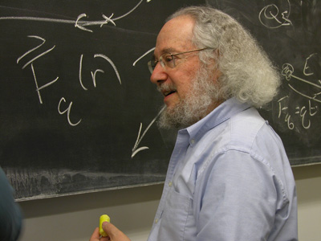
Over the past decade, biology and pre-health care students have grown into the largest population served by physics service courses. With the recent explosion of high-tech biology and medicine, both the character of the students in this class and their educational needs have changed dramatically from when the current course was designed decades ago. What can physics departments do to provide a better education for our students from biology? In order to answer this question, we have to understand not only the physics required but also the context and needs of the students.

The Discipline-Based Education Research Groups in Physics and Biology (PERG/BERG) at the University of Maryland have been studying this question for a decade. We have developed an understanding of the context and needs of biology students both through extensive observations (interviews, surveys, quizzes, exams, and videotaped observations of labs and tutorials) and through detailed negotiations with biology faculty. In this talk, I will discuss some of our previous reforms, our insights into interdisciplinary challenges, and our current work on developing a new biology-oriented introductory physics class.

References:

E. F. Redish and D. Hammer, “Reinventing College Physics for Biologists: Explicating an Epistemological Curriculum,” Am. J. Phys., 77, 629-642 (2009). [http://arxiv.org/abs/0807.4436]

“Collaboration seeks to create interdisciplinary undergraduate curriculum”, http://www.hhmi.org/news/nexus20110608.html

