
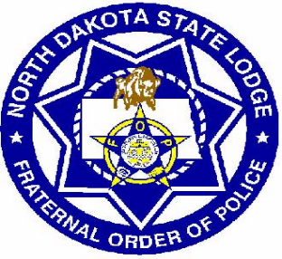Red River Valley Lodge
Fraternal Order of Police
Payroll Deduction Form

I, _______________________________, authorize North Dakota State University to deduct dues from my payroll checks on behalf of the Fraternal Order of Police, beginning with the check received on _________________________________.

Membership $5.50 per pay period

Legal Defense $11.00 per pay period

(Circle all that apply, Membership dues are required in order to have the option for Legal Defense)

Signature: _____________________________________________

Employee ID: __________________________________________

Date: _________________________________________________

************************************************************************
Internal HR/Payroll Use Only:
Received: ________________
Entered: _________________
Signature: ________________

(eff 2/1/2015)

