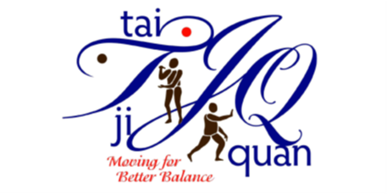

Tai Ji Quan: Moving For Better Balance (TJQMBB)
INSTRUCTOR AGREEMENT

I agree to the following terms, conditions, and responsibilities:

- I will adhere to program documentation and reporting requirements of NDSU Extension.
- I will register for Dr. Li’s TJQMBB website to have access to essential training videos to prepare for classes and maintain my skill level.

- I will prepare for and offer a minimum of one 12-week (twice a week for an hour) TJQMBB class within twelve months of the initial training and each year thereafter.

- I will not use any part of this program except as expressly described in the TJQMBB leader training and TJQMBB Teaching Plan.
- I will not exceed the scope of the program or include any additional information in the program classes.
- I will maintain participants’ privacy in documents and conversation at all times.

Signature ______________________________________Date ________________

Print Name _________________________________________________________

