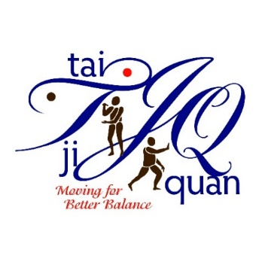
New Instructor Training Application
Tai Ji Quan: Moving For Better Balance (TJQMBB)
Location: Virtual via Zoom

Training Date: Tuesday & Wednesday, August 30 & 31, 2022 from 8:00 AM – 5:00 PM (CST)

Please select one of the following follow-up Enhanced training one-day sessions:
☐ Tuesday, September 27, 2022 (8:00 – 5:00) (CST)
☐ Wednesday, October 26, 2022 (8:00 – 5:00) (CST)

Please note: Class session availability is based on the timing the applications are received.

Instructions: Please provide the following information describing your ability to deliver TJQMBB classes in your community. Consult with your sponsoring organization for questions.
Name: |  |  | Title:
Sponsoring Organization Name:

Mailing Address for class materials: Street: | City: |  |  | State: | Zip:
County where classes program will be provided:

Email: |  | Phone:
Why are you interested in offering TJQMBB classes?

Please list your experience working with older adults.

Please list your experience leading exercise or physical movement classes.

Please list your experience, if any, participating in and/or leading Tai Chi or Tai Ji Quan classes.
(Note: This is not a pre-requisite.)

Training Capacity – Describe your plans to facilitate at least one 12-week (twice a week for an hour) class each year.

Please indicate any special accommodations you may require.

I have discussed the following topics with my sponsoring organization (check all that apply):
☐ Location and space where classes will be held
☐ Marketing
☐ Sponsoring organization’s commitment and support it will provide to you as an instructor

By checking each item below, I am agreeing to the specific responsibilities involved in becoming a North Dakota TJQMBB class instructor. I agree to:

☐ Successfully complete the initial 2-day training session and one-day follow-up session.

☐ Following the initial two-day training, register on Dr. Fuzhong Li’s TJQMBB website and practice with his video clips in preparation for your community class sessions.

☐ Conduct at least one 12-week (twice a week for an hour) community-based class within the first
year and each year thereafter adhering to TJQMBB program fidelity.

☐ Comply with program documentation and reporting requirements of NDSU Extension.

Additional comments:

______________________________________________________________________________________
______________________________________________________________________________________
______________________________________________________________________________________

Signature of applicant (type name as signature): Date:

☐ Submit by email no later than August 12th to: jane.strommen@ndsu.edu

