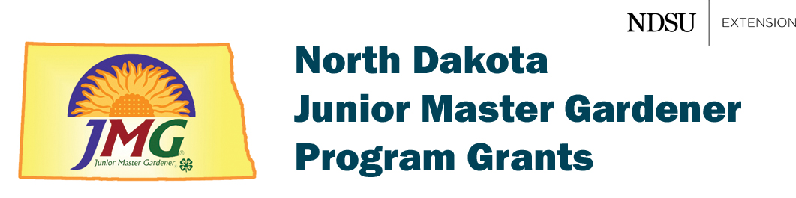
2023 Grant Application Worksheet

Project name: ____________________________________________________________

County: ________________________________________________________________

Project Coordinator: _______________________________________________________

Lead Organization: ________________________________________________________

Address: ____________________________________________________________

____________________________________________________________

Telephone: ______________________ Email: ________________________________

Location of Garden (for example, Jefferson School, Peace Church, Happy Oak Park, etc. We do not need street address: __________________________________________________

- Briefly describe your garden project including its major goals. Please include a description of activities. (150 words or less)

- How will your project make a difference to its children? (150 words or less)

- How will your project make a difference in your community? (150 words or less)

- Please estimate the number of participants directly involved in the project:
Young children (3–12 years old): _____
Teens (13–17 years old): _____
Adults: _____
Volunteers: _____

- Briefly list any partners (such as 4-H, FFA, school, church, garden center, parks department) that are involved. Briefly describe their roles in the project. Be very brief.

- Budget

Please estimate how you plan on using the grant money (maximum of $600).

Examples of allowable items include transplants, seeds, pots, soil, garden tools, gloves, food, lumber, fencing, mulch, fertilizer, tiller rental, etc.

Food, gas, transportation and major equipment purchases are not allowed. Major equipment is an individual item that exceeds $100 (excludes soil and soil amendments). Examples of major equipment include a roto-tiller, greenhouse, sheds and large raised-bed kits). See online information on reimbursements for details.

Expenditures Amount

- Reporting

We must document our impacts in this program. You must agree to complete an online evaluation form and submit at least one photo of project activities. The form will be sent to you after the gardening season is over. This information and photo(s) will be published in our reports, including our annual report.

Do you agree to complete our online evaluation form and submit at least one photo of project activities?
Yes _____ No _____

- NDSU Local Contact

Every application must be approved by a local NDSU educator before it can be reviewed for approval. You are encouraged to contact your local NDSU Extension Service office.

Did you contact a local Extension educator?
____ YES, I have contacted and received the approval of a local Extension educator.
His/her name is _____________________________________
____ NO, please send my application to the appropriate local Extension educator for local approval.

Please cut-and-paste this information into the
online application form. The link to the form is
https://forms.gle/DwGemz3dK58GWzV29

For more information, please contact either Tom Kalb (tom.kalb@ndsu.edu, 701.328.9722) or Carrie Knutson (carrie.knutson@ndsu.edu, 701.780.8229).

January 20, 2023

