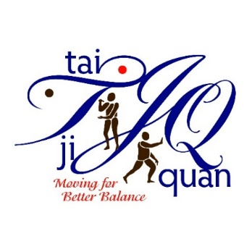
New Instructor Training Application
Tai Ji Quan: Moving For Better Balance (TJQMBB)
Location: Reimers Conference Room-McGovern Alumni Center, Fargo, ND
Training Date: Tuesday-Wednesday, April 9-10, 2024 (8:00 – 5:00 CST)

Please note: Class session availability is based on the timing the applications are received.
Instructions: Please provide the following information describing your ability to deliver TJQMBB classes in your community. Consult with your sponsoring organization (employer) for questions.
Name: |  |  | Title:
Sponsoring Organization Name:

Mailing Address: Street: | City: |  |  | State: | Zip:
County where classes program will be provided:

Email: |  | Phone:
Why are you interested in offering TJQMBB classes?

Please list your experience working with older adults.

Please list your experience leading exercise or physical movement classes.

Please list your experience, if any, participating in and/or leading Tai Chi or Tai Ji Quan classes.
(Note: This is not a pre-requisite.)

Training Capacity – Describe your plans to facilitate at least one 12-week (twice a week for an hour) class each year.

Please indicate any special accommodations you may require.

I have discussed the following topics with my sponsoring organization (check all that apply):
☐ Location and space where classes will be held
☐ Marketing
☐ Fee for classes (if any) - Implementation materials for participants is minimal ($3-$5 per person per
class) and will be covered by a ND Department of Health and Human Services grant for participants aged 60 and older. For additional information or questions on costs and reimbursement, contact Jane Strommen, NDSU Extension.
☐ Sponsoring organization’s commitment and support it will provide to you as a leader

By checking each item below, I am agreeing to the specific responsibilities involved in becoming a North Dakota TJQMBB class leader. I agree to:

☐ Successfully complete the initial 2-day training session and one-day follow-up session.

☐ Following the initial two-day training, register on Dr. Li’s TJQMBB website and practice with
Dr. Li’s video clips in preparation for your community class sessions.

☐ Conduct at least one 12-week (twice a week for an hour) community-based class within the first
year and each year thereafter adhering to TJQMBB program fidelity.

☐ Comply with program documentation and reporting requirements of NDSU Extension.
☐ Meet requirements to participate in the training, which include:
- Fitness level to fully participate in two days of very physical, movement-based training.
- Experience working with older adults (ideally leading exercise programs).
- Willingness to complete all assigned pre-work (estimated 1 – 2 hours) and post work practice and preparation for offering classes (initially estimated 20 – 30 minutes per class session).
- Full attendance at and engagement in all components of the training sessions.

Signature of applicant (type name as signature): Date:
CONTACT INFO for LOCAL SPONSORING ORGANIZATION (EMPLOYER):

Name: Agency Name___________________________

Address:_______________________________________________________________________

Phone: E-mail: ____________________
Our organization agrees to be the sponsoring organization (employer) for this TJQMBB applicant.

SIGNATURE of SPONSORING ORGANIZATION REPRESENTATIVE DATE

☐ Submit by email no later than Thursday, March 28th to: jane.strommen@ndsu.edu

