February 24, 2016
Summer Undergraduate Research Positions
Developmental Physiology and Ecology of Solitary Bees and Honey Bees
Department of Biological Sciences, North Dakota State University
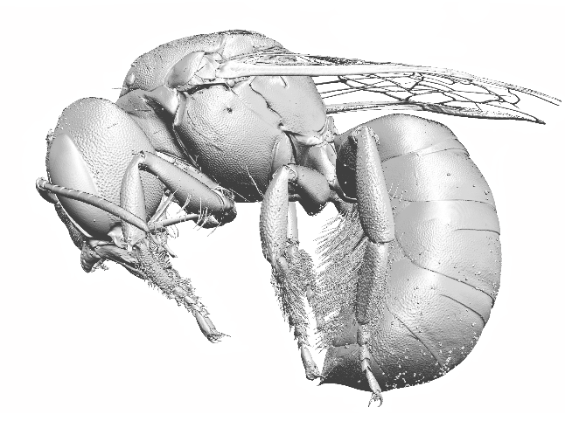
The Bowsher and Greenlee Labs in the Department of Biological Sciences at North Dakota State University (NDSU) in Fargo, ND are excited to invite applications for two NSF-funded research experiences for undergraduates (REU) during summer 2016. These REU students will assist with projects that investigate the development and health of agriculturally-beneficial bee pollinators (blue orchard mason bees, Osmia lignaria; alfalfa leaf cutter bees, Megachile rotundata; and honey bees, Apis mellifera).
One REU position will conduct lab work that assists with characterization of the physiological mechanisms regulating larval development in different species of bees. This student will contribute to: rearing research animals, hormone assays, and quantitative gene expression studies. The other REU position will conduct field-based work. This student will contribute to: maintaining local populations of bees, experimental studies of adult behavior and performance, and collaborating with lab-based personnel to ensure availability of samples.
Selected students will contribute to an active research group of insect biologists, including collaborators and graduate students from NDSU and the USDA. The final project for both REU positions will be a poster presentation at an undergraduate research symposium hosted at NDSU. Selected students will participate in a professional development program during the duration of the REU, and will also be invited to BBQs, game nights, and local outings to strengthen relationships among REU students, fellow undergraduate researchers, and mentors.
Expectations:
Duration of the Program: 10 weeks (May 23, 2016 – Aug 7, 2016)
Salary and Housing: $4500 ($450/week) and housing provided on NDSU campus.
Travel: Up to $500.00 will be provided to/from Fargo for selected REU students
How to Apply
Inquiries about the position should be directed to Bryan Helm, see email below. Complete online application (https://ndstate.co1.qualtrics.com/SE/?SID=SV_5tgAQ5a6jCt7zKt) and submit the following to Bryan Helm (bryan.r.helm@ndsu.edu, subject title “REU Position Summer 2016”):
- A personal statement that expresses interest in one or both positions, describes any previous research experience, and includes long-term career goals (2 pages max).
- A curriculum vitae (2 pages max)
- Contact information for two academic references.
Review of applicants will begin on March 15, 2016 and will continue until positions are filled

Additional Information:
Dr. Julia Bowsher: https://www.ndsu.edu/pubweb/~jbowsher/BowsherLab/Home.html
Dr. Kendra Greenlee: https://sites.google.com/site/greenleelab/
Dr. Bryan Helm: https://sites.google.com/site/brhresearch1/
USDA-ARS-Insect Genetics and Biochemistry: https://www.ars.usda.gov/main/site_main.htm?modecode=30-60-05-10
North Dakota State University does not discriminate on the basis of age, color, disability, gender expression/identity, genetic information, marital status, national origin, physical and mental disability, pregnancy, public assistance status, race, religion, sex, sexual orientation, or status as a U.S. veteran. Students with diverse backgrounds representing underrepresented groups are encouraged to apply.

