Blackboard Test Availability Exceptions
The Test Availability Exceptions settings allow instructors to change these options for selected students for each test in Blackboard as needed:
- Allow additional time to complete timed tests and/or remove the timed or Auto-Submit requirements
- Allow multiple attempts when only single attempts are permitted
- Allow access to tests before or after they are available to the rest of the class

Allow Additional Time
- Make sure Edit Mode: is ON in the top-right corner
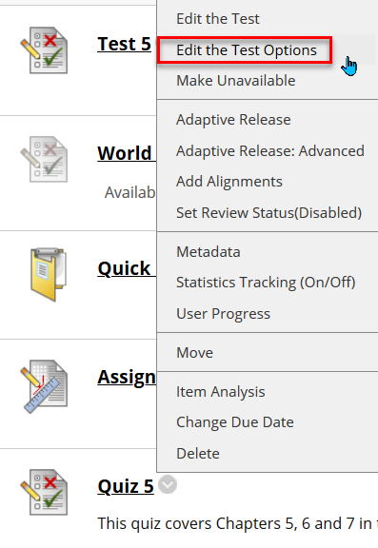
- Open the area where the test is located > click the down arrow icon to the right of the test title > Edit the Test Options
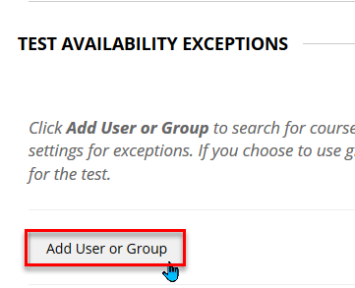
- Scroll down to the Test Availability Exceptions section > Add User or Group
- Check the box to the left of the student’s name > Submit
- Check the box below the Timer option > add the extended time amount > uncheck Auto Submit, if necessary > Submit

Allow Multiple Attempts
- Follow steps 1 – 4 above
- Select Multiple Attempts > enter the number of attempts allowed in the box to the right of Multiple Attempts > Submit

Change Availability Dates/Times
- Follow steps 1 – 4 above
- Click the calendar icon below Availability > choose After: and/or Before: dates/times as needed > Save > Submit

