Emergency Management Higher Education Today:
The 2014 FEMA Higher Education Program Survey



Carol L. Cwiak

North Dakota State University

INTRODUCTION

This year, 2014, marks the 20th year anniversary of FEMA’s Higher Education Program. In the span of 20 years, the FEMA Higher Education Program’s efforts have dramatically changed the face of emergency management higher education. At the program’s inception there was only one degree granting program in the United States at the University of North Texas and a couple of other institutions offering courses. Today, the FEMA Higher Education Program webpage boasts nearly 300 different degree and certificate offerings.

Higher education institutions in the United States listed on the FEMA Higher Education Program’s webpage as offering emergency management degree and certificate programs have been methodically surveyed over the past eight years (albeit, no survey was completed in 2013 due to federal budgetary constraints). The intent of the survey effort is to capture annually data on emergency management program growth, development, needs, concerns, challenges, and trends. This report, the 2014 FEMA Emergency Management Higher Education Report, details the data collected this year from responding colleges and universities. The goal of this report is to assist the FEMA Emergency Management Higher Education Program, policymakers, educators, students, practitioners, and other interested parties and organizations in understanding the state of emergency management higher education; the challenges facing the emergency management higher education community; and, the shifts and trends developing in the data.

In this year’s report, it is confirmed that institutions continue to develop new programs and nurture existing ones. The maturation of programs is now evident in the data as the majority of responding institutions reported programs that have been in existence for six years or longer, and a third of all responding institutions reported programs that have been in existence for 11 years or more. Unfortunately, the reported challenges facing higher education programs remained relatively static – jobs and internships; funding; identity, academic credibility, professionalism, and value; student enrollment and recruitment; and, faculty. These challenges have been consistently reported over the life of the survey effort.

Yet, even facing these enduring challenges, the emergency management higher education community continues its forward movement in a collaborative and committed manner with the heartwarming collegiality that is its hallmark. The past twenty years have been years well-spent. In those years a community has been built and nurtured one program at a time. The higher education community has worked tirelessly to build the discipline, advance professionalization efforts, and meet the research needs of the larger emergency management community. The work is far from done, but the community’s foundation is sturdy and its labor is fueled by the belief that each every member of the community can make a difference.

METHODOLOGY

An invitation to participate and a survey link were distributed via email to the point-of-contact (POC) for each institution listed on the following college lists on FEMA’s Emergency Management Higher Education Program webpage: Associate, Bachelor Level Concentrations and Minors, Bachelor, Masters, Doctoral and Stand-Alone Certificate Programs. Only those institutions listed as offering a certificate or degree program in emergency management (as of April 2014) were invited to participate in the survey. Each institution, regardless of its number of certificate or degree offerings, received a single invitation. In some instances, this invitation was handed off to another person at the institution for completion (as opposed to the listed POC).

The survey instrument was hosted online through North Dakota State University’s Group Decision Center. The survey sought to gather data similar to past years, but as has been true in the survey’s history, the survey instrument was fine-tuned (as it has been from year to year) based on the emergency management higher education community’s needs, developing trends, or community member suggestions. The challenge with the survey effort is to acquire a snapshot of the emergency management community - in all its diversity and similarities – without overwhelming the respondents and thereby discouraging participation. The survey instrument, which has historically been sent out late in the spring semester (a busy time for higher education programs), has always enjoyed a hearty response rate. Unfortunately, the census of programs the survey ideally seeks to achieve never has occurred. As such, a couple of key numbers relevant to the community’s benchmarking are extrapolated from the data each year to better capture the impact of the emergency management higher education community’s contributions via students.

In total, the survey was distributed to 179 institutions. 69 institutional responses were received for an institutional response rate of 39%. As has been true in past years, a handful of solicitation emails bounced back due to changes in the POC, out-of-date information, or changes in the institution’s email address system. Most institutions with programs listed on the college lists have been more regularly checking and updating their information sheets, either as an annual housekeeping task, or at the gentle prodding of the FEMA Higher Education Program. Regular updates of the information sheets not only ensures that prospective students can fairly assess whether programs fit their needs, but also assist higher education researchers that utilize the lists to survey or distribute information to the emergency management higher education community.

Surveyed institutions are asked to answer as many questions as they are able to given the relevancy of the question to their program and the data available to them. As such, note should be taken of the “n” for each item reported. The survey instrument elicited data in the following areas: general program information, student and graduate numbers, enrollment and graduation trends, program faculty and new hires, program access and support indicators, utilization of emergency management materials and technology, challenges facing emergency management programs, anticipated changes in programs, and additional products, activities or services that respondent institutions would like the FEMA Higher Education Program to provide. A number of the open-ended questions on the survey elicited narrative responses. These responses are included in varying levels in this report. While some comments are shared in their entirety, others are shared in part or summarized within a discussion of themes that emerged.

DISCUSSION
Programs
At the time of this year’s survey (April 2014), there were 179 institutions offering emergency management programs listed on the Associate, Bachelor Level Concentrations and Minors, Bachelor, Masters, Doctoral and Stand-Alone Certificate program FEMA college lists. Many institutions offered either multiple degree levels or multiple focus areas within a degree area. Table 1 provides the breakdown of the 133 reported program offerings reported by responding institutions (n=69).

Degree, Certificate, Etc. Offered | Reported Offerings
Doctoral Degree | 4
Doctoral Level Concentration | 1
Master’s Degree | 19
Master’s Level Concentration | 5
Graduate Certificate | 15
Bachelor’s Degree | 24
Bachelor’s Level Concentration | 4
Minor | 14
Associate Degree | 21
Undergraduate Certificate | 25
Other* (Diploma) | 1
Table 1: Offerings - Number and Type

Emergency management higher education program offerings continue to multiply as institutions add new degree and certificate options. Consistent with the pattern that is seen annually, 29 of the responding institutions (43%) reported that they plan to develop new offerings over the next year (n=68). The new offerings reported included programs at all levels, concentrations, minors, and new coursework within existing programs. The focus of those new offerings included emergency management, homeland security, disaster management, public safety leadership, trauma and disaster mental health counseling, business continuity, and floodplain management.
Respondents reported programs housed across a wide variety of departments. The only pattern evident across the departments was that 17 of the 69 reported departments contained the word, “public”. Table 2 provides a sampling of the departments reported to illustrate the extent of variation in the housing of emergency management higher education programs (n=69).

Emergency Management | Social Sciences
Earth Sciences | Public Administration
Administrative Science | Management
Public Safety | Environmental & Occupational Health
Technology | Political Science
Human Services | Urban Design and Planning
Public Service | Public Health
Business | Psychology
Emergency Services | Global Health
Nursing | Fire Protection
Criminal Justice | Public Policy
Homeland Security | Landscape Architecture & Urban Planning
Education | Protective Sciences
Table 2: Departments Programs Housed In (Sampling)

In contrast to the variety of departments that programs are housed in, are the similarities in the programs’ names. Of the 69 respondents, 65 program names fell within three clear categories (see Table 3; n=69). “Emergency Management” was included in 45 of the program names; “Homeland Security” was included in 11 of the program names (7 of those programs were combined with “Emergency Management” and 4 were stand-alone); and, “Disaster Management” was included in 9 of the program names (3 of those programs were combined with “Emergency Management” and the remainder were stand-alone or paired with other focus areas). This is the most consistent reporting of program names to date. The 2012 survey captured a similar pattern in regard to programs titled with “Emergency Management” or “Management”, but not to the extent evidenced in this year’s results.

Program Name | Number Reported
Emergency Management (EM) | 45
Homeland Security¹ | 11
Disaster Management² | 9
¹ 7 combined with EM; 4 stand-alone
² 3 combined with EM; remainder stand-alone or paired with other areas

Table 3: Consistency in Program Names

Respondents were asked how long an emergency management program had been offered at their institution. The goal of the query is to capture the length of time institutions have been engaged in emergency management higher education. Many institutions have a number of degree or certificate offerings that started at varying times; as such, the term program as used presently refers to the initial academic endeavor undertaken by the reporting institutions. This data has been tracked over the years to try and capture the maturation of emergency management higher education programs. Figure A shows that the majority of respondents (67%) report that their program has been in existence for 6 or more years (n=67). While this is not surprising data given the number of years the emergency management higher education community has been developing, it is a reminder that emergency management higher education is, with each year, cementing itself in higher education institutions across the United States.
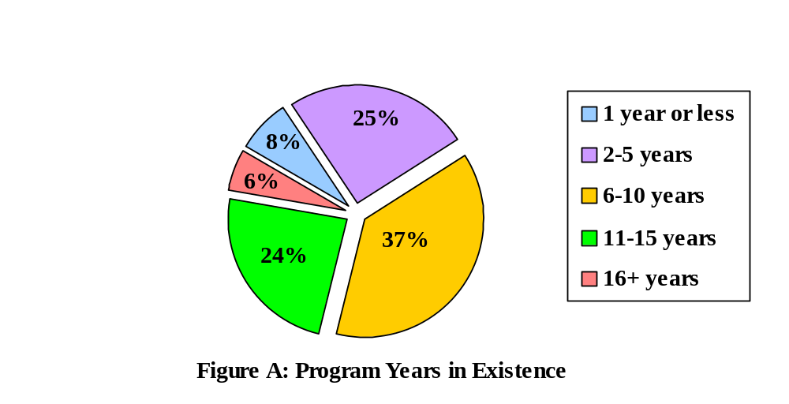

In past surveys, respondents’ choices for program focus were limited primarily to public and private. As a result of past survey comments and suggestions, expanded focus options were provided to respondents this year (public, private, VOAD, or humanitarian). The majority of respondents (59%) reported that their program focuses on two or more areas. Of those indicating a focus in two or more areas, the most frequent combination noted was a public/private focus. Other couplings referenced by respondents included leadership, mental health, and homeland security. The largest singular focus area reported was public. None of the responding programs reported a singular focus on VOAD or humanitarian. Of note, many respondents indicated that program focus could vary significantly within their institution’s offerings based on the degree level or specific nature of a given program. Table 4 provides the distribution of the program focus responses (n=66).

Program Focus
Public | 32%
Private | 5%
VOAD | ---
Humanitarian | ---
All of the above | 36%
Combination* | 23%
Other | 5%
* Combination of two or three focus areas
Table 4: Program Focus

67% of respondents reported the primary purpose of their program to be both pre-employment (i.e., preparation for entry in the field) and advancement (i.e., preparation of practitioners for advancement) (n=68). The remaining respondents leaned most heavily toward a pre-employment purpose (18%). Smaller percentages reported serving primarily an advancement purpose (9%) or indicated another purpose (6%) - such as a different purpose at the undergraduate and graduate level, faith-based, and an academic management purpose. Figure B illustrates the distribution in regard to program purpose.

Interestingly, respondents that indicated that they served both pre-employment and advancement frequently showed wide gaps in percentages regarding the predominant purpose of the program. Only about one fourth of these respondents evenly split the purpose between pre-employment and advancement (i.e., 50/50), while the remainder of respondents reported 20 to 65 point differences (i.e., 20/80; 30/70; 85/15) toward one purpose area or the other. How these distributions affect and are reflected in program structure and offerings would be an interesting area to examine in future survey efforts.

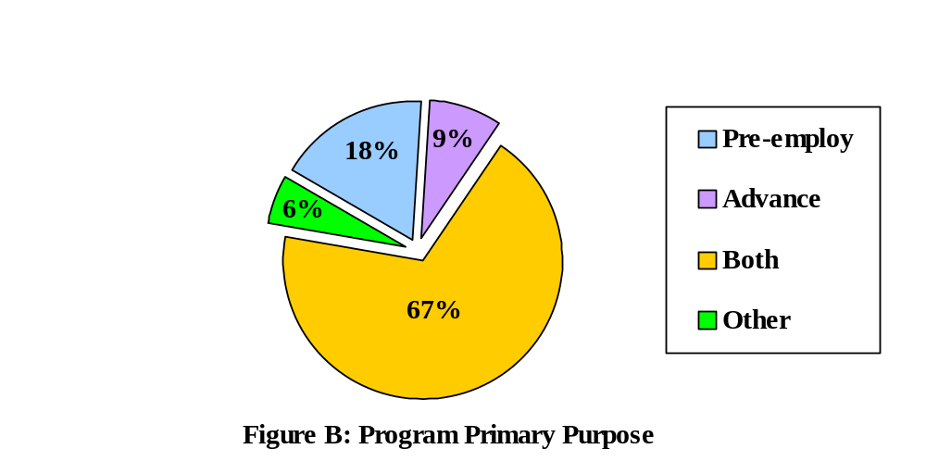

Past program data has evidenced that many emergency management higher education programs are offering some, if not all, coursework online. As can be seen in Figure C, 82% of responding institutions reported that they offered coursework through some form of distance education (n=68). In regard to the percentage of coursework offered online, 39% of all respondents (27) indicated that they offer 100% of their coursework online and 28% (19) indicated that they offer 100% of their coursework online only. A number of respondents noted that they were using varying levels of distance education based on the program or audience. Additionally, the classification of distance education by some respondents included models that require weekend visits or other arrangements that brought students to the campus for a short period of time. Figure D shows the percentage of online course offerings respondents reported (n=54).
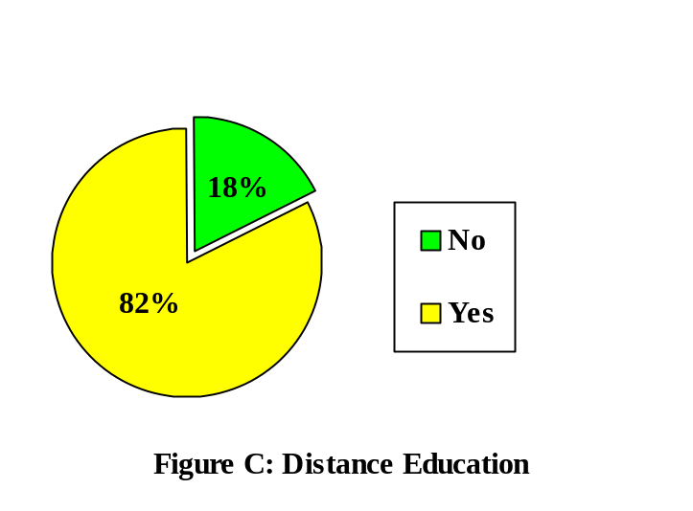

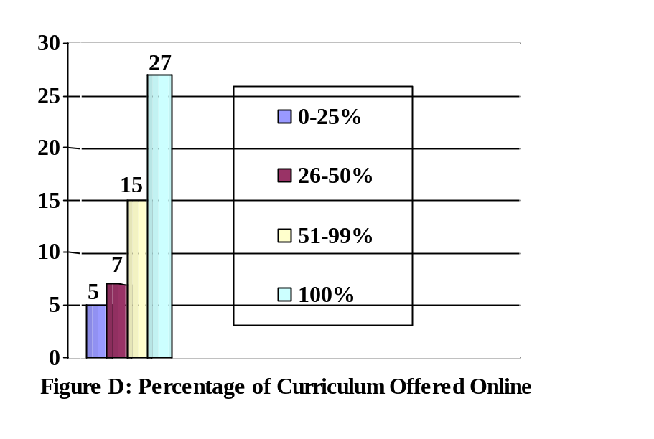
In regard to technology, the vast majority of respondents reported teaching about, or with, one or more type of technology in their program (n=68). At the top of the list for frequency were Web EOC and other web-based EOC systems, GIS, and social networking. Only 19% of respondents (13) reported no technology instruction. Table 5 details the technology-based instruction responses.

Technology | Number of Programs Teaching
GIS | 18
Web EOC/ Other web-based EOC system | 21
Social networking | 16
Planning software | 6
Media software | 8
Other (Google Earth, HAZUS, Intelligence Analysis, simulation software, Blackboard, D2L, SPSS, Canvas, course delivery software, Ping, Sakai, ALOHA) | 12
None | 13

Table 5: Technology-based Instruction

Respondents were queried in regard to their awareness of the Principles of Emergency Management document that provides the definition, vision, mission and eight principles of emergency management (http://www.training.fema.gov/EMIWeb/edu/emprinciples.asp). If respondents reported they were aware of the document, they were asked whether the document was utilized in instruction in their program. This data – Principles awareness and utilization - has been collected since 2008 in an effort to gauge to what extent students in emergency management higher education programs are benefitting from the inclusion of the Principles in their educational process.
Figure E illustrates that while the vast majority of respondents reported being aware of the Principles (91%), not all that are aware of the document are utilizing it in the classroom (n=67). 81% reported utilizing the Principles in their program’s classes (n=67). Comments provided by respondents indicated that the Principles are being used in varying degrees across programs, to include: across courses, to structure courses, and to guide and structure programs.

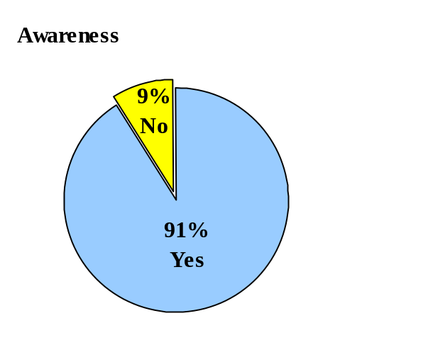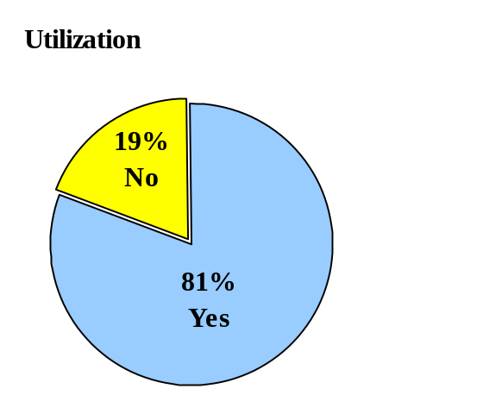

Figure E: Principles - Awareness and Utilization

In addition to usage of the Principles, respondents are also surveyed annually regarding their usage of the Emergency Management Institute’s (EMI) Independent Study coursework, the FEMA Higher Education course offerings, and the FEMA Higher Education Prototype Curriculum for Associate Degrees. Figure E shows the reported usage of these three FEMA generated resources. Of note, the FEMA Higher Education Prototype Curriculum for Associate Degrees theoretically only applies to a specific group of respondents who are offering coursework and degrees at that level; hence, the lower utilization figures are a function of the overall survey audience composition. The reported utilization of the Prototype Curriculum is similar to what has been reported in past years (n=66).
A large percentage of respondents (82%) reported that their program has utilized the Emergency Management Institute’s (EMI) Independent Study coursework in their program (n=65). Respondents who responded affirmatively in regard to the EMI Independent Study coursework usage were asked if they used that material as supplemental material or as a primary source of information. Respondents (n=53) overwhelming reported utilizing the courses as supplemental material (91%) as opposed to as a primary source of information (9%).

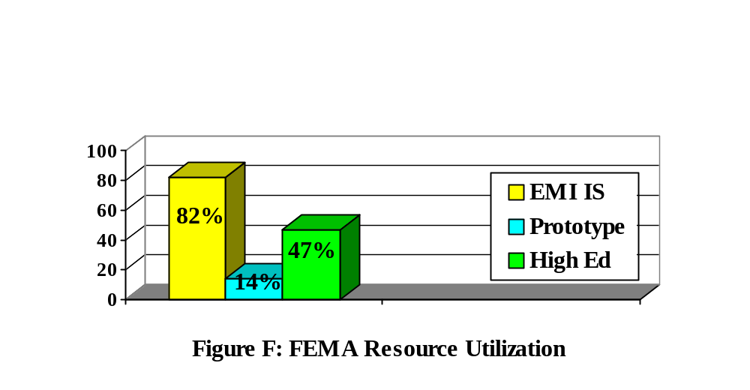 Nearly half of the respondents (47%) reported utilization of FEMA Emergency Management Higher Education courses (n=66). The most utilized courses in order of most used to least are shown in Table 6. While only those courses utilized by 30% or more of those responding to the query (n=30) are listed herein, every course was noted as being utilized by one or more respondent.

Higher Education Course | Selection Frequency
NIMS | 19
Disaster Response and Operations | 16
Terrorism & Emergency Management | 16
Hazards Risk Management | 14
Principles & Practice of Hazard Mitigation | 13
Homeland Security and Emergency Management | 13
Sociology of Disaster | 11
Building Disaster Resilient Communities | 10
Social Dimensions of Disaster | 10
Technology and Emergency Management | 10
Business Crisis and Continuity Management | 9
Public Administration and Emergency Management | 9

Table 6: Higher Education Specific Course Utilization

The survey annually collects data regarding support and access across a number of indicators. Respondents are asked to respond to the level of access or support their program has using a ten point Likert scale that ranges from “not at all” (1) to “very much so” (10). The access indicators measure access to external funding, institutional funding, and library resources. The support indicators measure support from institutional administrators, local emergency management, state emergency management, national professional organizations, FEMA, and DHS. Each indicator with its mean and standard deviation are captured in Table 7 to allow for better comparison between the indicators. Also included in the table are the means from 2012 and symbols which indicate whether the mean has increased (+) or decreased (-) compared to the 2012 data. Unfortunately, the 2014 data shows a decrease for every indicator but one. While indicator means do fluctuate from year to year, that fluctuation is typically slight (as can be see between 2012 and 2014).
The support and access indicators help the higher education community to ponder key areas that are important to program health. Any mean sitting below a 7 is an area that warrants discussion and potential action by the community. Those indicators hitting at 5 or below should be viewed as areas that require immediate and sustained action to protect the well-being of the higher education community.

Access/Support Indicators | n | Mean | Std. Dev.
Access to external funding opportunities to support your program (e.g., grants, contracts, etc.) | 65 | 4.12 (-) 4.35/2012 | 2.80
Access to institutional funding (e.g., stipends to develop courses/materials) | 66 | 4.85 (-) 5.02/2012 | 2.61
Access to library resources (e.g., ability to obtain new holdings) | 66 | 7.79 (-) 7.95/2012 | 1.96
Institutional administrative support (e.g., support attempts to develop & implement new program ideas) | 66 | 6.39 (-) 6.86/2012 | 2.49
Local emergency management community support  (e.g., county and regional) | 65 | 7.55 (-)  7.77/2012 | 2.36
State emergency management community support  (e.g., state-level agency & state professional organization) | 66 | 6.48 (-)  7.33/2012 | 2.53
National emergency management professional community support (e.g., IAEM, NEMA, EMPOWER, etc.) | 65 | 5.03 (-)  5.60/2012 | 2.82
FEMA-specific support (e.g., Higher Education Program, EMI, etc.) | 66 | 6.85 (-)  7.14/2012 | 2.23
DHS-specific support (e.g., overarching DHS programs & agencies within DHS other than FEMA-specific support) | 65 | 4.82 (+)  4.58/2012 | 2.60

Table 7: Access and Support Indicators

To assess growth in enrollment and graduation rates, the survey instrument has long queried the changes in enrollment and graduation looking both back and forward in time for three years. Without fail, the data reported by respondents to these queries has been overwhelmingly positive. The data this year, as can be seen below in Figure G, paints a fairly rosy picture of healthy programs that continue to grow and see no decrease in enrollment or graduation rates (n=66). As programs mature, it makes sense that their enrollment and graduation rates will stabilize somewhat and it is expected that at some point these dramatic increases will level out. However, it must be noted that some respondents reported decreases over the last three years and decreases moving forward. While there are many reasons why decreases may occur at program levels that are not troubling, decreases can signal significant program challenges. An increased reporting in decreased numbers regarding enrollment and graduation across the community could present a much more difficult situation for the emergency management higher education community, such as market saturation. Thus far, the data collected from respondents does not reflect such an issue.

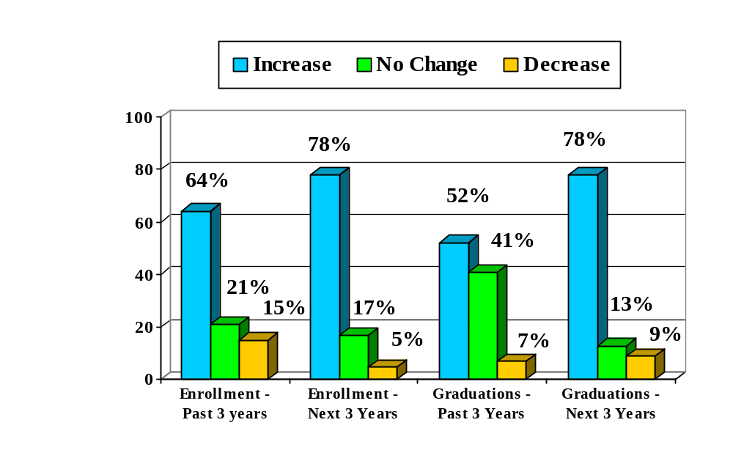

Figure G: Enrollment and Graduation

Faculty

The most important faculty information collected annually is the number of full-time faculty members principally devoted to emergency management higher education programs. The theory is that programs with one or more faculty members devoted to them are more likely to endure and thrive than those without such positions. This is not to say that other faculty configurations are not effective, indeed, there are many configurations that have been successful with no principally devoted faculty. However, in the framing of an academic discipline and the offering of degrees and certificates from that discipline, there is plenty of history in higher education institutions that shows that disciplines need their own full-time faculty (as opposed to an assortment of adjuncts or faculty bridged from other disciplines to teach a course or two) to have legitimacy and to more easily acquire resources.

Historically, the percentage of programs with no devoted full-time faculty
has averaged about 30% and the combined percentage for programs with zero and one, devoted faculty members has averaged about 70%. This year’s data
denotes an uptick in full-time devoted faculty that has not been seen before. The percentage for no devoted full-time faculty comprised 24% of the programs, while the percentage for one full-time devoted faculty member (35%) and two full-time devoted faculty members (21%) comprised in total 80% of the programs (n=66). These percentages represent growth and may be the beginning of a trend wherein full-time devoted faculty members in programs are increasing. As can be seen in Table 8, only a small percentage of respondents reported having three or more full-time devoted faculty.

Devoted Faculty
0 | 24%
1 | 35%
2 | 21%
3 | 9%
4 | 5%
5-10 | 6%

Table 8: Devoted Faculty

Also queried annually is the number of full-time, adjunct, and associated faculty (faculty from other departments/disciplines that teach a course or courses within the emergency management program. Tables 9-11 provide a summary of that data (n=65). As can be seen in the data, there can be tremendous variability in the number and type of faculty configurations in different programs. As an indicator of that variability, note the range of reported adjunct faculty (0-108) and the percentage of respondents who reported no associated faculty (61%). Respondents’ programs vary from fledgling brick and mortar programs to large, established online programs; hence, to compare one program to another is often the equivalent of comparing apples and oranges.

Full-time Faculty
0 | 15%
1 | 37%
2 | 17%
3 | 12%
4-5 | 12%
6+ | 7%

Range: 0-20

Table 9: Full-time Faculty
Adjunct Faculty
0 | 16%
1-3 | 26%
4-6 | 28%
7-9 | 10%
10-14 | 10%
15+ | 10%

Range: 0-108

Table 10: Adjunct Faculty
Associated Faculty
0 | 61%
1 | 10%
2 | 15%
3 | 5%
4 | 3%
5+ | 6%

Range: 0-7

Table 11: Associated Faculty

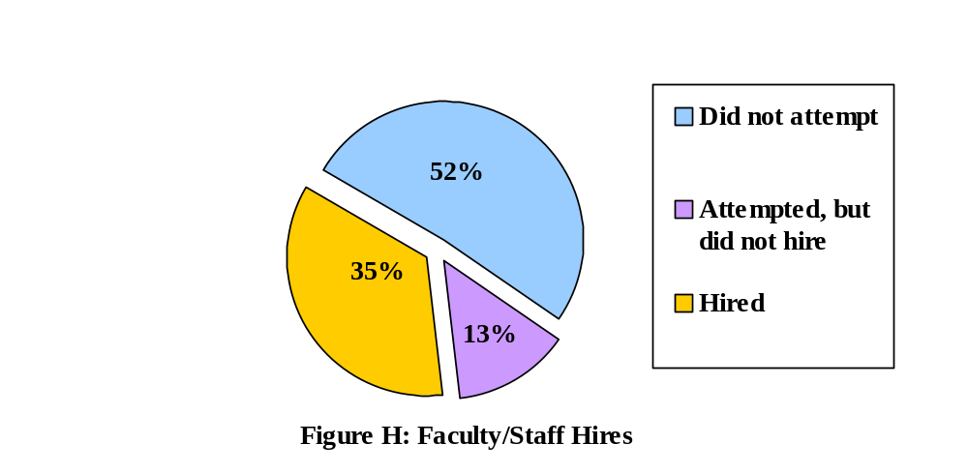Respondents are also asked if their program hired or attempted to hire new faculty or staff over the past academic year. As can be seen in Figure H, while almost half of respondents (48%) attempted to hire, only 35% successfully hired (n=68). Those that did hire reported hiring 12 full-time positions and 40 adjunct positions in 2013-2014.

Students & Graduates

In the early iterations of this survey effort, there was an attempt to collect additional demographic data about students from responding institutions. Providing this data was difficult for respondents, particularly those with large or online programs. Due to the inherent challenges in collecting this data from responding institutions, an independent survey effort was undertaken to collect information about emergency management students. This effort is now annually orchestrated by the student leadership from IAEM’s Student Region. As such, the FEMA Higher Education Program annual survey only collects data in regard to students in four areas: gender, students reached via emergency management coursework, the number of graduates (annually and cumulative), and employment.

The data on the gender composition of the emergency management higher education student community has varied little over the years. It has historically been about a 40/60 (female/male) split across all program levels with a more evenly distributed pie or a few extra points to females when just evaluating the graduate level. This year’s data reflects a more disproportionate general student gender distribution at 33/67 (n=64). Additionally, there was no dramatic shift reported at the graduate level that would evidence greater gender balance at the graduate level. The gender data is displayed in Figure I.
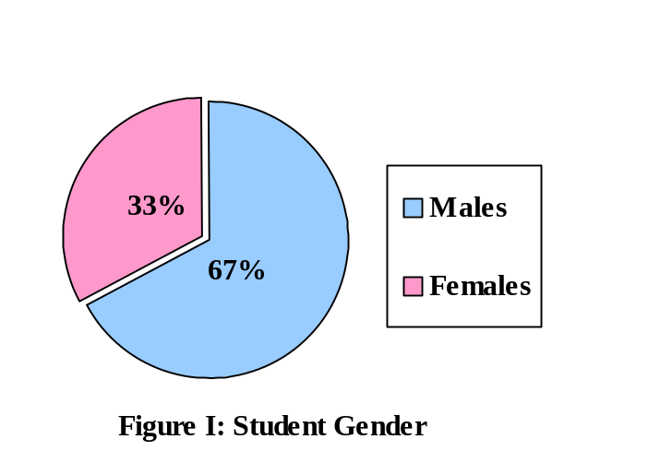

The FEMA Higher Education Program has collected data on emergency management graduates and students reached by emergency management coursework since 2008. The goal was to capture to what extent higher education programs were changing the landscape of emergency management practice from by both contributing educated professionals and educating the general citizenry it serves (via exposure to emergency management coursework). The number of graduates and students reached are extrapolated annually from the data received. Additionally, the number of graduates reported each year has been added to a running total since 2008 (absent 2013 data).
As seen in Table 12 below, the number of students who took an emergency management course during the 2013-2014 academic year was estimated to be 26,671 (extrapolated from a response of 10,402/39%) (n=69). The number of graduates since program inception was solicited from programs in 2008 and at 7,730 set the base for future graduate extrapolation additions (extrapolated from 3,414/44%) (n=69). This year’s figure 3,974 (extrapolated from a response of 1,550/39%) was added to the existing figure of graduates for a total of 22,770 graduates since the inception of emergency management higher education programs (current year extrapolation added to 2012 figure of 18,796).

Number of students who took an emergency management course  in 2013-2014 (extrapolated from response of 10,402/39%) | 26,671
Number of students that graduated this past year from emergency  management higher education programs (extrapolated from response  of 1,550/39%) | 3,974
Number of students that graduated since the inception of  emergency management higher education programs (current year  extrapolation added to 2012 figure of 18,796) | 22,770
Table 12: Extrapolated Student Data

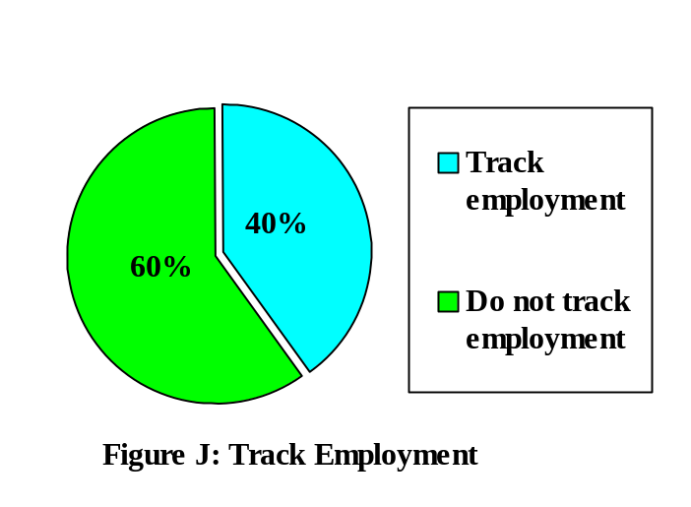 In an effort to better understand the comments that have been made by some emergency management students and educators about job availability in the field of emergency management, queries were added to the survey regarding employment tracking and graduates career-focused employment. Unfortunately, many programs do not track employment and when asked to report on graduates’ employment outcomes are hard-pressed to do so confidently. Hence, the data in regard to estimates of employment from programs that do not track employment should be considered with the aforementioned caveat in mind. Figure J shows that only 40% of respondents reported that they track graduates’ employment (n=68).

Figures K and L show graduates employment figures from both the respondents that tracks employment and the respondents that felt they could take an educated guess based on anecdotal evidence that had about their graduates. In both of these figures, the categories shown indicate the percentage of students who find career-focused employment (i.e., employment related to their emergency management education). As can be seen in the tracked group’s data (n=25), almost a third of respondents stated that their graduates’ employment percentages were between 76-100%. In contrast, the data from the respondents that felt comfortable estimating their graduates’ employment percentages (n=21) showed that only 19% of respondents believed that between 76-100% of their graduates moved into career focused employment. Employment tracking is an area that the emergency management higher education community needs to start paying closer attention to in the future. While the survey queries were wide open as far as timeframe goes, it would be ideal to be able to measure employment success within six month and one year windows.
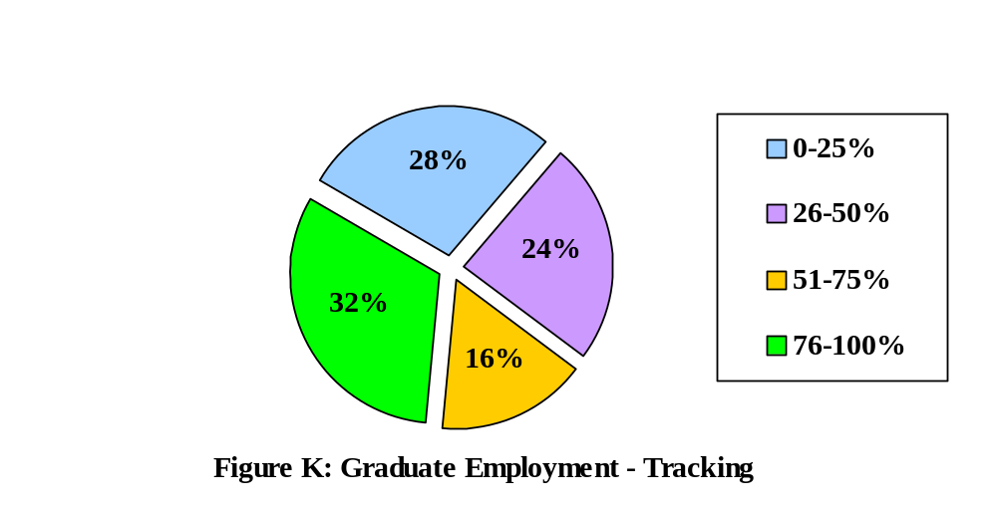

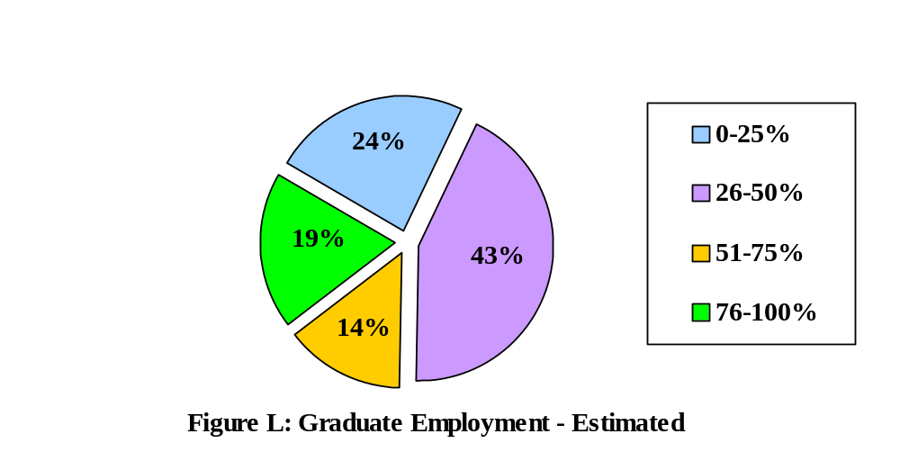

Additional Products, Activities and Services

Each year respondents are asked what other products, activities and services they would like to see the FEMA Emergency Management Higher Education Program provide. This query ultimately creates a laundry list of suggestions and requests. The suggestions have been interestingly similar most years. This year’s list reiterates some of the suggestions that have been made for many years running (e.g., update courses; more interactive material; update website; etc.) and adds some new suggestions. To the extent that suggestions were duplicative they were consolidated.

- Update the Hi Ed courses;
- Continue the FEMA Higher Education Conference;
- Update the website;
- Materials on legal issues in emergency management;
- E-resources at the undergraduate and graduate level;
- More opportunities for the community to collaborate;
- More bachelor degree level courses;
- Course on cybersecurity;
- Quarterly web conferences that are more inclusive and feature presenters from a greater diversity of institutions;
- Courses with combined emergency management and homeland security focus;
- Update FEMA video footage to be more relevant and current;
- Create material that is instructional with regard to Web EOC;
- Updated textbooks on emergency management;
- Resources to help graduates find jobs;
- Interactive material for online learning;
- More courses on holistic disaster recovery and vulnerable populations;
- Resources on resilience;
- ARC GIS training and webinars for students;
- Internship opportunities;
- Facilitation of student participation in exercises in each region;
- Better learning assessment in independent study courses;
- More course syllabi templates;
- Opportunities to meet AEM/CEM credentialing;
- More technology-focused resources;
- More networking opportunities for the Hi Ed community;
- Information on applying for extramural funding;
- Easier access to HAZUS MH; and,
- Development of accreditation standards.

Challenges Facing Emergency Management Programs

One of the most important tasks of the survey is to capture respondents’ thoughts on the top five challenges facing emergency management higher education programs. Each year the survey solicits a listing from respondents of the top five challenges facing emergency management programs. Unfortunately, the challenges that are most often mentioned each year are, on the whole, the same challenges. To some extent, the challenges facing emergency management higher education are endemic to higher education generally; alas, not all of emergency management higher education’s challenges are as pedestrian as others, and they all need the attention of the community. The five challenges that rose to the top this year have emerged a number of times in past years. This year’s challenges (as seen in Table 13) are: (1) jobs and internships; (2) funding; (3) identity, academic credibility, professionalism, and value; (4) student enrollment and recruitment; and (5) faculty (n=69).

Challenge Identified | Percentage (Number of Respondents That Noted Challenge)
Jobs and Internships | 43% (30)
Funding | 41% (28)
Identity, Academic Credibility,  Professionalism, and Value | 38% (26)
Student Enrollment and Recruitment | 20% (14)
Faculty | 20% (14)
Table 13: Challenges Facing Programs

This year, more so than past years, respondents took the time to articulate their angst with the challenges facing their programs. In their comments, the frustration with these enduring issues came across loud and clear. Additional issues that were mentioned by multiple respondents that did not end up in the top five are: the need for more quality textbooks that are regularly updated; politics continually re-shaping the emergency management community; training that seems to be trying to compete with education; lack of quality research; the challenge of keeping up with the ever-changing frameworks from the government; balancing theory and practice; greater focus on professionalization to ensure that emergency management is viewed as a career of first choice (as opposed to a post-retirement position for first responders); no degree requirement, or preference points for having a degree, in regard to emergency management position openings; convincing students of the value of publishing and attending conferences; competition amongst programs; accreditation; lack of funded research opportunities; poor articulation of curriculum to job market; staying on top of the new technology being used by emergency management practitioners and their partners; views of online education and hybrid models versus brick and mortar programs; potential students and faculty unable to meaningfully evaluate competing programs; standardization of curriculum; institutional support; emergency management practitioners greatly valuing credentials above education; linking programs to key community partners (e.g., private sector, NGOs, public sector, etc.); the ability to remain topical and timely in a global society; adapting to the ever-increasing severity and number of disasters; and, meeting the needs of both new career and advancing career student goals in the same program.

Clearly, there is work to be done. The above list is a consolidation beyond the top five challenges and in every challenge mentioned there are dozens of other programs out there nodding in agreement. It is time for the emergency management higher education community to more aggressively address these challenges – many of which weave in and out of each other. This cannot be done alone. It must be done in concert with the practitioner community and our partners. The challenges raised by the respondents in this survey effort will be here next year and the years after that absent concerted action.

CONCLUSION

The emergency management higher education community is a community fueled by passion and dogged determination. It is a community that over the past twenty years has been in continuous build mode. It is a community filled with promise that materializes in a dedication to continually pushing upward. This dedication is labor intensive and exhausting at times – building a discipline and professionalizing a field are not easy feats. And yet, the community continues to give of itself enthusiastically in the belief that at some point it will have the chance to take a deep breath, relax, and look back at what has been created. Twenty years have passed and much has been accomplished, but there is still so much to do before the community can take that deep breath.

It is, however, time for the emergency management higher education community to recognize that its contribution is irrefutable – this community has changed the face of the practice of emergency management and in doing so has changed communities across the country and world. The work being done day-to-day matters, whether it is contributing to the research in the field, educating future emergency management practitioners or scholars, or speaking at the local Rotary Club meeting. Keep looking upward and moving forward members of the emergency management higher education community, you are changing the world as we know it, and as Martha Stewart would say, “That is a good thing.”

“The most powerful weapon on earth is the human soul on fire.”
~Ferdinand Foch

Read more at http://www.brainyquote.com/quotes/quotes/f/ferdinandf130701.html#klIs6vFcm0VdUufl.99weapon on earth is the human soul on fire.
Ferdinand Foch
Read more at http://www.brainyquote.com/quotes/quotes/f/ferdinandf130701.html#klIs6vFcm0VdUufl.99
.”
~Margaret Mead

APPENDIX
Participating Colleges and Universities

Adler School
American Public University System
Anderson University
Arkansas State University
Baton Rouge Community College
Bellevue University
Bergen Community College
Broward College
Caldwell Community College
California State University, Long Beach
California University of Pennsylvania
Central Georgia Technical College
Central Texas College
Clackamas Community College
Community College of Rhode Island
Community College of Vermont
Concordia University
Crown College
Durham Technical Community College
Eastern New Mexico University
Erie Community College
Farleigh Dickinson University
Flathead Valley Community College
Florida State University
Guilford Technical Community
Hesston College
Idaho State University
Indiana University, Kokomo
Indiana University, Purdue
Jackson State University
Jacksonville State University
John Jay College of Criminal Justice (CUNY)
Lakeshore Technical College
Loma Linda University
Madonna University
Massachusetts Maritime Academy
Montgomery County Community College
New York Medical College

North Dakota State University
Northeastern State University
Ohio Christian University
Philadelphia University
Pikes Peak Community College
Portland Community College
Red Rocks Community College
Saint Louis University
San Antonio College
Savannah State University
SUNY, Canton
SUNY, New Paltz
Texas A & M University
Texas Southern University
Union College
University of Akron
University of Alaska, Fairbanks
University of Central Florida
University of Central Missouri
University of Chicago, Graham School
University of Delaware
University of Hawaii, West Oahu
University of Maryland, University College
University of Massachusetts, Boston
University of Nevada, Las Vegas
University of North Texas
University of South Florida
University of Washington
Western Carolina University
Yavapai College

“Individual commitment to a group effort – that is what makes a team work, a company work, a society work, a civilization work.”
~Vince Lombardi

