Blackboard Collaborate
This guide is designed to help familiarize you with Blackboard Collaborate. Blackboard Collaborate allows you to see and speak with your writing consultant online, and it also allows both of you to work on the same document together. The second page shows the interface of Blackboard Collaborate and the important functions. We suggest having this guide with you during your online appointment.

Logging in
- Use the link that was sent to your email.
- Type in your name and click Submit
- Open join.jnlp.
  - Depending on your browser and computer, you may receive additional messages asking permission to run the program. You may also need to download or update Java.
- If you run into problems during your appointment time, please call 701-231-5264
Application Sharing
To let your consultant view your document during the appointment, you need to initiate Application Sharing. First, make sure that your document is open on your computer. Then, click the Application Sharing button (see next page). The box shown to the right will appear. You may choose to share the entire desktop (top option) or only one of the programs. If you choose to only share one of the programs, you will need to move other windows (such as the video window) out of the way as these can obstruct the view of the document.
Once sharing has begun, the other user will be able to view the shared screen within his/her Blackboard Collaborate space. The viewer will also have the option to “Request Cursor Control” at the top of the screen.

Blackboard Collaborate Interface
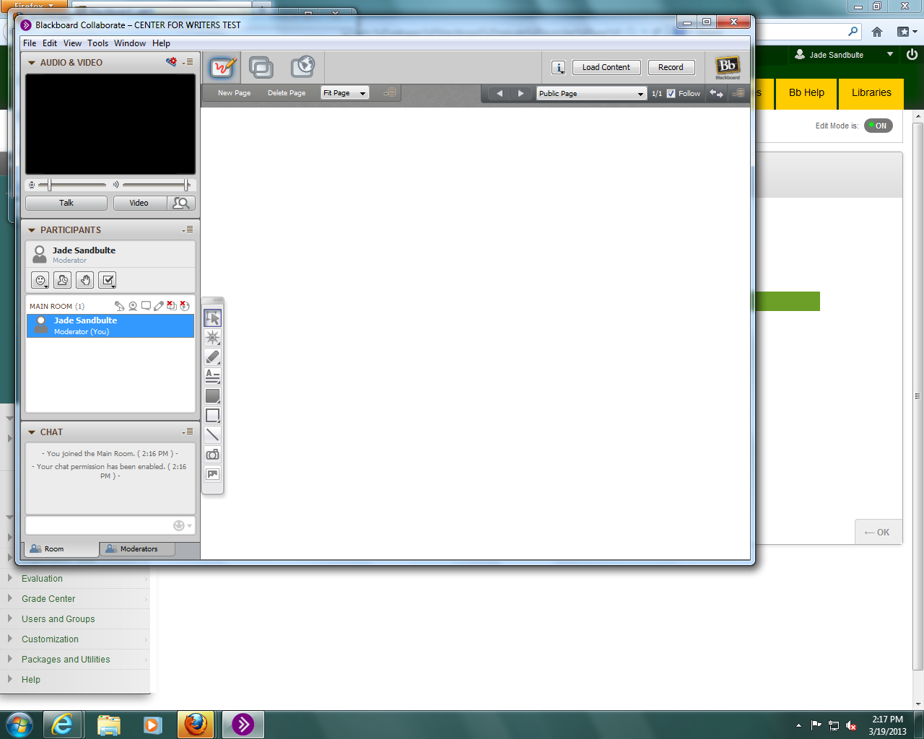
1
5
4
2
3
Chat: Instant Messaging tool. This is a good option for introducing yourself.
1
Talk: Press to activate your microphone. If it does not work, you may need to run the “Audio Setup Wizard” under Tools in the menu bar.
2
Video: Press to activate your camera. The video screen will usually show the other person and a small window of yourself.
3
Record: Creates a recording of the session that is stored on Blackboard. If Recording is selected, the Video window will only show the person who is speaking.
4
Content Options: The specific buttons are described below:
5
Whiteboard: Used for drawing. Text can be pasted into the whiteboard.
Application Sharing: Allows users to share what is on their screen and allow others to manipulate their computer. See first page for more information.
Web Tour: Allows one user to show a website to other users.

