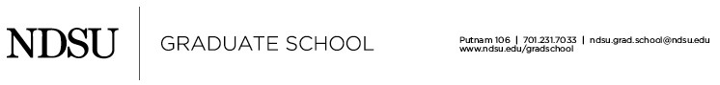

Dissertation Video Prescheduling Information

This information will be used to create the title and end slides of your video so make sure that each item is provided exactly as you want it to appear, and proofread carefully. Capitalize the first letter of all words except conjunctions, articles, and prepositions.

Please save completed form and email to Stephen.beckermann@ndsu.edu when you are scheduling the filming for your video. If you would like a graphic included in your video, attach it to the same email, ensuring that the font size of any text is no smaller than 32 pt.

Full Name:
Student ID #: ORCID # (if applicable): Graduation Year **:

Program Name: Academic College: Choose an item.

Dissertation Title:

Alternative Title (optional):

Supervisory Committee Chair:

Supervisory Committee Members:

Funding Source Acknowledgement (if any):

**Note—Graduation requires completing the disquisition review process and final approval by the Graduate School, thus may not be the same as the semester/year of Final Examination.

