Lost in Translation
Sharing Your Research With the Public

Resources
Start with WHY
People don’t buy what you do; they buy why you do it
http://www.ted.com/talks/simon_sinek_how_great_leaders_inspire_action.html

Distill Your Message

I help _________________ do _________________ so they can _________________.

Source: copyblogger.com via Flint Communications Fargo Connect Conference 2015

American Association for the Advancement of Science
How to Communicate Your Science
  - www.aaas.org/communicatingscience
  - http://www.aaas.org/page/communicating-science-online

National Science Foundation Science 360
- http://news.science360.gov/files/

Twitter Feeds About Science, by Subject Area
- http://indianapublicmedia.org/amomentofscience/twitter-science-accounts/

Infographics Resources
- Piktochart
- Infogr.am
- Icharts
- Venngage
- Google Charts
- Tableau
- Datawrapper
- Easel.ly
- Freeinfographictemplates.com

Become a science ninja. Spread the word.

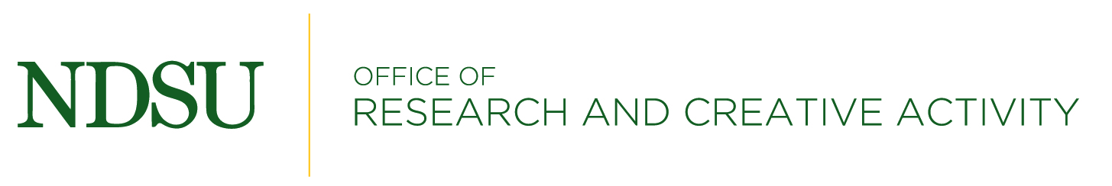
Resource Info provided by Carol Renner, Communications Manager, NDSU Office of Research and Creative Activity – carol.renner@ndsu.edu
10115

