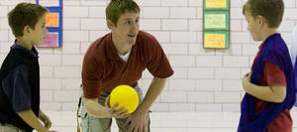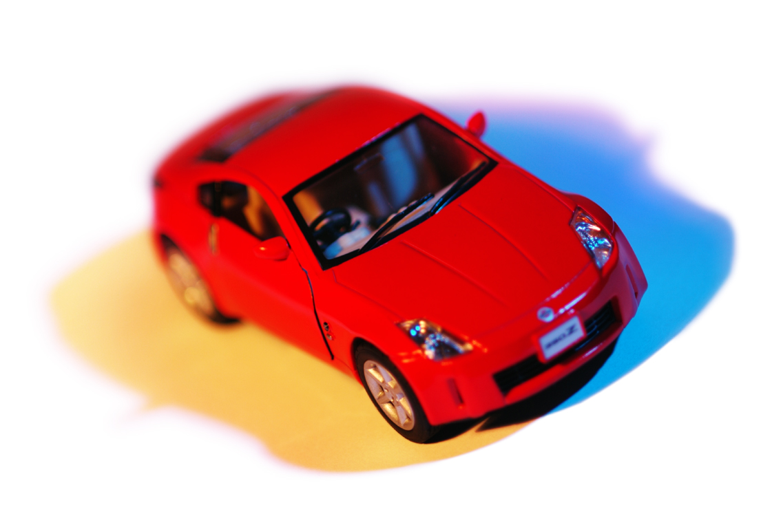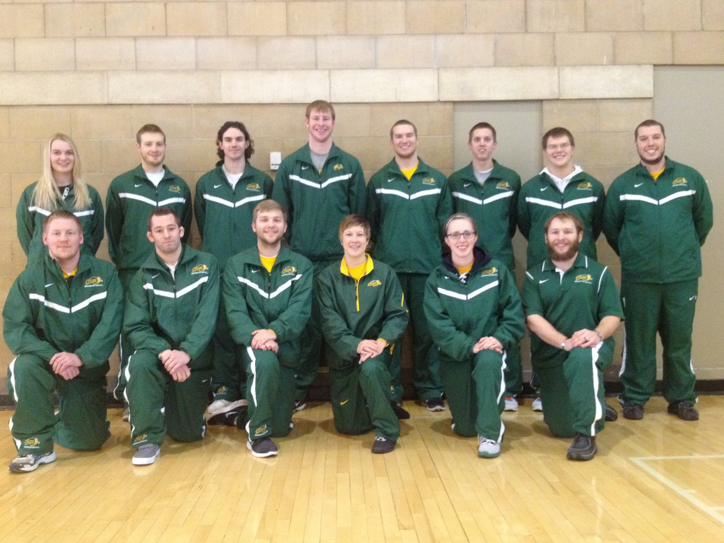

**Program Director Info:**

**Dr. Jenny Linker**

***email:*** Jenny.Linker@ndsu.edu

***phone:*** 701.231.8676

***mail:*** Dept. 2620, PO 6050, Fargo, ND 58108-6050

**Sept. 25**

**Oct. 2, 9, 23, & 30**

**Nov. 6, 13, 20, 27**

**Dec 4**

**\*11:00 a.m. - 11:45 a.m.**

**\*11:45 a.m. - 12:30 p.m.**

**NDSU Bentson-Bunker Field House**

#### **Times**

#### **Dates (Tuesdays)**

#### **Location**

**Total cost for all 10 sessions:**

**$10/child; $20 max/family**

#### **Cost**

#### **Program Details**

**We hope that you and your families will be able to join us for the upcoming Fall semester! The philosophy of the program is to provide children with enjoyable, age-appropriate physical activity experiences in an emotionally and physically safe environment. Our Fall 2018 program emphasizes motor skill development and personal success.**

# **Welcome to the 7th Year of NDSU’s Let’s Move in Homeschool Program!!!**

### **First Session is Sept. 25th**

**Let’s Move in Homeschool**

**FALL 2018**

Fall 2016

1. Please arrive 15 minutes prior to your child’s first class.
2. Enter Bentson Bunker Field House from the south entrance.
   1. All parents must check-in and sign the HIPAA receipt list. You will receive a copy of the HIPAA form.
   2. Submit waiver forms (if they haven’t been emailed or mailed yet).
   3. Have child find his/her name tag (organized by group).
   4. Bring child to his/her gym space at specified start time (Bears and Monkeys are on the south side of the gym; Lions and Dolphins are on the north side of the gym)
3. **At the end of the class:**
   1. Teachers will separate their students into two groups – those who have parents in the gym and those that will be picked up outside
   2. Parents in the gym
      1. Go over to your child’s teacher at the end of the class and “pick-up” your child – be sure their name tag has been returned.
   3. Parents picking up outside
      1. Park along the west side of the building (facing north) and your child’s teacher will walk them out to you.

# **1st Day Instructions**

### **Session Times**

### **11:00 a.m. - 11:45 a.m. & 11:45 a.m. - 12:30 p.m.**

Children’s lesson times are determined after all enrollment requests are received. Please check the “Homeschool Groups Fall 2018” email attachment for each child’s group and time of lesson. This email will go out by Sept. 14th. The program director scheduled families with convenience in mind.

**Parents are responsible for children until they have checked in and received their name tags each day. We are short-staffed this semester and cannot greet children at the outdoor drop-off point. If you are planning to drop-off your child(ren), please follow these procedures: Cars will enter from Centennial Blvd. and travel north on College St. Cars should pull over on the west side of Bentson-Bunker Fieldhouse (BBFH) to drop-off children. It is important that drop-off does not occur from vehicles headed south on College St. as we do not want children crossing the road. Cars are *not* allowed to park along the side of BBFH and drivers must remain with their vehicles. Pick-up procedures will be the same. By following this protocol, you will help prevent traffic congestion and keep our children safe. If you plan to have someone else pick-up your child(ren), please provide a signed note during drop-off.**

**At the end of each class, teachers will divide their group into two (those whose parent are in the gym and those that need to be walked outside to the pick-up location). Parents in the gym need to walk over and check-out their child. Staff will walk outside with the remaining children and stay with them until parents have picked them up at the pick-up/drop-off location.**

**Thank you in advance for your cooperation!**

# **Parking**

**During the program, families may park in pay lots (cash, debit, or credit) on campus. On the attached campus map, these are marked as “WE,” “SU,” and “Visitor’s Lot E.” BBFH is building “10” on the map.**

### **Drop-off/Pick-up Procedures**

### **Meet the Staff!**

# **What Should My Child Bring?**

**Children should be dressed for comfortable and safe movement. All children MUST wear sneakers in order to participate in the lessons. Footwear such as sport sandals, Crocs, and flip-flops are NOT allowed. Children are encouraged to bring their own sealable water bottle (no glass please). *We highly encourage parents to bring their child(ren) to the restroom prior to instruction.* If your child needs to use the restroom during instruction, parents may be asked to escort their child to the restroom if present.**

Fall 2016

**Instruction is provided by senior-level physical education majors who are appointed to each group of students. Dr. Jenny Linker will oversee daily operations.**

# **Allergy Alert**

**Due to food allergies, please refrain from bringing peanut-containing products to the gymnasium.**

**Parents and siblings are welcome to stay and watch during the program. Designated seating is provided. For liability reasons, all observers must stay in the designated seating area and are not allowed in the instruction area. In addition, parents are responsible for supervising children not in class– running and horseplay is not appropriate in this area. Parents and observers are not allowed to take videos during the program. Pictures may be taken, but only of your child (staff and other children should not be included unless permission has been gained). There will be an opportunity to take group photos on the last day of the program.**

# **Can I: Stay and watch? Take pictures? Take video?**

Fall 2016

# **Program Video for Educational Purposes**

**The NDSU Let’s Move in Homeschool Program reserves the right to video-record all lessons. Lesson videos are an essential component of the teacher candidate reflection cycle. These recordings are for educational purposes only and are not used in any other manner, shared, or published.**

# **Program Photos for Promotional Purposes**

# **The NDSU Let’s Move in Homeschool Program will take photos for program promotion. Children will not be named in any photos used for promotional purposes without receiving prior approval from parent/guardian. If you prefer we not include your child in promotional photos, please complete and return the “Promotional Photo Non-Permission Form” on the last page and return it on the first day of attendance.**

# **NDSU LMIHS**

# **Promotional Photo Non-permission Form**

**Only return this form if you *do not* want your child(ren) photographed for promotional materials. Children’s names will not be used in promotional materials.**

**_____ I do not want my child(ren) photographed during lessons for NDSU LMIHS promotional purposes.**

**Child(ren) Name(s):**

**__________________________ __________________________**

**__________________________ __________________________**

**Parent Name:**

**__________________________**

**Parent Signature: Date:**

**__________________________ __________________________**