Professional MATrg Faculty

Shannon David, PhD, ATC, LAT, ROT
Assistant Professor
Coordinator of Clinical Education
Office phone: 701-231-5686
Shannon.david@ndsu.edu
Research areas: Patient Clinician Relationship and Intervention Outcomes

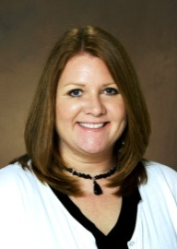 | Kara Gange, PhD, ATC, LAT  Associate Professor  Post-Professional Program Director  Office phone: 701-231-5777  kara.gange@ndsu.edu  Research areas: Therapeutic modalities and Diagnostic Ultrasound
Nicole German, PhD, AT
Assistant Professor of Practice
Professional Program Director
Office phone: 701-231-8624
Nicole.german@ndsu.edu
Research areas: Critical Thinking

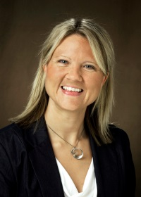 | Katie Lyman, PhD, ATC, LAT, NREMT, CKTI  Assistant Professor  Office phone: 701-231-8208  Katie.lyman@ndsu.edu  Research areas: Kinesio Tape$®$, Affective Domains, and Emergency Medicine

