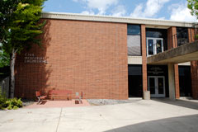
The purpose of the IME Recognition of Excellence program is to recognize individuals who have achieved service or professional excellence in concert with their relationship with the IME Department. The primary form of recognition will be a public display of the individual’s achievements housed in the IME Department. This “wall of IME excellence” will provide a direct motivational benefit to current and future IME students by providing a historical perspective of the department and a vision of what they may achieve in their own careers.

Categories for Nomination
- IME Alumni with distinguished career and professional achievements
- Individuals that have made significant service contributions to the IME Department
- IME Alumni that have made significant service contributions at the community, state, or societal level.

Nomination Procedure
- Nominations will be open to all
- Self-nominations is allowed
- Nominations will include completing the nomination form
- Nominations will include a 1-2 page(s) letter identifying category under which the individual is being nominated and an outline of the individual’s accomplishments
- Nominations are renewed every year

Selection Process
- Recipients (0-3 per year) will be selected by the majority vote of the Advisory Board from a short list of nominees prepared by the committee.
- Nominations for spring recognition are reviewed in fall and nominations for fall recognition will be reviewed in spring.

Recognition
- The IME department will recognize the recipients by presenting their photo and a summary of their accomplishments on the “Wall of Excellence” located in the department.
- The recipients will also be recognized on the IME department website under the Advisory Board site.
- Recipients will also be recognized in the college, university, and community publications or news papers.
- The Advisory Board may choose to recognize the recipients with a plaque
- Recipients need not to be present to be recognized.

Fall 2010 Recipients
Inside. . . .
2 Fall 2010 Recipients
3 Fall 2009 Recipients
4 Spring 2009 Recipients
5 Fall 2008 Recipients
6 Spring 2008 Recipients
7 Fall 2007 Recipients

Industrial and Manufacturing Engineering
Recognition of Excellence Award

James Anderson
Jim Anderson graduated with a BS Industrial Engineering from NDSU in 1983. Jim has spent a majority of his professional years in leadership roles in the technology industry. Jim worked for Andersen Consulting for 9 years and in the software industry for 18 years for JD Edwards, PeopleSoft, Lawson Software and Healthland. Jim’s Industrial Engineering education provided an excellent foundation for applying business acumen, process methodology and people management skills to the technology industry. Jim has had the opportunity to lead large global organizations, work with significant M&A integration activities and drive business transformation in a rapidly evolving industry.

Jim was instrumental in helping create a significant job placement program between Andersen Consulting and NDSU. Once this program was launched, Andersen Consulting became the largest employer or IME students over the next 15 years.

Jim lives with his wife (Mary) and twins (Jack and Emily) in Minnetonka, Minnesota.

Jodi Uecker-Rust
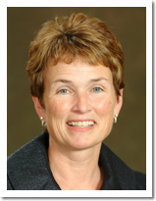
Microsoft veteran Jodi Uecker-Rust came out of retirement in 2008 to become President of Sage Business Solutions. Jodi is what could be termed a “heavy hitter” in the world of accounting software. Ms. Uecker-Rust was previously corporate vice president of Business Solutions with Microsoft and COO of Great Plains Software. For a period of time she was very widely considered to be the # 2 in command behind former Great Plains leader Doug Burgum. Jodi retired early from Microsoft in 2004 to devote time to non-profit organizations.

Fall 2009 Award Recipients

John Hansmann
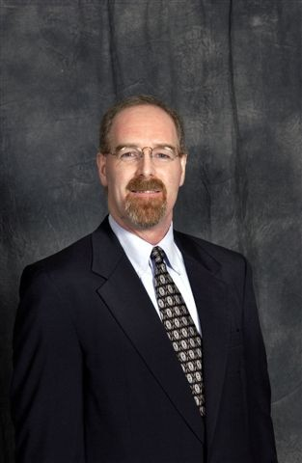
John Hansmann, MSIE, CPHIMS, FHIMSS, DSHS is currently the Director of Labor Management & Productivity for Tenet Healthcare Corporation, a 49 hospital for-profit health care system based in Dallas, TX. His current focus is the development and implementation of the labor management system across Tenet Healthcare. Prior to Tenet, Mr. Hansmann worked for Intermountain Healthcare, Salt Lake City, Utah as the Urban South Region Manager of Management Engineering. He has almost 25 years of healthcare experience in operations, productivity management, strategic and IT analyses. He has expertise in the development of standardized nursing care models and staffing practices, optimizing patient throughput, and leading workflow analysis. Mr. Hansmann is a frequent speaker on the effects and implications that technology has on clinical operations.

Mr. Hansmann is a Fellow of the Healthcare Information and Management Systems Society (HIMSS.) He is a past Board member and former chair of the Board Finance Committee. Prior to his Board experience, Mr. Hansmann served on numerous committees, and has been an annual conference paper reviewer/coach and presenter many times. Mr. Hansmann is the author of two chapters in the HIMSS Guidebook Series: Management Engineering and one chapter in the Performance Improvement in Hospitals and Health Systems book on management engineering and process improvement in healthcare. In 2002, he received the prestigious HIMSS Leadership award. Mr. Hansmann is also a senior member of the Institute of Industrial Engineers (IIE) and Diplomat within the Society for Health Systems (SHS), a society within IIE. He has served in many different roles in IIE and SHS, culminating with being the national President for SHS in 1999/2000.

Mr. Hansmann currently serves on the Advisory Board for the school of Industrial Engineering at North Dakota State University. He is a frequent speaker at student chapter events, guest lecturer in the classroom and was the keynote speaker at the senior Capstone Banquet in April 2005. Mr. Hansmann also is the past chair of the Logistics Committee for the Susan G. Komen Foundation Race for the Cure event in Salt Lake City.

Mr. Hansmann received his BSIE and MSIE from North Dakota State University.

Spring 2009 Recipients

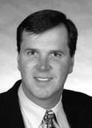
Jeff Bigger
Jeff is the President and Owner of Massman Automation Designs, LLC, in Villard, Minnesota, a company in transition from a small, stable, one-product, domestic company to a growth-oriented, multi-product, international company.

Jeff had held previous management positions with Brenton Engineering, Douglas Machine, Andersen Consulting and Arthur Andersen.

His areas of expertise include Operations Management, Strategic Planning, Mergers and Acquisitions, Sales and Marketing Management.

Jeff received his B.S. in Industrial Engineering from North Dakota State University in 1990. In 1996 he attended the Minnesota Executive Program at the University of Minnesota.

Jeff is active with the Twin Cities chapter of the Young Presidents Organization; he was recently elected to the Packaging Machinery Manufacturers Institute Board of Directors; and he is a former member of the NDSU-IME Advisory Board.

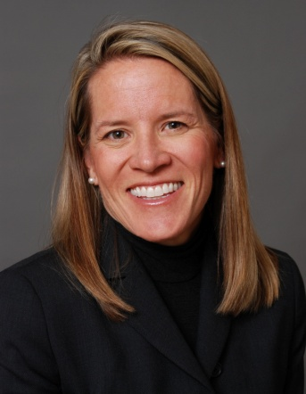
Jennifer Hopkins
Jenny is a Managing Partner at Crescendo Capital Partners, LLC, a private investment company. Crescendo targets investments in small operating businesses within Colorado.

Prior to forming Crescendo, Jenny was employed at Hewlett Packard and Agilent Technologies She has held leadership roles in all functional areas (R&D, Marketing, Manufacturing), and Executive General Management roles for hardware, software and services organizations. Most recently she was Vice President of the Global Solutions Business Unit, a $500M organization with 4 divisions and over 1500 people in 35 countries. She has led business teams in product categories ranging from Computers (workstations & servers), to semiconductors to electronic test equipment.

She is active in several nonprofit organizations including Social Venture Partners, Opportunity International, the NDSU Alumni Board and, her daughters Charter School. She is also currently serving on the Colorado State Board of Community Colleges and Occupational Education.

Hopkins holds a bachelor's degree in Industrial Engineering from North Dakota State University, and master's degree from Stanford University.

Jenny lives in Niwot, Colorado with her husband, Mark, and two teenage daughters. She is an active ultra runner, golfer and downhill skier.

Fall 2008 Recipients

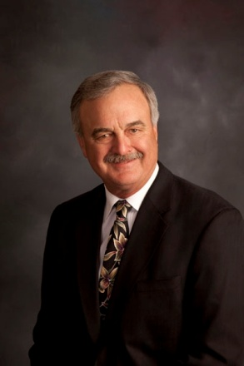
Paul Madson
1966, Graduated BS, Industrial Engineering
1966, Went to work at ALCOA as IE
1968 , Became (drawn tube) division head IE
1970, Moved to Fargo and joined Border States Electric in Inside Sales
1972-77, Border States Salesman
1977, Became Partner and Manager for Border States
1984-2002, President and/or CEO of Border States
2002, Retired at ripe old age of 58!
Border States now has 59 branch locations and is the 10th largest electrical distributor in the country. It is 100% owned by the employees through an ESOP (Employee Stock Ownership Plan); headquarters in Fargo.

Lieutenant General Claude V. Christianson
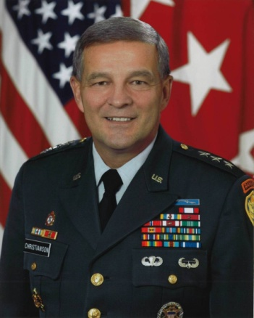
Lieutenant General Claude V. (Chris) Christianson is the Director for Logistics, the Joint Staff, Washington, D.C. He assumed his duties on October 11, 2005. Lieutenant General Christianson, a Distinguished Military Graduate of the Army ROTC program at North Dakota State University, was commissioned as an Ordnance Officer in 1971.
LTG Christianson has a Bachelor's Degree in Industrial Engineering from North Dakota State University. His military education includes the Infantry Officer's Basic Course, Ordnance Officer's Advanced Course, the Armed Forces Staff College and the Army War College. His awards and decorations include the Distinguished Service Medal, Defense Superior Service Medal, Legion of Merit, Bronze Star Medal, Meritorious Service Medal, Armed Forces Expeditionary Medal, Global War on Terrorism Expeditionary Medal, Global War on Terrorism Service Medal, Korea Defense Service Medal, Armed Forces Service Medal, NATO Medal, the Expert Infantryman's, Parachutist, Air Assault, and Army General Staff Identification Badges, and the Ranger Tab.

Spring 2008 Recipients

Brian Johnson
Brian Johnson has worked in manufacturing for 22 years in the areas of Research and Development, Manufacturing, Process Design and Leadership. After graduation, he had the opportunity to work for a small Sealy company in Phoenix, AZ which allowed him to be exposed to multiple functions, including R&D, Sales and Manufacturing. From there, he moved to Warroad, MN and accepted a position as Industrial Engineer at Marvin Windows and Doors. After 7 years, he transitioned from leading a group of 10 manufacturing engineers to Fargo with a new product line developed by Marvin known as Integrity Windows, utilizing state of the art technology in pultruded fiberglass.

Brian holds a degree in Industrial Engineering and Management from NDSU. After 12 years in industry, he went back to school and received an executive MBA from St. Thomas University in Minneapolis, MN. He’s been an active member of the IME Advisory Board for 13 years.

Brian is currently the Director of Operations for Integrity Windows and Doors as well as Infinity Windows and Doors, both Marvin Companies. Integrity has facilities in Fargo, ND, Roanoke, VA and West Fargo, ND. Infinity has a facility in West Fargo, ND.

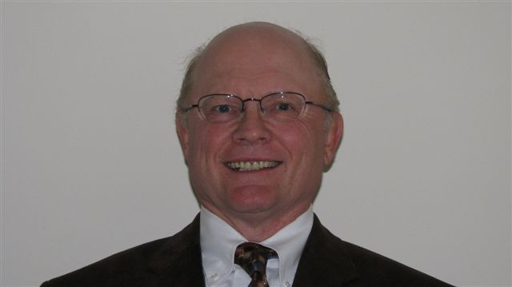
Robert W. Heller
Mr. Heller (Bob) is currently a venture capitalist owning his own company. He has an ownership stake in many types of businesses and is generally involved with those businesses on a consulting basis. Bob has had a significant amount of experience in operations management, spending a better part of his 35-year career in manufacturing. At one time in Bob’s career he served for 5 years as CEO of Advance Circuits, a public company that manufactured printed circuit boards and other interconnect solutions. He also was Chairman of the Board for two years. Currently Mr. Heller is on the Board of Directors of 3 companies and is Audit Committee Chairman of one of those. Mr. Heller has an under graduate degree in industrial engineering from North Dakota State University and masters degree in business from Purdue where specialized in operations management.

Fall 2007 Award Recipients

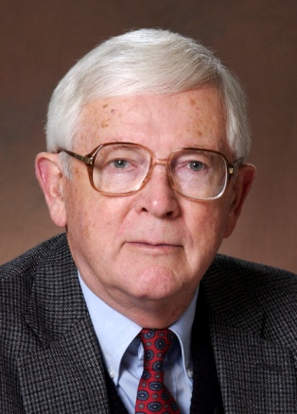
Elvin Isgrig
Elvin Isgrig did systems engineering and was a project manager in USAF for 27 years. He then taught for 23 years, developed capstone courses for companies, chaired two years in Industrial Engineering and Management at NDSU, and helped Computer Sciences and Software Engineering for two years. Introduced, organized, and facilitated capstone experiences for students in teams (over 100 client projects). That was after beginning an academic career as Dean of Defense Acquisition University (Defense Systems Management College, now DAU). Holds degrees in Industrial Engineering & Management (IE&M), Aeronautical (AE) and Mechanical Engineering (ME), and studied for an academic year with the Boeing Company in a formal Education-With-Industry program in Astronautics and Space Vehicles.

Over two decades were spent conceiving, proving, producing and supporting high technology devices and systems: (1) products: airplanes, sensors (cameras, television, lasers, radar and infrared), missiles, spacecraft and simulators, and (2) global systems for communications, reconnaissance, logistics, training, and testing. Retired from USAF in the grade of Colonel.

For ten years he served as Director of Educational Services for the Project Management Institute (PMI) and taught project management in companies in the US, Europe, and Australia, while a full-time faculty member at NDSU. He was recognized as a Fellow in PMI. During that time he conducted surveys of educational needs for a broad range of industries and developed, or hired, instructors for scores of short courses and seminars offered.

Brigadier General (Retired) Allen J. Henderson

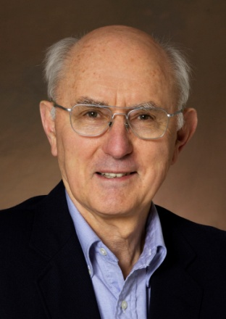
Brigadier General Allen J. Henderson is the chief of staff, North Dakota Air National Guard. He graduated from Fargo Central High School in May 1955. He graduated from North Dakota State University, Fargo, ND in 1961 with a Bachelor of Science degree in mechanical engineering. He was a graduate assistant in the mechanical engineering department from 1961-1962. He received his Master of Science degree in engineering valuation from Iowa State University, Ames, Iowa in 1965 and his doctor of philosophy degree in industrial engineering in 1968. His military education includes the National Security Management Course in 1984.

General Henderson began his military career in 1954 as an enlisted member of the North Dakota ANG, and in January 1957 he was commissioned a second lieutenant. General Henderson was promoted to and federally recognized as a brigadier general on March 14, 1996. He is a command pilot with over 3,800 hours in the C-130A, T-33, F-4, F-101B/F and the F-102 aircraft.

In his civilian life he has served as chairman and professor, Department of Industrial Engineering and Management, North Dakota State University, since 1978. General Henderson is also a consulting engineer. He has been a registered professional engineer in the state of North Dakota since 1975. From 1975 to 1978, he was assistant to the president at North Dakota State University, and acted as a coordinator and liaison to all academic areas. From 1969 to 1975, he was an assistant and associate professor of industrial engineering.

