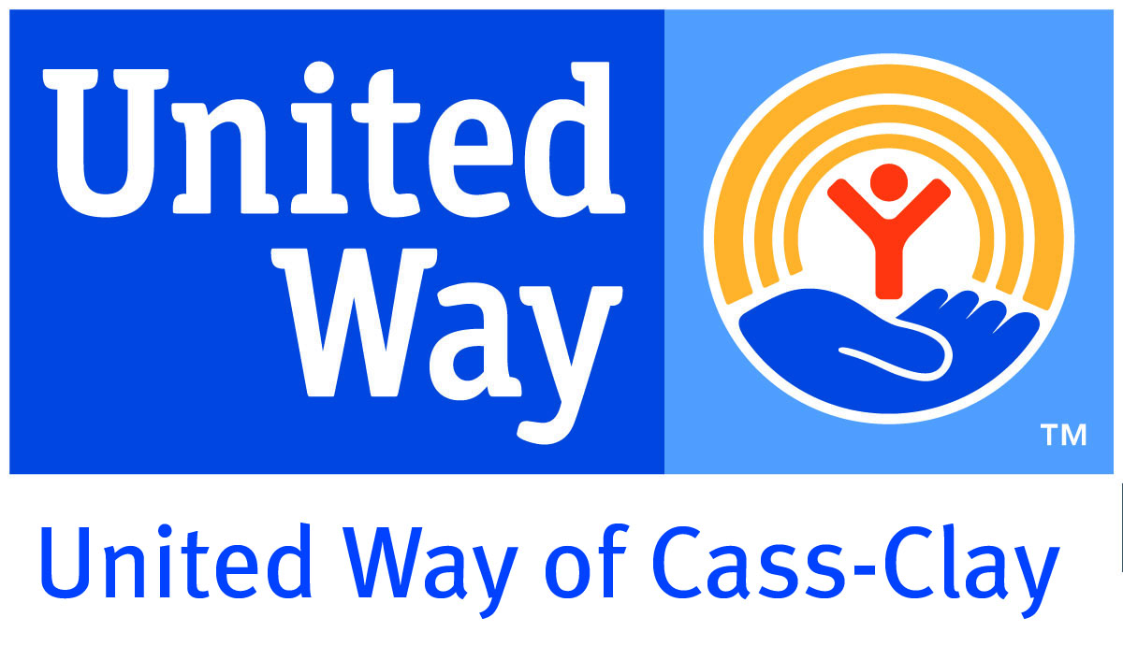

You Are Needed
Today’s Date: February 27, 2012
Publication Date: March 4, 2012

Massage Therapist
Hospice of the Red River Valley is looking for licensed massage therapists to give one massage a week to their patients. Days and hours are flexible and will work around the volunteer and patient’s schedule.

Exercise Transport Aide
Eventide in Moorhead is looking for individuals and older adults to greet residents in their room and provide transportation to the therapy room. The Exercise Transport Aide would also visit casually and provide transportation home. Volunteers are needed one or more days a week from 2:30-4:00pm Tuesday – Friday.

Heart Warmer
Ronald McDonald House Charities needs ‘Heart Warmer’ volunteers once a week (M-F), for two hours between 9am and 5pm to assist guests and guest staff.

Arts & Crafts Volunteers for the Celtic Festival
Fargo Park District is seeking individuals or groups ranging from 2-30 people over the age of 14 to assist children with various arts & craft projects including Celtic Shields, Greeting Cards, Celtic Knots and more. Volunteers are needed for the 9:30am-1:30pm and 1:00-5:00pm shifts on March 17, 2012 at the Hjemkomst Center located at 202 1st Ave N, Moorhead. The actual event hours will be from 10am-4pm.

Greeter for the Celtic Festival
Fargo Park District is looking for volunteers to be stationed at the front door and welcome people into the Celtic Fest. Greeters must be at least 14 years old. They will also use a counter to keep attendance and assist people with information about the activities available at Celtic Fest. Greeters are needed for the 9:30am-1:30pm and 1:00-5:00pm shifts on March 17, 2012 at the Hjemkomst Center located at 202 1st Ave N, Moorhead. The actual event hours will be from 10am-4pm.

Shelter Volunteers
The local shelters need assistance to get the shelter ready for the evening by putting down mattresses and so forth. They also need volunteers to provide oversight for individuals preparing to shower, to be present in the sleeping areas, and to clean up the area in the morning.

Gift Shop/Coffee Shop Attendant
Eventide is looking for two types of volunteers. Gift Shop Attendants: run merchandise sales on cash register and assist shoppers as needed with cards and gifts. Crossings Café Attendant: run coffee/snack and merchandise sales on cash register and assist shoppers as needed with cards and gifts. They will train volunteers on cash register. They are looking for individuals to help out one to five days a week or month from 10:30-1:30 or 1:30-4:30 at Eventide in Moorhead or 1:30-4:30 at Eventide at Sheyenne Crossings in West Fargo.

Retail Specialist
HERO is looking for individuals to assist customers and design displays of HERO product (wound care, personal hygiene, mobility items, etc.) Volunteer hours vary and HERO is open Monday-Friday 9am-5pm.

Food Distribution and /or Food Order
Dorothy Day Food Pantry is in need of volunteers to help clients with picking up food, stocking shelves, unloading food orders, and shelving the food orders. They are in need Monday-Thursday 11am-4pm and 6-8:30pm. Volunteers should be age 10 or older.

Big Brothers
Big Brothers Big Sisters is looking for male volunteers. Volunteers are asked to make a one year commitment and meet with a child every other week to participate in a variety of activities.

Meal Delivery Volunteers
Valley Senior Services is recruiting volunteers to assist with meal delivery in North, South, and West Fargo. It is about an hour time commitment and would be for the noon meal. Volunteers deliver the meals to homebound elderly in our community.

