M
Pathways to Nursing:
Sharing Our Journeys
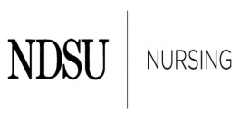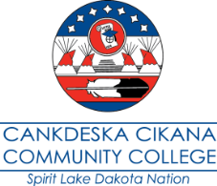
Tuesday, May 20, 2014, Heritage Center, Bismarck, North Dakota
Wednesday, May 21, 2014, Ramada Inn, Bismarck, North Dakota

Registration Form
Registration deadline May 15, 2014

First name: Click here to enter text.
Middle name: Click here to enter text.
Last name: Click here to enter text.
Address: Click here to enter text.
City: Click here to enter text.
State: Click here to enter text.
Zip code: Click here to enter text.
E-mail address: Click here to enter text.
Phone number: Click here to enter text.
Name of company: Click here to enter text.
Job title: Click here to enter text.
Will be attending the full conference ☐
Will be attending only one day ☐
Which day? Click here to enter text.
Will be attending the Tuesday evening traditional dinner ☐
Will you need a vegetarian choice ☐
Registration form submission options:
Email to - Loretta.heuer@ndsu.edu,
Mail to - Loretta Heuer, PhD, RN, FAAN, North Dakota State University, Department of Nursing
Department 2670, PO Box 6050 / Fargo ND 58108-6050, or Fax to - 701.231.6257

For questions please call Loretta Heuer at 701-231-8205 or 701-238-8484

