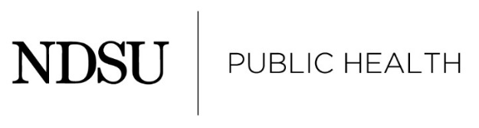
PRACTICUM ORGANIZATION, preceptor, and Student Agreement form
- Names
- Student ID
- Email addresses
- phone
- Title of Project
- Address and location of organization
- Background
  - Host Organization and Its Public Health Mission
  - Preceptor’s Role in Host Organization
  - Practicum’s Contribution & Importance to Host Organization
- Project Description
  - Synopsis of the problem, issue or situation
  - Detailed description of the two deliverables/products

Is this a research project that will require IRB approval?
Yes No Not Sure
- Roles, Responsibilities, and Resources
  - Roles and responsibilities of all personnel (student, preceptor, etc)
  - Resources need for the project and who will provide them

In order to assure all visa requirements are followed, international students must consult with NDSU’s International Student and Study Abroad Services before agreeing to accept a stipend or any form of payment for completion of the practicum

- Communication and Scheduling Expectations
  - Communication plan
  - Schedule expectations
  - Will you be working on-site or remotely? (Students should make it a priority to be on-site or be present at a site as often as possible for the best experience)
On-site Remotely Some of both
- Contributions to MPH Learning
Must demonstrate attainment of at least five competencies, three of which must be from the foundation. Competencies will be assessed through the two submitted deliverables/products.
- Timeline
  - Measurable objectives
  - Realistic timeline to complete deliverables
Use this outline to draft your project description and then enter into this docusign form to collect signatures.

