Campus Solutions Training Guide
Faculty/Advisor Homepage

Faculty and Advisors will have their own homepage when logging in.
The homepage gives faculty and advisors quick access to the Faculty and Advisor Centers.

Select the My Advisees tile to open the My Advisees page, where you can:
- View a list of your advisees in either grid or tile format. You can view the advisee’s name and ID, and the committee for the advisee.
- Email your advisee by clicking the corresponding ID.
- View your advising notes for each advisee on the Advising Notes page. On this page, you can create an advising note, or select the drop down button below the page title to view data for other advisees or students.
- Notify one or more advisees by selecting the corresponding Notify check box. You can also select the Dropdown button below the page title to select notification options, or navigate to the Advising Note page.
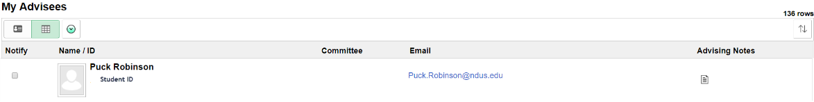
Grid View

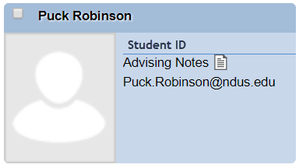
Tile View

Select My Advising Notes tile to open the My Advising Notes page, where you can:
- Search for and view the notes you have created or that have been assigned to you.
- View, create, and update notes for other students by clicking the View data for other students button.

The Faculty Center tile provides access to the Faculty Center area that is located under Self Service. This will allow for a user to access their Schedule, Class Roster, and Grade Roster.

The Advisor Center tile provides access to the Advisor Center area that is located under Self-Service. This will allow for a user to access their advisee lists, Advisee Student Center, and other pertinent information related to advising.

The Information Center tile provides information on planned Campus Connection Outages, other related announcements, and Help Desk contact information.

