Cost Share

Cost Share – portion of costs not covered by the sponsor
Cash Contributions – represent cash outlay
  - Waived Indirect Costs
  - Salary paid by other NDSU (non-federal) funds
  - Tuition Waivers
  - Supplies, etc.
In-kind Contributions
  - Non-Employee volunteer labor
  - Meeting facilities
  - Performance of services at a reduced cost
3rd Party
  - Contributions given by an individual or group outside NDSU AND outside the sponsor agency. Can be Cash match or In-kind (non-cash).
    - personnel effort/services, supplies, materials, etc.

As a reminder, if cost share isn’t ‘REQUIRED’ in the proposal, don’t include it in the budget and budget justification.
Voluntary Cost Share
- Contribution to a sponsored project but not required as a condition of obtaining funding
- Committed (if it’s in the budget it’s committed): cost share must be setup, tracked and reported (example: the PI commits 20% of his/her time during the academic year with no compensation. The 20% effort must be captured during the academic year.)
- Uncommitted: Report by “writing in” the award/project # and the % of effort on the PAC, certify and submit to GCA
Mandatory Committed Cost Share
- Contribution to a sponsored project that is a requirement of receiving the award, such as the sponsor requires a 25% match of the award.

Effort Certification
Reason for Effort Certification
The University receives federal funding on sponsored project agreements and is required to comply with the Uniform Guidance, 2 CFR 200, which states that the University has a system in place for certifying salaries and wages associated with federally sponsored agreements. The UG stipulates that the personnel activity confirmation reports should reasonably reflect effort allocated to the activities for which the employee is compensated and that they are to be signed by the employee, principal investigator or responsible official(s) using suitable means of verification that the work was performed.
REMEMBER:
- 100% is 100%
- There are no nights and weekends
- All your activities must add up

Who Needs to Know About Effort Certification?
Employees who are compensated in whole or in part by sponsored projects or who are involved with the administration of sponsored agreements should be familiar with effort certification. This includes central and departmental sponsored project administrators, deans, chairs, principal investigators and other sponsored research personnel.

Explanation of University Compensated Effort
University compensated effort includes research, teaching, administration, clinical activity, service, and any other activity for which an individual receives compensation of salary, wages, additional salaries and overloads from the University. University compensated effort must be reasonable, allowable and allocable to the sponsored research in order to be properly charged and certified to the sponsored program. For example, it may be inappropriate to charge or certify costs to a sponsored agreement for time spent preparing a proposal for an unrelated or competing agreement because such costs would not be allocable to the sponsored agreement.

Personnel Activity Reports (PAC)
The technical name for the effort certification forms used at NDSU are Personnel Activity Confirmation (PAC) Reports. These reports list the Project ID, Fund Code, Dept. ID, Salary Paid (%), Effort (%), and Cost Share (%). Certification of this report requires that the principal investigator, department chair, or someone who has first had knowledge of the project sign, date, and print name at the bottom of the report and return it to the Grant and Contract Accounting within the defined deadline. Signing the report confirms that effort, as certified, reasonably represents the effort expended during the period. If the PAC has multiple departments listed and you are only signing for yours, please indicate that on the report so it can be sent to the other departments for their certification as well.

Frequency of Certification
NDSU has three effort reporting periods which follow the University’s semester schedule:
August 16 – December 31
January 1 – May 15
May 16 – August 15
Approximately 15 days after each effort reporting period, the NDSU Grant and Contract Office will generate effort certification reports which are to be reviewed, signed, and returned within 30 days after the department receives them to avoid audit issues.

Corrections to the Effort Certification Report
Actual effort should be closely monitored throughout the life cycle of each award and significant changes to estimated effort calculations should be made as soon as they become known. If the information shown on the PAC is incorrect, the employee is to make the appropriate changes to the form and indicating a retroactive distribution form (retro) will be processed. Do not sign the PAC but return it to the Grant and Contract Accounting Office and submit all proper documentation for the retro to be processed. Once the retro has been approved and processed, a new PAC report is generated and sent out for the required signatures.

Calculation of the Effort Percentage
The effort certification report accounts for 100% of all effort for which the University compensates the individual. Even where the number of hours of effort the individual expends each week substantially differs from the “normal” workweek of 40-hours, effort percentages must be based on total effort, not hours.
Keep in mind that these reports show an average effort percentage over the time period of the report. For example, if your effort report is for the time period of May 16th through August 15th (six pay periods), and you are showing 10% effort for the first three pay periods of this report and 0% effort for the last three pay periods of this report, your report will show 5% effort (as it is taking the average of the six pay periods).
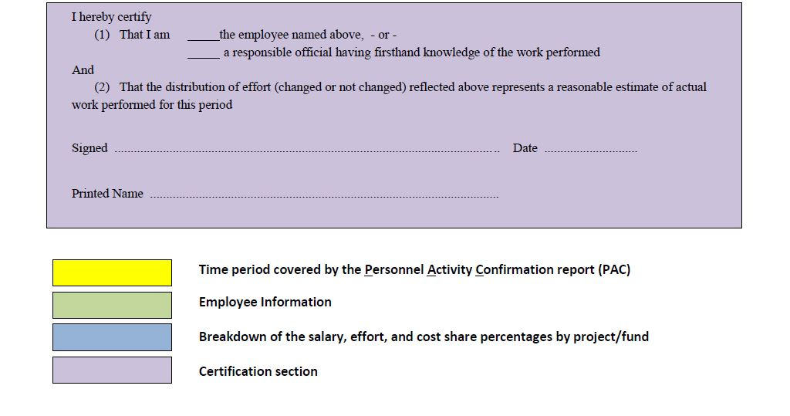
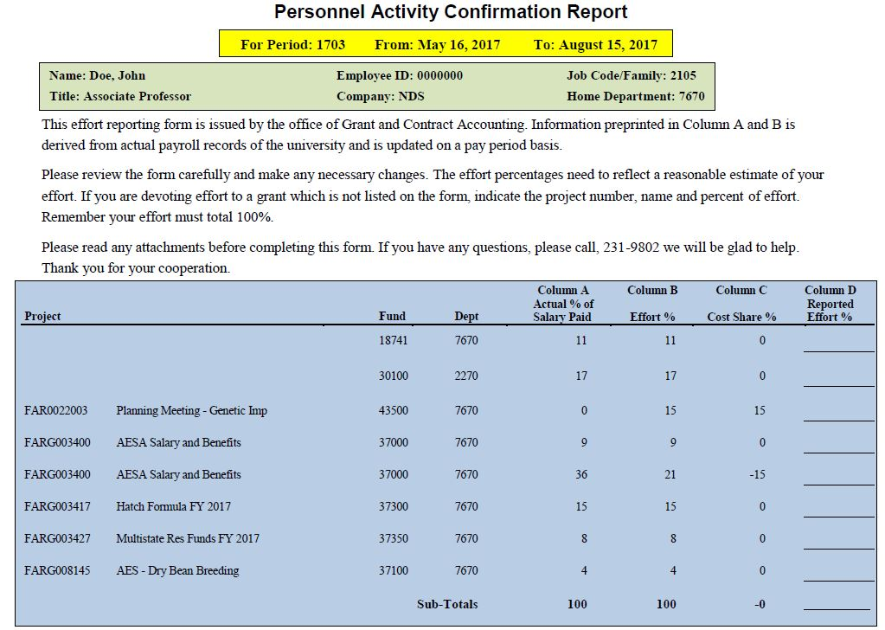
How to Read Your PAC

THE TOP 10 THINGS A P.I. (AND OTHERS) SHOULD KNOW ABOUT EFFORT REPORTING
- Effort is your work on a project, whether the sponsor pays your salary or not.
- When you write yourself into a grant proposal, you are committing your effort to the sponsor.
- If you reduce your effort, paid or unpaid, on a federal grant by 25% you must have agency approval. If you reduce your paid effort, you may choose to document cost-sharing so that the total effort does not decrease.
- Many activities cannot be charged to a federally sponsored project. For example:
  - Time spent writing a proposal
  - Serving on an IRB, IACUC or other research committee
  - Serving on a departmental or university service committee
- If you work on a sponsored project, you MUST certify your effort.
- Certifying effort is NOT the same as certifying payroll.
- Certifying effort must reasonably reflect all the effort for all the activities that are covered by your University compensation.
- Effort is not based on a 40-hour work week. It is not based on hours at all.
- Effort must be certified by someone with suitable means of verifying that the work was performed.
- Timeliness of effort certification is paramount. Auditors look for effort reports that are NOT certified in a timely manner - typically within 30 days after being sent out for certification.

