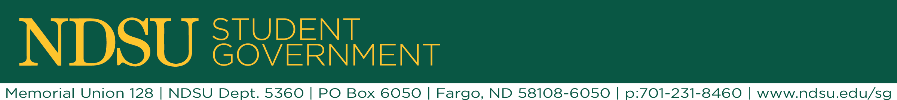
ASA Commission Agenda 11/18/15

- Table go around

- Holiday lighting – solidify locations to request

  - Two main entrances of the union (south and west)
  - The “bridge” in the engineering complex (between ECE and CIE)
  - The babbling brook

- Bike Repair Stations – Work order to have them moved into storage for the winter

  - They have been moved into storage by facilities – working with Jobey to make sure they have a permanent home in the Wellness Center

- Alumni Awareness – Meeting with Sarah Wald on Friday at 1:00 pm

- Robert Odney Award promotion – deadline to nominate is Dec 4th

  - Nominate your professors!
  - We are going to send out some listservs to make sure students have the link and know how to nominate

- Parents Day – (or family day) what do people know about it?

  - Turns out we don’t know anything about it… It isn’t a thing anymore but we will be looking into this in the future!

- NO COMMISSION NEXT WEEK!

