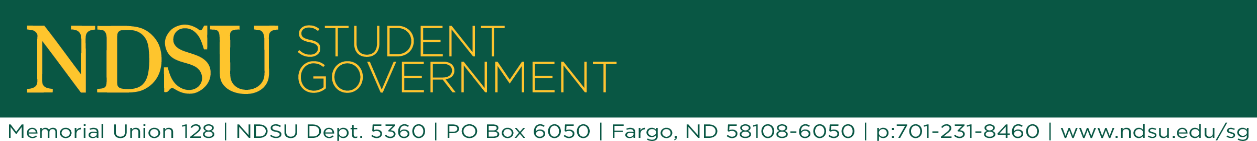
ASA Commission Agenda 01/19/16

- Table go around

- Members Present: Mackayla Headlee, Michelle Sauvageau, Jamie Behymer, Lauren Algyer, Seth Bisbee, Preston Gilderhus, Anuj Teotia

  - Favorite celeb BFFs

- Commission restructuring – we will be working on 4 main projects this semester

  - Looking for commissioners to step up and be a lead with Mackaya on each of them.
  - Commission with be an update / brainstorming session to help the leads accomplish the projects they are working on!

- Bid process meeting – update – Mackayla is staying the lead on this

  - Mackayla met with Stacey, NDSU Director of Purchasing, on 1/14 to solidify the bid process for the taxi program
  - Stacey was briefed of previous contracts and she is going to use that information to compile the new bid package
  - Once the bid is out we will review the responses and choose the company that we would like to move forward with

- Discount Cards – Michelle is taking the lead

  - Currently have 10 signed contracts
  - Possible rebrand, # of contracts etc.
  - Current contracts for 2016/2017
    - The Shack, Herd & Horns, Sweet, Sandy’s, Ruby Tuesday’s, Boiler Room, Stamart, Halberstadt’s, Moes, Sweeney Cleaners

- Undergraduate Research – Preston is taking the lead

  - Overview – compiling all undergraduate research into one database/area for students to access
  - ROPES, a program in the Math & Science Department
    - Research opportunities for engaging students

- Alumni Awareness – Lauren is taking the lead

  - Overview – has met with Stacey previously to talk about the idea
  - Going to work with Bison Ambassadors VP of alumni engagement – Kyle Knudtson

