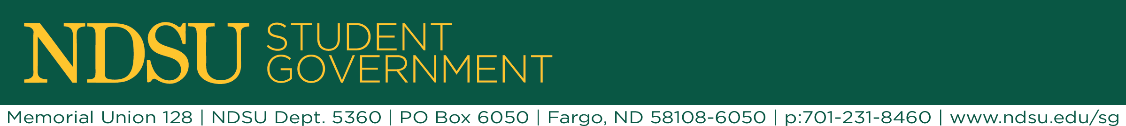
ASA Commission Agenda

- Table go around

- Uber update
  - Getting contract in place
    - Have NDSU legal department review once we get it
  - Promotion plan – working with Nikki
  - Contact table: Oct. 26th – 30th from 10 am – 2 pm
    - Reserve table this week
  - Thunder X-Press
  - Thundering Express
  - NDS-Uber
  - Campus Cruzer
  - Ready Riders @ NDSU

- Discount card
  - See Google doc for list of companies, contacts, and current contracts
  - Same contract goal October 21st
  - Feedback

- Safe walkways project
  - Identify campus locations (see campus map)
  - Contact facilities – Mike Ellingson (ask about the bike racks)
  - Downtown contact to replicate what they have…?
    - Police chief / city commissioner (Tim Mahoney) / city works / bike ped committee

- Holiday lighting – look at ASA budget to see if we can use programming money to buy more lights
  - Lead – Bri
  - Old reserve request
    - Mack needs to send to bri
  - Timeline
    - Start set up after thanksgiving
    - RR through finance November 3rd
    - RR through senate November 8th
  - Places to decorate on campus
    - Babbling brook
    - Table area by bike share
    - Bridge by engineering complex
    - Dining venters

