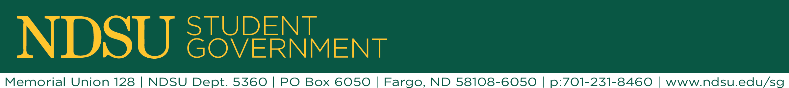
ASA Commission Agenda

- Table go around

- Uber update
  - Waiting on contract
  - New name – NDSU+Uber

- Discount card
  - Any updates?
  - Ruby Tuesday, No-Thunder Road, Sandy’s is Pending
  - Use the Google doc

- Safe walkways project
  - Mike Ellingson kind of shut me down…
  - New avenues to get something like this on campus:
    - Working of the BFU (bike friendly university) project with Preston and Spencer

- Alumni Awareness Project
  - Alumni appreciation “events”
  - Going to talk to Eric more about what he wants to see with this program…

- Holiday lighting
  - Lead – Bri
  - Old reserve request
  - Timeline
  - We currently have a programming budget of $2500, last year we spent $1350 on new holiday light inventory

