ASA Commission Agenda - Minutes

- Elect meeting minute taker – Bre Heskin
- ABSA – 2 ASA at-large members
  - Bring up at senate
  - Talk to Alvarez about whether or not is has to be an ASA senator
- Uber – working on taxi discount
  - Campus safe ride program
    - Safe ride zone: possibly cut down to reduce costs
    - Establish discount / promo
    - Register with NDSU email accout
    - It is $5 back first free ride, or $5 back for every ride?
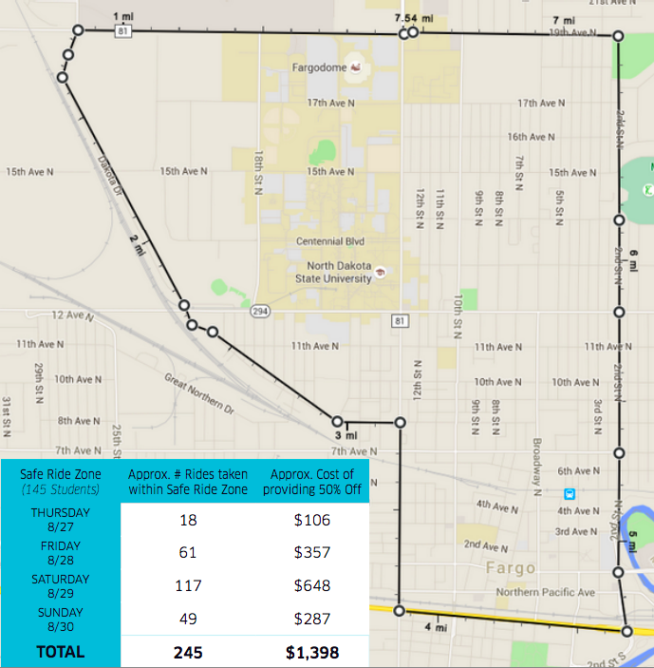
This numbers could be off – depending what we hear back from Uber
Line Item | Cost
50% discount | $1,398
$5 back per rider | $1,225
Cost for SG | $173

Herd Hauler Budget (fiscal year) ~ $13,000
Starting program in October ~ 10 month period (40ish weeks)
Weekly Budge ~ $325
Approx. Number of student riders per week ~ 230

- Deans Meetings
  - Google doc
    - Send out to senators and commissioners

Interrupted by Michael Russell. He gave us cookies.

- Speakers Database
  - Promotion
    - Faculty Listserv
    - Faculty Senate
    - Talk to Dennis Cooley, or Canan Bilen Green about how we can better promote this to the faculty
- Discount Card
  - Promotion of 2015-16 card
    - Listserv
    - 189 mentors hand out
    - Get people into the SG office
    - Bring to events – large group, IT expo, etc.
  - Brainstorming for 2016-2017 card
    - Brainstorm 5 new businesses that aren’t on the discount card already
    - Have businesses promote that they are on the discount card too

