ASA Commission Agenda – Minutes

- Commissioners present – Amelia Pfarrer and Preston Gilderhus
- Elect meeting minute taker
  - Postpone until we have a full ASA commission
- ABSA – 2 ASA at-large members
  - Meets on Monday’s at 5:00 pm
  - Postpone until we have a full ASA Commission
- Uber – working on taxi discount
  - If we need to cut down the rider zone we can cut across on 12 Ave. to 10th St and connect up to 19th Ave.
  - Amelia – student drivers?
  - FM taxi still thinks we are working with them…
    - Ask Jay for a copy of the contract. Following up with them to clear up confusion about the program still going on

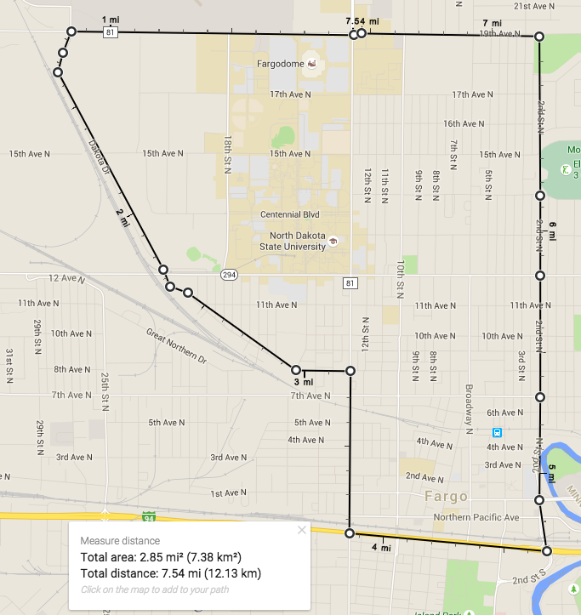

- Deans Meetings
  - Dr. Grafton, agriculture/food systems/natural resources, 9/21/15 @ 3:00 pm
  - Dr. Wittrock, graduate school, 9/22/15 @ 1:00 pm
  - Dr. Smith, engineering, 9/22/15 @ 3:30 pm
  - Dr. Schnell, health professions, 9/23/15 @ 3:00 pm
  - Dr. Schuh, business, 9/23/15 @ 3:00 pm
    - Preston is available to come, Amelia is a maybe
    - Follow up with Nick and Isaac about availability
- Discount Card
  - Consensus is to keep the discount card local
  - Next commission meeting we will compile a master list of businesses we want to ask for discounts and divide them amongst the commissioners
    - Ideas mentioned – Shack, Stamart, Heard & Horns
- Non agenda items discussed
  - Undergraduate research hub
    - Check out libraries new website for to see what they already have up there
  - Holiday lighting storage space might be taken away… Talk to Kim about finding a new space for it
  - Follow up with speakers database to make sure the alumni center has taken control of that program

