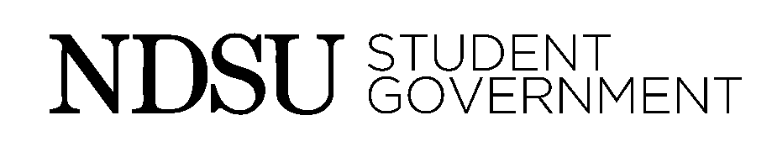
Organization Equipment Agreement Form
This agreement is established to make sure that organizations purchasing equipment assisted with funds from Student Government understand that that the equipment then belongs to Student Government and there are certain agreements that the organizational leadership must be aware of.
By signing this contract you agree to all of the following:
- Groups must take proper care of the equipment.
- Equipment must remain with the group for the duration of the equipment’s life.
- Equipment must be stored in a convenient, secure location where access is available to all members of the organization.
- If gear is damaged or goes missing, the organization will be responsible for the cost of the gear.
- Equipment reimbursed with Student Government cannot be sold. If the group dissolves or disbands, said equipment must be returned to Student Government, in which the equipment will be liquidated.
- A copy of the organization’s Member Equipment Agreement must be on file in the Student Government office.
No funds will be approved to help purchase new equipment without an up-to-date Organization Equipment Agreement form signed for that fiscal year.
More information can be found about equipment funded by Student Government Finance in the Finance Guidelines and the Organization Transitional Document on the Student Government Website (www.ndsu.edu/sg).
This agreement will last for the next fiscal year (July 1st, 2016 to June 30th, 2017). A new Organization Equipment Agreement form will have to be signed by the organization’s leadership during budgeting again next year.

__________________________________ __________________________________
Organization Name President Date

__________________________________ __________________________________
Treasurer Date Faculty Advisor Date

