The Student Fee Advisory Board (SFAB) was created with the purpose of having a unified system of reviewing proposals to increase or decrease the six mandatory fees which the University President controls: The Library Fee, Technology Fee, Student Activity Fee, Health Fee, Wellness Fee, and Career Services Fee.

This year only four of the six fees are requesting increases: The Library Fee, Student Activity Fee, Health Fee, and Technology Fee. As per state law, the total amount of fee increases must equal $2.88 per credit (up to 12 credits), which is 1% of the current, in-state, base tuition at NDSU.

Membership includes:
Title | Representative Unit | Name | Voting Status
Student Body President | Student Government | Spencer Moir | Tie Breaker
ASA Commissioner | Student Government | Lauren Algyer | Full
Finance Commissioner | SG/Student Activity Fee | Mason Wenzel | Full
Student Senator | Student Government | Klarissa Walvatne | Full
Student Senator | Student Government | Asif Arshid | Full
UG Student-At-Large | Student Body | Jason Guo | Full
G Student-At-Large | Student Body | Amy Nash | Full
Provost appointed | Information Technology | Jason Blosser | Full
VPSA appointed | Health and Wellness | Barb Lonbaken | Full
VPSA appointed | Career Services | Mark Mathes | Full
Provost appointed | Libraries | Alissa Kuntz | Full
Provost/Designee | Office of the Provost | Beth Ingram | Non-Voting
VPSA/Designee | Office of the VP SA | Tim Alvarez | Non-Voting
VPFA/Designee | Office of the VP F&A | Bruce Bollinger | Non-Voting
Budget Director | Budget Office | Cynthia Rott | Non-Voting

SFAB Process and Hierarchy:

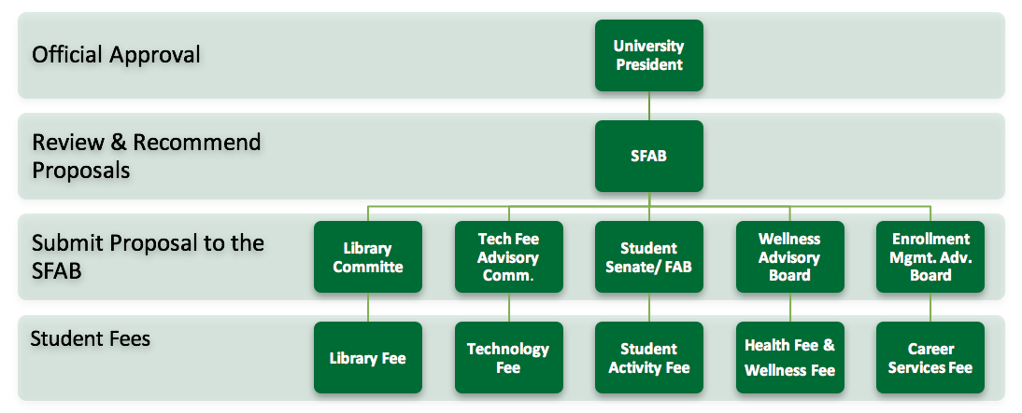

Current Fee Amounts and Proposals:

NDSU Student Fees
Fee | Contact | Current $/Credit | Increase Proposal 1 | New Total/Semester | Increase Proposal 2 | New Total/Semester
Library | Alissa Kuntz | $3.32 | $0.53 | $3.85 | $0.28 | $3.60
Tech | Jason Blosser | $8.44 | $0.91 | $9.35 | $0.63 | $9.07
Student Activity* | Mason Wenzel | $12.64 | $0.75 | $13.39 | $0.65 | $13.29
Health | Patty Dirk | $5.29 | $1.20 | $6.49 | $1.00 | $6.29
Wellness | Jobey Lichtblau | $12.56 | N/a | $12.56 | N/a | $12.56
Career Services | Mark Matthes | $1.83 | N/a | $1.83 | N/a | $1.83
Union Bond | Steve Winfrey | $3.85 | N/a | $3.85 | N/a | $3.85
NDSA | Jacob Dailey | $0.04 | N/a | $0.04 | N/a | $0.04
Connect ND | N/A | $5.50 | N/a | $5.50 | N/a | $5.50
TOTAL: |  | $53.47 | $3.39 | $56.86 | $2.56 | $56.03

*Student Activity Fee includes Athletics, Campus Recreation and Intramurals, Tier II Student Organizations, Memorial Union, and Campus Attractions

Because of the $2.88 cap for student fee increases, the State Board of Higher Education would need to approve the $3.39 increase if all of the primary proposals are granted to fee seeking entities. SFAB will take this into consideration when recommended fee increases to the President.

