Chapter 4. Tornado Recovery in Pilger, Nebraska

Kurt Mantonya and Milan Wall

Pilger, located in Stanton County in northeast Nebraska, is positioned in the northern part of “Significant Tornado Alley” (Edwards, 2016). Tornado Alley refers to a broad swath across the Plains that has a relatively high occurrence of tornadoes. Significant tornadoes are those that rate EF-2 or stronger or wind speeds of at least 111 miles per hour (Table 1). The odds for a tornado of any strength occurring with 25 miles of Pilger in mid-June are 1 percent (Figure 1). When the criteria is raised to significant tornadoes, the odds drop to 0.25 percent.

Table 1: The Enhanced Fujia Scale.
Enhanced Fujita Scale
EF Number | Strength | Wind Speed
0 | Weak | 65-85
1 | Weak | 86-110
2 | Strong | 111-135
3 | Strong | 136-165
4 | Violent | 166-200
5 | Violent | Over 200

Source: Edwards, LaDue, Ferree, Scharfenberg, Maier, & Coulbourne, 2013.

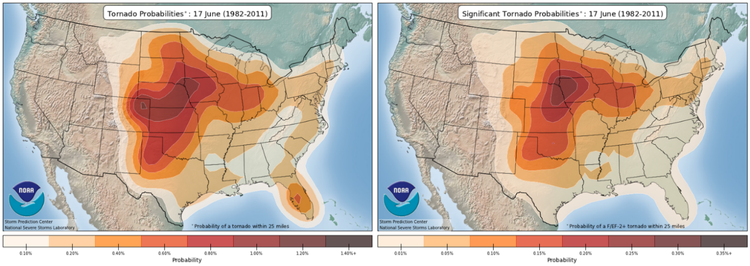
Figure 1: Probability of (a) any tornado and (b) a significant tornado occurring within 25 miles of a given location in mid-June.
Source: NWS, 2013.

On June 16th at approximately 4:00 PM twin tornadoes struck the town of Pilger, Nebraska. These tornadoes were the part of a larger outbreak of 109 tornadoes reported over the three day period of June 16-18, 2014 (Figure 2). As a whole, June 2014 turned out to be a particularly active month for tornadoes. The twin tornadoes that struck Pilger on June 16 were two of 287 tornadoes that struck the U.S., of 36 that struck Nebraska, in June that year (Carbin & Guyer, 2015; SNR, 2017). June 2014’s tornado occurrence was nearly 24 percent higher than the average 233 for the United States and 200 percent higher for the average 18 that occur in the state of Nebraska.

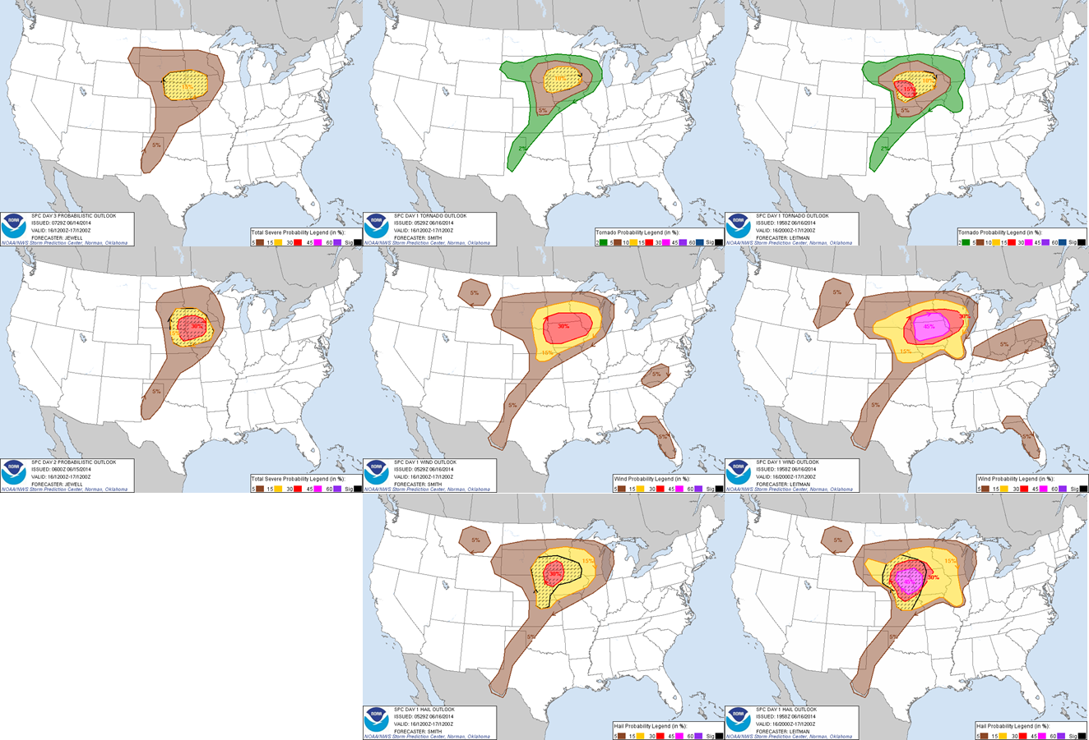

Figure 2. Probabilistic outlook.
Source: SPC, 2014.

Early Warning and Predictions
The National Oceanic and Atmospheric Administration (NOAA) Storm Prediction Center (SPC) first noted the potential for severe weather across the Plains and into the upper- and mid-Mississippi River Valley on June 9^{th.} However, the predictability of this event was too low for the SPC to designate specific areas and times for severe weather risk (SPC, 2014). By June 14th, two days out from the event, predictability had increased to where SPC was able to indicate a 15 percent probability of significant (Box 1) severe weather events across the region (Figure 2). The probability values represents the chance of severe weather occurring within 25 miles of any point. The next day, the outlook was revised to indicate a 30 percent probability of significant severe weather events.

Significant Severe Weather Event: Weather event with tornadoes rated EF2 or greater, thunderstorm wind gusts of hurricane force (74 mph) or higher, or hail 2 inches or larger in diameter.

Severe Thunderstorm: Thunderstorms that have the potential for winds in excess of 58 MPH, quarter size hail or larger, or tornadoes.

Severe Thunderstorm Watch: Issued by the SPC when atmospheric conditions are favorable for severe thunderstorm development within the watch area.

Severe Thunderstorm Warning: Issued by local NWS offices when severe thunderstorms are occurring or are imminent in the warning area.

Tornado Watch: Issued by the SPC when atmospheric conditions are favorable for the development of tornadoes and severe thunderstorms within the watch area.

Tornado Warning: Issued by local NWS offices when tornadoes, as indicated by radar or trained storm spotters, are occurring or are imminent in the warning area.

Box 1. Weather Terminology.
Source: NOAA, n.d.

Shortly after midnight on June 16th, the day of the event, the SPC outlook (SPC, 2014) indicated that very large hail, damaging winds, and isolated tornadoes were likely across much of Nebraska as a low pressure system and increasing atmospheric instability developed. At this time frame, certainty was high enough that the outlook contained individual probabilities for tornadoes (10 percent), damaging wind (30 percent), and large hail (30 percent). While a 10 percent probability for a tornado may seem low, it’s important to remember that tornadoes are very uncommon at a given location. Consider that since 1980, an average 50 tornadoes per year have occurred in 77,358 square miles in the state of Nebraska (SNR, 2017). This corresponds to an average .65 tornadoes per 1000 miles. As Figure 2 shows, the statistical odds of a tornado occurring in Stanton County are about 1 percent. Having a 10 percent probability, as on June 16th, means that that Pilger had 10 times the normal odds of a tornado occurring. These odds were high enough for the SPC to issue a Public Severe Weather Outlook and a Severe Thunderstorm Watch (Box 1) indicating a moderate risk for these hazards (hurricane force winds, tornadoes, and baseball size hail) and recommended that individuals review severe weather safety procedures and stay tuned to NOAA weather radio (Figure 3).

By 3:00 PM, the severe weather odds increased to 15 percent for an EF2 tornado or larger, 30 percent for winds greater than 75 mph, and 45 percent for hail 2 inches in diameter or larger (SPC, 2014). Within minutes, SPC issued a Severe Thunderstorm Warning (Box 1) for northwestern Stanton County and a Tornado Watch (Box 1) for the entire county. At the time, severe thunderstorms were located less than 15 miles southwest of Pilger and moving to the northeast at 35 MPH.

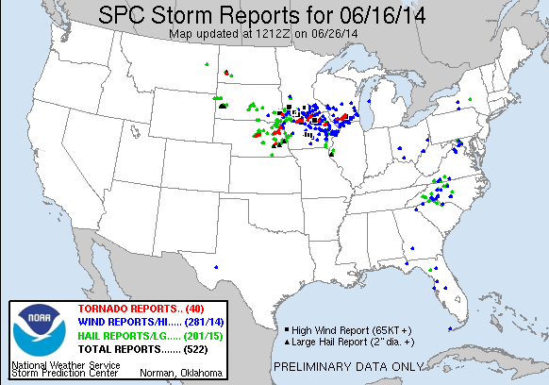

Figure 1: Storm reports for June 16, 2014.
Source: SPC, 2014.

At 3:40 PM, the Omaha NWS office issued a Severe Thunderstorm Warning (Box 1). At 3:41, 35 minutes before a tornado destroyed Pilger, Omaha NWS issued Tornado Warning for northern Stanton County in response to a radar indicated severe thunderstorm located about 7 miles southwest of Stanton (16 miles southwest of Pilger) and moving to the northeast at 35 MPH (ISU, 2016). The thunderstorm was noted to have rotation, making it capable of producing a tornado. Omaha NWS forecasters estimated the dangerous storm to be near Pilger at approximately 4:10 PM. Residents were warned to take cover immediately. Minutes later, a tornado (Figure 4) was confirmed near Stanton and moving to the northeast at 45 MPH, with an estimated arrival time in Pilger at 4:05 PM. Residents were again warned to take cover immediately. Ultimately, this was a brief (less than 2 minutes, weak tornado (EF-0) that passed to the west of Stanton and remained over open areas before dissipating (NCEI, n.d.).

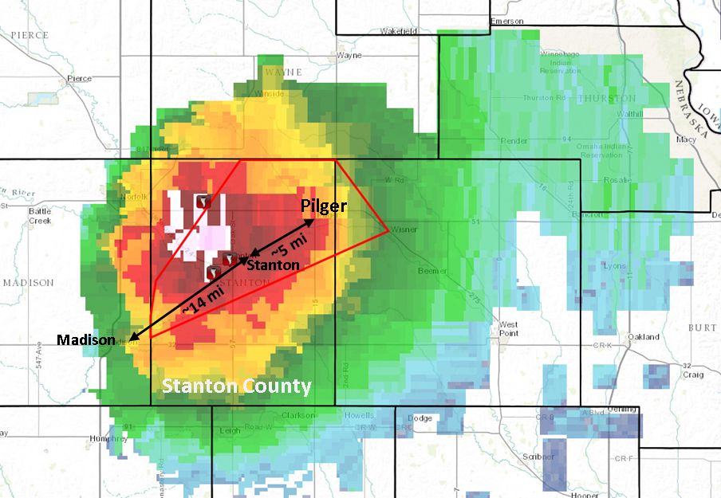

Figure 4. Counties included in the June 16, 2014 tornado warning (red rectangle) in northeast Nebraska overlaid on the radar image for the severe thunderstorm and tornadoes located near Stanton, NE. at 3:36 PM.
Source: ISU, 2016.

At 3:55, a second tornado (Figure 6) was confirmed near Stanton and estimated to arrive in Pilger around 4:10 PM PM (ISU, 2016). This tornado began to the southwest of Stanton and increased in size and intensity as it moved to the northeast. While the city of Stanton did not take a direct hit, farms, homes, vehicles, and trees to the north of town were destroyed. This tornado lasted for about 29 minutes before dissipating north of Stanton. It was later rated an EF-4 (Table 1) at its greatest intensity and caused over 2.25 million dollars in damage to property and crops (NCEI, n.d.).

At 4:02 PM, a third tornado (Figure 5) was confirmed near Stanton and was estimated to arrive in Pilger around 4:15 PM (ISU, 2016). Pilger fireman headed toward Stanton to respond to the Stanton Fire Department’s request for aid (Krause, 2014). Driving through Pilger they noticed people standing outside watching the incoming storm. As they left town, they realized that the electronic activation for the town’s siren had failed. At this point, they turned around and raced back to town and manually activated the alarm about 4 minutes before the tornado hit. Another city official took the town’s fire truck out of town so that it would be available for use after the storm (Topp, 2015). This tornado touched down southwest of town (Figure 6) before intensifying and moving directly to the northeast where it then struck the town at 4:16 PM. In 81 seconds, this tornado killed one person, injured at least 20 others, and damaged nearly 75 percent of the town’s structures, completely destroying those near the center of the tornado. The tornado continued to move northeast past the exiting Stanton County about 2.25 miles northeast of Pilger and moving into Cuming County. By the time the tornado dissipated, it had been on the ground for 46 minutes, covering 23. 94 miles (Table 2). The NWS rated this tornado as at least an EF-4 (Table 1) at its greatest intensity and caused an estimated 14.25 million dollars in damage to property and crops (NCEI, n.d.).

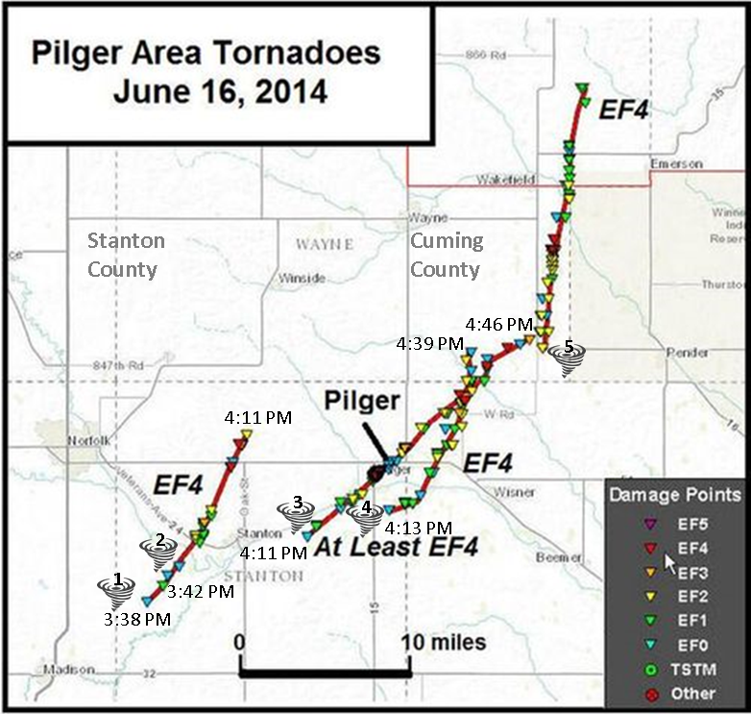

Figure 5. Pilger area tornado paths.
Source: NWS Omaha, 2014.

Table 2: A comparison of the Pilger tornado to a typical tornado.

Parameter | Typical Tornado | Pilger Tornado | Pilger East Tornado
Path length | 3.5 miles | 23.94 miles | 11.5 miles
Width | 300-500 yards | 500 yards | 500 yards
Time on ground | 5 minutes | 46 minutes | 26 minutes
Wind speed/EF-Scale | Less than 110 mph (EF-0/1) | EF-4 | EF-4
Sources: NSSL, n.d.; NWS, 2015a; Edwards, 2016.

Around 4:13 PM, as the third tornado was nearing Pilger, a fourth tornado (Figures 6 and 7) developed east of the town (ISU, 2016) and paralleled the path of the main tornado striking farm buildings, trees, and powerlines south and east of town. This tornado continued into Cuming County, eventually strengthening to an EF-4 near the moment it crossed paths with the main Pilger tornado, completely destroying two farm homes and outbuildings, lofting vehicles, debarking trees, causing one fatality, and killing over 300 head of cattle. By the time it dissipated, this tornado covered 11.5 miles in 26 minutes, causing an estimated $1.375 million dollars (NCEI, n.d.).

As Pilger’s twin tornadoes were dissipating, a fifth tornado was confirmed at 4:39 PM (ISU, 2016) approximately 12 miles northeast of Pilger (Figure 6). This tornado was on the ground for 28 minutes and travelled nearly 16 miles before dying out in Dixon County. At its strongest, the tornado was rated an EF-4 and caused over 3 million dollars in property damage (NCEI, n.d.). Tornado warnings in the Pilger area remained until 4:30 PM. The tornado watch was cancelled at 10:00 PM (ISU, 2016) (Figure 6).

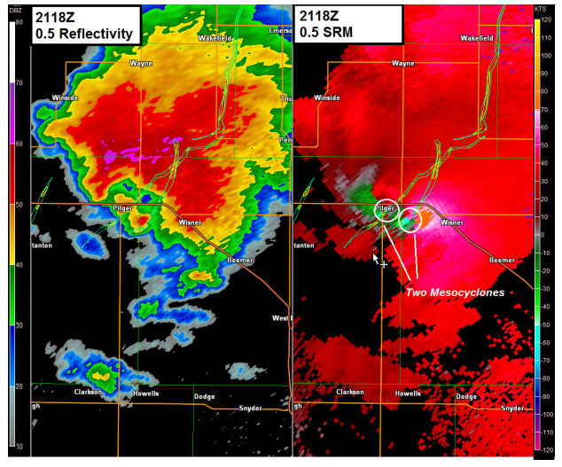
Figure 6. Omaha NWS radar images during the Pilger tornadoes. Radar reflectivity (left) and velocity (right). The image on the right shows the location of the two tornadoes as they passed through and near Pilger. The tornado paths are indicated by the yellow lines.

Source: NOAA, 2014.

Pilger, Nebraska: The Case Study
On June 16, 2014, twin tornadoes destroyed nearly three-fourths of the small town of Pilger, Nebraska (pop. 352), leaving a desolate landscape where tree-lined streets, residences and businesses once stood. One of the community’s two churches was completely destroyed, as was a middle school serving the combined Wisner-Pilger school district with the community of Wisner (pop. 1200), seven miles away (Photograph 1). The unusual dual twisters made national news, and offers of emergency assistance began pouring in from around the country. There was very little time to ponder the question, “why did this happen to our community?” nor was there any “woe is me” attitude. Instead these residents along with their neighbors in Wisner and Stanton County rolled up their sleeves and started the recovery and rebuilding process.

Once the severely damaged buildings and landscaping had been bulldozed and moved aside, the 200 or so residents who remained and those wanting to return began wondering what their town could look like in the future. No one seriously considered the possibility of abandoning what was left of the community and moving on.
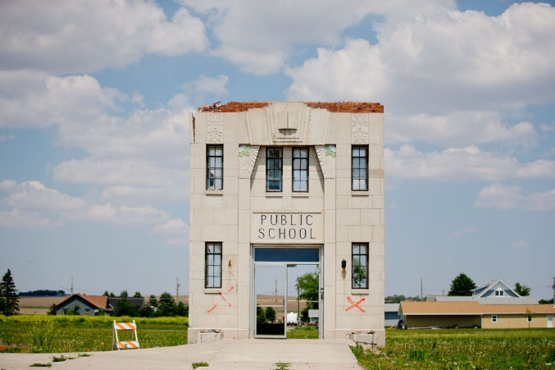

Photograph 1. Remnants of Pilger Middle School.
Source: Kurt Mantonya

In late August, the Heartland Center for Leadership Development received a call for help from Pilger community leaders. The call came from the president of Midwest Bank, a family-owned chain of banks in eight Nebraska communities, ranging from tiny Pilger to the capital city of Lincoln (pop. 250,000). Now in its fourth generation of bank ownership, the Cooper family retained the original bank in Pilger as the chain’s headquarters. Soon after the massive devastation that leveled the main bank building, the owners announced that they intended to rebuild (financial capital). The Co-Op (financial capital) followed suit, and the volunteer fire department (built capital) said it would also replace its building, which was also destroyed. By early September, the city clerk and her husband had replaced their home with a brand new one (built capital), and other homeowners were looking into the options to replace or restore their residences.

The Midwest Bank president explained a critical question facing the community in this way: “If we are going to rebuild our bank in Pilger or a resident wants to rebuild their home (social and built), we need to know where the streets are going to be!” With the help of a longtime northeast Nebraska leader and recently retired director of economic development for Northeast Community College, the bank president reached out to Milan Wall, Co-Director of the Heartland Center for Leadership Development. Wall immediately contacted other resources such as the University of Nebraska Rural Futures Institute to rally partners for a long-term community re-visioning process.

The Heartland Center is an independent nonprofit corporation, headquartered in Lincoln, Nebraska, with 30 years of experience in helping rural communities strengthen their capacity for sustainability. The Center is recognized nationally for its groundbreaking research, begun during the farm crisis of the mid-1980s, which led to “20 Clues to Rural Community Survival,” a list of characteristics found commonly in thriving small towns. The list has become a standard tool for small town community and economic development throughout the U.S. What the Heartland Center discovered in its case study research is that the key to prosperity is what community leaders say and do. That credo has guided the Heartland Center’s training and facilitation since its incorporation in 1986, and today the Center annually reaches an estimated 2,500 leaders in up to 300 small towns throughout the United States and Canada.

The Rural Futures Institute (RFI) is a new University of Nebraska commitment to make the resources of the university’s five campuses available to help rural communities develop and implement the kinds of strategies that they themselves find useful to grow or maintain their communities and regions. RFI already is having an impact beyond Nebraska, with projects engaging colleges and universities in six states, impacting viability in 70 communities.

What the Heartland Center, RFI and additional partners that made up the Pilger Recovery Team accomplish (in two years) is considerable:

- catalyze leadership from Pilger and surrounding communities (human/social),

- connect the community with a variety of regional, state and federal resources (human/social/financial),

- engage high school youth in activities envisioning the community as they’d like to see it in the future (social/human),

- bring together residents and resource agencies to focus on key priorities for the community’s redevelopment (human/social), and

- help provide hope for people whose lives and, in some cases livelihoods, were severely interrupted by a natural disaster (human/social/cultural, financial).

The goal of this case study is examine the community capitals in Pilger, both pre-and post-disaster, to see the significance of each capital and the importance of their evolution over time. For example, one would expect to see high levels of bonding social capital right after such an event because of the numerous volunteers involved. But how do the other capitals evolve? How important is financial capital? Built capital is necessary, but following a natural disaster, what is replaced first? Do governmental regulations hinder these advancements? The involvement of the Heartland Center and its partners is addressed largely in Human Capital but in other capitals as well.

Methods
The Heartland Center’s case study approach follows closely the methodology of Robert Yin (1993), one of the most noted authorities on case study research. Yin defines six steps to be used:
- Determine and define the research setting
- Select the cases and determine data gathering and analysis techniques
- Prepare and collect the data
- Collect data in the field
- Evaluate and analyze the data
- Prepare the report

Case studies report the data in a way that transforms a complex issue (such as tribal economic development) into one that can be understood, allowing the reader to question and examine the study and reach an understanding independent of the researcher. Case studies present data in very publicly accessible ways and may lead the reader to apply the experience in his or her own real-life situation. This methodology helps create an educational curriculum by identifying emerging themes and looking for “best practices.”

This research is applied in nature and demonstrated itself by the successes seen during the “Reinventing of Pilger.” Case studies themselves tend to be selective, focusing on one or two issues that are fundamental to understanding the system being examined, such as economic development. Case studies are also heavily qualitative, relying on interview information and sifting through emerging issues or themes that are brought up by asking similar questions among a number of informants. “Qualitative data analysis depends heavily on the presentation of selected anecdotes and comments from informants-quotes that lead the reader to understand quickly what the field team found out” (Bernard, 2011). Finally through these mixed methods, we were able to create an individual case study for each tribe, a case study overview and a teaching profile all encapsulated into this report.

An advisory group was established consisting of local residents, village board employees, community development fund board members, and others. The purpose of the Pilger Recovery Team was to help with the interviews and focus groups, guide the public participation process, inform citizens of recent updates and provide sources of funding for recovery and rebuilding efforts.

Observations and windshield surveys were conducted on every trip to Pilger. The first windshield survey conducted by the Heartland Center was in September, 2014. Subsequent visits to Pilger for town hall meetings and the interviews and focus groups also included windshield surveys that focused on rebuilding efforts.

Interviews and focus groups were conducted with a wide array of stakeholders to capture diverse opinions across the board. Selected respondents included local residents, village employees, members of the community development fund, governmental agencies, school leaders, non-profits and regional development organizations. In order to capture an essence of the importance of the community capitals, a pre- and post-tornadic survey was constructed. The survey treated each capital before and after the event (where applicable), asking folks to provide their input.

Secondary data was obtained during research at the local library (one of the few public buildings that was not destroyed). “A History of Stanton County, Nebraska” was located and read thoroughly. This book contains a concise history of Stanton County and each of its municipalities. It documents such things as the newspapers over time, churches, civic and social clubs, banks, and people of note. Literature on the Internet also provided contextual information, such as the US Census, and a photographic site published by the Omaha World Herald (Moring and Hendee, n.d.) details before and after photos of Pilger as well as National Weather Service storm damage assessments. Finally, LaRayne Topp’s book “Eighty-One Seconds: The Attack and Aftermath as Tornadoes Hit Pilger, Stanton, Wakefield and Wisner, Nebraska” became an important source of first-hand accounts (human capital) from that fateful day.

Flora, Flora, & Gasteyer (2016) developed the Community Capitals Framework as an approach to analyze how communities work. Based on their research to uncover characteristics of entrepreneurial communities, they found the communities that were most successful in supporting healthy sustainable community and economic development paid attention to all seven types of capital: 1) natural; 2) cultural; 3) human; 4) social; 5) political; 6) ﬁnancial; and 7) built. In addition to identifying the capitals and the role each plays in community economic development, this approach also focuses on the interaction among these seven capitals as well as how investments in one capital can build assets in others (Figure 7).
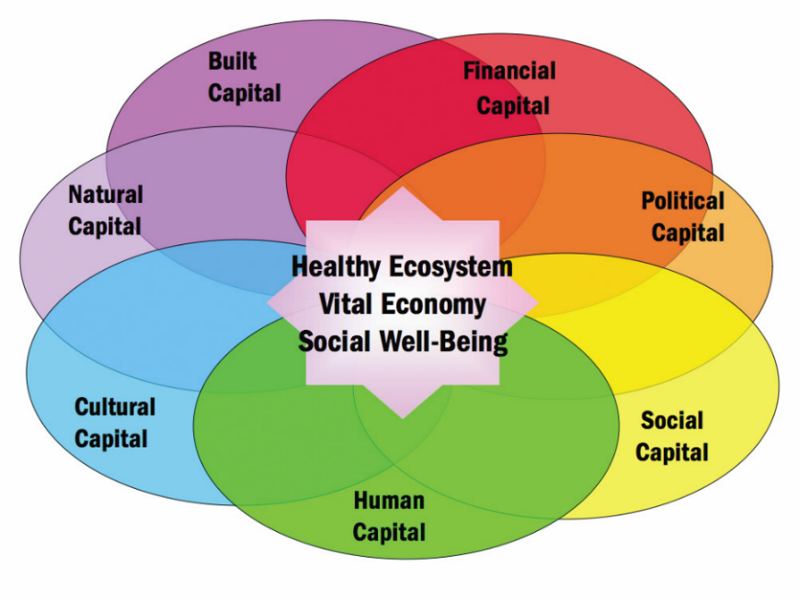
Figure 7. Community Capitals Framework.
Source: Flora, Flora, & Gasteyer, 2016
Human Capital
Human Capital refers to the individual and collective knowledge, skills, intelligence, training, health, physical ability, and wisdom of a population. This form of wealth includes leadership and the ability to access knowledge and information from beyond the community. Human capital is fundamental to community resilience in that economic development and capacity building require a skilled, trained, and healthy workforce.

The tenacity of human capital in Pilger’s residents is reflected in the heart of this close-knit community--which had overcome other major natural tragedies in the past--combined with a vision focused on new opportunities. Over the decades, Pilger has persevered floods, fires and another major tornado that struck 60 years to the month in June 1954. Now, on the road to recovery, Pilger was ready to “reinvent” itself for not only survival but prosperity into the future. Immediate human capital indicators were realized right after the disaster when 1500 volunteers showed up on the first day alone and over the course of the following five days, an estimated 3,834 volunteers donated 24,518 hours of their time (Photograph 2).
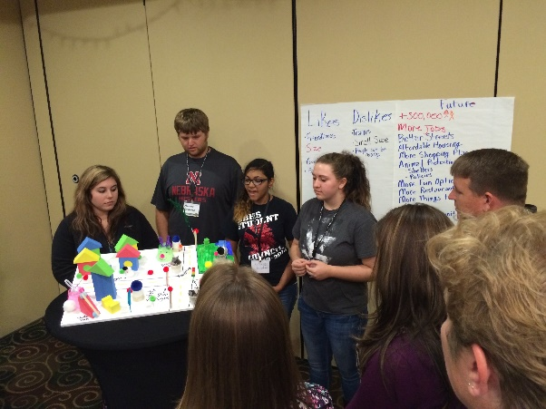

Photograph 2. Youth Engagement Activities
Source: Kurt Mantonya

All totaled, 18,000 volunteers from every state in the union ended up helping the community of Pilger and Stanton County through the first few days and on through the next several months. Famed 90’s Poison front man and TV personality Bret Michaels who was on tour in the area, donated his time as well as his band to the recovery efforts (Photograph 3). Government agencies, both state and federal, provided additional sources of human capital (among other capitals) and included Nebraska Emergency Management Agency (NEMA), the Federal Emergency Management Agency (FEMA), the Northeast Recovery Team, and local resources such as the Salvation Army, local fire departments and others. Other key human capital influences include:

- Statewide collaboration with the Nebraska Chapter of the American Planning Association to help the community update its Comprehensive Plan. All planners involved are donating their time.

- Collaboration with Greensburg, Kansas which, in 2007, faced a similar circumstance when a F-5 tornado leveled their community. Mayor Dixson was invited to speak to the folks from Pilger and the surrounding area.

- Creighton Prep sent 30 students to help with recovery efforts.

In an effort to grow future human capital, the community is working on efforts to attract new residents as well as retain young adults. One step in this process is the formation of the People Attraction/Branding task force mentioned below. This task force was responsible for identifying needs of new residents and working with experts on strategies to recruit new residents.

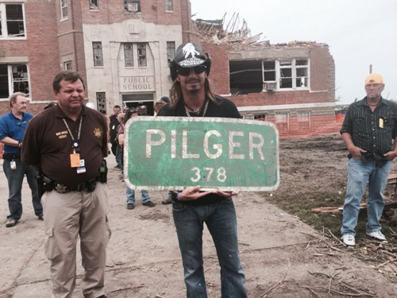

Photograph 3. Bret Michaels Holding Piger Sign
Source: BretMichaels.com

Heartland Center Efforts
The Heartland Center in collaboration with those partners mentioned earlier helped the citizens of Pilger come together to think about the future of their town. Dozens of area residents attended a series of community meetings showing the significance of strong human and social capital. The details for these meetings are outlined below.

A preliminary meeting of community leaders in early September 2014 brought together 70 people to begin a visioning and strategic planning process known as “Reinvent Pilger.” In late September, 150 people gathered at a Pilger community town hall meeting at the city auditorium in Wisner. They established eight task forces, comprised of community residents, who are developing strategic action plans to help reinvent their community. Those task forces are organized around these topics: Community Center, School/Pre-School, Sustainability/Trees, Bar/Restaurant/Coffee Shop, Recreation, Communications, Community Clean-Up, and People Attraction/Branding. Each task force identified an initial focus for its attention and has named or is recruiting two co-chairs. The Heartland Center also facilitated monthly check-in calls with the leadership team and other partners to include updates from the Village Clerk and the task forces as well as agenda-setting for town hall meetings and other events (Photograph 4).

Follow-up town hall meetings were held in 2015 and 2016, at which time the strategic plan was completed, as well as a parallel yet integrated land use planning process that the community is undertaking with the assistance of students and faculty from the University of Nebraska-Lincoln College of Architecture and members of the Nebraska chapter of the American Planning Association. The Heartland Center published a periodic electronic newsletter for everyone who attended one of the community meetings plus resource agency representatives or anyone else who has asked to join the list. The Rural Futures Institute produced a short video documenting the process and outcomes of the town hall meeting in late September 2015, and that video is received widespread distribution to regional media outlets.

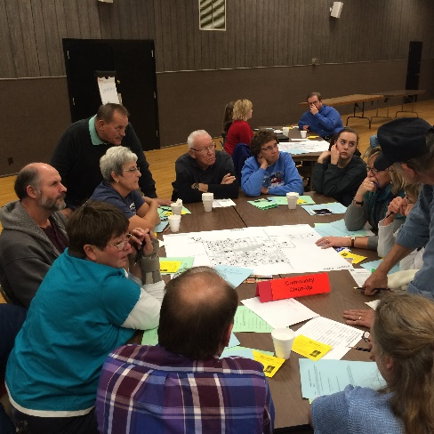

Photograph 4. Task Force Discussing Action Plans
Source: Kurt Mantonya

LaRayne Topp, a local newspaper reporter and author who lives in the area published “Eighty-One Seconds: The Attach and Aftermath as Tornadoes Hit Pilger, Stanton, Wakefield and Wisner, Nebraska,” in 2015. This oral history documents 200 first-hand interviews with the victims as well as those who helped in rescue, and recovery and then numerous volunteers that gave their time.

Financial Capital
Financial Capital refers to wealth, financial savings, income, investments, and available credit to support businesses, entrepreneurship and other forms of community development. Financial capital is usually measured in currency such as dollars, but employment and poverty rates also provide insights. Financial capital is closely tied to the other forms of capital, particularly natural and built capital.

Prior to the June tornado, Pilger as a community, like many small towns struggled financially. With a dwindling population and aged housing, tax revenue continued to decline. The community was laden with debt from USDA for infrastructure improvements such as the new sewer. Street maintenance and the pool bond as well as general operating expenditures further put a burden on Pilger’s coffers. Largely dependent on agriculture, a co-op is located in Pilger and other businesses that are ag-related. The long-standing family run chain of Midwest Banks also makes its home in Pilger

As devastating as the twin tornadoes were to Pilger, the storm literally created a “clean slate” upon which to envision a new future with the infrastructure and amenities needed to draw new residents. Pilger’s location enjoys two specific advantages: First, its close proximity to three larger trade center communities and, second, a beautiful river and several lakes providing a variety of recreational opportunities. A third and closely tied advantage is Pilger’s reputation as a family friendly and safe community for rearing children.

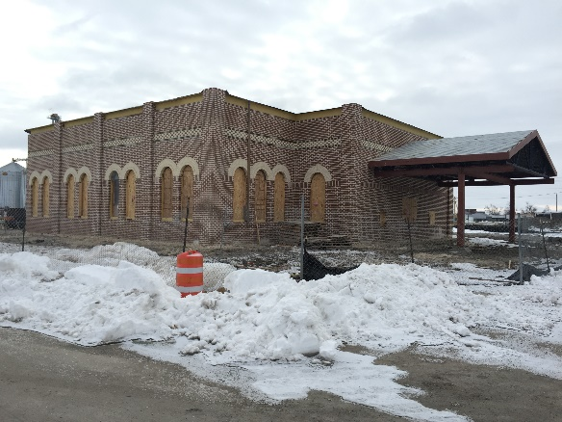

Photograph 5. Midwest Bank Construction.
Source: Kurt Mantonya

Midwest Bank was the first to say that they would re-build but with an upcoming harvest and, the CO-OP was the first to break ground and had bins available for storage by corn and soybean harvest by fall (Figure 13). They also completed their ancillary buildings such as fertilizer storage, multi-suite office space and repair shop. Midwest Bank completed its construction in June of 2016. The convenience store “Pilger Pride” opened its doors in June 2016. Although 70 houses were destroyed, many of these in dilapidated condition to begin with, it only took the new construction of 15 houses to replace to tax value of those 70. More new houses will add to those coffers. Other financial capital developments include:
- GoJoe Trucking
- Lampan Tire & Towing
- Oswald Farm Supply
- Dustin Topp Body Shop
- A CPA business

The amount of financial capital goes on. An anonymous donor funded the cost and operation and maintenance for the swimming pool during the summer of 2015 to the tune of $25,000. A Federal Home Loan Bank of Topeka JOBS grant was submitted and approved for $25,000. The Nebraska Corn Board provided a grant in the amount of $65,000 to fund the blender pumps at the to-be constructed convenience store. The local NRD is donated $31,000 to cover the cost of culverts and dirt work at the convenience store. With regard to the community center, significant donations of materials, cash and in-kind services have poured into this important multi-capital facility. Almost $2M to date has been donated to the center that included large donations for building materials and smaller amounts placed in an endowment to run the center in the future.

Built Capital
Built capital is the infrastructure that supports the community, such as telecommunications, industrial parks, main streets, water and sewer systems, roads, etc. Built capital is often a focus of community development efforts.

In the months after the tornado, debris from destroyed homes, trees, businesses, pavement, etc., was located across the highway just west of the community. And clean-up has a price tag. Just clearing the debris from the town cost $1 million and the total cost for repairs was in the $4 million range. The Federal Emergency Management Agency (FEMA) helped to offset a portion of those costs.

Many of the updates and new construction that were mentioned in financial capital also have a home in built capital such as new homes, businesses and municipal buildings to name a few (Photograph 6). There have been several obstacles to the new construction that is going on though. Pilger has recently updated their sewage and water treatment facility with the aid of a USDA loan. This loan still has to be repaid in spite of the dwindling village coffers (there have been several months in which the village struggled to make payroll. Village staff and UDSA officials continue to meet on this topic.

Photograph 6. New “Welcome to Pilger” Signage.
Source: Pilger Branding Task Force

The neighboring Elkhorn River to the south of town has placed Pilger in a flood zone for years but homes and businesses in Pilger were grandfathered in. Now with new home construction, the land must be elevated and flood water pass-thru gates must be incorporated into the cinder block foundation. This means that basements are not allowed in much of the community so tornado safe-rooms should be installed. Speaking of safe rooms, as of this writing, five houses have safe rooms in their construction and several applications for safe rooms have been received. These were provided by various granting organizations.

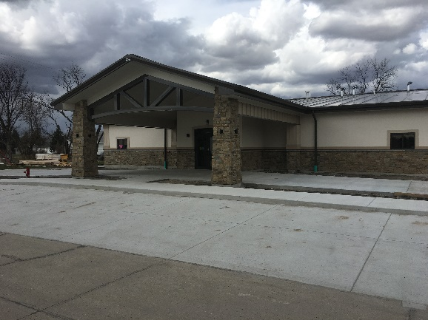

Photograph 7. Pilger Community Center.
Source: Milan Wall

The community center is nearing completion after its capital campaign to raise $2.5 Million for construction and an operating endowment (Photograph 7). This 8,800 square foot facility will serve as the community’s focal point and strengthen several capitals. In addition to conference facilities, a fitness center, commercial grade kitchen and senior center, this facility will have the capability to provide education benefits to the Pilger community and the larger area with a variety of programming, such as:

- Pre-school and early childhood education that will prepare those younger than Kindergarten age to excel when they are enrolled in an attendance center.

- Before and after school programs that enhance elementary and middle school student learning and help students with homework and educational enrichment. In collaboration with Wisner-Pilger Public Schools and other partners, career exploration such as STEM and academic success programming can be offered. There are also opportunities to explore entrepreneurship, leadership development and civic engagement.

- Adult education. The community center can also help adults in the area pursue a degree, obtain continuing education units or lean a new skill. As the community center will have state of the art technology, adults (and youth) will be able to tap into expertise from around the world through online learning, teleconferencing and high-speed computer connections.

- Entrepreneurship camps for middle school and high school youth, using national recognized curricula such as EntrepreneurShip Investigation (ESI), developed by University of Nebraska Extension and distributed nationally by 4-H.

- The community center can also host day care programs, tutoring and mentoring opportunities, study circles and other collaborative learning opportunities for both youth and adults.

Additional Built Capital Developments:
- New signage was installed in November 2016
- St. John’s Lutheran Church is done
- A new village office is complete
- 22 applications for assistance for funding safe rooms have been received and approved.

Natural Capital
Natural capital are those assets that abide in a location, including resources, amenities and natural beauty. Among the many natural capital amenities that Pilger prides itself on is the fact that it is a Tree City USA community for 16 years straight. During the ravaging winds, over 300 trees were lost. Thanks to numerous donors, Pilger is once again seeing tree-lined streets coming into existence. Nelson Tree Farm donated 90 trees and Benson Plan Rescue in Omaha provided many more. Black Hills Energy in conjunction with the Arbor Day Foundation donated several trees as well. To date, 275 of those 300 trees lost have been replaced. This also provided ample opportunity for the students and service clubs in Pilger to volunteer to help plant some of the trees.

After the disaster, temporary housing became an issue. The alleviate some of that burden, four additional hook-ups were added to the village park to accommodate camping trailers brought in for short-term housing. This brought the total of connections to eight and remains a place for travelers and campers to stay today.

Pilger has numerous other natural capital related amenities such as the Elkhorn River about one mile south of town. Recreation opportunities abound with the Elkhorn for kayakers and canoers, fisherman and hunters. The swimming pool and ballfields were also labeled as natural capital.

Political Capital
Political refers to the ability and power to influence resource acquisition and distribution, and the ability to engage external entities in efforts to achieve local goals. Political capital is used to develop, establish, and enforce rules, regulations and policies. Effective political capital fosters resilience through networking with local, state, and federal governments and agencies that can provide assistance in disaster preparedness, response, recovery, and mitigation. Community resilience is enhanced when political capital involves the public in pre- and post-disaster planning and by ensuring that traditionally underrepresented groups have a voice.

Political capital before the tornado was limited to the village board, planning commission, village attorney and the fire and rescue department. After the tornadoes, political capital surged briefly as evidenced by the state and federal offers of assistance in both hands-on help and money as well as “having the ear” of one of the local state senators who helped work on tax relief. Also after the tornadoes, attendance in the planning commission and village board meetings was up. During the town hall meetings facilitated by the Heartland Center, various office holders from the local and state level were in attendance.

With the assistance of the University of Nebraska-Lincoln College of Architecture and the Nebraska Chapter of the American Planning Association, a comprehensive plan was created for this community (Photograph 8). The last comp plan was completed in 1998. The comp plan will help the village board and the planning commission guide future development in Pilger. Both the University as well the planning members provided their time and service free of charge to Pilger.
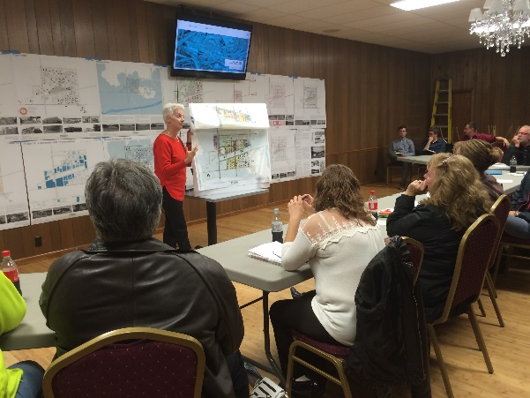

Photograph 8. University of Nebraska-Lincoln Architecture Department Conducting Charrette.
Source: Kurt Mantonya

Social Capital
Social Capital refers to the value of social interactions, relationships, and networks among people, groups, and organizations and the ability to accomplish mutually beneficial goals and objectives. Social capital bonds similar people together and is a bridge between diverse people. Social capital also links a community with other communities and outside organizations. Social capital is embedded into a community’s structure through established networks, roles, rules, procedures, and precedents. Social capital is embedded in individuals through commonly held beliefs, attitudes, and values that encourage people to work together.

Of all of the community capitals, social may have had the largest impact. There was a high degree of bonding social capital immediately after the disaster onto the short-term recovery efforts. The people of this tiny community worked together immediately after the disaster on rescue and recovery efforts and finally on into the rebranding/rebuilding phase. As discussed previously, attendance at the town hall meetings, was extremely high with not only Pilger residents in attendance but folks from neighboring Wisner and throughout Stanton/Cuming County. Each of the task forces created as a result of the town halls were also highly attended as well.

- An answering machine service was setup at the public library for announcements.

- Community bulletin boards were created near the temporary village clerk’s office that contained announcements, relief information, meeting times, etc. (Photograph 9).

- Mayor Bob Dixson of Greensburg, Kansas came up to a February 2015 tow
n hall meeting to talk about the tornado of 2007 in this tiny Kansas community and spoke about their efforts to rebuild. Efforts like this created regional opportunities to build social networks.

- One of the more important social and cultural capital institutions was the school. Completely destroyed, one of the task forces was created specifically for this issue. As the local school board was leaning toward consolidating all the facilities in Wisner, this task force made its case to keep the middle school in Pilger. Once the final determination was made, and everything was consolidated to nearby Wisner, this task force spent little time feeling sorry for itself, rolled up their sleeves and started tackling other issues.

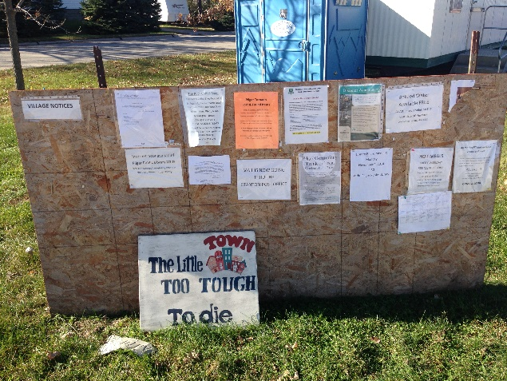

Photograph 9. Post Tornado Bulletin Board.
Source: Kurt Mantonya

Increases in social capital were seen in other ways as well. The annual sweet corn and hamburger feed topped $100,000 since its inception, money used over time to cover expenses at the Pilger pool. In 2016, it took over 70 volunteers to pick 14,000 ears of corn, clean and dip them in butter as well as fry over 1,000 hamburger patties for over 1,000 people.

While it is difficult to reflect on the tornado of 2014, Pilger residents have chosen to mark this day as a celebration. In 2015, it was more somber reflecting on the event, the lives lost, the destruction but over time and as new houses emerged, more trees were planted and businesses were established, it became a time of celebration. In June of 2016 that became very evident with Pilger Days returning, highlighted by several business open houses and ribbon cuttings, food, street dancing, kid activities and free swimming at the pool.

Cultural Capital
Cultural capital refers to assets community members use to understand and make sense of their world. This ‘worldview’ provides a sense of purpose that guides individual and group behavior. Cultural assets include language, heritage, ethnicities, traditions, religion, symbols, and local knowledge (Flora and Flora 2013). Cultural capital influences a community’s capacity to draw on its collective experiences and shared values, which enhances resilience.

Pilger has clung on to its cultural capital by resurrecting events and celebrations that mark Pilger’s history while also paying careful attention to its future. The annual Pilger Day’s celebration mentioned in social capital has elements that show up in cultural capital. Holiday-related celebrations such as Trunk or Treat, Turkey Bingo and Small Town Christmas are recent additions to Pilger and were well attended by youth and adults.

St. John’s Lutheran church as well as St. Johns parsonage are completed. A recent “mobile” church service was recently retired from service (Photograph 10).

Photograph 10. Mobile Church Service sign for St. John’s Lutheran Church.
Photo Courtesy of Kurt Mantonya

Conclusion
As with any healthy system or community as laid out by Flora and Flora, there needs to be elements of each capital to maintain that health. Communities such as Pilger may lose a capital or two immediately after a disaster but attempt to regain those during the course or recovery and rebuilding. With such a large response post-tornado with regard to volunteers and donations to the community indicates that immediate disasters such as tornadoes or fires yield high boding social capital whereas long-term disasters like drought may not. Finally as Pilger rebuilt, it was noted that there is reliance on all of the capitals and they are dependent on one another and there are enough assets within each capital to sustain them. For example, the loss of a school in a community the size of Pilger may decimate all of the cultural capital but there are enough institutions such as churches to maintain a level of cultural capital.
References

Bernard, H. R. (2011). Research Methods in Anthropology: Qualitative and Quantitative Approaches, 5th ed. Waltnut Creek, CA: Altamira Press.

Carbin, Greg, & Guyer, J. (2015). “The 2015 Tornado Season: In Like a Lamb, Out Like a Lion.” Weatherwise 69(3): 43-49. Retrieved from http://dx.doi.org/10.1080/00431672.2016.1159490.

Edwards, R. (2016). “The Online Tornado FAQ: Frequently Asked Questions about Tornados.” NOAA, National Weather Service, Storm Prediction Center. Retrieved from www.spc.noaa.gov/faq/tornado.

Edwards, R., LaDue, J. L., Ferree, J. T., Scharfenberg, K., Maier, C. & Coulbourne, W. L. (2013). “Tornado Intensity Estimation: Past, Present, and Future.” Bulletin of the American Meteorological Society (May): 641-653. Retrieved from http://journals.ametsoc.org/doi/pdf/10.1175/BAMS-D-11-00006.1.

Flora, C., Flora, J. & Gasteyer, S. (2016). Rural Communities: Legacy and Change, 5th ed. Boulder, CO: Westview Press.

Iowa State University of Science and Technology (ISU). (2016). Archived Data and Plots. Retrieved from: https://mesonet.agron.iastate.edu/archive/.

Krause, R. (2014). Six Months Later: Pilger, NE First Responders Recall Life Saving Choices that June Day. Siouxland Matters. Retrieved from: www.siouxlandmatters.com/news/local-news/six-months-later-pilger-ne-first-responders-reca.

National Oceanic and Atmospheric Administration (NOAA). (n.d.). Severe Weather Terminology. Retrieved from www.crh.noaa.gov/Image/gid/WCM/safety/terms.pdf.

National Oceanic and Atmospheric Administration (NOAA). (2014). June 16, 2014 Pilger Tornado Event. US Department of Commerce, NOAA, National Weather Service. Retrieved from www.weather.gov/oax/event_archive_20140616.

NOAA National Centers for Environmental Information (NCEI). (n.d.). Storm Events Database. Retrieved from https://www.ncdc.noaa.gov/stormevents/choosedates.jsp?statefips=31%2CNEBRASKA.

NOAA National Severe Storms Laboratory (NSSL). (n.d.). Severe Weather 101 – Tornadoes. Retrieved from http://www.nssl.noaa.gov/education/svrwx101/tornadoes/faq/.

NOAA National Weather Service (NWS). (2013). Severe Thunderstorm Climatology. Retrieved from www.nssl.noaa.gov/projects/hazard/.

NOAA National Weather Service (NWS). (2015). 2014 Nebraska Tornado Facts. Nebraska/Iowa Severe Weather Awareness Week, March 23-27, 2015. Retrieved from www.weather.gov/media/gid/awareness/swaw/SWAW2015.pdf.

NOAA Storm Prediction Center (SPC), 2014. Storm Prediction Center Storm Reports for 06/16/14. Retrieved from: http://www.spc.noaa.gov/climo/reports/140616_rpts.html.

NWS Omaha [@NWSOmaha]. (2014, June 18). Map of the #Pilger, NE area tornadoes on 6/16/2014. Retrieved from https://twitter.com/nwsomaha/status/479392612994916352. Tweet.

School of Natural Resources (SNR). 2017. Nebraska Tornado Frequency, Counties, 1950 to 2015. Retrieved from http://snr.unl.edu/extremeweather/netornado/Nebraska-Tornadoes-Counties.asp.

Topp, LaRayne. 2015. Eighty-One Seconds: The Attack and Aftermath as Tornadoes Hit Pilger, Stanton, Wakefiled and Wisner, Nebraska. Cedar Knolls Press.

Yin, Robert K. 2014. Case Study Research: Design and Methods, 5th edition. Thousand Oaks, CA: SAGE.

Moring, Roseann and David Hendee. n.d. “Path of Destruction.” Omaha World Herald. Retreived from http://dataomaha.com/media/pilger/damage-map/.

