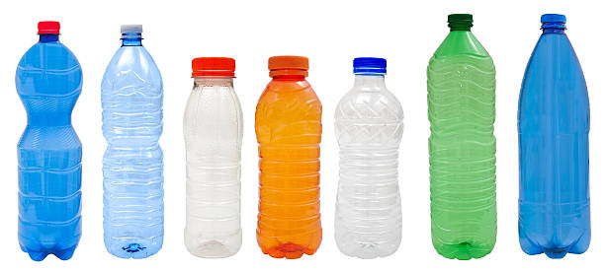
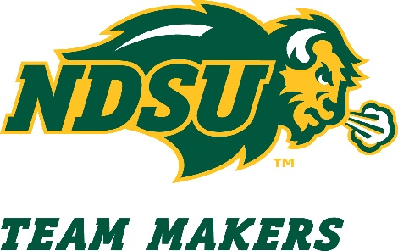
Team Makers is pleased to announce that can and bottle recycling is now available during tailgating events! Place your plastic bottles and aluminum cans in the clear plastic bags provided by the Team Makers staff. Bags will be collected by the Fargo Dome at the end of tailgating. Proceeds from the recycling program will come back to Team Makers and support student-athlete scholarships.

This recycling is ONLY for aluminum cans and plastic bottles, tubs or jugs.
We cannot accept:
- Food waste
- Plastic silverware
- Paper products

