TITLE IS CENTERED AND WRITTEN IN ALL CAPS: TITLES THAT EXTEND BEYOND ONE LINE ARE DOUBLE SPACED

A Dissertation/Thesis/Paper
Submitted to the Graduate Faculty
of the
North Dakota State University
of Agriculture and Applied Science

By
Student’s full name or preferred name from Campus Connection

In Partial Fulfillment of the Requirements
for the Degree of
NAME OF DEGREE

Major Department/Program:
Department/Program Name
Option: Name of degree option, if applicable

Month and year of final defense

Fargo, North Dakota

North Dakota State University
Graduate School
Title
 | DISQUISITION TITLE SAME AS TITLE PAGE BUT SINGLE SPACED
 | By
 | Student’s full name same as title page
 | The Supervisory Committee certifies that this disquisition complies with North Dakota State University’s regulations and meets the accepted standards for the degree of
 | NAME OF DEGREE
 | SUPERVISORY COMMITTEE:
 | Committee Chair’s Name
 | Chair
 | Committee Member’s Name
 | Committee Member’s Name
 | Approved:
 | Date from Copy 1 |  | Department Chair’s Name
 | Date |  | Department Chair

ABSTRACT
This page is required as page “iii” of the disquisition. Use the “NDSU Paragraph Double Space 0.5 First Line” style for the paragraph text. Abstracts for doctoral dissertations must use 350 words or less. Abstracts for master’s papers or master’s theses must use 150 words or less. Note: This abstract will be used in your publication entry in the online repository.

ACKNOWLEDGMENTS
Acknowledgments text should be placed here. In this section you can acknowledge or thank those who assisted or supported you in your disquisition, and you can acknowledge any external funders that may have supported your project with grant funding. Use the “NDSU Paragraph Double Space 0.5 First Line” style for the paragraph text. This page is optional—delete if not using.

DEDICATION
This section dedicates the disquisition to a few significant people.
The text must be double spaced and aligned center to the page with no paragraph indents. This page is optional—delete this page if you are not using it.

TABLE OF CONTENTS
ABSTRACT iii
ACKNOWLEDGMENTS iv
DEDICATION v
LIST OF TABLES vii
LIST OF FIGURES viii
LIST OF SCHEMES ix
LIST OF ABBREVIATIONS x
LIST OF SYMBOLS xi
LIST OF APPENDIX TABLES xii
LIST OF APPENDIX FIGURES xiii
1. MAJOR HEADING IN STYLE “NDSU 1: CHAPTER TITLE NUMBERED” 1
1.1. First-Level Subheading in Style “NDSU 1.1: First subheading numbered” 1
1.1.1. Second-Level Subheading in Style “NDSU 1.1.1: Second subheading numbered” 2
2. MAJOR HEADING FOR SECOND CHAPTER IN STYLE “NDSU 1: CHAPTER TITLE NUMBERED” 4
2.1. First-Level Subheading in Style “NDSU 1.1: First subheading numbered” 4
REFERENCES 6
APPENDIX A. HEADING FOR APPENDIX USING “NDSU 0: MAJOR HEADING NOT NUMBERED” STYLE 7
APPENDIX B. HEADING FOR SECOND APPENDIX USING STYLE “NDSU 0: MAJOR HEADING NOT NUMBERED” 8

LIST OF TABLES
Table Page
1. Title of Table in “NDSU Table title” Style, same font and font size as the paragraph text, single spaced. If you bold the “Table #” And “Figure #” labels, then be sure to remove the bolding in the List of Tables/Figures when you update the entries. Also remove the “Table” and “Figure” word from in front of each number in the List of Tables/Figures and fix any alignment issues after the update. 2
2. Title of Table in “NDSU Table title” Style from the Styles pane. 4

NOTE TO USER: To populate the List of Tables with titles and to update with changes, right click on the entries, choose “Update Field” then choose to update the page numbers only or update the entire table if you made changes to or added new table titles. When you update the whole table you will have to reformat the list to manually remove the label word “Table” from each entry, and align the title column. Use the style “List of Tables Figures entry” to help with formatting and Tab settings to align entries. DELETE THIS NOTE WHEN DONE.

LIST OF FIGURES
Figure Page
1. Title of Figure in “NDSU Figure title” style. 3
2. Title of the figure. 5

NOTE TO USER: To populate the List of Figures with titles and to update with changes, right click on the entries, choose “Update Field” then choose to update the page numbers only or update the entire table if you made changes to or added new table titles. When you update the whole table you will have to reformat the list to manually remove the label word “Figure” from each entry, and align the title column. Use the style “List of Tables Figures entry” to help with the formatting and Tab settings to align entries. DELETE THIS NOTE WHEN DONE.

LIST OF SCHEMES
Scheme Page
1. Example of a schematic. If you use schemes, you can have a List of Schemes after a List of Figures and before a List of Abbreviations. Format the List of Schemes the same way as a List of Tables or List of Figures. Use the “NDSU Schematic title” from the Styles pane to format the Scheme titles and populate the List of Schemes. 3

NOTE TO USER: If you have labeled schemes in your disquisition, you need to use a List of Schemes. If you have no schemes, you can delete this page, or convert it to a different directory if you need, such as a List of Equations, List of Algorithms, List of Musical Examples. DELETE THIS NOTE WHEN DONE.

LIST OF ABBREVIATIONS
Abbrev. Explanation of the Abbreviation.
Directions These entries have been formatted with an automatic dot leader and our required alignment. Press “Enter” after the previous definition to start a new entry. After typing the abbreviation, press “Tab” to get the Dot Leader up to the definition column. There is also a Style for these list entries: “List Entry Abbreviations, Symbols”.
ETD Electronic Thesis or Dissertation

LIST OF SYMBOLS
Symbol Explanation of Symbol. If the symbol definition text runs longer than one line, the subsequent lines are aligned with the first word in the entry.
Directions After entering a Symbol, press Tab to get an automatic dot leader to the definition column. After typing the definition, press Enter to start a new line for a new symbol.
X Definition
Y Definition

LIST OF APPENDIX TABLES
Table Page
A1. Title of Appendix Table in “NDSU Appendix Table title” Style from the Styles pane. Appendix tables should include the letter of the appendix in its number (if you have only one appendix, then use the default letter “A” in the number). 7
B1. Resources and More Information for Disquisition Writers 8

LIST OF APPENDIX FIGURES
Figure Page
A1. Title of Appendix Figure in “NDSU Appendix Figure title” Style. Bison art created in a beta version of Adobe Firefly, a generative AI app. 7

- MAJOR HEADING IN STYLE “NDSU 1: CHAPTER TITLE NUMBERED”
Use our NDSU Styles to simplify your formatting. If you are pasting in text from another source, we recommend using Ctrl+Alt+V to Paste Special – Unformatted Text, which will remove other formatting code that may be acting on that text. Then apply the appropriate formatting from the Styles Pane.
For paragraph text use the style “NDSU Paragraph Double Space 0.5 First Line”.
- For bulleted list items
- Use the “NDSU Bullets” style from the Styles pane
Use Styles to auto-populate and auto-update the Table of Contents and Lists of Tables/Figures/etc. For headings, use the styles marked NDSU: NDSU 0, 1, 1.1, 1.1.1, 1.1.1.1, 1.1.1.1.1. For non-text items use these NDSU styles: Table title, Figure title, Schematic title, Appendix Table title, and Appendix Figure title. You can make modifications if necessary—refer to our user guide (“How to Use NDSU Disquisition Templates” on our Disquisition Formatting Guidelines web page) and our Formatting Tutorial videos on the GPS Academy YouTube channel for more information about formatting with Styles, modifying Styles to fit your style manual’s guidance, and using and adjusting this template.
  - First-Level Subheading in Style “NDSU 1.1: First subheading numbered”
An example table is below. Your tables can look different from the example—follow the style of your discipline and stay within our guidelines—but keep a consistent look to all of your tables. We recommend a clean and simple style. Do not extend any tables or figures into the 1” page margins.

Table 1. Title of Table in “NDSU Table title” Style, same font and font size as the paragraph text, single spaced. If you bold the “Table #” And “Figure #” labels, then be sure to remove the bolding in the List of Tables/Figures when you update the entries. Also remove the “Table” and “Figure” word from in front of each number in the List of Tables/Figures and fix any alignment issues after the update.
Column 1 | Column 2 | Column 3 | Column 4
Row 1 | “Table text” style | Data | Data
Row 2 | Data | Data | Data
Note: This style (NDSU Table note) is used for any table notes. Single spaced and same font and font size as the paragraph text.
    - Second-Level Subheading in Style “NDSU 1.1.1: Second subheading numbered”
Paragraph text paragraph text paragraph text paragraph text paragraph text paragraph text paragraph text.
      - Third-level subheading in style “NDSU 1.1.1.1: Third subheading numbered”
A sample figure is below. Use the “NDSU Figure” style to center your figures. For inserting figures, we recommend that you do not anchor them and do not wrap text around them; instead, insert them in-line with text and center them. Follow your discipline’s style guide for figure title format—it may differ from our template’s examples.
Also make sure table and figure titles are on the same page as the table and figure itself. If a table and figure can fit on the same page as its title and notes, do not split them across two pages. If you must carry something across multiple pages, follow our guidelines for “Continued” table and figure titles.
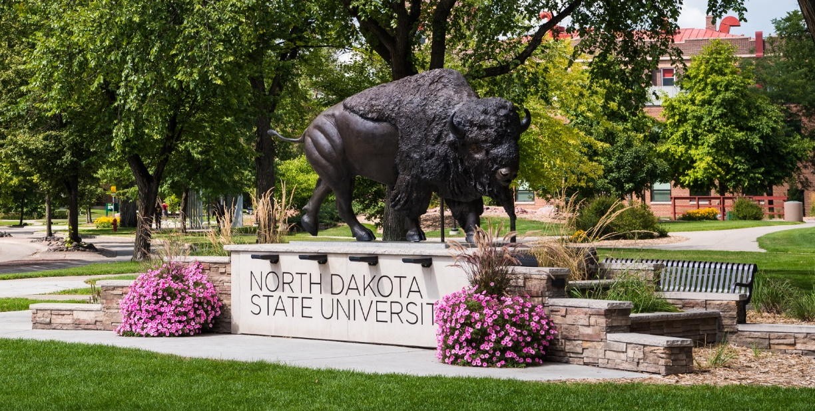
Figure 1. Title of Figure in “NDSU Figure title” style.
Note: This style (NDSU Figure Note) is used for any notes related to a figure. (If you use a table, figure, or non-text item that is not your original design, you must cite the original source of the item and obtain any necessary permissions according to copyright. Refer to the style manual of your discipline for more information about citations of non-text items.)
        - Fourth-level subheading in style “NDSU 1.1.1.1.1: Fourth Subheading numbered”
Below is an example of a schematic. Non-text items must be labeled and titled and entered in an appropriate list of items in the prefatory section. (There are some exceptions—when in doubt follow the conventions of your discipline and consider the needs of your reader.)
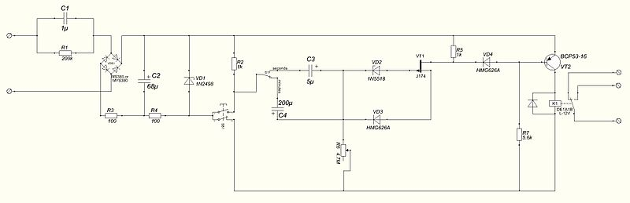
Schematic 1. Example of a schematic. If you use schemes, you can have a List of Schemes after a List of Figures and before a List of Abbreviations. Format the List of Schemes the same way as a List of Tables or List of Figures. Use the “NDSU Schematic title” from the Styles pane to format the Scheme titles and populate the List of Schemes.
Note: This style (NDSU Schematic Note) is for notes related to a schematic.

- MAJOR HEADING FOR SECOND CHAPTER IN STYLE “NDSU 1: CHAPTER TITLE NUMBERED”
If you turn on the Paragraph symbol ¶ on the Home tab to view the document formatting, you will see that there is a Page Break at the end of Chapter 1. Inserting a page break at the end of a chapter helps ensure that the next chapter’s (or REFERENCES or APPENDIX) major heading will appear at the top of a new page. Warning: Do not use section breaks unless you are inserting landscape pages, because using section breaks instead of page breaks can cause you extra formatting headaches.
  - First-Level Subheading in Style “NDSU 1.1: First subheading numbered”
Paragraph text paragraph text paragraph text paragraph text paragraph text paragraph text paragraph text paragraph text.
Table 2. Title of Table in “NDSU Table title” Style from the Styles pane.
Column 1 | Column 2 | Column 3 | Column 4
Row 1
Row 2
Note: This style (NDSU Table note) is used for any table notes.
If you use equations in your text, they should be centered in order to stand out from the paragraph text. If you number the equations, they must be numbered consecutively throughout the document (1, 2, 3, and so on) or consecutively within each chapter (1.1, 1.2, 2.1., 2.2., and so on), and the numbers must be flush against the right margin. You can set Tabs to format these, such as a 3.0” Centered Tab and a 6.48 Right Tab.
$a\left(b+c\right)=ab+ac$ (1)
$x=\frac{-b±\sqrt{b^{2}-4ac}}{2a}$ (2)
More details on tab settings for equations can be found in our “How to Use NDSU’s Disquisition Templates” documents on our formatting guidelines web page.
Figure 2. Title of the figure.
If you are using a figure title without figure notes, make sure there is a single line of space (12 points of space) between the figure title and other content below (text, subheading, other non-text item, etc.).

REFERENCES
Citation example using the “NDSU Citation” style. This style is double spaced with a hanging indent, but you can use a format that fits your disciplinary conventions.
Follow your discipline’s preferred style guide for reference list formatting guidance. Modify our citation formatting style if needed.
Use only one citation style throughout the document. For example, do not mix APA and AMA citation styles in your document. Consistency is important.
Note: Remember to proofread all entries carefully. Be sure to double-check automatically generated citations for accuracy and completeness, paying special attention to capitalization, punctuation, author names, font style, consistency in how you list journal titles (full vs. abbreviated), and accordance with the citation style manual you are using.
Citation citation citation citation citation citation citation citation citation citation citation citation citation citation

APPENDIX A. HEADING FOR APPENDIX USING “NDSU 0: MAJOR HEADING NOT NUMBERED” STYLE
Please read our appendix format guidelines thoroughly, as they contain specific instructions pertaining to how your appendix material should be presented.
Note that if you have only one appendix, then remove the letter A from the major heading, but keep using the letter A in any table and figure numbers to denote that they are appendix tables and figures.
Table A1. Title of Appendix Table in “NDSU Appendix Table title” Style from the Styles pane. Appendix tables should include the letter of the appendix in its number (if you have only one appendix, then use the default letter “A” in the number).
Column 1 | Column 2 | Column 3 | Column 4
Row 1 | “Table text” style
Row 2
Note: This style (NDSU Table note) is used for any table notes.
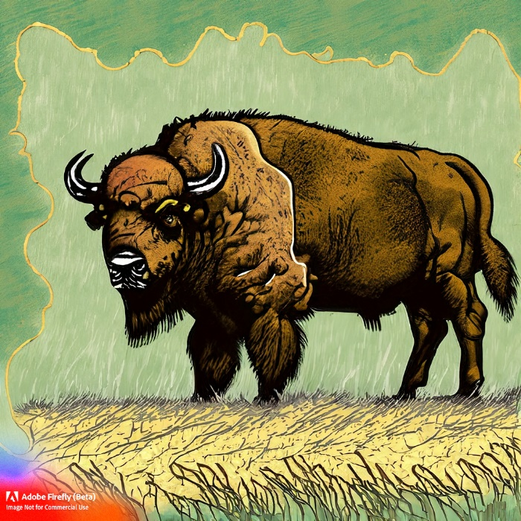
Figure A1. Title of Appendix Figure in “NDSU Appendix Figure title” Style. Bison art created in a beta version of Adobe Firefly, a generative AI app.
Note: This style (NDSU Figure note) is used for any figure notes. Remember that the value of academic accountability must guide the use of AI tools, and you must cite any AI-generated work.
APPENDIX B. HEADING FOR SECOND APPENDIX USING STYLE “NDSU 0: MAJOR HEADING NOT NUMBERED”
Table B1. Resources and More Information for Disquisition Writers
NDSU Website | For more information about:
Graduate School Current Students | Graduate School policy, deadlines, forms, graduation
- https://www.ndsu.edu/gradschool/current_students
Graduate School Dissertations, Theses, and Papers | Disquisition policies, formatting guidelines, templates, a guide to using the templates, submission procedures, publication and delayed release information
- https://www.ndsu.edu/gradschool/current_students/graduation/papers_theses_dissertations
Center for Writers | Writing consultations, writing workshops, disquisition boot camps, writing resources on site and online
- www.ndsu.edu/cfwriters/
Learning and Applied Innovation Center (LAIC) | Thesis formatting workshops. Help with our template. Help with using Microsoft Word and other software applications. Walk-in consulting service in Quentin Burdick Building 150C, or schedule an in-person or virtual appointment with their thesis formatting specialist. Note: The LAIC does not consult on guidelines nor conduct reviews of your formatting. See them for technical help carrying out formatting functions.
- https://www.ndsu.edu/it/help/laic/
Formatting Tutorial Videos | Hosted on the GPS Academy YouTube Channel. “Navigating the Review Process” workshop recording and “Word Crash Course” videos on In-Paragraph Formatting; Styles; Section Breaks and Page Numbers; Table of Contents; Tables and Figures; Landscape Pages and More about Tables; Template Overview.
- https://youtube.com/playlist?list=PLWKsN3lW50IexOpLRkNjh2HDuVKp3XjFH&si=Cksb4ZlFK3X1uCCh

If your chapter is using or reproducing content you previously published or that has (or would have) co-authors listed in the publication, then you must include a footnote to the chapter title with the appropriate acknowledgments: follow the publisher’s instructions to cite the previous publication; follow the Graduate School’s guidelines for the mandatory footnote describing your role in the co-authorship, even if you are the primary author. Details and an example are on our General Requirements web page under “Copyright”. To insert a footnote, go to the References tab in the Word ribbon and click “Insert Footnote”—do not place it in the footer.

