Settings to Align Lists of Tables/Figures/Schemes
These are the preferred settings for aligning the entries and applying the Dot Leader in the List of Tables and List of Figures, using the Paragraph dialog box. Select the entries to configure, then apply:
- Line spacing: Single spacing, Points After: 12 pts (This establishes single spacing within an entry, double spacing between entries)
- Indentation:
  - Special: Hanging by 0.5 (This adjusts the title alignment of subsequent lines.)
  - Right, 0.5 (This keeps the title text out of the page number column)
- Tabs:
  - Alignment Left, 0.5, Leader: None (no dots) (This Tab stop aligns the first line of the title column)
  - Alignment Right, 6.49, Leader: 2 (low dots) (This Tab stop establishes the dot leader for the entry page numbers)

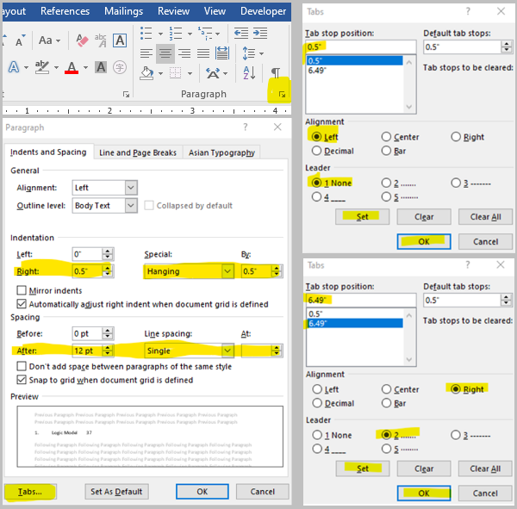
Dot Leaders in Tables of Contents and Lists of Things
In order to form a dot leader in a Table of Contents and List of Tables/Figures/etc., it is best to use a dotted Tab instead of pressing the period key repeatedly to align page numbers (because the period method will not get them in perfect alignment). You can find the dotted Tab settings by opening the Paragraph dialog box and clicking on the Tabs button (see images and settings on the previous page).
The Table of Contents and List of Tables entries below have dotted tabs you can experiment with.
In TABLE OF CONTENTS, place your cursor before “11” in the Chapter 2 entry, and press Tab once to fix the alignment; then open the paragraph settings as shown below to view the settings used.
In LIST OF TABLES, place your cursor in front of “Demographics” and press Tab to align it with “Logic” and “Example”, then place it in front of the 45 to align the page number with a dot leader. Place your cursor in the third title to view the Indentation and Line Spacing settings.
TABLE OF CONTENTS
CHAPTER 1. INTRODUCTION 1
CHAPTER 2. RESEARCH QUESTION11
CHAPTER 3. METHODS 20

LIST OF TABLES
Table Page
1. Logic Model 37
2. Demographics of Survey Responders45
3. Example of a Long Title to Demonstrate the Alignment Needed for Second Lines of Text and the Prevention of Extending into the Page Number Column 58

Equation Formatting Tips
To center equations and keep the equation number flush with the right margin:
- Keep the text left aligned as you type/insert the equation followed by the equation number you will be marking it with.
- Place your cursor to the left of your equation and open the Paragraph Settings. Click on the Tabs… button.
- Set two tab stops:
  - Set one at 3.25”, aligned center, leaders none. Click set.
  - Set another at 6.5”, aligned right, leaders none. Click set.
  - Click OK.
- With your cursor to the left of the equation, press the Tab key. This should center the equation.
- With your cursor to the left of the equation number, press the Tab key. This should place your equation number flush with the right margin.
- Experiment below with the second equation—the Tabs are set; place your cursor as directed in steps 4 and 5, and hit Tab:

a² + b² = c² (1)
E=mc² (2)
1. 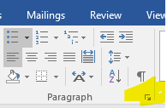 2. 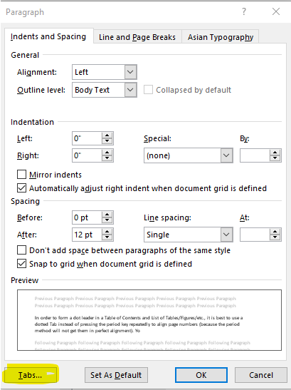
3. 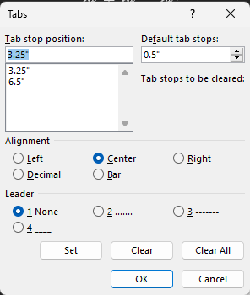 4. 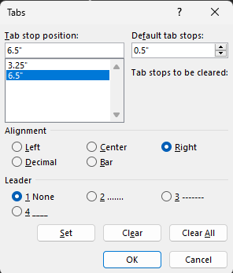
Images: 1. Where to find the Paragraph Settings. 2. Where to find the Tab settings. 3. The Tab stops to set for centering. 4. The Tab stops to set for aligning the number to the right.

Splitting tables to place a continued title and header row on each page
Our formatting guidelines advise:
- When a table or figure continues over multiple pages, make sure that the title of the item appears on all pages of the item. On the subsequent pages, add the phrase “(continued)” to the end of the first sentence of the item title. This helps the reader to remember what information they are looking at, and that it is all part of the same item.
- When a table must extend for multiple pages, the header row of the table should appear at the top of the table on the subsequent pages. This helps the reader remember what the columns of data represent.

How to split a table and add the title and header rows to subsequent pages:
- Locate a good row at which to split the table, one that gives you enough room for your title and doesn’t cut off information awkwardly within your table.
  - To split a table: insert your cursor in the cell that you want as the last cell on that page of your table. In the Table Tools - Layout tab, click "Split Table".
  - Your table should continue on the next page, although it is split.
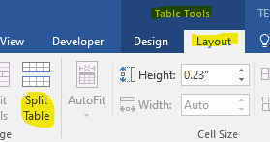
- To insert the continued title: Position your cursor to be able to type text above the table but not inside the table, and type or copy/paste your table title, adding "(continued)." to the end of the first sentence of the title.
- Add the header row to the top of the continued table.
  - You will need to insert the header row manually (the “Repeat header row” function may not work with the split).
    - Copy your header row from the first page of the table.
    - Insert your cursor at the front of the first cell in the second page of the table and paste in the header row.
- If you need to continue to another page, look for the next spot to split the table that will give you enough space to insert a header row and a table title on the top of the page and not cut information off awkwardly. Split the table at that point, and again copy and paste your continued title and the header row on the next page of the table.
- Make sure that in the List of Tables, the item is listed only once, and that the entry indicates on which page the item begins.
Notes for Adjusting Page Number Position on Landscape Pages:

The landscape page numbers are most often too close to the edge of the page if you do not take steps to adjust them when you create them. They default to about 0.5” instead of the 0.75” of the rest of the page numbers.

- To adjust the height of your landscape page numbers, turn on the Gridlines in the View tab of Word’s ribbon (shown in the third image on the right). This helps you visualize the page margins by filling all usable space with a grid.

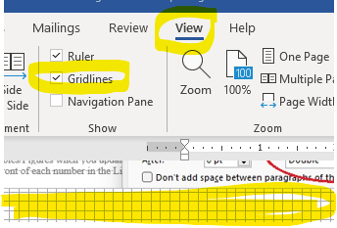

- Drag your textbox to just touch the Gridlines, or to almost touch them. This will “raise” your page numbers to be closer to where we need them.
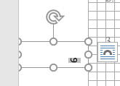

- Check that you have not introduced any problems into the page number position of your portrait pages before and after the landscape section.

To set Tabs, open the Paragraph Dialog box, Click “Tabs…” in lower left, enter the settings shown.
