Mandatory Direct Deposit Set-Up Guide (NDSU HCM Peoplesoft)
- Search “NDSU Peoplesoft”
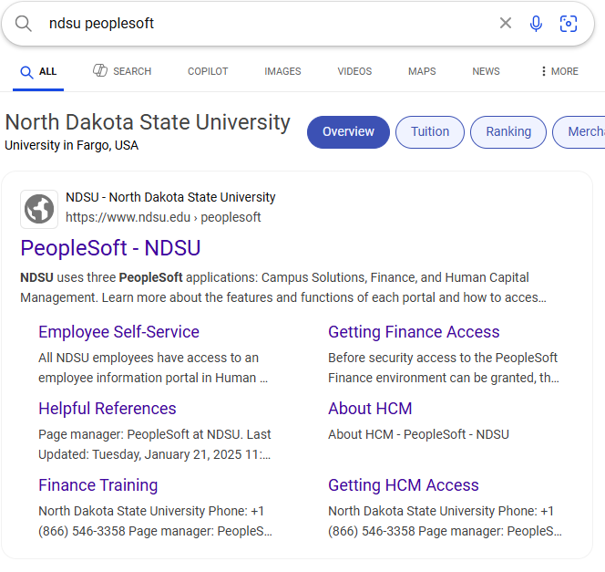
- Select “HCM” on the right-hand side of the web page
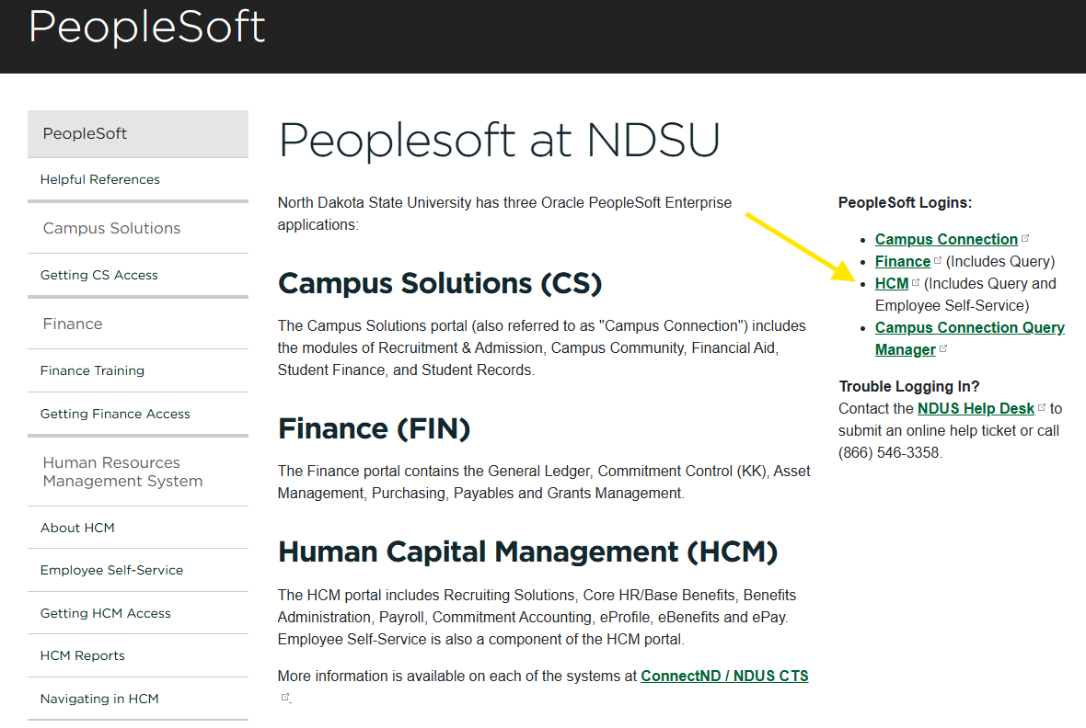
- Log in with your Campus Connection information
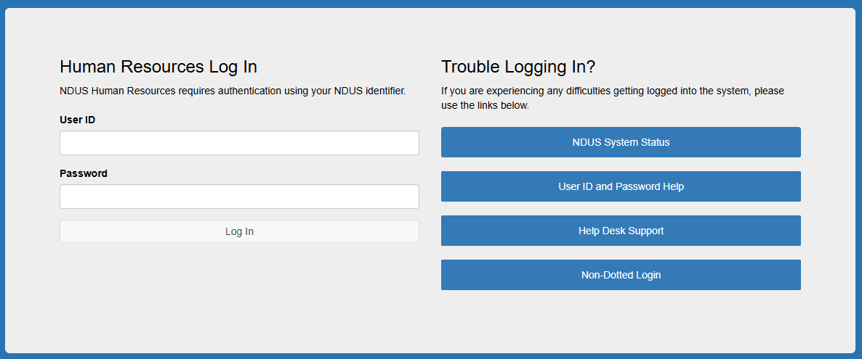
- Click on the “Payroll” tile
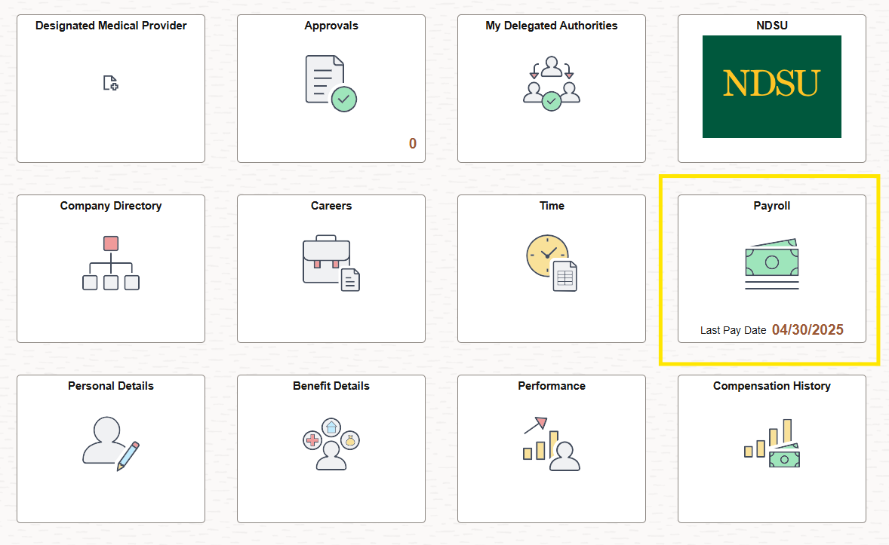
- Click on the “Direct Deposit” tile
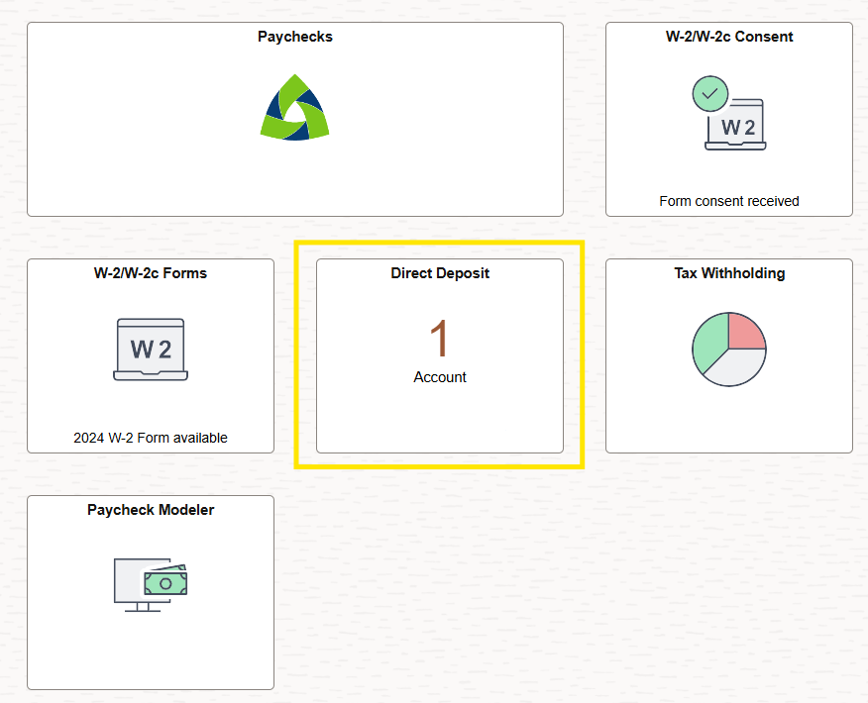
- Select the “+” icon to enter your banking information*
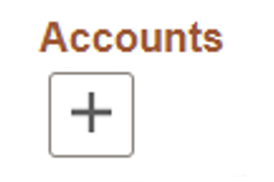

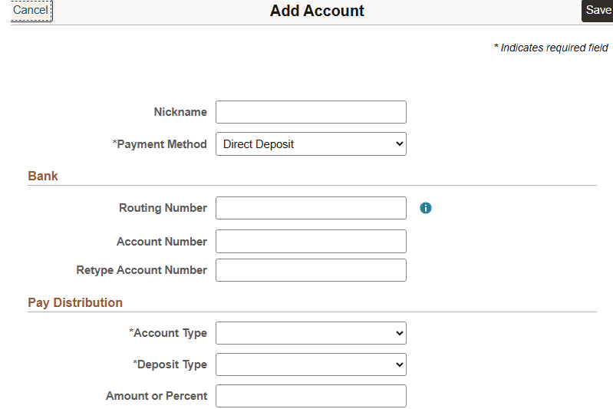
- Create a nickname for the account (e.g. FirstName’s Checking Account)
- Enter the routing number for your account**
  - Click on the blue circle to the right of the field for information on how to find your routing number
- Enter your account number
  - This is not your debit card number
- Retype your account number
- Select the account type from the drop-down menu
  - Usually checking or savings
- Select the deposit type
  - Usually remaining balance*
- Click “Save”

*If you’re splitting your Direct Deposit between multiple accounts, click the “+” icon to enter the next account > in this case, the Deposit Type might be an amount or percentage
**If a message saying “Contact Your Payroll Administer” comes up when entering your routing number, please email ndsu.payroll@ndsu.edu

