COVID-19
Pharmacy Assessment Protocol

ELIGIBILITY FOR SERVICE
The pharmacy will refer patients with the any of the following symptoms/conditions for further medical evaluation:
- Patients that are pregnant
- Immunocompromised
- Any condition requiring supplemental oxygen therapy
- Patients <18 and >64 years of ages
- Temperature >103° F
- Respiratory rate of >30 breaths per minute
- Oxygen saturation <94%
- Pulse > 125 beats per minute

TESTING CRITERIA
Consider testing anyone presenting within 5 days of symptom onset during times of COVID-19 activity when the result will influence clinical management and outbreak response:

Chills | Cough | Headache | Nasal congestion | Vomiting | Sore throat | Muscle pain
Fever | Shortness of breath | Rhinorrhea | Fatigue | Diarrhea | Nonproductive cough

PRESCRIBING
Upon a positive test result, those at increased risk for progression to severed disease should be considered for treatment.
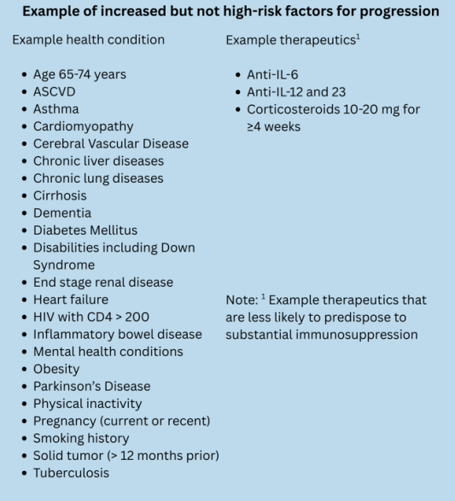

The pharmacist will identify any precautions or contraindications to therapy prior to prescribing, and if deemed appropriate, prescribe the most appropriate treatment.

Treatment
Drug | Dose | Duration
nirmatrelvir with ritonavir | 300 mg nirmatrelvir (two 150 mg tablets) with 100 mg ritonavir (one 100 mg tablet), with all 3 tablets taken together twice daily | 5 Days
Dose reduction for moderate renal impairment (eGFR ≥30 to <60 mL/min):
Drug | Dose | Duration
nirmatrelvir with ritonavir | 150 mg nirmatrelvir (one 150 mg tablet) with 100 mg ritonavir (one 100 mg tablet), taken together twice daily | 5 Days

FOLLOW-UP
The patient should be instructed to contact the pharmacy if symptoms do not improve within 48 hours or if symptoms worsen, so the pharmacist can refer the patient for further medical evaluation. If a prescription is provided, and a primary care provider is identified, the pharmacy will notify the provider of record within three business days following the patient encounter.

IDSA guidelines on the treatment and management of patients with COVID-19. October 14, 2025.

