[TITLE IS CENTERED AND WRITTEN IN ALL CAPS: TITLES THAT EXTEND BEYOND ONE LINE ARE DOUBLE SPACED]

A [Dissertation (or: Thesis, or: Paper)]
Submitted to the Graduate Faculty
of the
North Dakota State University
of Agriculture and Applied Science

By
[Student’s full name or preferred name from Campus Connection]

In Partial Fulfillment of the Requirements
for the Degree of
[NAME OF DEGREE]

[Major Department (or: Major Program)]:
[Department Name (or: Program Name)]
[Option: Name of degree option, if applicable]

[Month and year of final defense]

Fargo, North Dakota

North Dakota State University
Graduate School
Title
 | [DISQUISITION TITLE; AS TITLE PAGE BUT SINGLE SPACED]
 | By
 | [Student’s full name same as title page]
 | The Supervisory Committee certifies that this disquisition complies with North Dakota State University’s regulations and meets the accepted standards for the degree of
 | [NAME OF DEGREE]
 | SUPERVISORY COMMITTEE:
 | [Committee Chair’s Name]
 | Chair
 | [Committee Member’s Name]
 | [Committee Member’s Name]
 | Approved:
 | [Date from Copy 1] |  | [Department Chair’s Name]
 | Date |  | Department Chair

ABSTRACT
The NDSU disquisition templates are designed for your convenience, but they will require additional formatting to fit the style manual of your discipline. Furthermore, we recommend reading the accompanying manual for these templates, located on our website: www.ndsu.edu/cfwriters/disquisitions/guidelines-templates-forms.
This page is required as page “iii” of the disquisition. Use the “NDSU Paragraph Double Space 0.5 First Line” style for the paragraph text. Abstracts for doctoral dissertations must use 350 words or less. Abstracts for master’s papers or master’s theses must use 150 words or less. Note: This abstract will be used in your publication entry in the online repository.

ACKNOWLEDGMENTS
Acknowledgments text should be placed here. In this section you can acknowledge or thank those who assisted or supported you in your disquisition, and you can acknowledge any external funders that may have supported your project with grant funding. Use the “NDSU Paragraph Double Space 0.5 First Line” style for the paragraph text. This page is optional—delete if not using.

DEDICATION
This section dedicates the disquisition to a few significant people.
The text must be double spaced and aligned center to the page with no paragraph indents. This page is optional—delete this page if you are not using it.
TABLE OF CONTENTS
ABSTRACT iii
ACKNOWLEDGMENTS iv
DEDICATION v
LIST OF TABLES vii
LIST OF FIGURES viii
LIST OF SCHEMES ix
LIST OF ABBREVIATIONS x
LIST OF SYMBOLS xi
LIST OF APPENDIX TABLES xii
LIST OF APPENDIX FIGURES xiii
1. MAJOR HEADING FOR FIRST CHAPTER USING STYLE “NDSU 1 MAJOR HEADING/CHAPTER TITLE” 1
1.1. First-Level Subheading in Style “NDSU 1.1: First subheading numbered” 1
1.1.1. Second-Level Subheading in Style “NDSU 1.1.1: Second Subheading Numbered” 2
2. MAJOR HEADING USING STYLE “NDSU 1: MAJOR HEADING NUMBERED” 5
2.1. First-Level Subheading in Style “NDSU 1.1” 5
REFERENCES 7
APPENDIX A. HEADING USING “NDSU 0: MAJOR HEADING NOT NUMBERED” 8
APPENDIX B. HEADING USING “NDSU 0: MAJOR HEADING NOT NUMBERED” 9

LIST OF TABLES
Table Page
1. Title of table in “NDSU Table Title” style, which uses the same font typeface and font size as the paragraph text, single spaced. Table titles using this style are automatically placed into the List of Tables. Right-click the list and update it to pull the title into the list. After updating a prefatory list, remove the “table” and “figure” label from in front of each number and apply the “List of Tables/Figures/Etc” style to the entries. You may need to fix the alignment of the entries after updating. If you use bold for the table and figure numbers in the chapters, as this template does, remove the bolding in the List of Tables/Figures when you update the entries. 2
2. Title of table in “NDSU Table Title” style from the Styles pane. 5

NOTE TO USER: To populate the List of Tables with titles and to update with changes, right click on the entries, choose “Update Field” then choose to update the page numbers only or update the entire table if you made changes to or added new table titles. When you update the whole table you will have to reformat the list to manually remove the label word “Table” from each entry, align the title column with a tab space, and unbold text. Use the style “List of Tables/Figures/Etc Entry” to help with formatting and Tab settings to align entries DELETE THIS NOTE BEFORE YOU SUBMIT YOUR DISQUISITION.

LIST OF FIGURES
Figure Page
1. Title of figure in “NDSU Figure Title” style. Note that the style automatically places 24 pts of line spacing after figure titles; if you include a figure note, you will need to manually adjust this line spacing, as there should be one line of space (roughly 12 pts) between a figure title and a figure note. 3
2. Title of the figure. Caption or notes of the figure. If you elect to add a separate note below this title/caption, as in figure 1 above, you may need to manually remove the line spacing from the figure title/caption (line spacing can be set in the paragraph settings). 6

NOTE TO USER: To populate the List of Figures with titles and to update with changes, right click on the entries, choose “Update Field” then choose to update the page numbers only or update the entire table if you made changes to or added new table titles. When you update the whole table you will have to reformat the list to manually remove the label word “Figure” from each entry, align the title column with a tab space, and unbold text. Use the style “List of Tables/Figures/Etc Entry” to help with the formatting and Tab settings to align entries DELETE THIS NOTE BEFORE YOU SUBMIT YOUR DISQUISITION.

LIST OF SCHEMES
Scheme Page
1. Example of a schematic. If you use schemes, you can have a List of Schemes after a List of Figures and before a List of Abbreviations. Format the List of Schemes the same way as a List of Tables or List of Figures. Use the “NDSU Schematic Title” from the Styles pane to format scheme titles and populate the List of Schemes. 4

NOTE TO USER: If you have labeled schemes in your disquisition, you need to use a List of Schemes. If you have no schemes, you can delete this page, or convert it to a different directory if you need, such as a List of Equations, List of Algorithms, List of Musical Examples. DELETE THIS NOTE BEFORE YOU SUBMIT YOUR DISQUISITION.

LIST OF ABBREVIATIONS
Abbrev. Explanation of the Abbreviation. Remove these entries before submitting your disquisition.
Directions These entries have been formatted with an automatic dot leader and our required alignment. Press “Enter” after the previous definition to start a new entry. After typing the abbreviation, press “Tab” to get the Dot Leader up to the definition column. There is also a Style for these list entries: “List Entry Abbreviations, Symbols”. Remove these entries before submitting your disquisition.
ETD Electronic Thesis or Dissertation

LIST OF SYMBOLS
Symbol Explanation of Symbol. If the symbol definition text runs longer than one line, the subsequent lines are aligned with the first word in the entry. Remove these entries before submitting your disquisition.
Directions After entering a Symbol, press Tab to get an automatic dot leader to the definition column. After typing the definition, press Enter to start a new line for a new symbol. Remove these entries before submitting your disquisition.
© Copyright

LIST OF APPENDIX TABLES
Table Page
A1. Title of appendix table in “NDSU Appendix Table Title” style from the Styles pane. Appendix tables should include the letter of the appendix in its number (if you have only one appendix, then use the default letter “A” in the number). 8
B1. Resources and more information for disquisition writers. 9

LIST OF APPENDIX FIGURES
Figure Page
A1. Title of appendix figure in “NDSU Appendix Figure Title” Style. Bison art created in a beta version of Adobe Firefly, a generative AI app. 7

- MAJOR HEADING FOR FIRST CHAPTER USING STYLE “NDSU 1 MAJOR HEADING/CHAPTER TITLE”
Use our NDSU Styles to simplify your formatting. If you are pasting in text from another source, we recommend using Ctrl+Alt+V to Paste Special – Unformatted Text, which will remove other formatting that may be on that text. Then, apply the appropriate formatting from the Styles Pane. For paragraph text use the style “NDSU Paragraph Double Space 0.5 First Line”.
- For bulleted list items, use the “NDSU Bullets” style from the styles pane. Bulleted and numbered lists should be formatted consistently throughout the document.
Use styles to auto-populate and update the Table of Contents and Lists of Tables/Figures/etc. For headings, use the styles marked “NDSU”: NDSU 0, 1, 1.1, 1.1.1, 1.1.1.1, 1.1.1.1.1. For non-text items, use the styles marked as “table”, “figure”, or “schematic”. You can make modifications if necessary—refer to our user guide (“How to Use NDSU Disquisition Templates” on our Disquisition Formatting Guidelines web page) and our Formatting Tutorial videos on the GPS Academy YouTube channel for more information about formatting with styles, modifying styles to fit your style manual’s guidance, and using and adjusting this template.
Note that you not be able to automatically populate and update the Table of Contents and prefatory lists if styles are not used appropriately for their respective items.
  - First-Level Subheading in Style “NDSU 1.1: First subheading numbered”
An example table is below. Your tables and table titles can look different from the example; we encourage you to follow the style of your discipline, but your tables must stay within our guidelines. A consistent design is required for all of your tables, including the line spacing above and below your tables, and no tables should extend into the 1” page margins. The line spacing options in the styles have been set for their most common use and are not intended to work for all situations; you will need to review the line spacing options for non-text items on a case-by-case basis.
Table 1. Title of table in “NDSU Table Title” style, which uses the same font typeface and font size as the paragraph text, single spaced. Table titles using this style are automatically placed into the List of Tables. Right-click the list and update it to pull the title into the list. After updating a prefatory list, remove the “table” and “figure” label from in front of each number and apply the “List of Tables/Figures/Etc” style to the entries. You may need to fix the alignment of the entries after updating. If you use bold for the table and figure numbers in the chapters, as this template does, remove the bolding in the List of Tables/Figures when you update the entries.
Column 1 | Column 2 | Column 3 | Column 4
Row 1 | “Table text” style | Data | Data
Row 2 | Data | Data | Data
Note: The “NDSU Table Note” style is used to format table notes, including line spacing. Table notes are single spaced and have the same font typeface and font size as the paragraph text. If you do not have a table note, you will likely need to change the line spacing manually after the table. See our website or the text at the bottom of page 9 in the appendix for more information.
    - Second-Level Subheading in Style “NDSU 1.1.1: Second Subheading Numbered”
Paragraph text paragraph text paragraph text paragraph text paragraph text paragraph text paragraph text paragraph text paragraph text paragraph text paragraph text paragraph text paragraph text paragraph text paragraph text paragraph text paragraph text paragraph text.
      - Third-level Subheading in Style “NDSU 1.1.1.1: Third Subheading Numbered”
A sample figure is below. Use the “NDSU Figure” style to center your figures. For inserting figures, we recommend that you do not anchor them and do not wrap text around them; instead, insert them in-line with text and center them. Follow your discipline’s style guide for figure title format—it may differ from our template’s examples.
Table and figure titles should be on the same page as table or figure itself. If a table or figure can fit on the same page as its title and notes, all of that table or figure—including its title and/or notes—should appear on one page, regardless of whether it creates a large gap in your content. If an item is too large to fit onto a single page, see the Format Guidelines on how to create multi-page tables and figures.
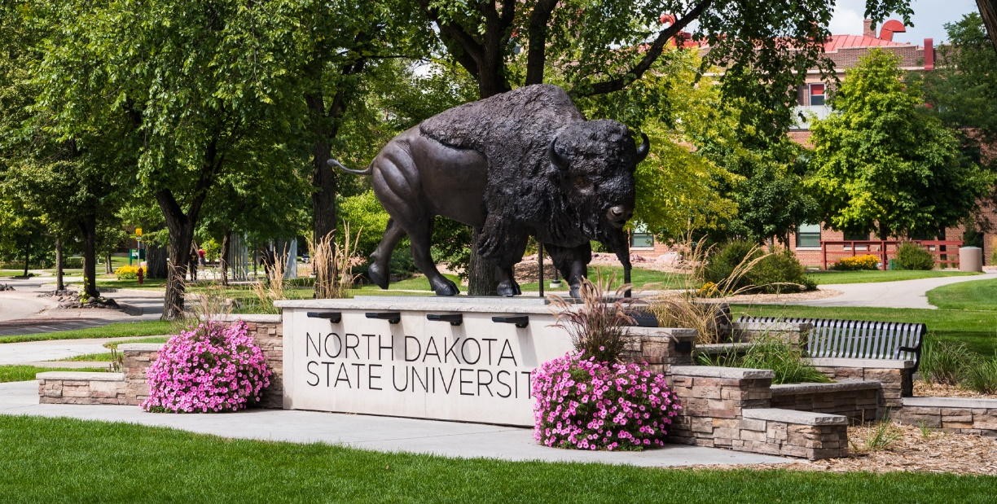
Figure 1. Title of figure in “NDSU Figure Title” style. Note that the style automatically places 24 pts of line spacing after figure titles; if you include a figure note, you will need to manually adjust this line spacing, as there should be one line of space (roughly 12 pts) between a figure title and a figure note.
Note: This style (NDSU Figure Note) is used for any notes related to a figure. (If you use a table, figure, or non-text item that is not your original design, you must cite the original source of the item and obtain any necessary permissions according to copyright. Refer to the style manual of your discipline for more information about citations of non-text items.)
        - Fourth-level subheading in style “NDSU 1.1.1.1.1: Fourth Subheading Numbered”
Below is an example of a schematic. Non-text items must be labeled and titled and entered in an appropriate list of items in the prefatory section. (There are some exceptions—when in doubt follow the conventions of your discipline and consider the needs of your reader.) Additionally, note that the whitespace between the end of this paragraph and the bottom of the page is acceptable to ensure that the schematic appears on the same page with its title and notes.
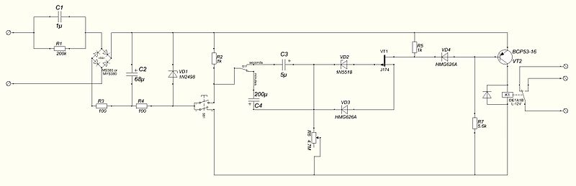
Schematic 1. Example of a schematic. If you use schemes, you can have a List of Schemes after a List of Figures and before a List of Abbreviations. Format the List of Schemes the same way as a List of Tables or List of Figures. Use the “NDSU Schematic Title” from the Styles pane to format scheme titles and populate the List of Schemes.
Note: This style (NDSU Schematic Note) is for notes related to a schematic.
- MAJOR HEADING USING STYLE “NDSU 1: MAJOR HEADING NUMBERED”
You should review your document before and after it has been printed to PDF to ensure its compliance with the Format Guidelines. You can view formatting marks using the “Show/Hide Formatting Marks” button on the Home tab in the Paragraph section (or: Ctrl+Shift+8). Some formatting is embedded in styles for your convenience; for example, the major heading style automatically forces the heading to appear at the top of a new page. We do not recommend using line breaks (Enter) to space out content, as any changes to line spacing or other formatting above the line breaks will likely cause issues for content below the line breaks. Instead, if you need to force content onto a new page—such as a full page table or figure—insert a page break on the Insert tab. Warning: Use page breaks, not section breaks, unless you are inserting landscape pages.
  - First-Level Subheading in Style “NDSU 1.1”
Paragraph text paragraph text paragraph text paragraph text paragraph text paragraph text paragraph text paragraph text.
Table 2. Title of table in “NDSU Table Title” style from the Styles pane.
Column 1 | Column 2 | Column 3 | Column 4
Row 1
Row 2
Note: This style (NDSU Table Note) is used for any table notes.
If you use equations in your text, they should be centered to help them stand out from the paragraph text. If equations are numbered, they must be numbered consecutively throughout the document (1, 2, 3, and so on) or consecutively within each chapter (1.1, 1.2, 2.1., 2.2., and so on), and the equation numbers must be flush against the right margin. You can set tabs to format these: a 3.25” centered tab is used for the equation and a 6.49” right tab is used for its number.
$a\left(b+c\right)=ab+ac$ (1)
$x=\frac{-b±\sqrt{b^{2}-4ac}}{2a}$ (2)
More details on tab settings for equations can be found in our “How to Use NDSU’s Disquisition Templates” documents on our formatting guidelines web page.

Figure 2. Title of the figure. Caption or notes of the figure. If you elect to add a separate note below this title/caption, as in figure 1 above, you may need to manually remove the line spacing from the figure title/caption (line spacing can be set in the paragraph settings).
If you are using a figure title without figure notes, make sure there is a single line of space (12 points of space) between the figure title and other content below (text, subheading, other non-text item, etc.).

REFERENCES
Citation example using the “NDSU Citation” style. This style is double spaced with a hanging indent, but you are welcome to use a format that fits your disciplinary conventions.
Follow your discipline’s style guide for reference list formatting guidance and modify our style as needed.
Use only one citation style. For example, do not mix APA and AMA citation styles in your document.
Before submitting your document, proofread all entries. Citations that have been automatically generated by citation management software likely have missing information or inconsistent formatting. Double-check all citations for accuracy and completeness, paying special attention to capitalization, punctuation, author names, font style, consistency in how you list journal titles (e.g., full vs. abbreviated, italicized), and compliance with the citation style manual you are using.
Citation citation citation citation citation citation citation citation citation citation citation citation citation citation.

APPENDIX A. HEADING USING “NDSU 0: MAJOR HEADING NOT NUMBERED”
Please read our appendix format guidelines thoroughly, as they contain specific instructions pertaining to how your appendix material should be presented.
If you have only one appendix, then remove the letter A from the major heading, but keep using the letter A in any table and figure numbers to denote that they are appendix tables and figures.
Table A1. Title of appendix table in “NDSU Appendix Table Title” style from the Styles pane. Appendix tables should include the letter of the appendix in its number (if you have only one appendix, then use the default letter “A” in the number).
Column 1 | Column 2 | Column 3 | Column 4
Row 1 | “Table text” style
Row 2
Note: This style (NDSU Table Note) is used for any table notes.
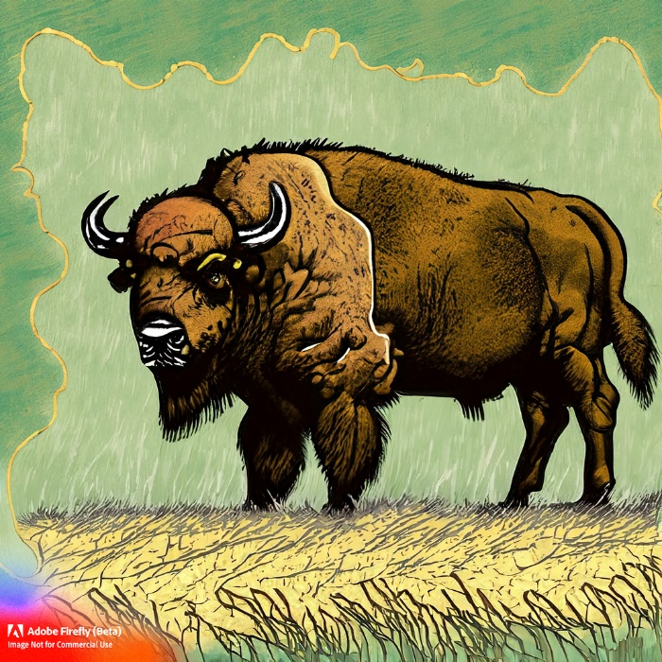
Figure A1. Title of appendix figure in “NDSU Appendix Figure Title” style. Bison art created in a beta version of Adobe Firefly, a generative AI app.
Note: This style (NDSU Figure note) is used for any figure notes. Remember that the value of academic accountability must guide the use of AI tools, and you must cite any AI-generated work.

APPENDIX B. HEADING USING “NDSU 0: MAJOR HEADING NOT NUMBERED”
Table B1. Resources and more information for disquisition writers.
NDSU Website | For more information about:
Graduate School Current Students | Graduate School policy, deadlines, forms, graduation
- https://www.ndsu.edu/gradschool/current_students
Graduate School Dissertations, Theses, and Papers | Disquisition policies, formatting guidelines, templates, a guide to using the templates, submission procedures, publication and delayed release information
- https://www.ndsu.edu/gradschool/current_students/graduation/papers_theses_dissertations
Center for Writers | Writing consultations, writing workshops, disquisition boot camps, writing resources on site and online
- www.ndsu.edu/cfwriters/
Learning and Applied Innovation Center (LAIC) | Thesis formatting workshops. Help with our template. Help with using Microsoft Word and other software applications. Walk-in consulting service in Quentin Burdick Building 150C, or schedule an in-person or virtual appointment with their thesis formatting specialist. Note: The LAIC does not consult on guidelines nor conduct reviews of your formatting. See them for technical help carrying out formatting functions.
- https://www.ndsu.edu/it/help/laic/
Formatting Tutorial Videos | Hosted on the GPS Academy YouTube Channel. “Navigating the Review Process” workshop recording and “Word Crash Course” videos on In-Paragraph Formatting; Styles; Section Breaks and Page Numbers; Table of Contents; Tables and Figures; Landscape Pages and More about Tables; Template Overview.
- https://youtube.com/playlist?list=PLWKsN3lW50IexOpLRkNjh2HDuVKp3XjFH&si=Cksb4ZlFK3X1uCCh

For any tables without notes, you will need to set the line spacing beneath the table manually. For example, the blank line above this text has been formatted to be single-spaced with 6 pts of additional line spacing in order to maintain the correct line spacing after the table. (12 pts for the blank line plus 6 pts equals 18 pts total, the same as for tables with notes.)

If your chapter is using or reproducing content that is now or will be published, and that content has co-authors listed in the publication, then you must include a footnote to the chapter title with the appropriate acknowledgments, including any instructions from the publisher to cite the publication. These acknowledgements are mandatory and must follow the Graduate School’s guidelines for describing your role in the co-authorship. Details and an example are on our General Requirements web page under “Copyright”. To insert a footnote, go to the References tab in the Word ribbon and click “Insert Footnote”—do not place it in the footer.

